MPI LANCHESTER–OSIPOV
Assessment of the military power of eight states
United States, Russia, France, United Kingdom, Germany, Israel, Ukraine, Iran — a rapid assessment under the Lanchester–Osipov MPI methodology
Document 2 of 5 · Country assessment
Data cut-off: October 2026 · Open sources
Military power assessment programme for states · project documentation
Contents
Summary
1. How the assessment was obtained
2. Comparison
2.1. Key data
2.2. Sensitivity to weights
2.3. Power projection
2.4. Pairwise MPI ratios
2.5. Nuclear axis
3. United States
4. Russia
5. France
6. United Kingdom
7. Germany
8. Israel
9. Ukraine
10. Iran
11. Limitations of the assessment
Sources

If page numbers are not visible, press F9 in Word (update field) or right-click the table of contents → “Update field”.

Summary
Rank | Country | MPI | 90% interval | Rank in 90% of runs | With nuclear as a pillar | Without alliances | Nuclear status | λ, thousand km
1 | United States | 90.4 | 87.5–92.3 | 1 | 90.8 | 90.6 | nuclear triad | 12.0
2 | France | 66.9 | 63.4–70.0 | 2–4 | 67.5 | 65.4 | Nuclear, 2-leg | 7.0
3 | Israel | 64.4 | 59.6–68.5 | 2–5 | 64.0 | 63.7 | Nuclear, limited | 4.0
4 | Russia | 63.4 | 57.7–68.3 | 2–6 | 65.9 | 65.3 | nuclear triad | 5.0
5 | United Kingdom | 62.0 | 58.4–65.3 | 3–6 | 62.3 | 60.2 | Nuclear, 2-leg | 7.0
6 | Germany | 58.9 | 55.3–62.2 | 4–6 | 54.3 | 56.9 | No nuclear | 4.0
7 | Ukraine | 47.3 | 39.2–53.0 | 7 | 44.1 | 46.8 | No nuclear | 2.5
8 | Iran | 31.5 | 22.4–38.1 | 8 | 31.3 | 32.4 | Threshold | 3.0

MPI — the index excluding strategic forces (the nuclear axis is separate), CES aggregation ρ = 0.5, “balanced” weights. Intervals — Monte Carlo, 4,000 runs: pillar scores ± country σ, weights ±15%, ρ from 0.3 to 0.7.

Main conclusions
- The United States is the only leader with a clear gap (MPI ≈ 90, rank stable in 100% of runs). The gap is created by multipliers: space, intelligence, AEW&C, tankers, global logistics and the economy.
- Ranks 2 to 6 are statistically indistinguishable. France, Israel, Russia, the United Kingdom and Germany fall within the range 59–67 with overlapping intervals. The order within the group is set by the weights: with “conventional” weights (close to GFP) and weights for the land theatre in Europe, Russia moves into 2nd place; with “expeditionary” weights — France and the United Kingdom.
- The profiles differ more than the final scores. Russia has the largest ground forces, nuclear arsenal and depth, but the economy, alliances and C4ISR pull its index down. Israel has quality in its air force, intelligence and missile defence but lacks depth. Germany has the economy and industry but lacks people.
- Ukraine (≈ 47) is stronger than score-based ratings suggest thanks to ground forces with combat experience, C4ISR and mass drone production. Its weak points are the economy, aviation and the navy.
- Iran (≈ 32) has suffered heavy damage in 2025–2026. Its air force, air defence and economy under blockade are the “weakest link” that, under CES, determines the outcome. The preserved missile arsenal and the Strait of Hormuz provide asymmetric capabilities.
Assessment status. pillar scores — an expert rapid assessment from open data as of October 2026, with an error of ±5–14 points depending on data quality. The full assessment in the programme is built from 253 indicators. The document shows how the methodology works on real countries and is not a forecast of the outcome of wars.

1. How the assessment was obtained
The assessment follows the methodology of document 1 in a simplified mode: instead of 253 indicators, each of the 12 pillars is assigned an expert score of 0–100 on the global scale (100 — the best world level). The scores rest on open data: SIPRI (2025 expenditure, nuclear forces as of January 2026), IISS Military Balance 2026, official budgets and laws, and the chronicle of the wars of 2025–2026. The rationale for each score is given in the country profiles.
Data class | Countries | σ, score points | Why
A | United States, France, United Kingdom, Germany | 5–6 | open budgets, parliamentary oversight, detailed statistics
B | Israel | 8 | opacity of part of the data, unconfirmed nuclear status
C | Russia, Ukraine | 10–12 | wartime: classification of the budget, losses and production; the sides' data contradict each other
D | Iran | 14 | opacity, IRGC off-budget expenditure, disputed damage assessments for 2026.

The final index is calculated as a CES aggregation with ρ = 0.5 across 11 pillars (strategic forces are placed on a separate axis). The following are also calculated: the MPI with the nuclear pillar, “autonomous power” without the alliances pillar (for coalition scenarios, so that allies are not counted twice), variants with other weights, and power projection over distance.
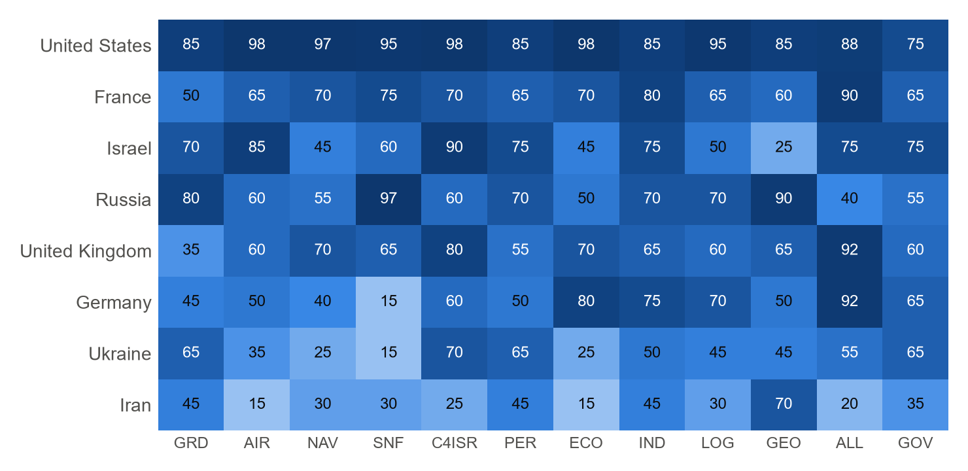
Fig. 1. Scores for the 12 pillars, 0–100. Dark colour — a strength.
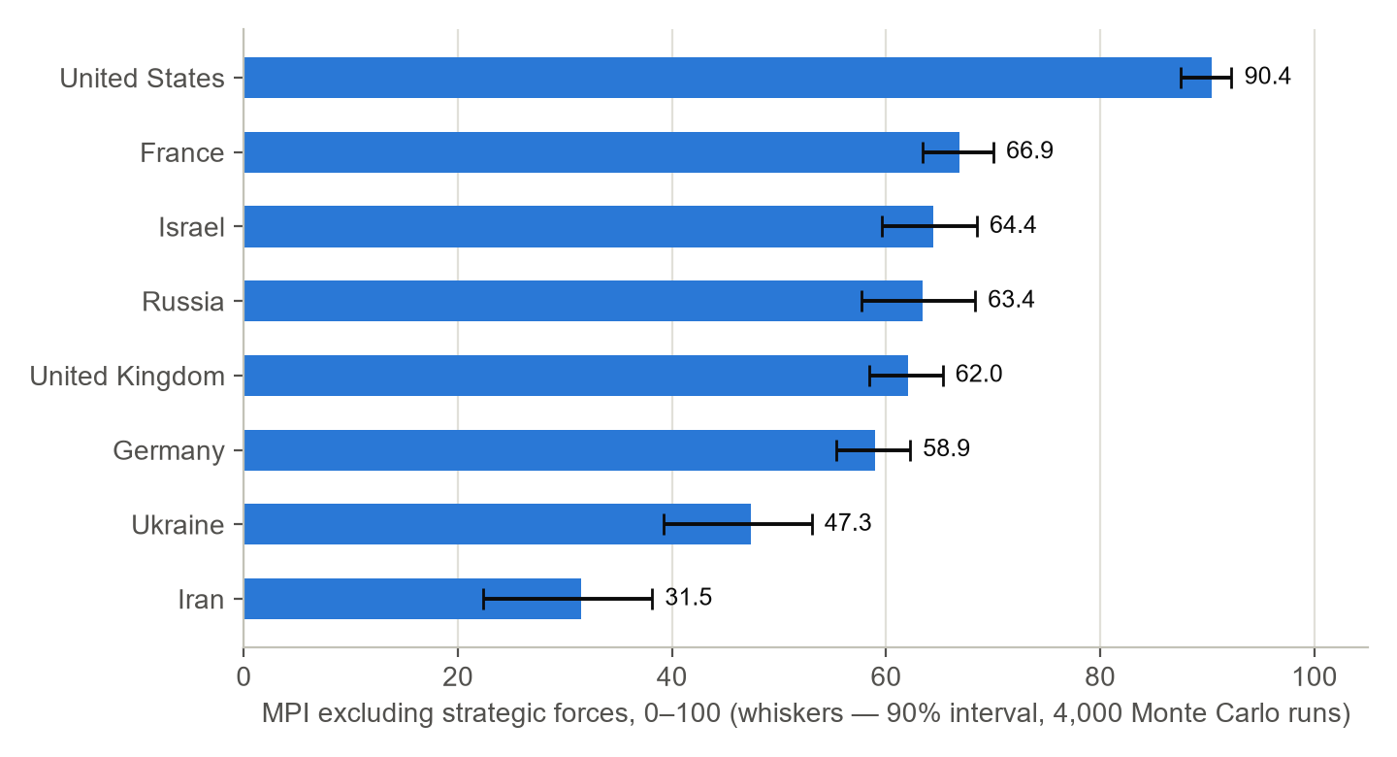
Fig. 2. MPI excluding strategic forces with a 90% uncertainty interval.

2. Comparison

2.1. Key data
Country | Military expenditure 2025, billion $ | % of GDP | Rank in the world | Nuclear warheads, Jan. 2026 | Service members (estimate)
United States | 954 | 3.1 | 1 | 5,042 | ≈ 1.3 million
Russia | ≈ 190 | 7.5 | 3 | 5,420 | 1.55 million authorised strength
Germany | 114 | 2.3 | 4 | — (NATO nuclear participation) | 186.7 thousand
United Kingdom | 89.0 | 2.4 | 6 | 225 | ≈ 140 thousand
Ukraine | ≈ 84.1 | 40 | 7 | — | ≈ 0.9 million
France | 68.0 | 2.0 | 9 | 370 | ≈ 200 thousand
Israel | 48.3 | 7.8 | 11 | ≈ 90 (estimate) | ≈ 170 thousand + 465 thousand reserve
Iran | 7.4 (official) | 2.1 | 38 | — | ≈ 0.6 million (pre-war estimate)

Sources: SIPRI Fact Sheet, April 2026 (expenditure, ≈ — SIPRI estimate); SIPRI Yearbook 2026 (nuclear); IISS Military Balance, national ministries (numbers, rounded).

2.2. Sensitivity to weights
The order of countries depends on the question the analyst asks. The programme makes this choice explicit through weight sets.
Country | Balanced | Conventional (≈ GFP) | Land, Europe | Protracted war | Expeditionary | ρ = 1 (sum) | ρ = −0.5 (weakest link)
United States | 90.4 | 91.2 | 89.8 | 90.5 | 92.5 | 90.6 | 90.1
France | 66.9 | 64.3 | 63.8 | 67.7 | 68.8 | 67.2 | 66.2
Israel | 64.4 | 61.2 | 67.4 | 62.4 | 65.2 | 65.9 | 60.8
Russia | 63.4 | 65.7 | 67.7 | 64.7 | 60.2 | 64.1 | 62.2
United Kingdom | 62.0 | 58.6 | 56.6 | 61.9 | 65.7 | 62.9 | 60.1
Germany | 58.9 | 55.3 | 56.4 | 62.2 | 58.8 | 59.9 | 57.1
Ukraine | 47.3 | 44.9 | 51.1 | 46.6 | 45.0 | 48.8 | 44.3
Iran | 31.5 | 32.0 | 33.7 | 32.5 | 28.1 | 33.2 | 28.2

- Conventional weights (close to GFP): 1. United States; 2. Russia; 3. France; 4. Israel; 5. United Kingdom; 6. Germany; 7. Ukraine; 8. Iran.
- Land theatre in Europe: 1. United States; 2. Russia; 3. Israel; 4. France; 5. United Kingdom; 6. Germany; 7. Ukraine; 8. Iran.
- Protracted war: 1. United States; 2. France; 3. Russia; 4. Israel; 5. Germany; 6. United Kingdom; 7. Ukraine; 8. Iran.
- Expeditionary operations: 1. United States; 2. France; 3. United Kingdom; 4. Israel; 5. Russia; 6. Germany; 7. Ukraine; 8. Iran.
Conclusion: the claim that “country X has the world's second army” without specifying the theatre, horizon and weights is incorrect. The right answer is a profile and an interval.

2.3. Power projection
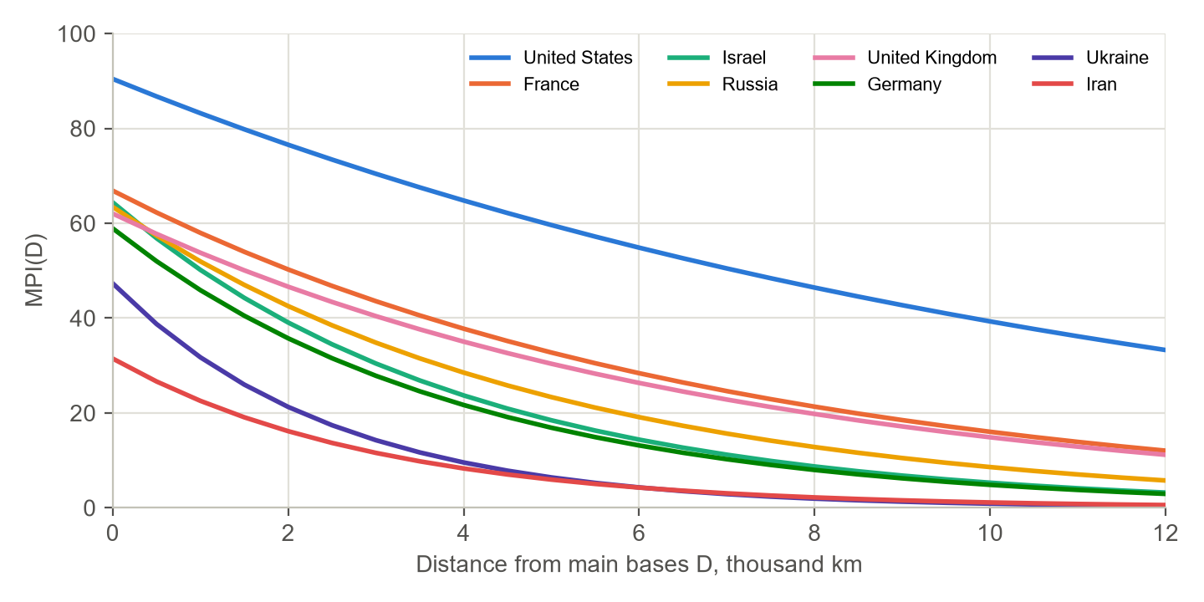
Fig. 3. MPI versus the distance of the theatre from main bases.
Country | λ, thousand km | MPI at its own borders | MPI at 2 thousand km | MPI at 8 thousand km
United States | 12.0 | 90.4 | 76.5 | 46.4
France | 7.0 | 66.9 | 50.3 | 21.3
Israel | 4.0 | 64.4 | 39.1 | 8.7
Russia | 5.0 | 63.4 | 42.5 | 12.8
United Kingdom | 7.0 | 62.0 | 46.6 | 19.8
Germany | 4.0 | 58.9 | 35.7 | 8.0
Ukraine | 2.5 | 47.3 | 21.3 | 1.9
Iran | 3.0 | 31.5 | 16.2 | 2.2

At a distance of 8 thousand km the United States retains about half of its potential, France and the United Kingdom about a third, and the rest less than a fifth. This explains why only the United States conducted operations in 2026 simultaneously in the Western Hemisphere and the Middle East.

2.4. Pairwise MPI ratios
Row ÷ column: how many times the MPI of the country in the row is higher than that of the country in the column. This is a crude measure that does not account for the theatre, coalitions or time. For specific scenarios the combat model is used (document 4).
 | United States | France | Israel | Russia | United Kingdom | Germany | Ukraine | Iran
United States | — | 1.35 | 1.40 | 1.43 | 1.46 | 1.53 | 1.91 | 2.87
France | 0.74 | — | 1.04 | 1.05 | 1.08 | 1.14 | 1.41 | 2.13
Israel | 0.71 | 0.96 | — | 1.02 | 1.04 | 1.09 | 1.36 | 2.05
Russia | 0.70 | 0.95 | 0.99 | — | 1.02 | 1.08 | 1.34 | 2.02
United Kingdom | 0.69 | 0.93 | 0.96 | 0.98 | — | 1.05 | 1.31 | 1.97
Germany | 0.65 | 0.88 | 0.91 | 0.93 | 0.95 | — | 1.24 | 1.87
Ukraine | 0.52 | 0.71 | 0.73 | 0.75 | 0.76 | 0.80 | — | 1.50
Iran | 0.35 | 0.47 | 0.49 | 0.50 | 0.51 | 0.53 | 0.66 | —

2.5. Nuclear axis
Country | Warheads (SIPRI, Jan. 2026) | Class | Components and features
Russia | 5,420 | 4 — triad | the largest arsenal; new delivery systems; non-strategic nuclear weapons
United States | 5,042 | 4 — triad | modernisation of all components; Golden Dome missile defence
France | 370 | 3 — two components | naval and air components; a declared European role
United Kingdom | 225 | 3 — naval + NATO aircraft | Trident; purchase of the F-35A for NATO's nuclear mission
Israel | ≈ 90 (estimate) | 2 — limited | non-confirmation policy
Iran | — | 1 — threshold (before the strikes) | enrichment facilities attacked in 2025–2026.
Germany | — | 0, NATO nuclear participation | carriers for US bombs under NATO
Ukraine | — | 0 | renunciation of nuclear weapons in 1994.

3. United States
MPI 90.4 (90%: 87.5–92.3), rank 1 of 8 (in 90% of runs — 1). With the nuclear pillar — 90.8, without alliances — 90.6. Nuclear status: nuclear triad. Projection radius λ ≈ 12.0 thousand km. Data class: A.

Key facts
- Military expenditure in 2025 — 954 billion $ (3.1% of GDP, 33% of the world total; SIPRI). IISS expects it to exceed 1 trillion $ in 2026, including on the Golden Dome missile defence system.
- Nuclear arsenal — 5,042 warheads, of which about 1,770 are deployed (SIPRI, January 2026). A full triad.
- About 1.3 million service members (IISS, estimate). 11 aircraft carriers, the largest fleet of 5th-generation aircraft.
- 2026: an operation in Venezuela with the capture of N. Maduro (3 January), a campaign against Iran together with Israel (from 28 February), a naval blockade of Iran (from April, resumed from mid-July). In September an agreement was signed with Denmark and Greenland on expanding the military presence.

Pillar scores and rationale
Pillar | Score | Rationale
Ground forces | 85 | Large armoured and infantry forces, PGMLRS, the best logistics; but the army is below the required levels and has no experience of a land war with an equal adversary.
Air force & air defence | 98 | The largest air force and naval aviation, F-22 and F-35, tankers, AEW&C; air dominance over Iran in 2026.
NAV | 97 | 11 aircraft carriers, the largest nuclear submarine fleet, about 80 cruisers and destroyers; shipbuilding is the weakness.
Strategic forces | 95 | Triad, 5,042 warheads, modernisation (Columbia, Sentinel, B-21); close to the top of the scale.
Space, cyber, C4I | 98 | Global satellite intelligence and communications, cyber forces, leadership in military AI.
Personnel | 85 | A professional army, high training standards; recruitment problems of 2022–2024 partly resolved.
Defence economy | 98 | The world's largest economy and military budget.
Defence industry & tech | 85 | The most powerful defence industry, but chokepoints in munitions and interceptor output and in shipbuilding.
Logistics & mobilisation | 95 | Global logistics, military airlift, sea transport, energy self-sufficiency.
Geography & demography | 85 | Protection by two oceans, vast strategic depth; distance from theatres is offset by bases.
Alliances & presence | 88 | NATO, Japan, Republic of Korea, Australia, Israel; reliability reduced by the frictions of 2025–2026 (tariffs, Greenland).
Governance & experience | 75 | Extensive combat experience and rapid operations in 2026; political polarisation and an unpredictable policy course.

Strengths and vulnerabilities
Strengths | Vulnerabilities
Dominance in the air, at sea and in space  Power projection in any theatre (λ ≈ 12 thousand km)  Multipliers: intelligence, communications, AEW&C, tankers  Economic and technological lead | Munitions and interceptor production lags behind the needs of a long war  Shipbuilding is inferior to China  Overstretched commitments: Europe, the Middle East, the Indo-Pacific region, the Western Hemisphere  Declining trust of allies

Trend 2026–2030
Budget growth above 1 trillion $, a focus on missile defence (Golden Dome) and the Western Hemisphere; pressure on NATO allies to reach 5% of GDP.

4. Russia
MPI 63.4 (90%: 57.7–68.3), rank 4 of 8 (in 90% of runs — 2–6). With the nuclear pillar — 65.9, without alliances — 65.3. Nuclear status: nuclear triad. Projection radius λ ≈ 5.0 thousand km. Data class: C.

Key facts
- Military expenditure in 2025 — about 190 billion $ (7.5% of GDP, 20% of government spending, the highest in the history of SIPRI observations). The share of classified items is about 79% of the “National Defence” budget.
- Nuclear arsenal — 5,420 warheads (SIPRI, January 2026), the largest in the world. A full triad, new systems.
- Establishment strength — 1,550,500 service members (decree of September 2026). Recruitment is estimated at about 30 thousand people per month, with a decline in 2026.
- The war with Ukraine is in its fifth year. North Korean troops are involved (according to Seoul's estimate — about 15 thousand combat service members and more than 6 thousand engineers and builders since October 2024).

Pillar scores and rationale
Pillar | Score | Rationale
Ground forces | 80 | The largest ground force grouping in Europe with combat experience, mass artillery and drones; heavy armour losses, depletion of storage stocks.
Air force & air defence | 60 | Numerous aerospace forces and air defence, effective glide bombs; air dominance over Ukraine has not been achieved.
NAV | 55 | A strong submarine fleet; the Black Sea Fleet has suffered heavy losses from missiles and unmanned surface vessels.
Strategic forces | 97 | The largest arsenal, a triad, new delivery systems; the top of the scale.
Space, cyber, C4I | 60 | Strong electronic warfare, a satellite constellation; gaps in intelligence and command, dependence on imported electronics.
Personnel | 70 | Large numbers and combat experience; high losses, the quality of training of replacements, declining recruitment.
Defence economy | 50 | An economy of about 2.5 trillion $ with a high burden of 7.5% of GDP; sanctions, limited room for growth.
Defence industry & tech | 70 | High output of shells, strike drones and glide bombs; dependence on imported components and supplies from North Korea.
Logistics & mobilisation | 70 | Rail logistics, energy self-sufficiency; refineries and ports vulnerable to long-range strikes.
Geography & demography | 90 | Vast territory and depth, a harsh climate.
Alliances & presence | 40 | Belarus, North Korea (troops), partnership with Iran and China without military commitments; the CSTO is weak.
Governance & experience | 55 | Centralised command, war experience; inflexibility, corruption risks, personnel losses.

Strengths and vulnerabilities
Strengths | Vulnerabilities
Mass of ground forces and artillery  The largest nuclear arsenal  War economy: high output of cheap mass means  Strategic depth | Casualties outpace recruitment (2026 estimates)  Economic burden of 7.5% of GDP under sanctions  Vulnerability of oil infrastructure to long-range strikes  Weak allies

Trend 2026–2030
A course towards a war of attrition, scaling up the output of mass means; a new mobilisation is under discussion. The key question is economic resilience.

5. France
MPI 66.9 (90%: 63.4–70.0), rank 2 of 8 (in 90% of runs — 2–4). With the nuclear pillar — 67.5, without alliances — 65.4. Nuclear status: nuclear, 2-leg. Projection radius λ ≈ 7.0 thousand km. Data class: A.

Key facts
- Military expenditure in 2025 — 68.0 billion $ (2.0% of GDP; SIPRI). Under the revised military programming law — 63.3 billion € by 2027 (about 2.6% of GDP).
- Nuclear arsenal — 370 warheads in the total inventory according to SIPRI 2026 (an estimate of about 290 was cited earlier). Sea and air components.
- About 200 thousand service members (IISS, estimate). The aircraft carrier “Charles de Gaulle”, 4 SSBNs, nuclear-powered attack submarines.
- From 2026 voluntary military service is being introduced; the reserve is planned to be brought to 50 thousand. Together with the United Kingdom it leads the “coalition of the willing” for guarantees to Ukraine.

Pillar scores and rationale
Pillar | Score | Rationale
Ground forces | 50 | Small but experienced expeditionary forces (Leclerc, CAESAR); limited mass for a large war.
Air force & air defence | 65 | Rafale, A330 MRTT tankers, SCALP cruise missiles; a limited fleet.
NAV | 70 | An ocean-going navy with an aircraft carrier, SSBNs and nuclear submarines.
Strategic forces | 75 | Independent deterrence with two components, a declared European role.
Space, cyber, C4I | 70 | Own satellites, strong intelligence.
Personnel | 65 | A professional army with combat experience in Africa.
Defence economy | 70 | An economy of about 3.3 trillion $, but a high deficit and debt constrain growth.
Defence industry & tech | 80 | A fully autonomous defence industry: aircraft, submarines, missiles, nuclear weapons.
Logistics & mobilisation | 65 | Good logistics, nuclear power generation.
Geography & demography | 60 | Overseas territories, global presence; distance from the eastern flank.
Alliances & presence | 90 | NATO, EU (Art. 42.7), strategic treaties (Greece), leadership of the coalition of the willing.
Governance & experience | 65 | A strong strategic culture; frequent changes of government.

Strengths and vulnerabilities
Strengths | Vulnerabilities
Fully autonomous defence industry  Independent nuclear deterrence  Expeditionary experience and an ocean-going navy | A small mass of ground forces  Budget constraints and political instability  Limited ammunition stocks

Trend 2026–2030
Accelerated budget growth, a larger reserve, an expanded role for nuclear deterrence in Europe.

6. United Kingdom
MPI 62.0 (90%: 58.4–65.3), rank 5 of 8 (in 90% of runs — 3–6). With the nuclear pillar — 62.3, without alliances — 60.2. Nuclear status: nuclear, 2-leg. Projection radius λ ≈ 7.0 thousand km. Data class: A.

Key facts
- Military expenditure in 2025 — 89.0 billion $ (2.4% of GDP; SIPRI, 6th in the world). The Defence Investment Plan (30.06.2026): about 298 billion £ over 4 years, 2.7% of GDP by 2029.
- Nuclear arsenal — 225 warheads (SIPRI), a naval component (Trident).
- About 140 thousand service members of the regular forces (estimate); two aircraft carriers, Astute nuclear submarines.
- Political instability: in June 2026 Defence Minister J. Healey resigned.

Pillar scores and rationale
Pillar | Score | Rationale
Ground forces | 35 | A small army (about 70 thousand in the ground forces), a small tank fleet.
Air force & air defence | 60 | Typhoon, F-35B, Voyager tankers; delays in AEW&C programmes.
NAV | 70 | Two aircraft carriers, nuclear submarines, Type 45 destroyers; ship readiness problems.
Strategic forces | 65 | One naval component; purchase of the F-35A for NATO's nuclear mission.
Space, cyber, C4I | 80 | Strong signals intelligence (GCHQ), the “Five Eyes”, cyber capabilities.
Personnel | 55 | A professional army; a chronic shortfall.
Defence economy | 70 | An economy of about 3.7 trillion $; strained public finances.
Defence industry & tech | 65 | BAE, Rolls-Royce, MBDA UK; limited munitions capacity.
Logistics & mobilisation | 60 | An island position, maritime logistics.
Geography & demography | 65 | An island, distance from the eastern flank, global bases.
Alliances & presence | 92 | NATO, the “Five Eyes”, AUKUS, the Joint Expeditionary Force (JEF).
Governance & experience | 60 | Experienced command; political turbulence in 2026.

Strengths and vulnerabilities
Strengths | Vulnerabilities
Intelligence and allied networks  Submarine fleet and deterrence  High technological sophistication | Small ground force numbers  Navy readiness  Funding lagging behind declared tasks

Trend 2026–2030
Growth to 2.7–3% of GDP, a bet on sovereign munitions production and long-range strikes.

7. Germany
MPI 58.9 (90%: 55.3–62.2), rank 6 of 8 (in 90% of runs — 4–6). With the nuclear pillar — 54.3, without alliances — 56.9. Nuclear status: no nuclear. Projection radius λ ≈ 4.0 thousand km. Data class: A.

Key facts
- Military expenditure in 2025 — 114 billion $ (2.3% of GDP, for the first time since 1990 above 2%; 4th in the world; SIPRI). The 2026 budget — about 108 billion € (82.7 billion € core + 25.5 billion € special fund), about 152 billion € by 2029 (3.5% of GDP).
- Bundeswehr strength — 186,705 (August 2026). The target by 2035 is 460 thousand, including 200 thousand reserve.
- From 1 January 2026 a new military service law is in force (questionnaires for 18-year-olds, medical examinations for men from 2027).
- It has no nuclear weapons of its own; it participates in NATO nuclear planning. An armoured brigade is deployed in Lithuania.

Pillar scores and rationale
Pillar | Score | Rationale
Ground forces | 45 | Leopard 2 and a brigade in Lithuania; understrength, rebuilding after decades of cuts.
Air force & air defence | 50 | Eurofighter, Tornado, F-35 deliveries; strong air defence (Patriot, IRIS-T SLM, Arrow 3).
NAV | 40 | U212A submarines and frigates; a regional fleet.
Strategic forces | 15 | No nuclear weapons, NATO nuclear participation; the score reflects deterrence through an ally and long-range non-nuclear strikes.
Space, cyber, C4I | 60 | A good base, but lagging in digitalisation.
Personnel | 50 | Personnel shortages, ageing; a new service model from 2026.
Defence economy | 80 | An economy of about 5 trillion $, fiscal space after the change to the “debt brake”.
Defence industry & tech | 75 | Rheinmetall, KNDS, Diehl; rapid growth in munitions output.
Logistics & mobilisation | 70 | Europe's transport hub; dependence on energy imports.
Geography & demography | 50 | No common border with Russia, depth provided by allies.
Alliances & presence | 92 | NATO, EU; a key node of Europe's defence.
Governance & experience | 65 | An effective state, but slow procurement and no recent combat experience.

Strengths and vulnerabilities
Strengths | Vulnerabilities
Economic and industrial potential  The fastest budget growth in Europe  Air defence and a NATO logistics hub | Personnel shortages  Slow procurement  No combat experience

Trend 2026–2030
The largest conventional army in Europe by the 2030s if the plans are fulfilled; the key question is people.

8. Israel
MPI 64.4 (90%: 59.6–68.5), rank 3 of 8 (in 90% of runs — 2–5). With the nuclear pillar — 64.0, without alliances — 63.7. Nuclear status: nuclear, limited. Projection radius λ ≈ 4.0 thousand km. Data class: B.

Key facts
- Military expenditure in 2025 — 48.3 billion $ (7.8% of GDP; SIPRI). After the war with Iran the 2026 budget was increased to about 144 billion shekels; up to 184 billion has been requested.
- Nuclear arsenal — about 90 warheads (estimate; not officially confirmed).
- About 170 thousand service members and about 465 thousand reservists (IISS, estimate).
- Wars with Iran (June 2025; from 28 February 2026), a ground operation in Lebanon from March 2026, operations in Gaza and Syria. US military aid — 3.8 billion $ per year.

Pillar scores and rationale
Pillar | Score | Rationale
Ground forces | 70 | Experienced, well-equipped forces (Merkava, Namer) with a large reservist pool; overstretch on many fronts.
Air force & air defence | 85 | F-35I, F-15I/IA, F-16; air dominance over Iran in 2025 and 2026.
NAV | 45 | Dolphin submarines, Sa'ar 6 corvettes; a limited fleet.
Strategic forces | 60 | An unconfirmed arsenal of about 90 warheads, “Jericho” missiles; opacity.
Space, cyber, C4I | 90 | World-class intelligence and cyber forces, multi-layered missile defence (Iron Dome, “David's Sling”, Arrow, the Iron Beam laser).
Personnel | 75 | Conscripts and well-trained reservists; fatigue after three years of war.
Defence economy | 45 | An economy of about 0.6 trillion $; a military burden of about 8% of GDP.
Defence industry & tech | 75 | Advanced defence industry, record exports; dependence on US supplies of aerial bombs and interceptors.
Logistics & mobilisation | 50 | A small territory, dependence on seaborne imports.
Geography & demography | 25 | No strategic depth, surrounded on several fronts.
Alliances & presence | 75 | Close military ties with the US (joint operations in 2025–2026); growing international isolation.
Governance & experience | 75 | Vast combat experience, fast decisions; internal polarisation.

Strengths and vulnerabilities
Strengths | Vulnerabilities
Quality of the air force, intelligence and missile defence  Combat experience  US support | No depth or scale  Expenditure of interceptors and munitions  Reservist fatigue and multiple fronts

Trend 2026–2030
Record budgets, a focus on laser missile defence and long-range strikes; dependence on the United States is growing.

9. Ukraine
MPI 47.3 (90%: 39.2–53.0), rank 7 of 8 (in 90% of runs — 7). With the nuclear pillar — 44.1, without alliances — 46.8. Nuclear status: no nuclear. Projection radius λ ≈ 2.5 thousand km. Data class: C.

Key facts
- Military expenditure in 2025 — about 84.1 billion $ (40% of GDP, 7th in the world; SIPRI).
- About 0.9 million service members (2026 estimates). No nuclear weapons of its own.
- More than 4 million drones in 2025; the plan is 7–10 million in 2026. Up to 1,000 interceptor drones per day. Long-range strikes on Russia's oil refineries and ports.
- On 11 October 2026 an “energy truce” was announced; the strikes continue. The coalition of the willing (Paris, 6 January 2026) undertook to deploy forces after a ceasefire.

Pillar scores and rationale
Pillar | Score | Rationale
Ground forces | 65 | A large army with combat experience, leadership in drones; a shortage of people and heavy equipment.
Air force & air defence | 35 | A small air force (F-16, Mirage), strong ground-based air defence but a shortage of interceptors.
NAV | 25 | Almost no navy, but unmanned surface vessels and missiles pushed the Black Sea Fleet back.
Strategic forces | 15 | No nuclear weapons; the score reflects long-range non-nuclear strikes (drones and missiles at 1,000+ km).
Space, cyber, C4I | 70 | Network-centric command, satellite communications, allied intelligence, innovation in EW.
Personnel | 65 | High motivation and experience; mobilisation difficulties, unauthorised abandonment of units.
Defence economy | 25 | An economy of about 0.2 trillion $, dependence on external financing.
Defence industry & tech | 50 | Mass drone production, domestic missiles; a shortage of shells and heavy equipment.
Logistics & mobilisation | 45 | A damaged power grid; supply through Poland and Romania.
Geography & demography | 45 | A large territory, but a long front and the loss of part of the territory.
Alliances & presence | 55 | No formal alliance; EU support, the coalition of the willing, purchases through allies.
Governance & experience | 65 | Rapid adaptation and decentralisation; corruption scandals, political tension.

Strengths and vulnerabilities
Strengths | Vulnerabilities
Drones and innovation  Combat experience and motivation  C4ISR and allied intelligence | Human resources  Dependence on external financing and supplies  A small air force and a shortage of air-defence interceptors

Trend 2026–2030
Ceasefire and security-guarantee talks; growth of the domestic defence industry (drones, missiles).

10. Iran
MPI 31.5 (90%: 22.4–38.1), rank 8 of 8 (in 90% of runs — 8). With the nuclear pillar — 31.3, without alliances — 32.4. Nuclear status: threshold. Projection radius λ ≈ 3.0 thousand km. Data class: D.

Key facts
- Military expenditure in 2025 according to official data — 7.4 billion $ (2.1% of GDP; SIPRI). A significant part of IRGC expenditure is not reflected.
- No nuclear weapons of its own; the nuclear programme and enrichment facilities were attacked in 2025–2026.
- About 0.6 million service members before the war (IISS, estimate), including the IRGC.
- The 2026 war: US and Israeli strikes from 28 February, the death of Ali Khamenei, the appointment of Mojtaba Khamenei (8 March), a truce on 8 April, the resumption of fighting from 8 July, a US naval blockade. According to US intelligence (May 2026, disputed), about 70% of the pre-war missile stockpile has been preserved.

Pillar scores and rationale
Pillar | Score | Rationale
Ground forces | 45 | Numerous but outdated army and IRGC ground forces.
Air force & air defence | 15 | Old aircraft, air defence suppressed in 2025–2026; air superiority lost.
NAV | 30 | IRGC boats, mines and anti-ship missiles pose an asymmetric threat to the Strait of Hormuz.
Strategic forces | 30 | No nuclear weapons; a large medium-range missile arsenal, partly preserved in underground bases.
Space, cyber, C4I | 25 | Degradation of command after strikes on the leadership.
Personnel | 45 | Mass conscription, IRGC-motivated; decapitation of the command.
Defence economy | 15 | Sanctions, a naval blockade, falling oil exports.
Defence industry & tech | 45 | Own missiles and drones; according to CENTCOM, up to 90% of the defence industry has been hit (the estimate is disputed).
Logistics & mobilisation | 30 | Blockade, damaged infrastructure; a large territory and its own oil.
Geography & demography | 70 | Mountains, size, control of the Strait of Hormuz coast.
Alliances & presence | 20 | The “Axis of Resistance” has been weakened; Russia and China did not intervene.
Governance & experience | 35 | Hereditary succession, strikes on the leadership; the regime held.

Strengths and vulnerabilities
Strengths | Vulnerabilities
Missile and drone arsenal in underground bases  The threat to the Strait of Hormuz  Territory and depth | Air force & air defence  Economy under blockade and sanctions  Isolation, degradation of allies

Trend 2026–2030
A focus on missiles, maritime asymmetry and rebuilding air defence; the risk of a renewed full-scale war.

11. Limitations of the assessment
- Pillar scores are an expert assessment. A full calculation across 253 indicators will give more accurate and testable values.
- Wartime data (Russia, Ukraine, Iran, Israel) are incomplete and contradictory; therefore their σ is higher and the intervals wider.
- The index does not account for intentions, the will to fight in a particular war, or future decisions of allies.
- Snapshot — October 2026. Rapidly changing circumstances (truces, the blockade of Iran, negotiations on Ukraine) require quarterly updating.

Sources
- SIPRI Fact Sheet “Trends in World Military Expenditure, 2025”, April 2026
- SIPRI Yearbook 2026: World nuclear forces (January 2026)
- IISS Military Balance 2026 (reviews of key findings)
- Budgets and laws: the Bundestag (2026 budget, military service law), the French Ministry of Defence (LPM review, April 2026), the UK MoD (Defence Investment Plan, 30.06.2026), Israel's 2026 budget
- Britannica “2026 Iran war”; CFR Global Conflict Tracker; US intelligence estimates of Iran's missiles (CNN, NYT, WP, May 2026)
- ISW, Kyiv Independent, Moscow Times, Euromaidan Press, Militarnyi — data on the war in Ukraine, recruitment and drone production
- Al Jazeera, PBS, ABC, CBS — the “energy truce” of 11.10.2026; Gulf News — the blockade of Iran

