MPI LANCHESTER–OSIPOV
Pilot on 40 countries
Collection of open data, the index computational core, validation against the wars of 2020–2026 and sensitivity analysis
Document 6 · Pilot and core
MPI-LO methodology 0.1 (pilot, October 2026); data snapshot hash 9e84e3a6deffc44f
Data cut-off: October 2026 · Open sources
Military power assessment programme for states · project documentation
Contents
Summary
1. Pilot data
1.1. Composition
1.2. Sources
1.3. Coverage
1.4. Fleet quality by weapons and equipment composition
1.5. Expert indicators: objective proxy measures
1.6. AI expert assessment (temporary)
2. Computational core
2.1. Stages
2.2. Combat model and coalitions
2.3. Tests
3. Rating of 40 countries
4. Cross-check against the expert assessment
5. Validation against the wars of 2020–2026
5.1. Expert assessment of 8 countries
5.2. Pilot, 40 countries
5.3. What the second data stage changed
6. Sensitivity
7. Calibration of parameters against test cases
7.1. Protocol
7.2. Result
7.3. Identifiability of parameters
7.4. Contradiction between cases
7.5. Combat model parameters from historical battles
7.6. Extended validation: 10 wars of 2018–2025 using data from each war's own year
7.7. Solution: α = 1.0, d from the battles, d of the war in Ukraine — from its losses
7.8. Model error
7.9. Quality by year and the strike-campaign model
7.10. Flashpoint monitor: conflict probability in a country pair
8. Conclusions and next steps
Sources

If page numbers are not visible, press F9 in Word (update field) or right-click the table of contents → “Update field”.

Summary
The pilot tests whether the military power index can be computed from 253 indicators on open data and how closely the result matches the expert assessment and the outcomes of real wars. 40 states were taken: the 20 largest military powers and 20 flashpoint participants from document 4. The snapshot — 2025, the panel — 2015–2025.
- Data. Values were collected automatically for 84.0% of “country × indicator” cells (8,499 of 10,120): open statistics are 91% filled, the IISS block — 67%, OSINT indicators — 69%, expert ones — 99% (a template has been prepared for them).
- Quality — the second data tranche. The weapons and equipment model reference turns Wikipedia tables into shares of modern tanks, IFVs and APCs, the average age of the tank and aircraft fleets and the number of precision-guided launchers; long-range SAM battalions, scales for missile defence, missile attack warning, hypersonic and anti-satellite weapons, the ITU cybersecurity index, UN peacekeepers, USGS titanium and rare earth metals, and FAO food self-sufficiency have been added. The index now has 215 indicators instead of 107.
- Third tranche of open sources (13.10.2026). 10 previously empty structural indicators: allies under mutual defence treaties, partners and recipients of arms deliveries (SIPRI), overseas bases, defensive terrain and climate, airfields with long runways, shipbuilding, graduate output of STEM specialists, mechanical engineering. The rating shifted by no more than a point: these indicators are almost unrelated to the discrepancy with the experts.
- Core. The `core/lanmil` package computes the index by the same scheme as the prototype and documents 1–3. The index includes 215 indicators for which data exist for at least half the countries; 26 tests of formula properties and of expert panel processing pass, including agreement with the analytical solution of the Lanchester square law to within 0.1%.
- Rating. United States 79.7, China 75.7, Russia 70.4; then a tight group of seven countries from 50 to 55 points, whose places are statistically indistinguishable.
- Expert indicators — replaced by objective measurers. Expert scores have been replaced by measurable quantities from open databases where these reflect the same phenomenon (13 indicators: willingness to fight and trust in the army from WVS, combat experience from UCDP, the share of domestically produced weapons and equipment, strategic depth from GIS, etc.). 64 expert indicators have no objective measurer: until the expert panel is conducted (document 7) they are temporarily filled with an AI expert assessment — class D, with intervals, the lowest source priority (section 1.6).
- Cross-check with experts. The rank correlation with the expert assessment of 8 countries — 0.81. The pilot systematically overrates large armies and underrates small high-quality ones: shares of modern equipment are already accounted for, but training, serviceability, motivation and combat experience are still absent from it.
- Validation against wars. The expert assessment is correct in 2 of 2 cases for the balance of forces and in 2 of 2 for the outcome of campaigns; the pilot — in 2 of 5 and 2 of 3. Russia's advantage over Ukraine in the pilot fell from 5.9 to 2.52 : 1, but is still twice as high as the expert one (1.68 : 1).
- Main conclusion. Automated collection has exhausted most open sources. Further gains in accuracy will come not from tuning the weights (according to Sobol, they explain only a small share of the spread) but from expert indicators of training, serviceability and motivation.
- Calibration (section 7). A search over 1350 combinations of α, ρ, κ and weights with cross-validation: the fitted parameters predict the held-out war worse than the default parameters (−31.71 versus −19.59), so the defaults remain. Russia — Ukraine and small wars require an opposite κ — there is no common value; the model's probabilistic forecasts are worse than simple benchmarks because of overconfidence.
- Independent validation (sections 7.5–7.6). Across 404 battles of 1900–1973 the square law is not confirmed (α = 0.65, adjusted for effectiveness ≈ 1), and numbers hardly predict victory. On the 10 wars of 2018–2025 selected from the UCDP register and computed from data for the year before the war began, all parameter variants are worse than the uniform forecast: an index reconstructible by year overrates mass armies. The best of the pre-specified variants — α 1.0 and d around 1 (from battles).
- Solution (section 7.7). As of 13.10.2026 α = 1.0, d = 1.3 (hasty defence, strikes) and 1.0 (prepared and fortified); the d of the war between Russia and Ukraine is measured from the equipment loss ratio for 2024–2025 (Oryx) — 1.70.

1. Pilot data

1.1. Composition
Major powers: United States, China, Russia, India, United Kingdom, France, Germany, Japan, Republic of Korea, Italy, Türkiye, Israel, Iran, Pakistan, Ukraine, Poland, Saudi Arabia, Egypt, Brazil, Australia.
Flashpoint participants: Taiwan, North Korea, Philippines, Vietnam, Indonesia, Thailand, Cambodia, Afghanistan, Ethiopia, Eritrea, DR Congo, Rwanda, Belarus, Azerbaijan, Armenia, Greece, Serbia, Venezuela, Finland, Sweden.

1.2. Sources
Source | What it provides | Class
World Bank (WDI, WGI, HCI) | economy, demography, military expenditure and numbers (SIPRI and IISS series in WDI), governance, mechanical engineering (UNIDO), forest cover | A–B
IMF, World Economic Outlook | GDP, PPP, growth, government debt, inflation, budget; including Taiwan (API closed, data obtained via Firecrawl) | A
SIPRI: Milex 2026, Top-100, Yearbook 2026 | military expenditure 1949–2025, defence industry revenue, nuclear arsenals as of January 2026 | B
Our World in Data | energy (Energy Institute), median age and population (UN) | A
CIA World Factbook | railways, airports, ports, merchant fleet, borders, conscription | C
UCS Satellite Database | military satellites by purpose (as of 1 May 2023) | B
UCDP/PRIO ACD 26.1 | experience of interstate and internal conflicts through 2025 | B
Wikipedia | personnel from the IISS Military Balance, the TI corruption index, steel, GII, orbital launches, weapons and equipment tables (parsed by script) | A–C
Global Firepower 2026 | equipment stockpiles, fleet, roads and inland waterways | C
Weapons and equipment model reference | year of adoption and generation of tanks, IFVs, APCs, MLRS and combat aircraft → shares of modern equipment, fleet ages, precision-guided launchers (from Wikipedia tables) | C
Oryx (via Wikipedia notes) | the composition of Russia's losses by modification — a proxy estimate of the fleet composition where modifications are not specified | D
ITU (via World Bank Data360) | Global Cybersecurity Index 2020 and 2024 | A
UN, Department of Peace Operations (HDX) | peacekeepers: annual average numbers by country, 2015–2025 | A
USGS Mineral Commodity Summaries 2026 | titanium sponge and rare earth metals, 2024–2025 | B
FAOSTAT | dependence on grain imports (3-year average) | A
SIPRI Arms Transfers Database (API) | partners in major arms supplies and recipient states, 2021–2025 | B
Mutual defence treaty reference | treaty allies: NATO, EU (Art. 42.7), CSTO, US bilateral treaties, the Rio Treaty, the League of Arab States, SADC, etc. (treaty texts, ATOP) | A–C
Wikipedia: overseas military bases | number of countries hosting bases | C
Nunn–Puga, CRU TS (World Bank CCKP) | the share of highly rugged terrain and forests; months unfavourable for an offensive (climatology 1991–2020) | C
OurAirports | airfields with paved runways of 2,400 m or more, including civilian ones | C
UNCTAD, UNESCO UIS, CSET | civilian shipbuilding (thousand GT per year) as shipyard capacity; output of STEM graduates | B–C
Manual OSINT table | nuclear delivery systems (FAS), alliances, ocean access, 5th-generation fighters; scales for missile defence, missile attack warning, hypersonic and anti-satellite weapons (IISS, CSIS, Secure World Foundation); long-range SAM battalions | B–D

Reliability classes: A — official statistics, B — a research database with a methodology, C — an open-source aggregator or a derived calculation, D — expert assessment.

1.3. Coverage
Value class | Cells | Share
A | 1428 | 17%
B | 1207 | 14%
C | 3111 | 37%
D | 2714 | 32%
WB AG.LND.FRST.ZS" | 39 | 0%

Of the 253 indicators, 22 have no data for any country: these are expert scores, production and operational OSINT indicators (shell and drone output, flying hours, days at sea) and part of the IISS indicators that are absent from open tables (special operations forces, SAM battalions, vertical launch system cells, average age of fleets). A manual entry template for 1,268 cells has been created for them. Quality indicators (role Q) are filled to 88%.
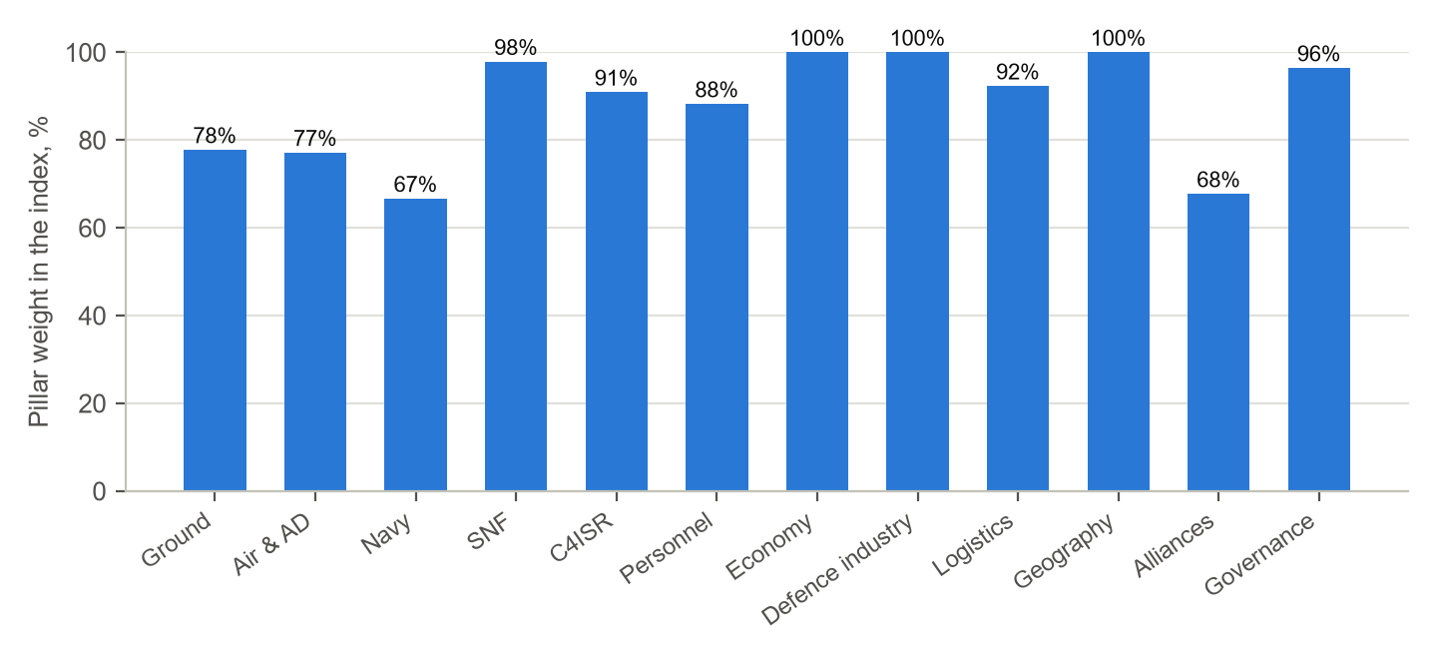
Fig. 1. Share of each pillar's weight covered by the indicators included in the index

1.4. Fleet quality by weapons and equipment composition
Wikipedia tables with arms lists give not only numbers but also models with modifications. The model reference (data/ref/equipment_models.csv) matches each position with a model, a year of adoption into service and a generation. Thus quality indicators were obtained from open data:
- G02 — share of modern tanks: 3rd generation and deep modernisations after 2000 (T-72B3, T-80BVM, Type 96A).
- G06 — share of modern IFVs and APCs: models adopted since 1990 or modernised after 2000; unarmoured vehicles are not counted.
- G03, A19 — average age of the tank and combat aircraft fleets: 2025 minus the year the modification was adopted. This is the age of the model, not of the vehicle or airframe: the age of individual vehicles is not available in open data.
- G12 — precision-guided weapons from 70 km: tactical missile system and MLRS launchers with guided rockets (HIMARS, M270A1, “Tornado-S”, PHL-16, “Chunmoo”, PULS).
- A05 — share of stealth aircraft: 5th-generation fighters (OSINT) as a proportion of combat aircraft (GFP 2026).
- A23 — long-range SAM firing battalions (an S-300/400 battalion or a Patriot, SAMP/T or THAAD battery): a manual OSINT table based on open IISS data and delivery reports, class B–D.
Where the table gives only the family (for Russia: “BTR-80 — 1,200”), and in the note — the breakdown of losses by modification from the Oryx database (“292 BTR-80, 865 BTR-82A(M), 389 BTR-82AT”), the row is split in proportion to the losses. This is a proxy estimate (class D): the losses contain more of the equipment that fights at the front. If the modifications are listed without numbers (“T-72AMT, T-72AV, …, T-72B3”), the position refers to the family as a whole.
The share is calculated only if at least 60% of the country's units and at least 30% of the tank fleet by GFP are identified; otherwise no value is assigned. If a table cell gives a number by modification (“1,000 (T-72A/B) 470 (T-72B3/B3M)”), the position is split. Reliability class — C: dates and composition differ in Wikipedia, and for some countries modifications within a family are not specified (in Russia — for IFVs and APCs), so the share comes out below the actual one.
Country | Tanks | IFVs and APCs | Tank age | Aircraft age | Launchers from 70 km | Long-range SAM | Stealth
United States | 100% | 54% | 45 | 28 | 1359 | 68 | 35%
China | 89% | 97% | 28 | 15 | 415 | 50 | 17%
Russia | 42% | 16% | 36 | 30 | 282 | 90 | 2%
France | 100% | 94% | 33 | 24 | 9 | 8 | 0%
South Korea | 99% | 38% | 35 | 29 | 30 | 8 | 12%
India | 37% | 40% | 45 | 25 | 0 | 6 | 0%
United Kingdom | 100% | 82% | 27 | 17 | 43 | 0 | 28%
Japan | — | 98% | — | 33 | 99 | 24 | 18%
Germany | 100% | 77% | 20 | 21 | 33 | 10 | 0%
Türkiye | — | 69% | — | 31 | — | 4 | 0%
Italy | 100% | 91% | 30 | 21 | 21 | 5 | 26%
Israel | 100% | 33% | 21 | 23 | 30 | 7 | 16%
Poland | 84% | 41% | 23 | — | 176 | 4 | 9%
Australia | 100% | 5% | 33 | 13 | — | 0 | 76%
Pakistan | 31% | 95% | 53 | — | 0 | 4 | 0%
Taiwan | 11% | 15% | 47 | — | 11 | 22 | 0%
Ukraine | 9% | 54% | 52 | 24 | 61 | 28 | 0%
Azerbaijan | 14% | 47% | 54 | 35 | 123 | 4 | 0%
Armenia | 1% | 0% | 53 | 38 | 14 | 3 | 0%

A dash — insufficient data (positions not identified or the list incomplete). Tanks and IFVs/APCs — the share of modern models; age — years since the adoption of the modification; launchers — tactical missile systems and MLRS with guided rockets, units; long-range SAM — firing battalions of long-range SAM systems; stealth — the share of stealth combat aircraft.
A review of the tables found and corrected errors that affected the numbers in the first version: modification counts separated in a cell by a line were merged (Thailand 19,113 APCs instead of 1,154; Serbia 5,206 instead of 652; the Philippines 3,813 IFVs instead of 60); the PHL-16 MLRS and the “Chunmoo” were counted as tactical missile systems; the air force pages for Thailand and Australia were swapped; Russian IFVs (1,950 units) did not enter the sample because of the “in storage” note in the table subheading.
Not collected: the average age of the fleet (dates of ship commissioning are available in Wikipedia tables for only about 15 countries, and the indicator would not pass the threshold of half the countries) and medium-range SAM battalions (there are three times as many systems as long-range ones, and data on the number of units are more heterogeneous).

1.5. Expert indicators: objective proxy measures
An expert score is subjective and non-reproducible. Therefore, instead of judgements, measurable quantities from open databases were used that reflect the same phenomenon: population surveys, event databases, geodata, statistics, official statuses. Each substitution — a modelling assumption (class C): the quantity is measured precisely, but it is only indirectly related to the concept. Where no such quantity exists, the indicator is left empty.
Indicator | Measurer | Source | Countries
P15 Morale and unit cohesion | share willing to fight for their country, % | WVS/EVS 2017–2023 (QoG) | 34
H12 Public support for the army and defence | trust in the armed forces, 1–4 | WVS/EVS 2017–2023 (QoG) | 31
H14 Risk of a military coup and politicisation of the army | attempted military coups, 2000–2025 | Bjørnskov–Rode (QoG) | 40
P14 Share of personnel with combat experience | intensity of participation in armed conflicts over 5 years, % of the maximum | UCDP/PRIO ACD 26.1 | 40
P12 Educational level of the officer corps | tertiary education enrolment, % | World Bank (UNESCO UIS) | 37
P10 Training expenditure per service member | all military expenditure per service member, thousand $ | SIPRI, IISS | 39
I04 Share of domestically produced weapons and equipment | the share of units of domestic design or licensed production, averaged over 11 classes of weapons and equipment | Wikipedia, Origin column | 38
I05 Full-cycle capability: weapon classes produced domestically | the number of weapons and equipment classes with domestic models (scaled to 11) | Wikipedia, Origin column | 38
D02 Strategic depth (border to key centres) | distance from the capital to the nearest foreign territory, km | Natural Earth | 40
C20 Control of undersea cables and communications nodes | submarine cable landing points | TeleGeography | 40
C04 Own satellite navigation system (GNSS) | own GNSS: global / co-owned Galileo / regional | system operators | 40
D09 Control of straits and key sea lines of communication | adjacent global maritime chokepoints | U.S. EIA | 40
X05 Interoperability with allies (standards, exercises) | NATO member / US major non-NATO ally or NATO partner / CSTO member | NATO, US Department of State, CSTO | 40

64 expert indicators have no objective measurer. These are training and readiness (flying hours, days at sea, serviceability, manning), the quality of command, doctrine and governance, network-centric warfare and EW, munitions and drone production, missile and shell stockpiles, mobilisation readiness, ally reliability. They can only be filled with closed data or an expert panel with a reconciliation procedure (for example, the Delphi method with spread estimation).
Without a measurer: G07 Tanks with active protection systems (APS); G14 Counter-battery radars and artillery reconnaissance; G18 Counter-UAV means (EW, close-in weapon systems); G22 Loitering munitions and FPV drones (annual output); G26 Tactical electronic warfare systems; G28 Personnel manning of units; G29 Equipment serviceability rate; G30 Field training intensity (exercise days per year); G31 Thermal imagers and night sights; G32 Artillery ammunition stocks; A13 Long-range loitering munitions (annual output); A14 Long-range air-to-air missiles (class); A15 Air-launched cruise missile stocks; A16 Precision-guided bombs and guided bomb units; A17 Average annual pilot flying hours; A18 Aircraft fleet serviceability; A21 Hardened aircraft shelters; A25 Surface-to-air missile stocks; A27 Territory coverage by an integrated air-defence system; N08 Naval area air defence; N09 Anti-ship missiles (range, speed); N24 Days at sea per ship per year; N25 Operational availability rate of ships; S05 Latent nuclear potential (enrichment, reprocessing); S11 Assured retaliation (force survivability); S14 Extended deterrence (allied “nuclear umbrella”); S16 Long-range land- and sea-based cruise missiles; S18 Non-nuclear precision weapons with range from 1,500 km; C08 Cyber command (existence, personnel); C10 Offensive cyber capability; C11 Military use of AI (programmes, adoption); C12 Quantum technologies and cryptography; C13 Integrated automated command system (network-centricity); C14 Secure military communications at all levels; C17 Strategic electronic warfare systems; C18 Radar coverage of airspace; C19 Scale of military intelligence (resource estimate); P05 Share of contract personnel; P08 Personnel retention (share renewing contracts); P11 Share of professional NCOs; P16 Desertion and draft evasion; P19 Foreign instructors and training abroad; I06 Armoured vehicle output per year; I07 Artillery shell output per year; I08 Combat aircraft output per year; I09 Missile output (cruise, ballistic, SAM) per year; I10 UAV output per year; I12 Industrial mobilisation readiness; I17 Microelectronics: domestic chip production; I18 Domestic aero-engine industry; I24 Propellant and explosive production capacity; L07 Military transport rolling stock (carriers, tractors); L17 Mobilisation reserve deployment time; L19 Mobilisation stocks of materiel; L21 Power grid resilience (redundancy, protection); L22 Civil defence and protective structures; D07 Neighbours with territorial disputes; X04 Reliability of allied commitments; X11 Intelligence sharing with allies; H03 Battle casualty replacement rate; H07 Quality of military doctrine and its fit to modern war; H08 Quality of senior command; H09 Decision speed and delegation of authority; H13 Resilience to adversary information operations.
Limitations of proxy measurers. The WVS/EVS surveys were conducted before 2022 (in Russia — 2017, in Ukraine — 2020) and do not reflect changes during the war. UCDP-based combat experience accounts for the state's participation in conflicts, not the share of service members with experience. The share of domestically produced weapons and equipment depends on the completeness of Wikipedia tables.
Limitation. Training, equipment serviceability, flying hours, days at sea, motivation and combat experience are absent from open data: these are expert or closed data (in the pilot — a temporary AI estimate, section 1.6). Scales of strategic capabilities (missile attack warning, strategic missile defence, hypersonic and anti-satellite weapons) are part of the “Strategic forces” pillar, which under default settings is placed on the nuclear axis and does not affect the MPI.

1.6. AI expert assessment (temporary)
By the user's decision, indicators without an objective measurer were filled with an AI expert assessment (model Claude Opus 5.5) from open sources up to mid-2026: 64 indicators × 40 countries (2,622 cells), a point estimate and an 80% interval, with a rationale for each indicator — data/delphi/ai/aiexpert.txt and the workbook aiexpert.xlsx.
- This is the judgement of a single model, not a panel. The spread within one model does not replace independent experts, so Delphi statistics (consensus, Kendall's W, calibration) are not applied to it.
- Class D, lowest priority. The error comes from intervals but is no less than class D; any measurements and the result of the expert panel automatically supersede the AI estimate.
- No fitting. The values were not tuned to the validation against wars; the calculation without them — python core/run.py --no-ai.
- Not shown to the panel experts, so as not to create anchoring.
Country | Experts (doc. 2) | Pilot without AI | Pilot with AI
United States | 90.4 | 80.3 | 79.7
France | 66.9 | 56.5 | 59.0
Israel | 64.4 | 45.0 | 52.4
Russia | 63.4 | 70.7 | 70.4
United Kingdom | 62.0 | 51.9 | 56.3
Germany | 58.9 | 52.1 | 55.0
Ukraine | 47.3 | 35.7 | 45.2
Iran | 31.5 | 41.5 | 44.7

2. Computational core

2.1. Stages
- Normalisation to the global scale. Count and monetary quantities — a logarithmic scale 3 orders of magnitude below the sample leader (invariant to units of measurement); shares — 0–100%; indices with a known scale — their bounds (WGI ±2.5, CPI and GII 0–100); the rest — the sample spread. Indicators where “more is worse” are inverted.
- Selection and imputation. An indicator enters the index if data exist for at least 50% of countries; the weight of the rest is redistributed within the pillar. A missing value is replaced by the mean of the observed values for the same country in the same pillar and role group (N / Q and M / others) with an uncertainty of at least 0.10.
- Pillars. A weighted mean of the indicators; in the combat pillars the weight of numbers is multiplied by α (the logarithmic form of Lanchester's law).
- Aggregation, nuclear axis, projection. CES with ρ = 0.5; strategic forces are placed on a separate axis; autonomous power — excluding nuclear forces and alliances; projection radius λ = 2 + 10·P̄[projection indicators].
- Monte Carlo (1000 runs): data ± σ by reliability class, weights × LogN(0; 0.15²), ρ ~ U(0.3; 0.7), α ~ U(0.8; 1.2) (until 13.10.2026 — U(1.2; 1.8)) and the structural uncertainty of the pillar σ = 0.10 × (share of the pillar's weight without data).
x̃ = (lg x − lg(H·10^−3)) / 3 log scale, H — the sample leader
P = (α·Σw·x̃[N] + Σw·x̃[other]) / (α·Σw[N] + Σw[other]) combat pillars
MPI = (Σ ω·P^ρ)^(1/ρ), MPI(D) = MPI·e^(−D/λ)
observation σ: log — A 5%, B 10%, C 30%, D 50%; other — A 0.02, B 0.04, C 0.08, D 0.12

2.2. Combat model and coalitions
The Lanchester–Helmbold combat model with replacement and reinforcements, and the coalition builder, have been carried over into the core (document 3). Both reproduce the prototype: on the expert data the coalitions give the same ratios as in document 3 (Russia–Ukraine 1.68 : 1; Israel and the United States versus Iran 6.84 : 1). Since 13.10.2026 the required ratios are calculated at α = 1.0 and with the new table of d (section 7.7): for Ukraine — 1.70 : 1, for Iran — 1.30 : 1, the window of superiority in the Baltics — days 0–7 (previously 2.02 : 1 and days 0–4).

2.3. Tests
Property | Test
Scale invariance | multiplying an indicator by a constant does not change the log scale
Monotonicity | an increase in any indicator does not lower a country's index
CES limiting cases | ρ = 1 — arithmetic mean, ρ → 0 — geometric mean; the “weakest link” at ρ < 0
Role of α | a larger α increases the weight of numbers in the combat pillar
Imputation | observed values do not change; an indicator with data for one country out of six is excluded
Reproducibility | the same seed — the same result; the data snapshot hash in the output
Square law | the numerical solution agrees with the analytical one to within 0.1% (RK4) and 1% (the prototype scheme)
Lanchester invariant | b·A^α − a·B^α is conserved at α = 1; 1.5; 2
Document 3 | coalition scenarios reproduce the document's numbers

3. Rating of 40 countries
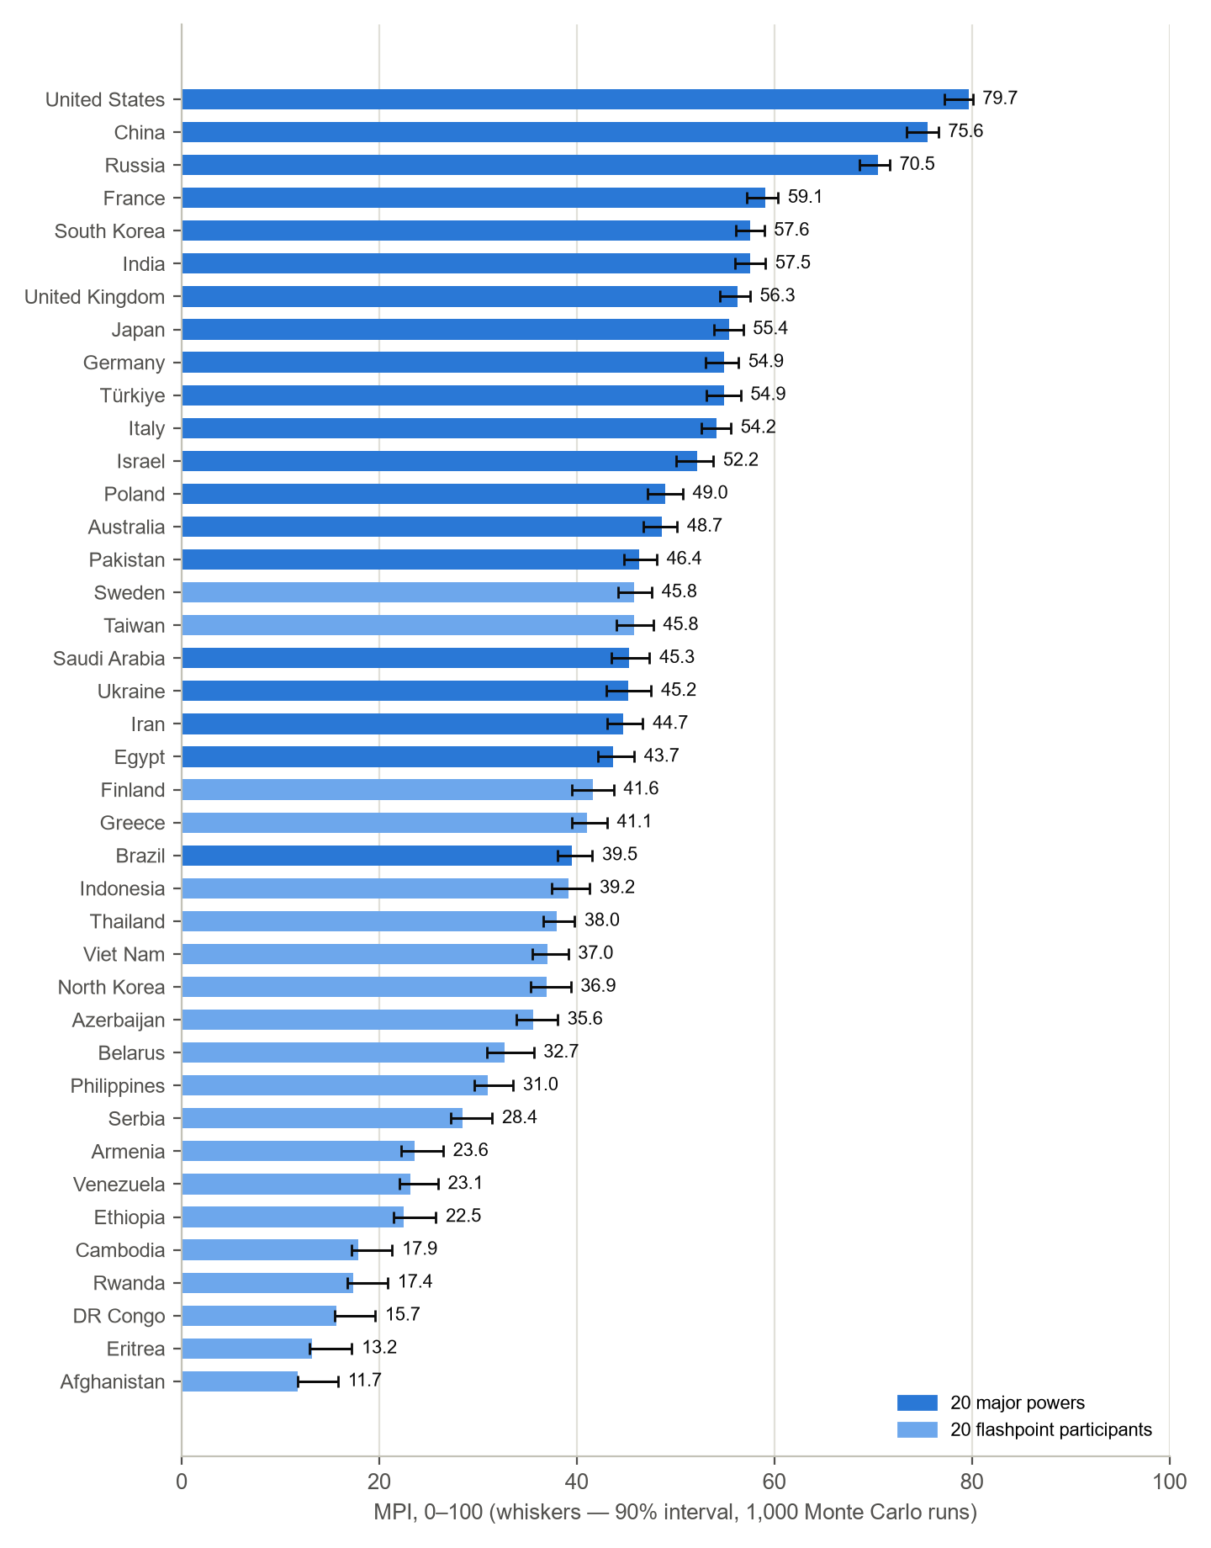
Fig. 2. Pilot MPI with the 90% interval
# | Country | MPI | 90% interval | Rank | Autonomous power | λ | Nuclear class | Imputed
1 | United States | 79.7 | 77.2–80.1 | 1 | 78.8 | 10.8 | nuclear triad | 1%
2 | China | 75.7 | 73.5–76.8 | 2 | 77.5 | 9.2 | nuclear triad | 1%
3 | Russia | 70.4 | 68.6–71.6 | 3 | 71.1 | 7.0 | nuclear triad | 1%
4 | France | 59.0 | 57.2–60.4 | 4–6 | 57.1 | 7.8 | Nuclear, large arsenal | 1%
5 | South Korea | 57.7 | 56.3–59.1 | 4–7 | 57.9 | 5.7 | No nuclear | 1%
6 | India | 57.4 | 55.9–59.0 | 4–8 | 59.4 | 7.5 | Nuclear, large arsenal | 1%
7 | United Kingdom | 56.3 | 54.5–57.6 | 5–9 | 54.2 | 7.8 | Nuclear, large arsenal | 1%
8 | Japan | 55.5 | 54.0–56.9 | 6–10 | 55.5 | 6.9 | No nuclear | 1%
9 | Germany | 55.0 | 53.1–56.4 | 7–11 | 53.3 | 5.1 | No nuclear | 1%
10 | Türkiye | 54.5 | 52.8–56.2 | 7–11 | 52.8 | 7.2 | No nuclear | 2%
11 | Italy | 54.1 | 52.5–55.5 | 9–12 | 52.4 | 6.9 | No nuclear | 0%
12 | Israel | 52.4 | 50.2–53.9 | 11–12 | 52.7 | 4.2 | Nuclear, limited | 4%
13 | Poland | 48.9 | 47.1–50.7 | 13–14 | 47.5 | 3.2 | No nuclear | 1%
14 | Australia | 48.6 | 46.7–50.1 | 13–15 | 47.6 | 6.6 | No nuclear | 1%
15 | Pakistan | 46.3 | 44.7–48.0 | 14–19 | 46.0 | 4.6 | Nuclear, large arsenal | 2%
16 | Taiwan | 45.9 | 44.2–47.8 | 14–20 | 46.9 | 3.8 | No nuclear | 11%
17 | Sweden | 45.8 | 44.2–47.6 | 15–21 | 44.4 | 4.5 | No nuclear | 2%
18 | Saudi Arabia | 45.4 | 43.6–47.5 | 15–21 | 45.4 | 4.0 | No nuclear | 2%
19 | Ukraine | 45.2 | 43.0–47.5 | 15–21 | 46.3 | 3.3 | No nuclear | 1%
20 | Iran | 44.7 | 43.1–46.8 | 16–21 | 47.3 | 5.4 | Threshold | 2%
21 | Egypt | 43.7 | 42.1–45.8 | 18–22 | 43.8 | 5.5 | No nuclear | 2%
22 | Finland | 41.7 | 39.6–43.8 | 21–24 | 40.0 | 3.4 | No nuclear | 1%
23 | Greece | 41.3 | 39.7–43.2 | 22–24 | 39.5 | 4.2 | No nuclear | 1%
24 | Brazil | 39.4 | 38.0–41.5 | 23–26 | 39.6 | 5.0 | No nuclear | 1%
25 | Indonesia | 39.1 | 37.4–41.2 | 23–27 | 40.9 | 5.5 | No nuclear | 1%
26 | Thailand | 37.9 | 36.5–39.7 | 25–28 | 37.7 | 4.9 | No nuclear | 1%
27 | North Korea | 37.0 | 35.4–39.4 | 25–29 | 37.2 | 3.5 | Nuclear, limited | 15%
28 | Viet Nam | 36.9 | 35.4–39.0 | 25–29 | 39.1 | 4.0 | No nuclear | 1%
29 | Azerbaijan | 35.5 | 33.8–38.0 | 27–29 | 35.5 | 2.7 | No nuclear | 2%
30 | Belarus | 32.7 | 30.9–35.6 | 29–31 | 31.8 | 2.2 | No nuclear | 1%
31 | Philippines | 30.9 | 29.5–33.4 | 30–32 | 30.0 | 4.1 | No nuclear | 3%
32 | Serbia | 28.4 | 27.3–31.5 | 31–32 | 29.3 | 2.7 | No nuclear | 7%
33 | Armenia | 23.8 | 22.4–26.6 | 33–35 | 23.7 | 2.2 | No nuclear | 3%
34 | Venezuela | 22.5 | 21.5–25.4 | 33–35 | 23.4 | 3.9 | No nuclear | 6%
35 | Ethiopia | 22.4 | 21.3–25.7 | 33–35 | 23.1 | 2.1 | No nuclear | 3%
36 | Cambodia | 18.1 | 17.4–21.5 | 36–38 | 18.2 | 3.1 | No nuclear | 7%
37 | Rwanda | 17.5 | 17.0–21.0 | 36–38 | 17.7 | 2.3 | No nuclear | 14%
38 | DR Congo | 15.7 | 15.5–19.6 | 37–38 | 15.1 | 2.6 | No nuclear | 6%
39 | Eritrea | 13.2 | 13.0–17.1 | 39–40 | 14.2 | 3.5 | No nuclear | 11%
40 | Afghanistan | 12.0 | 11.9–16.2 | 39–40 | 12.8 | 2.2 | No nuclear | 12%

The top three are stable: the United States and China share places 1–2, Russia — third. Then France, South Korea, India, the United Kingdom, Japan, Germany and Türkiye lie within 4.5 points, and in 90% of runs their places are shuffled within the range 4–11. Imputed values are noticeable only for countries with poor open data: North Korea, Rwanda, Afghanistan, Taiwan, Eritrea.

4. Cross-check against the expert assessment
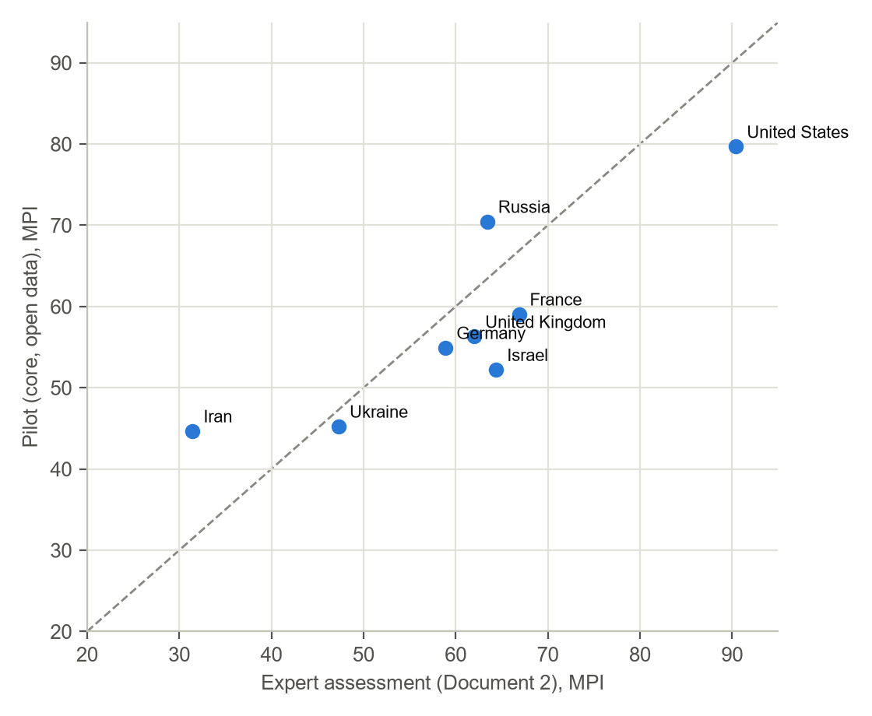
Fig. 3. Pilot versus the expert assessment of document 2 (8 countries)
Country | Experts | Pilot | Difference
United States | 90.4 | 79.7 | −10.8
France | 66.9 | 59.0 | −7.9
Israel | 64.4 | 52.4 | −12.1
Russia | 63.4 | 70.4 | +7.0
United Kingdom | 62.0 | 56.3 | −5.7
Germany | 58.9 | 55.0 | −3.9
Ukraine | 47.3 | 45.2 | −2.1
Iran | 31.5 | 44.7 | +13.3

The rank correlation — 0.81. The discrepancies are systematic: the pilot rates states with large armies and equipment stockpiles (Russia, Iran) higher than the experts do, and lower — small armies with high quality and combat experience (Israel) and Ukraine, which is at war. The reason — the absence of expert indicators of quality, training and motivation: in the pilot they were replaced by pillar means, that is, numbers.

5. Validation against the wars of 2020–2026
Each case is checked against two criteria. Balance: whether the attacker has a sufficient force ratio at the start, R = (eB·d / eA)^(1/α). Outcome: the probabilities of a successful offensive, of holding the defence and of protracted fighting in the combat model (only for campaigns; short exchanges of strikes ended in a truce, and their outcome is not checked by force collapse).

5.1. Expert assessment of 8 countries
Case | A : B | Required | Balance | Outcome (P of A's success / defence / protracted fighting) | Fact
Russia versus Ukraine, 2023–2026 | 1.68 | 1.70 | A's advantage is insufficient — correct | protracted fighting (36% / 13% / 52%) — correct | positional war of attrition, slow progress by the attacker
Israel and the United States against Iran, 2025–2026 | 6.84 | 1.30 | A's advantage is sufficient — correct | offensive success (100% / 0% / 0%) — correct | rapid suppression of Iran's air defence and air force, a truce

Result: the balance is correct in 2 of 2, the campaign outcome — in 2 of 2.

5.2. Pilot, 40 countries
Case | A : B | Required | Balance | Outcome (P of A's success / defence / protracted fighting) | Fact
Russia versus Ukraine, 2023–2026 | 2.52 | 1.70 | A's advantage is sufficient — incorrect | offensive success (97% / 0% / 3%) — incorrect | positional war of attrition, slow progress by the attacker
Israel and the United States against Iran, 2025–2026 | 1.59 | 1.30 | A's advantage is sufficient — correct | offensive success (59% / 2% / 40%) — correct | rapid suppression of Iran's air defence and air force, a truce
India against Pakistan, May 2025 | 0.92 | 1.30 | advantage with the defence — incorrect | — | four days of strikes, India's advantage in strikes on airbases, a truce on 10 May below the nuclear threshold
Thailand versus Cambodia, July 2025 | 1.16 | 1.30 | A's advantage is insufficient — incorrect | — | five days of fighting, Thailand's superiority in the air and in artillery, a truce mediated by Malaysia
Azerbaijan against Armenia, 2020 (Karabakh) | 2.13 | 0.89 | A's advantage is sufficient — correct | offensive success (100% / 0% / 0%) — correct | breakthrough of the defences and Azerbaijan's victory in 44 days (UAVs, precision-guided weapons)

Result: the balance is correct in 2 of 5, the campaign outcome — in 2 of 3. Assumptions for the new cases: Russia versus Ukraine, 2023–2026 — d = 1.7 measured from this war's equipment losses (Oryx, 2024–2025) — not an independent test; India versus Pakistan, May 2025 — India's s = 0.3 — western sector; d = 1.3 — air and missile strikes; both sides with nuclear weapons; Thailand versus Cambodia, July 2025 — Thailand's s = 0.3 — border grouping; Azerbaijan versus Armenia, 2020 (Karabakh) — a fortified line in the mountains (d from the table); Türkiye — intelligence and supply; 2025 data for the 2020 war.
Main lesson of the validation. In the pilot the model sees Russia as 2.5 times stronger than Ukraine in theatre and predicts a successful offensive, whereas a positional war is under way. The expert assessment, which allows for training, experience and motivation, gives 1.68 : 1 and a correct forecast. For Karabakh 2020 the pilot, on 2025 data, sees a sufficient advantage (2.13 where 0.89 is required) but too small for a rapid victory: the combat model gives protracted fighting a probability of 0%, while the war ended in 44 days — the decisive role of UAVs and training is not visible in open data. Conclusion: shares of modern equipment moved the balance in the right direction, but without indicators of training and motivation predictive power is insufficient.

5.3. What the second data stage changed
Indicator | Version 1 | Equipment and capabilities | + proxy measurers | + AI estimate (now)
Indicators in the index | 107 | 125 | 138 | 215
Snapshot coverage | 42.3% | 48.7% | 53.6% | 84.0%
Rank correlation with experts | 0.79 | 0.79 | 0.76 | 0.81
Russia : Ukraine in theatre | 5.90 : 1 | 4.62 : 1 | 4.63 : 1 | 2.52 : 1
Force balance correct | 3 of 5 | 4 of 5 | 3 of 5 | 2 of 5
Campaign outcomes correct | 1 of 3 | 1 of 3 | 1 of 3 | 2 of 3

Objective measurers of the expert indicators did not narrow the discrepancy for Russia and Ukraine: the willingness to fight before the war was close (Russia 76%, Ukraine 71%), combat experience is almost equal, and in the share of domestically produced weapons and equipment Russia is far ahead (98% versus 34%). The measurable quantities confirm Russia's advantage in resources.
The AI assessment for non-measurable indicators (training, command, network-centric warfare, EW, production) moved Ukraine's index closer to the expert one (35.7 → 45.2 against 47.3 for the experts) and reduced Russia's advantage to 2.52 : 1, but it is still above the required 1.70 : 1, and the model still predicts a successful offensive. At the same time Pakistan and Iran rose: the “India versus Pakistan” case became incorrect (0.92 : 1), and Iran (44.7) was rated higher than by the experts (31.5). The judgement of a single model improves agreement with the experts on average (Spearman 0.76 → 0.81) but does not confer predictive power; the latter requires a real panel with independent estimates and calibration (document 7) or closed data.

6. Sensitivity
Sobol indices show what share of the index spread is associated with each uncertainty factor: pillar weights, the form of CES aggregation ρ, the law exponent α, data error and structural uncertainty (gaps in pillar coverage).
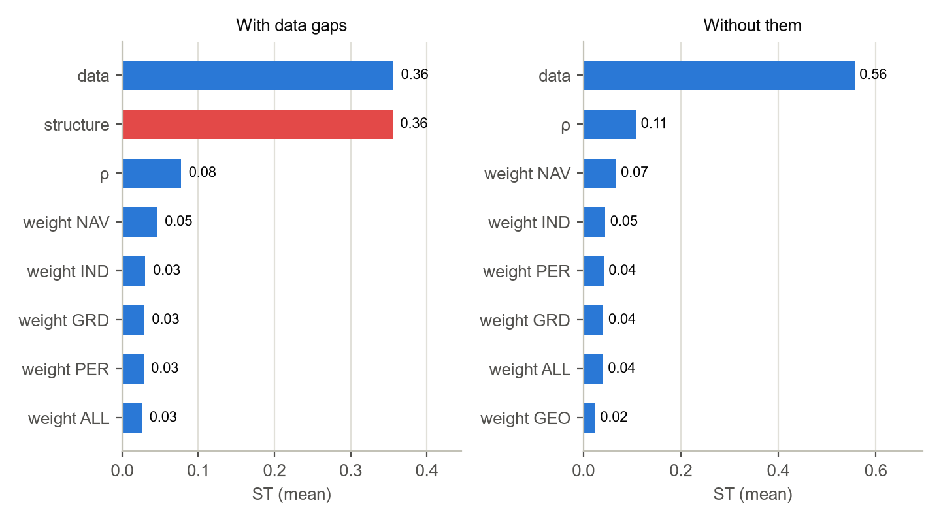
Fig. 4. Total Sobol indices ST, averages across 40 countries
Factor | ST with gaps | ST without them
structure | 0.36 | —
data | 0.35 | 0.55
ρ | 0.08 | 0.11
NAV weight | 0.05 | 0.07
IND weight | 0.03 | 0.05
GRD weight | 0.03 | 0.04
PER weight | 0.03 | 0.04
ALL weight | 0.03 | 0.04
AIR weight | 0.02 | 0.02
GEO weight | 0.02 | 0.02

About 36% of the spread is attributable to gaps in the data — under the adopted assumption of σ = 0.10 per uncovered share of the pillar. Without this factor the spread is divided between data error and the form of the aggregation ρ; among the weights, NAV, IND and PER are the most noticeable. The weight of strategic forces has no effect at all: the pillar is placed on the nuclear axis. The law exponent α has a weak effect (ST = 0.02): shares of modern equipment have appeared in the combat pillars, but numbers still predominate.

7. Calibration of parameters against test cases
The task — to fit the model's global parameters on five wars of 2020–2026 so that the result is not an artefact of overfitting. The rules are written in the code (core/lanmil/calibrate.py) and fixed in the repository history before the computation (commit 20559fa of 13.10.2026); the results were obtained afterwards.

7.1. Protocol
- Only global parameters are fitted: α (one per model — the weight of numbers in the combat pillars, the required force ratio and the combat model), the pillar aggregation ρ, κ converting the index into CPU of power, and one of five predefined weight sets. Grid: α 1.00; 1.25; 1.50; 1.75; 2.00; ρ -0.50; 0.00; 0.25; 0.50; 0.75; 1.00; κ × 0.50; 0.60; 0.70; 0.80; 0.90; 1.00; 1.15; 1.30; 1.50 of 2.6·ln 10; 1350 combinations in total.
- Not fitted are the scenario assumptions (force shares s, distance, ally reliability, defence coefficient d) and the outcome facts — they are fixed before calibration.
- Quality measure — the logarithmic score of a probabilistic forecast: the probability of the actual balance class over 200 runs of data uncertainty and the probability of the actual outcome over 400 runs of the combat model; the sum over 8 forecasts (5 balances, 3 outcomes). The closer to zero, the better; such a measure cannot be improved by distorting the probabilities.
- Protection against overfitting: leave-one-out cross-validation (the parameters are fitted on four wars and tested on the fifth); new parameters are accepted only if such a score is better than the score of the default parameters by at least 2; in a tie, the point closest to the default is chosen.
- Benchmarks: the uniform forecast (1/3 for each class) and the frequency forecast of outcomes in the remaining cases — a model that does not outperform them has shown no predictive power.

7.2. Result
Variant | Default: score, balance, outcome | Best in sample | Score, balance, outcome | Cross-validation | Decision
with AI estimate | −19.59; 2 of 5; 1 of 3 | α 1.00, ρ −0.50, κ × 1.30, “Balanced” | −11.48; 4 of 5; 1 of 3 | −31.71 (−12.13) | keep the default
without Karabakh | −18.47; 1 of 4; 1 of 2 | α 1.00, ρ 0.25, κ × 1.15, “Land, Europe” | −8.32; 3 of 4; 2 of 2 | −23.15 (−4.68) | keep the default
without AI estimate | −17.66; 3 of 5; 1 of 3 | α 2.00, ρ 0.25, κ × 1.50, “Conventional” | −13.52; 4 of 5; 2 of 3 | −19.40 (−1.75) | keep the default

Benchmarks: the uniform forecast — −8.79, the frequency forecast — −8.15 (excluding Karabakh — −6.59 and −7.69). Even the best parameters in the sample (−11.48) do not reach these benchmarks.
Held-out war | Parameters fitted on the other four | Ratio / required | Balance | Outcome
Russia — Ukraine | α 1.75, ρ 0.00, κ × 1.50, “Expeditionary” | 13.78 / 1.69 | incorrect | incorrect
Israel and the United States — Iran | α 1.00, ρ −0.50, κ × 1.30, “Balanced” | 2.41 / 1.30 | correct | correct
India — Pakistan | α 1.00, ρ 1.00, κ × 1.30, “Land, Europe” | 0.89 / 1.30 | incorrect | —
Thailand — Cambodia | α 1.50, ρ 1.00, κ × 0.90, “Land, Europe” | 0.92 / 1.19 | incorrect | —
Azerbaijan — Armenia | α 1.00, ρ 0.25, κ × 1.15, “Land, Europe” | 2.40 / 2.68 | incorrect | incorrect

Cross-validation on the main data: for each war the parameters were fitted without it.

7.3. Identifiability of parameters
Parameter | 95% region (with the AI estimate) | 95% region (without the AI estimate) | Values in the grid
α | 1.0; 1.25 | 1.0; 1.25; 1.5; 1.75; 2.0 | 5
ρ | −0.5; 0.0; 0.25; 0.5; 0.75; 1.0 | −0.5; 0.0; 0.25; 0.5; 0.75; 1.0 | 6
κ × (share of 2.6·ln 10) | 1.0; 1.15; 1.3; 1.5 | 0.9; 1.0; 1.15; 1.3; 1.5 | 9
weight set | Balanced; Conventional; Protracted war; Expeditionary; Land, Europe | Balanced; Conventional; Protracted war; Expeditionary; Land, Europe | 5

The 95% region — parameter values at which the best achievable score is worse than the maximum by no more than 1.92 (likelihood profile).

7.4. Contradiction between cases
An additional analysis after the calculation (not part of the protocol): for which κ the balance conclusion for each war is correct, with the other parameters at their defaults.
War | κ × at α = 1.0 | κ × at α = 1.5 | κ × at α = 2.0 | Without the AI estimate, α = 1.5
Russia — Ukraine | 0.35–0.95 | 0.35–0.75 | 0.35–0.60 | 0.25–0.50
Israel and the United States — Iran | 0.90–3.00 | 0.85–3.00 | 0.85–3.00 | 0.85–3.00
India — Pakistan | 1.45–3.00 | 1.35–3.00 | 1.30–3.00 | 0.95–3.00
Thailand — Cambodia | 1.10–3.00 | 1.05–3.00 | 1.00–3.00 | 1.05–3.00
Azerbaijan — Armenia | 1.30–3.00 | 0.85–3.00 | 0.65–3.00 | 0.95–3.00

There is no common κ at which all five wars are correct for any α. Russia — Ukraine requires compressing the difference between the indices (κ no more than 0.75 of the default at α = 1.5), while India — Pakistan, conversely, requires stretching it (κ no less than 1.35). The conclusions on the three small wars rest on the assumption about the share of forces committed by the lead participant: India — Pakistan: the conclusion changes at s ≈ 0.33 instead of the accepted 0.30; Thailand — Cambodia: the accepted share of 0.30 is already at the threshold; Azerbaijan — Armenia: the conclusion changes at s ≈ 0.62 instead of the accepted 0.70.
Calibration conclusion. The fitted parameters predict the held-out wars worse than the default parameters (cross-validated score −31.71 versus −19.59; without the AI assessment — −19.40 versus −17.66), so under the protocol rule the defaults remain. The model's probabilistic forecasts are worse than the simple benchmarks: the model is overconfident — data uncertainty produces narrow intervals, while the main error lies outside the data: in non-comparable inputs (the difference between the indices of Russia and Ukraine) and in scenario assumptions. The five wars do not identify the parameters: ρ and the weights — not at all; κ — only as “no less than the default”; α — a weak preference for 1.0–1.25 on the main data, which disappears without the AI assessment. Global tuning cannot fix the forecast for Russia and Ukraine: this requires different inputs (training, motivation, drones, allied support — an expert panel) or a different defence model, and for calibration — 20–30 cases with data from their own year and objective force shares.

7.5. Combat model parameters from historical battles
The five wars do not identify the parameters, so α and the defence coefficient d are estimated on independent data — the CDB90 battle database (CAA Database of Battles, 1990; after battle selection: 644 for 1600–1973, of which 404 for 1900–1973 — the main sample). The protocol was fixed before computation (commit 567224b). The combat model implies ln(Latt/Ldef) = ln d + (α − 1)·ln(Ndef/Natt): the loss-exchange ratio between attacker and defender depends on the force ratio with exponent α − 1. On the first run it emerged that in the version of the database used, 217 attacker defeats were recorded as blank; the winner was taken from the original tables, and the estimates of α and d do not depend on this.
Sample | Battles | α | d: hasty | d: prepared | d: fortified | Attacker victories | Model rule correct
1900–1973 (main) | 404 | 0.65 [0.46; 0.84] | 0.87 [0.68; 1.15] | 0.60 [0.47; 0.78] | 0.65 [0.51; 0.83] | 68% | 55%
all years | 644 | 0.63 [0.45; 0.81] | 0.81 [0.68; 0.96] | 0.69 [0.54; 0.87] | 0.67 [0.53; 0.86] | 65% | 51%
1939–1973 | 265 | 0.61 [0.35; 0.85] | 0.78 [0.53; 1.16] | 0.50 [0.36; 0.71] | 0.52 [0.37; 0.72] | 70% | 59%
reliable data | 486 | 0.67 [0.48; 0.88] | 0.84 [0.68; 1.02] | 0.65 [0.50; 0.86] | 0.66 [0.51; 0.85] | 65% | 53%

In brackets — the 95% interval (bootstrap, 2,000 resamples). The “model rule” — the attacker wins if Natt/Ndef ≥ d^(1/α) with the former α = 1.5 and d = 1.3 / 1.8 / 3.0.
- The square law is not confirmed. α = 0.65: a side's losses depend on its own numbers more strongly than on the adversary's numbers; the force ratio explains only 4% of the spread in the loss ratio.
- Numbers hardly predict victory. Cross-validation: a victory model based on the force ratio and defence type scores −0.62 per battle versus −0.63 for the forecast “the attacker usually wins”; the model's rule is correct in 55% of battles against 68% of attacker victories.
- The break comes earlier. By the end of a battle the loser loses a median of 10% of its forces, the winner — 4%; the model's 40% threshold is reached in only 15% of battles (under the protocol the threshold does not change: the model describes campaigns, not battles).
- d below 1 — selection bias. Those who attack are usually qualitatively stronger, and this understates the estimate. With the adjustment for the combat effectiveness of the sides made by the database compilers (outside the protocol): α = 0.97 [0.80; 1.13], d = 1.18 / 0.96 / 0.99 — about 1; one step of advantage in effectiveness changes the loss-exchange ratio by a factor of 2.36 and the chances of victory by a factor of 3.0 — more than a twofold numerical advantage.
Under the battles-protocol rule, candidate θB (α 1.5; d 0.87 / 0.60 / 0.65) performs better than the defaults on five wars. But d < 1 reflects bias rather than weakness of the defence, so the decision on the parameters is deferred to the extended validation against wars (section 7.6), where θ₀, θB and θC are compared (α 1.0; d 1.3 / 1.0 / 1.0 — from the estimate adjusted for effectiveness).

7.6. Extended validation: 10 wars of 2018–2025 using data from each war's own year
The set of wars is compiled by a rule, not by selection: episodes from UCDP/PRIO ACD 26.1 — a conflict onset after a pause or a transition to war where the pilot's countries stand on opposite sides (2016–2025), plus the carried-over case “Russia versus Ukraine, 2023”. Each war's index is calculated from the snapshot of the year preceding its start — only from data known before the war and without the AI assessment (which was made in 2026 with knowledge of the outcomes). The history of weapons and equipment numbers comes from archived Global Firepower editions, 2015–2025 (Wayback). The composition of the index is the same in all years: 72 indicators for which data are available for half the countries in each snapshot. The protocol was fixed before computation (commit 5ed015a).
War | Data | Fact | Outcome code | Contested
Israel against Iran in Syria, 2018 | 2017 | strikes on Iranian facilities in Syria (T-4, 10.05.2018 — about 50 targets), Iran's retaliatory missile strike intercepted | advantage is sufficient | yes
China versus India, Ladakh, 2020 | 2019 | PLA advance into disputed areas, the Galwan Valley clash on 15.06.2020, confrontation and partial disengagement of troops in 2021–2022 | protracted fighting / no turning point
Azerbaijan against Armenia, Karabakh, 2020 | 2019 | breakthrough of the defences, the capture of Shusha on 08.11.2020, a ceasefire agreement on 10.11.2020 | offensive succeeds
Rwanda (via M23) against DR Congo, 2021–2022 | 2020 | the resumption of the M23 offensive with the support of the Rwandan army; no major cities taken within 180 days (Bunagana — 13.06.2022) | protracted fighting / no turning point
Russia versus Ukraine, 2022 invasion | 2021 | the main objective (Kyiv, regime change) was not achieved, withdrawal from the north by 06.04.2022 | defence holds
Russia versus Ukraine, 2023 offensive | 2022 | positional fighting: Bakhmut taken on 20.05.2023 after 10 months of fighting, no breakthrough | protracted fighting / no turning point
Pakistan versus Afghanistan, 2024 | 2023 | Pakistani air strikes in Paktika, Taliban retaliatory attacks on border posts, no changes | advantage is insufficient
Rwanda (via M23) against DR Congo, 2025 | 2024 | Goma (27.01.2025) and Bukavu (16.02.2025) were taken | offensive succeeds
India against Pakistan, May 2025 | 2024 | strikes on 9 facilities and airbases, Indian aircraft losses in aerial combat, retaliatory strikes, a truce on 10.05.2025; both sides claimed victory | advantage is insufficient | yes
Israel and the United States against Iran, June 2025 | 2024 | air supremacy over Iran, strikes on nuclear facilities, a truce on 24.06.2025 | offensive succeeds

Excluded by the selection rule: Eritrea — Ethiopia, 2016 (Tsorona) — the attacker is disputed; Thailand — Cambodia, July 2025 — the attacker is disputed (the sides accuse each other, independent sources disagree); Azerbaijan — Artsakh, September 2023 — Armenia did not participate, the defending side is not a state; Syria (Russia, Iran versus Türkiye), 2020–2024 — the main participant — Syria, not one of the pilot's countries; India — Pakistan, 2014–2020 (incl. Balakot 2019) — the episode began before 2015, and there are no data for the year before its start; Ukraine — DPR/LPR with Russian participation, 2014–2015 — no data for 2013–2014; the United States and the United Kingdom — Yemen, Israel — Yemen, Israel — Syria — the second participant is not one of the pilot's countries.
Candidate | Score | Excluding contested | Balance | Outcome
θ₀ — defaults (α 1.5; d 1.3 / 1.8 / 3.0) | −74.58 | −67.50 | 2 of 10 | 1 of 7
θB — battles under the protocol (α 1.5; d 0.87 / 0.60 / 0.65) | −73.92 | −67.39 | 3 of 10 | 2 of 7
θC — battles adjusted for effectiveness (α 1.0; d 1.3 / 1.0 / 1.0) | −64.45 | −57.04 | 2 of 10 | 3 of 7

Benchmarks: the uniform forecast — −14.62, the frequency forecast — −17.42. Under the protocol rule, θC was selected.
War | Ratio / required | Balance forecast | Fact | Outcome forecast (probability of the actual outcome)
Israel against Iran in Syria, 2018 | 1.14 / 1.30 | insufficient | sufficient | —
China versus India, Ladakh, 2020 | 1.49 / 1.00 | sufficient | insufficient | protracted fighting / no turning point (51%)
Azerbaijan against Armenia, Karabakh, 2020 | 1.84 / 0.87 | sufficient | sufficient | offensive succeeds (100%)
Rwanda (via M23) against DR Congo, 2021–2022 | 1.19 / 1.00 | sufficient | insufficient | offensive succeeds (0%)
Russia versus Ukraine, 2022 invasion | 1.77 / 1.49 | sufficient | insufficient | protracted fighting / no turning point (0%)
Russia versus Ukraine, 2023 offensive | 8.83 / 1.15 | sufficient | insufficient | offensive succeeds (0%)
Pakistan versus Afghanistan, 2024 | 6.84 / 1.30 | sufficient | insufficient | —
Rwanda (via M23) against DR Congo, 2025 | 1.07 / 1.00 | sufficient | sufficient | offensive succeeds (53%)
India against Pakistan, May 2025 | 3.94 / 1.30 | sufficient | insufficient | —
Israel and the United States against Iran, June 2025 | 0.53 / 1.13 | with the defence | sufficient | protracted fighting / no turning point (0%)

The rows are for the selected candidate. The probability of the fact given the balance and the outcome — from a Monte Carlo over data uncertainty and the combat model.
Grid search over α, ρ, κ and the weights with the d table of the chosen candidate: the best point in the sample — α 1.00, ρ 1.00, κ × 0.50, “Land war in Europe” (score −46.75, balance 4 of 10, outcome 3 of 7); leave-one-war-out cross-validation — −51.92 versus −64.45 for the reference point (+12.53) → adopt. 95% regions: α — 1.0; 1.25; 1.5; 1.75; 2.0; ρ — −0.5; 0.75; 1.0; κ × — 0.5; weights — Conventional; Protracted war; Land war in Europe.
Extended validation conclusion. No variant outperformed the simple benchmarks: θC — −64.45, the best grid point under cross-validation — −51.92, the uniform forecast — −14.62. The pattern is the same as in battles: an index that can be reconstructed by year (economy, expenditure, numbers of equipment and personnel; indicators — 72) overrates numbers and does not see quality. Russia : Ukraine on 2022 data — 8.86 : 1, Pakistan : Afghanistan — 7.01 : 1, India : Pakistan — 3.84 : 1, and Israel with the United States versus Iran — 0.52 : 1 despite Israel's rapid victory. Under the protocol rules, θC (α 1.0; d 1.3 / 1.0 / 1.0), estimated from battles, performs better than the defaults on independent wars (+10.13), and the grid point (ρ 1.0; κ × 0.5; “Land war in Europe”) is better than θC out of sample (+12.53). But κ hit the lower edge of the grid, while on the full 2025 index (section 7.3) it was pulled upwards: its value depends on the composition of the index and it is not a robust parameter. The decision on the parameters — section 7.7.

7.7. Solution: α = 1.0, d from the battles, d of the war in Ukraine — from its losses
User decision of 13.10.2026: adopt θC — α = 1.0 (linear law; in Monte Carlo and Sobol analysis α ~ U(0.8; 1.2)) and defence coefficients d = 1.3 for hasty defence and strikes, 1.0 for prepared and fortified defence. Do not adopt the grid-search point (ρ 1.0; κ × 0.5; “Land war in Europe”): κ hit the edge of the grid and on the full index was pulled in the opposite direction. On the first recalculation it emerged that the “Russia versus Ukraine” scenario, on expert scores, predicts a successful offensive within a month (1.68 : 1 where 1.00 : 1 is required); the earlier explanation of the positional war rested on the scenario assumption d = 2.5 at α = 1.3. Therefore d for this war is measured from its own losses — the protocol was fixed before computation (commit 68b7081): at α = 1 the combat model implies d = Latt / Ldef.
Period | All equipment | Tanks | Armour | Artillery
2024–2025 (main) | 10,084 / 6,023 = 1.67 | 1,693 / 648 = 2.61 | 6,622 / 4,053 = 1.63 | 233 / 515 = 0.45
2023–2025 | 15,252 / 8,260 = 1.85 | 2,701 / 931 = 2.90 | 9,511 / 5,311 = 1.79 | 919 / 799 = 1.15
whole war | 23,812 / 10,937 = 2.18 | 4,301 / 1,370 = 3.14 | 14,228 / 6,914 = 2.06 | 1,538 / 1,010 = 1.52
invasion, 24.02–07.04.2022 | 2,572 / 854 = 3.01 | 452 / 127 = 3.56 | 1,381 / 409 = 3.38 | 184 / 66 = 2.79

Russian losses / Ukrainian losses according to Oryx (visually confirmed, including captured equipment), the difference between the totals in Wayback snapshots; the attacker — Russia, except for Ukraine's 2023 counteroffensive and the Kursk operation of 2024–2025.
The main estimate under the protocol rule — 2024–2025, all equipment: d = 1.70 (spread of variants 0.45–3.56; in artillery Russia lost less than Ukraine). Limitations: Oryx counts only visually confirmed photo and video, Russia's losses are documented more densely, so d is probably overstated; equipment — not the whole of combat power. The “Russia versus Ukraine” case is no longer an independent test: d is taken from the same war.
- The 2025 rating has barely changed (shifts of up to 1 point), the rank correlation with experts — 0.81.
- Validation against wars. The expert assessment — balance 2 of 2, outcome 2 of 2: Russia versus Ukraine 1.68 : 1 against the required 1.70 : 1 — the model again expects a positional war, but the margin — hundredths (with d = 1.67 unrounded the conclusion changes). Pilot — balance 2 of 5, outcome 2 of 3 (Karabakh turned out correct).
- Coalitions. Israel and the United States against Iran — 6.84 : 1 against the required 1.30 : 1; in the Baltics the attacker's window of superiority — days 0–7 instead of 0–4: with d = 1.0 a prepared NATO defence is weaker than under the former assumption.

7.8. Model error
The model's probabilities allowed only for data error and were therefore overconfident. The model error is introduced as a multiplier on the attacker's forces exp(σ·z), z ~ N(0; 1), and was estimated on the same 10 wars of 2018–2025 under the current methodology (α 1.0; d from the table, without the measured d of the war in Ukraine). The protocol was fixed before computation (commit f2a1a3c).
σ | Score | Balance | Outcome
0.00 | −64.45 | −34.78 | −29.67
0.10 | −61.25 | −32.95 | −28.30
0.20 | −57.71 | −30.29 | −27.42
0.30 | −54.91 | −28.65 | −26.26
0.50 | −48.50 | −23.37 | −25.13
0.75 | −42.05 | −18.60 | −23.45
1.00 | −35.29 | −13.83 | −21.46
1.25 | −33.46 | −11.49 | −21.97
1.50 | −29.78 | −10.74 | −19.03
2.00 | −27.88 | −9.41 | −18.47

The score rises to the edge of the grid: the best σ = 2.00, and cross-validation selects it for each of the 10 wars (−27.88 versus −64.45 at σ = 0), but even so the model is worse than the uniform forecast (−14.62). The reason is visible in the residuals ln(Fatt/Fdef ÷ R): where the attacker's advantage was insufficient, the model gave on average 0.92, and where it was sufficient — −0.02: on these wars the force ratio from the reconstructible index carries no predictive information.
Model error in the methodology. User decision of 13.10.2026: σ = 2.00 enters only the probability that the advantage is sufficient — P = Φ(ln(Fatt/Fdef ÷ R) / σ); the combat model remains without additional noise, and its outcomes are conditional (“if the force ratio is correct”). Under the protocol σ would also enter the combat model, but the wide spread of forces almost rules out protracted fighting in it (for Russia and Ukraine on expert scores, “offensive success” 48%, protracted fighting — 10%), so this deviation is made explicit. Currently: Russia versus Ukraine — P = 50%, Israel and the United States versus Iran — 80%.

7.9. Quality by year and the strike-campaign model
The protocol was fixed before computation (commit 67504ee). Annual series of military expenditure per service member (P10: SIPRI and IISS personnel numbers or the Global Firepower archive) and of higher education coverage (P12) were added to the snapshots of past years; both were included in the composition (74 indicators). Validation against the same 10 wars: −65.97 versus −64.45 at σ = 0 and −27.90 versus −27.88 at σ = 2.0, the advantage is correctly determined in 2 wars of 10 — these quality indicators did not improve the forecast.
The variant for strike campaigns calculates a side's strength from the “Air force & air defence” pillar instead of autonomous power. On the four strike wars at σ = 2.0 it is worse than the general model (−5.32 versus −4.36; correct conclusions 1 versus 0), so under the rule strike scenarios are calculated with the general model. The errors are instructive: Pakistan versus Afghanistan by air — 78.3 : 1, but the Taliban's response was on the ground; Israel versus Iran — 1.00 : 1, because counting aircraft does not distinguish generations.

7.10. Flashpoint monitor: conflict probability in a country pair
Ten wars are too few for validation, so the question was posed more broadly: how predictable armed conflicts between the pilot's states are in general, and whether the military power index adds anything. The unit — a pair of the 40 countries in a year, 2016–2025 (7,800 pair-years), the outcome — conflict under UCDP/PRIO, the features — only data from the previous year. The protocol was fixed before computation (commit cb72541).
Outcome | Model | Logarithmic score | AUC | Forecasts / conflicts
conflict incidence | frequency | −227.92 | 0.55 | 5,460 / 38
conflict incidence | geography, history, democracy, alliance | −66.65 | 0.96 | 5,460 / 38
conflict incidence | M1 + MPI indicators | −68.61 | 0.98 | 5,460 / 38
conflict onset | frequency | −61.39 | 0.36 | 5,427 / 8
conflict onset | geography, history, democracy, alliance | −51.50 | 0.75 | 5,427 / 8
conflict onset | M1 + MPI indicators | −55.87 | 0.74 | 5,427 / 8

Forward-in-time validation: a forecast for each year 2019–2025 from a model trained on the preceding years. AUC — the probability that a pair with a conflict receives a higher score than a pair without one.
Pair conflicts are well predicted by contiguity, history and regime (AUC 0.96), while the MPI indicators — the closeness of forces and the strength of the strongest — do not improve the out-of-sample forecast (−68.61 versus −66.65), so under the rule they are not included in the monitor. This is consistent with validation against wars: the index describes resources, but not decisions about war or its outcome. New flashpoints are predicted worse (AUC 0.75 across 8 onsets).
Pair | Probability in 2026 | Conflict in 2025 | Years of conflict per 10
Russia — Ukraine | 99.2% | yes | 10
India — Pakistan | 96.8% | yes | 6
DR Congo — Rwanda | 96.7% | yes | 5
Iran — Israel | 95.0% | yes | 8
Afghanistan — Pakistan | 94.1% | yes | 2
Iran — United States | 87.9% | yes | 6
Cambodia — Thailand | 82.6% | yes | 1
North Korea — Ukraine | 69.3% | yes | 2
Armenia — Azerbaijan | 21.4% | none | 6
Eritrea — Ethiopia | 3.6% | none | 1
China — India | 2.5% | none | 1
South Korea — North Korea | 1.0% | none | 0

The first 12 pairs; the full list is on the “Flashpoint monitor” tab of the prototype and in data/pilot/monitor_2026.json. Events after 2025 (truces, agreements) are not in the data.

8. Conclusions and next steps
- Expert indicators without an objective measurer (64, a template for 1,268 cells): training, serviceability, flying hours, quality of command, munitions production. They are to be filled — by an expert panel under the Delphi procedure with explicit uncertainty; without them the pilot does not pass validation on the war between Russia and Ukraine.
- Missing IISS data: special operations forces, marines, SAM battalions, VLS cells, average age of fleets, modifications within families (the share of T-72B3 among T-72, BMP-2M among BMP-2); cross-checking of Global Firepower and Wikipedia numbers against the IISS Military Balance 2026.
- Reference of models, second stage: quality coefficients q (benchmark = 1.0) for weighted numbers, ships; medium-range SAM battalions; fleet age by ship commissioning dates.
- Calibration. Performed (section 7): on five wars the parameters cannot be identified, and the fitted ones are worse than the defaults out of sample. Next — 20–30 test cases (wars of 1990–2026 and battles with data from their own year), objective force shares in scenarios, and an explicit model error in Monte Carlo estimated from these cases.
- Core, second stage: API (FastAPI) and migration of the interface to React; quarterly updating of the “fast” indicators.

Sources
- SIPRI Military Expenditure Database (April 2026), SIPRI Top-100 (December 2025), SIPRI Yearbook 2026 (June 2026)
- World Bank — World Development Indicators, Worldwide Governance Indicators, Human Capital Index
- IMF — World Economic Outlook (DataMapper)
- Our World in Data — energy-data (Energy Institute Statistical Review), UN World Population Prospects 2024
- CIA World Factbook (factbook.json mirror), UCS Satellite Database (May 2023)
- UCDP/PRIO Armed Conflict Dataset, version 26.1
- IISS, The Military Balance 2024–2026 (via Wikipedia tables), Global Firepower 2026
- Transparency International CPI 2025, WIPO Global Innovation Index 2025, worldsteel, FAS Nuclear Notebook
- ITU Global Cybersecurity Index 2024 (World Bank Data360), UN — Uniformed Personnel Contributions (HDX), USGS Mineral Commodity Summaries 2026, FAOSTAT — Suite of Food Security Indicators
- Secure World Foundation, Global Counterspace Capabilities (April 2025), CSIS Missile Threat
- Oryx — Documenting Russian Equipment Losses (via the notes to Wikipedia tables, data as of 25 October 2025)
- Quality of Government Standard Dataset (January 2026): World Values Survey / European Values Study, Bjørnskov–Rode Coup Data; Natural Earth; TeleGeography Submarine Cable Map; U.S. EIA — World Oil Transit Chokepoints
- SIPRI Arms Transfers Database (data as of October 2026); ATOP 5.1 and the texts of mutual defence treaties (data/ref/defense_treaties.csv); Wikipedia — List of countries with overseas military bases
- Nunn N., Puga D. Ruggedness: The Blessing of Bad Geography in Africa (2012), terrain data; World Bank Climate Change Knowledge Portal (CRU TS 4.08, 1991–2020); OurAirports
- UNCTADstat — Ships built by country of building; UNESCO UIS (February 2026); CSET — The Global Distribution of STEM Graduates (2023)

