TCSPC analysis snippets

Decay fitting with detector dead time correction.
At high count rates, the fluorescence intensity decay seems to be shifted shorter lifetimes due to pile-up effects (ref). These can be corrected in ChiSurf using the (i) known detector deadtime (as measured or specified from the manufacturer) and (ii) the measurement time of the sample.
How-to
- Open ChiSurf and load your data
- Fit your data as usual using the appropriate model (here we show a biexponential lifetime decay)
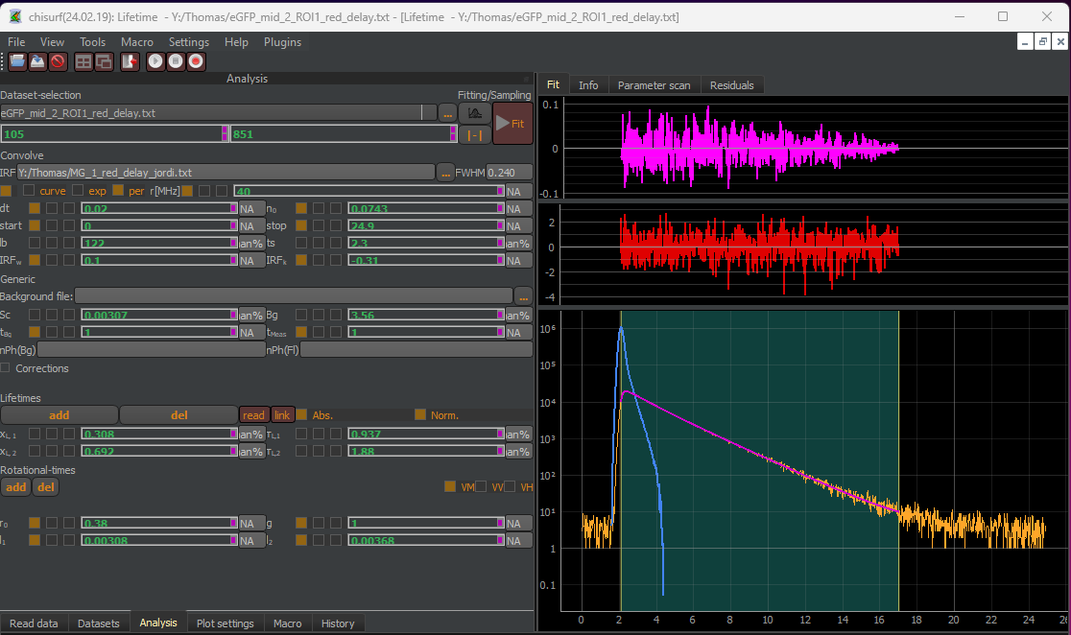
- Here an average lifetime of 1.59 ns is obtained from the biexponential fitting, where the shorter lifetime is half of the longer lifetime (0.937 ns vs 1.88 ns). This is a clear sign of pile-up.
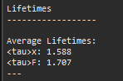
- To correct the pile-up, tick the “corrections” box and the corrections option unfold:
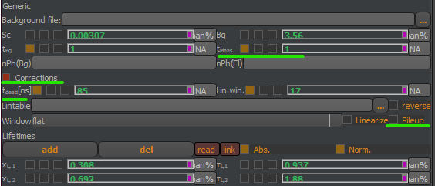
- Fill in the appropriate values for your detector dead time ($t_{dead}$, in ns) and your measurement time (($t_{meas}$, in sec). Make sure to tick the box “Pile-up”!
Note:
For FLIM measurements, the easiest approach to estimate the measurement time is to sum up all pixels in the ROI and multiply this number with the pixel dwell time and number of frames, e.g. for a ROI of 1000 px, 8 µs dwell time and 40 frames, an estimated measurement time of 0.32 sec is obtained.
For event-wise single-molecule analysis (BIFL-scatter), the total measurement time can be estimated by the sum of the single-molecules events duration.
After adding your numbers and ticking the “Pile-up” box, you can see effect on the weighted residues and the autocorrelation of the weighted residuals:
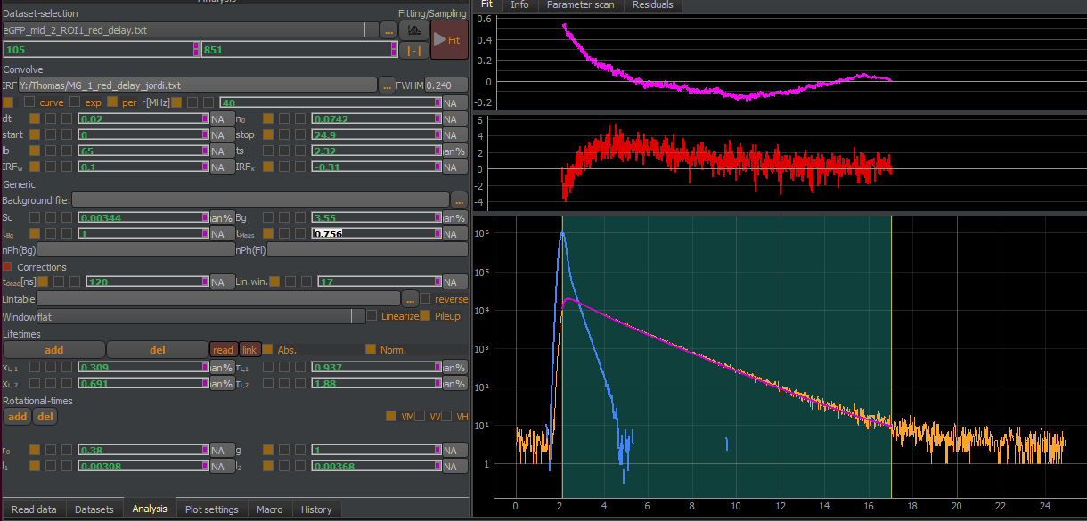
- Press fit again and observe the fit results:
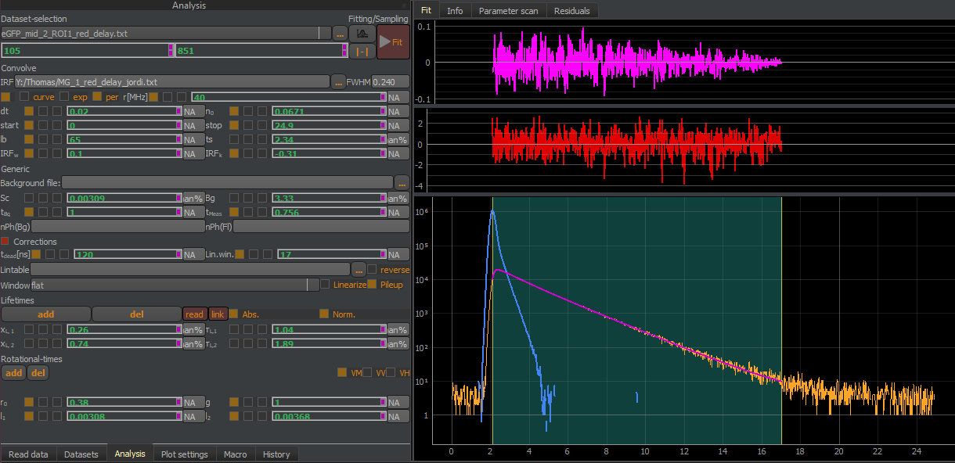
Now, the shorter lifetime has changed, and the average lifetime has increased:
