Global view

Overview
In ChiSurf dependencies between parameters can be introduced by linking and visualized in graphs (Fig.XX1). The Global view plugin (i) visualizes parameter dependencies in directed graphs, (ii) saves parameter dependencies, and (iii) restores dependencies from files.
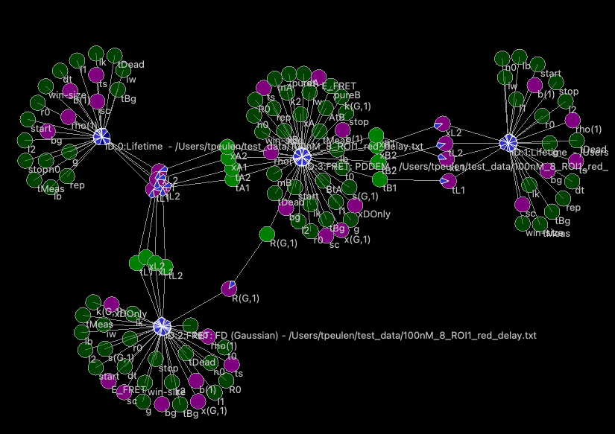
$$f_{D|D}^{D0}$$
$$f_{D|A}^{DA}$$
$$f_{A|A}^{DA}$$
$$f_{A|D}^{DA}$$
Fig.XX1. Parameter dependency graph of time-resolved fluorescence decays, $f$, that describe the donor fluorescence in the absence of an acceptor in a donor only, $f_{D|D}^{(D0)}$, the donor fluorescence the presence of an acceptor, $f_{D|D}^{DA}$, the acceptor fluorescence in a FRET sample $f_{A|A}^{DA}$, and the FRET sensitized acceptor fluorescence, $f_{A|D}^{DA}$. Parameters and models are represented by circles. Dependencies are illustrated by arrows. Parameters dependent on other parameters are colored in green. Fixed parameters are displayed in light green. Variable parameters are highlighted in magenta.
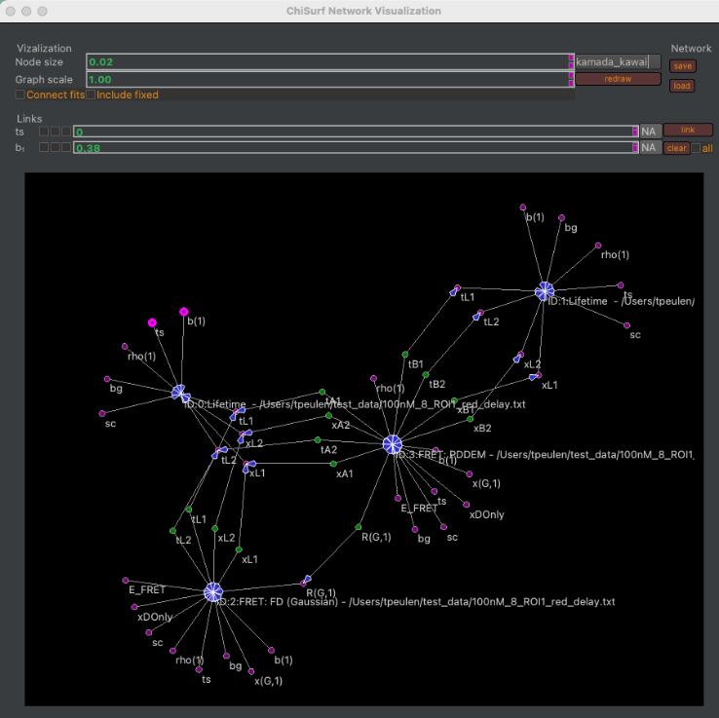
The Global view plugin opens from the Plugin menu, Plugins → Global view, in a separate window (Fig.XX2).

Fig.XX2. User interface of the Global view plugin. The plugin represents models and parameters in graphs (bottom). The Visualization group box of the plugin gathers options controlling the graph visualization (Node size, Graph scale). The Network group box can be used to save and load dependencies. The Link group box can be used to introduce and delete (clear) dependencies across selected and all parameters.

Changing visualizations
The visualization of the graph is controlled by widgets in the visualization box (Fig.XX3).
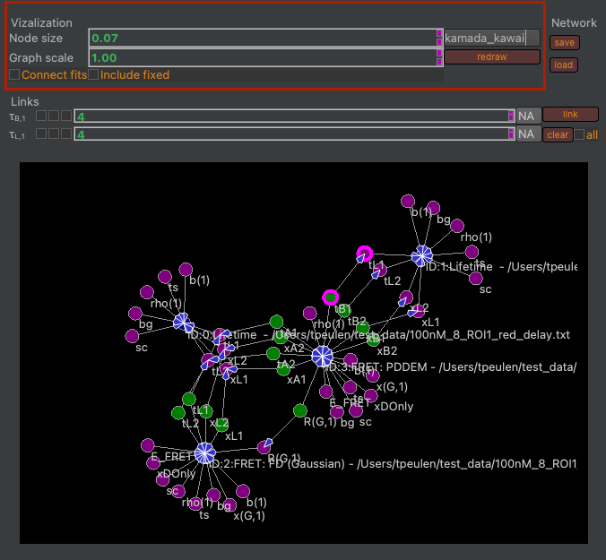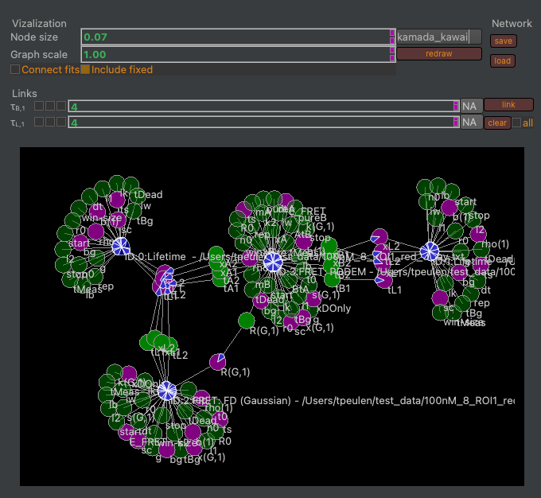
Fig.XX3. The graph visualization is controlled by the group box highlighted in red (left). The node sizes and the graph scale are controlled by respective spin boxes. The connect fits checkbox introduces additional edges between fits. The include fixed checkbox controls wether or not fixed parameters are displayed in the graph. The dropdown menu can be used to select a different algorithm for node placement.
The position of nodes can be controlled by dragging nodes of the graph.

Saving and loading networks
By default, the Global view plugin displays all models / fits in the current ChiSurf instance. Parameter networks can be saved using the save button (Fig.XX4).
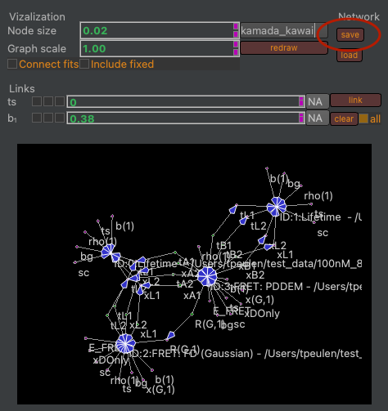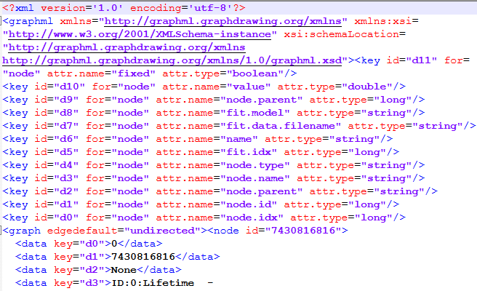
Fig.XX4. Saving parameter dependency networks (left). Parameter dependency networks are saved in GraphML files (right).
ChiSurf stores fits are in an ordered list. Hence, when loading networks file make the fits in the saved network must match the order of the fits in the running ChiSurf instance. After loading a GraphML file containing the parameter links the values of the parameter and their connections are restored (Fig.XX5).
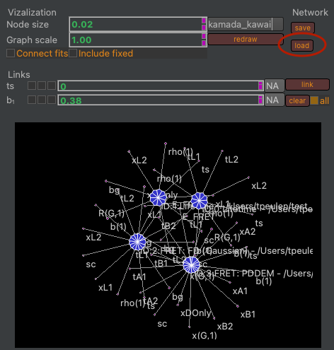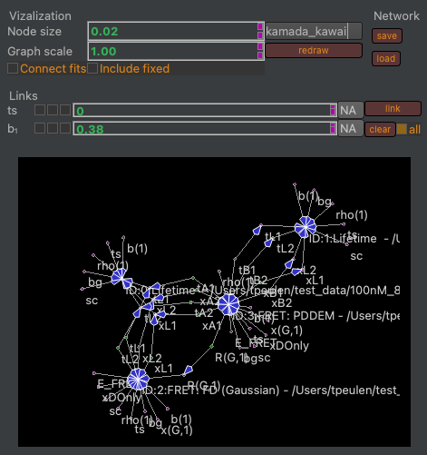
Fig.XX5. Loading parameter values and connections (left). After loading a matching GraphML file the dependencies between parameters are restored (right).

Linking parameters
Parameters can be selected by clicking on the respective nodes. Selected nodes are highlighted in magenta (Fig.XX6). The parameters of the selected nodes are displayed in the Links group box (Fig.XX6). The “link” button creates a link between selected nodes. The clear button removes a link between selected nodes. The “all” checkbox controls if clearing removes the link between selected nodes or the link between all nodes.
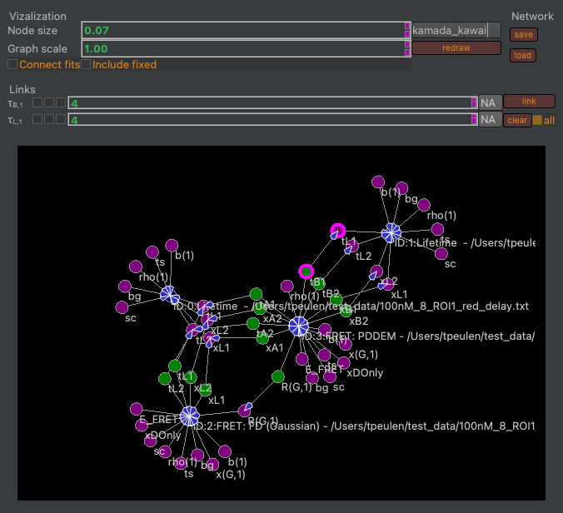
Fig.XX6. Selecting and linking parameters. The parameters “tB1” and “tL1” are selected (highlighted by magenta circles). Selected parameters are displayed in the Link group box. The clear button removes a link between selected parameters. Checking the “all” checkbox before clicking on clear removes all links. The “link” button creates a link between selected parameters.

