Determination of g-factor and depolarization factors using ChiSurf

Download options
Compiled windows versions:
https://www.peulen.xyz/downloads/chisurf/
Installing from conda:
https://github.com/Fluorescence-Tools/chisurf
On the GitHub page also some manuals are present.
Preprint: https://www.preprints.org/manuscript/202501.1615/v1

Introduction
High NA objectives cause a partial depolarization of the linearly polarized excitation and the collected emitted light. This influences the observed fluorescence anisotropy in fluorescence spectroscopy experiments:
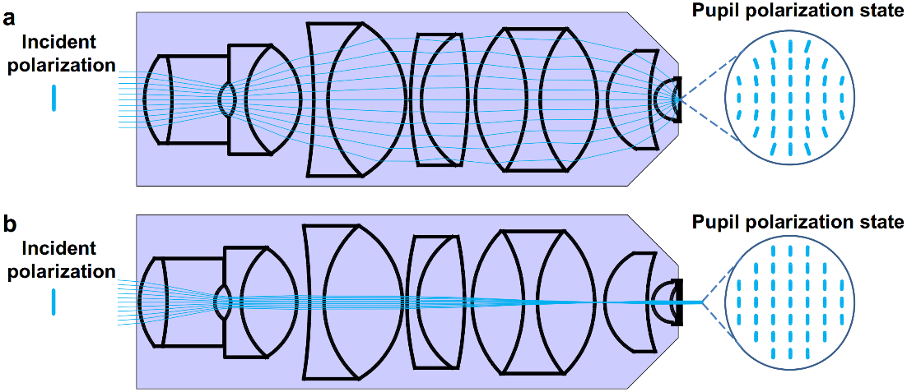
Figure 1. Depolarization introduced by a high NA microscope objective.
(a) The microscope objective is illuminated by a linearly polarized plane wave and focuses the beam onto the sample. This mode of illumination is used in confocal microscopy. (b) The linearly polarized beam is focused into the back-focal plane of the objective (widefield illumination). The sample is illuminated by a collimated plane wave. The “pupil” polarization states in the image planes are depicted using vertically polarized incident beams. Widefield illumination (b) leads to lower loss of polarization in the illumination field than focused beam illumination (a) as confirmed by optical ray tracing simulations.
(Image taken from: https://doi.org/10.1371/journal.pone.0100526)
The correction of this phenomenon has first been described already by M. Koshioka, K. Sasaki and H. Masuhara (https://opg.optica.org/as/abstract.cfm?uri=as-49-2-224, , Appl. Spectrosc., 1995, 49, 224–228).
In the more recent, open access publication of Erdelyi et al. a more illustrative description can be found (Erdelyi M, Simon J, Barnard EA, Kaminski CF (2014) Analyzing Receptor Assemblies in the Cell Membrane Using Fluorescence Anisotropy Imaging with TIRF Microscopy. PLOS ONE 9(6): e100526. https://doi.org/10.1371/journal.pone.0100526).
Next to the depolarization due to the objective, the different detection sensitivity of the parallel and perpendicular detector must be considered. In microscopy-based experiments, this so-called g-factor is often defined as the ratio of parallel (I_{p}) over perpendicular (I_{s}) light, however, some software also uses the inverse definition. In either case, the g-factor should ideally lie close to 1.
To determine both the g-factor and polarization correction factors, l_{p}, and l_{s}, we use here a joint analysis of a small, fast rotating fluorophore such as Alexa, Atto or Cy fluorophores and a larger, slow rotating fluorophore such as a fluorescent protein. Please note that both selected fluorophores must show a mono-exponential rotation, i.e. proteins labelled with an organic fluorophore connected via a flexible maleimide linker or similar are not recommended.

Joint analysis with ChiSurf

Data input and file format
ChiSurf can read a variety of text files and formats. For time-resolved fluorescence intensities in polarization-resolved experiments, we usually use two different file formats: (ii) two-columns/two files or (ii) single-column/single file (“Jordi-format”).
In the first case, two files are required, one containing the parallel channel and one the perpendicular channel data. Both files contain two columns; the first column is the time in nanoseconds, while the second column contains the actual data (photon counts in this respective time bin).
In the second case, only a single file is required, in which the data from perpendicular and parallel channel are stacked on top of each other.
Please note that in both format no header is used, however, it can be defined to skip header rows while file loading.
Case I: two files / two columns | Casse II: single file (“Jordi” format)
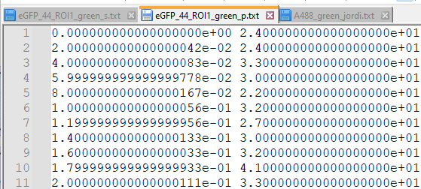  - File 1: 2500 lines in total, parallel  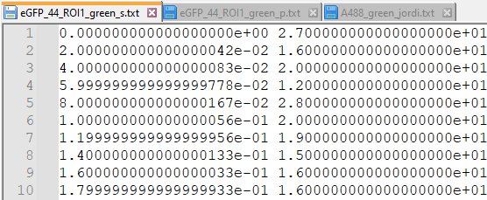  - File 2: 2500 lines in total, perpendicular | 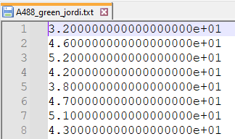  - Lines 1- 2500 = parallel  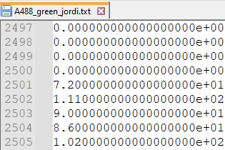  - Lines 2501 – 5000 = perpendicular

I personally prefer the single-column Jordi-format as it reduces the amount of files in my data export folders by 50%, however, I need of course to remember with which time resolution (here 20 ps) the TCSPC histograms were exported.

Start the software
The newest version of the software can be downloaded from:
https://github.com/Fluorescence-Tools/chisurf
Please note that the software is currently ported from python 2.7 to python 3.10 including major feature updates. If you notice any bugs/weird behaviour or not-working plugins, please let the developer know via the github issue page:
https://github.com/Fluorescence-Tools/chisurf/issues
@Elizabeth: For your convenience I sent you a link to a zipped Windows version from which I know the anisotropy plugin is working fine and I also did not notice any other bugs. Best is to unzip the software to a local hard drive as network shares might create problems (Unzipping takes a while as a whole python environment with tons of little files is unpacked).
To start the software, double-click on the .bat file:
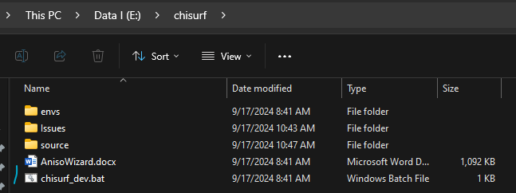
Next, two loading window will open, the command line and the ChiSurf start-up window. Do not close the command line window!
1:command window: | 2. ChiSurf startup window
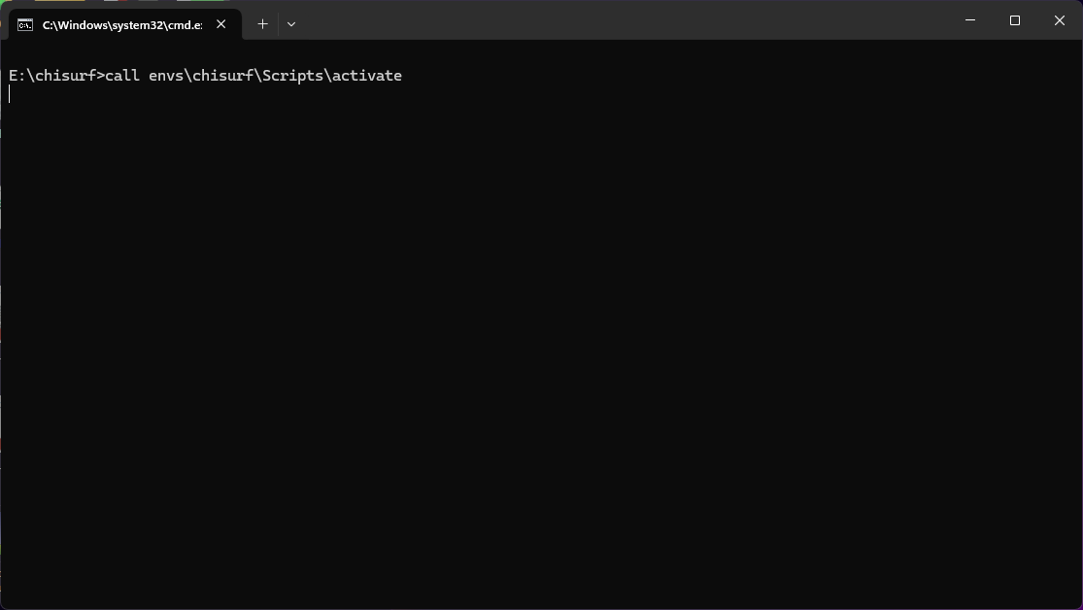 | 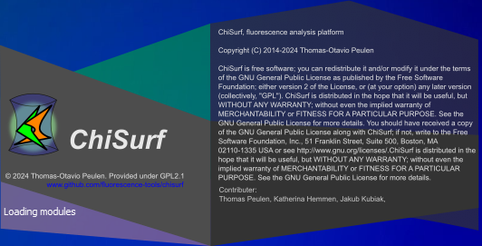
3. command window (final) | 4. ChiSurf Main window
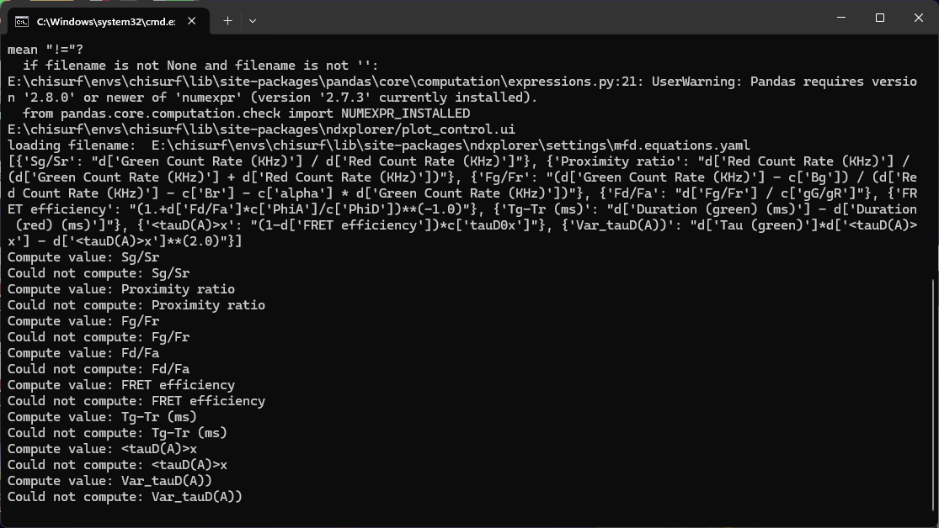 | 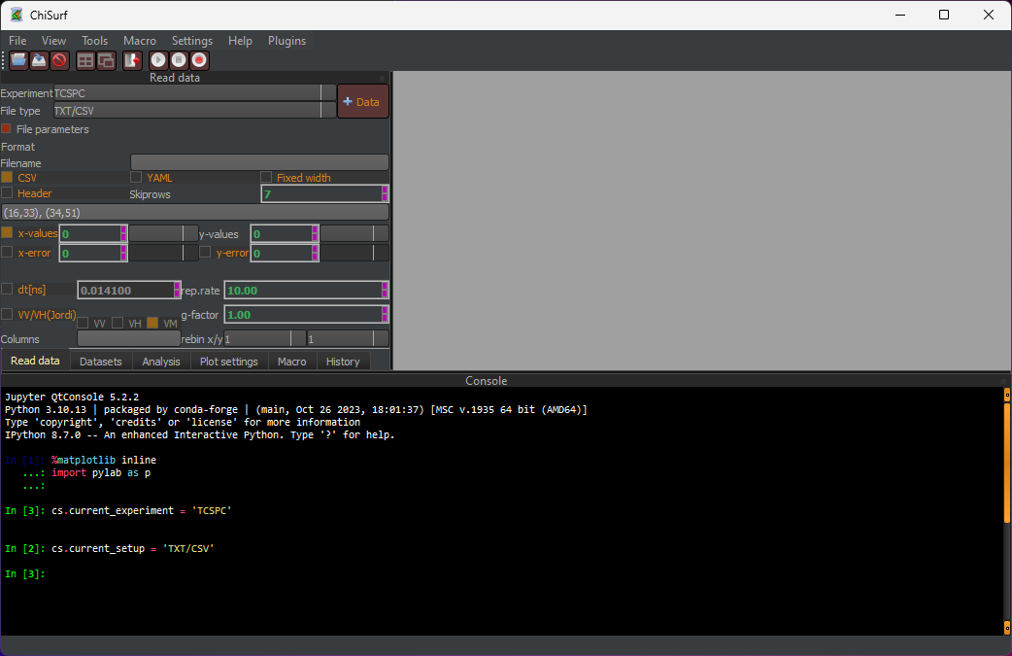

Loading the data: Defining the reading parameter
As ChiSurf is been developed to support a variety of experiment types (TCSPC, FCS, Modelling) and file formats (e.g. txt or csv, tttr, sdt,...) it is vital to define the correct reading parameter.
Here, our experiment is “TCSPC” and the File Type is “TXT/CSV”.

Two single files
If the parallel and perpendicular data is saved in two separate files, including a time axis, the following reading parameter should be set:
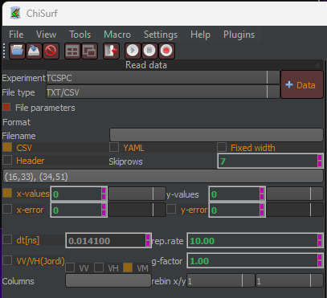
Note that if the files would contain a header, the checkbox next to Header must be selected and the number of rows to skip must be indicated in the Skiprows box.
Both g-factor and repetition rate (rep.rate) can already be fixed here. Giving the correct repetition rate is required in single-molecule experiments where the high repetition rates do not allow a full intensity decay of the fluorophores, and the repeated excitation must be considered in the fluorescence lifetime analysis.

Jordi format
If both parallel and perpendicular data is saved within the same file and no time axis is defined, the following settings need to be made:
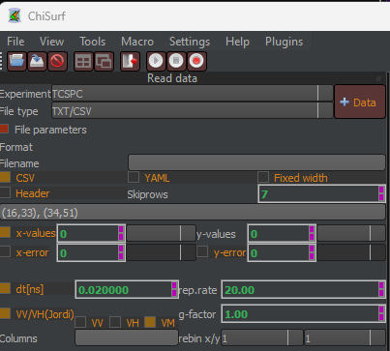
The example data was collected in total 40 MHz PIE mode, i.e. every fluorophore got excited with at 20 MHz, and the data was exported with a time resolution of 20 ps.

Loading the Alexa488 data into the anisotropy plugin
After the reading parameter have been correctly set, the anisotropy wizard can be started from the “Plugins” tab:
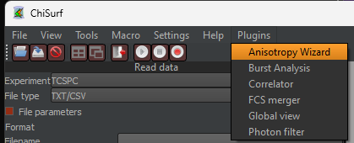
The anisotropy wizard opens in a new window and leads step-by-step through the joint fit setup.
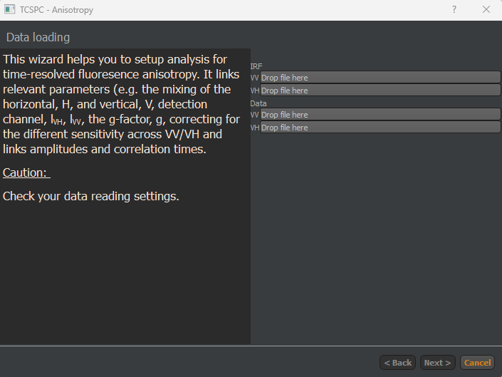
Load the data by “drag’n’drop” the files into the respective boxes. In case the single-file format is used, the still the same file must be loaded twice (The software will automatically load either the parallel or perpendicular section of the data column).
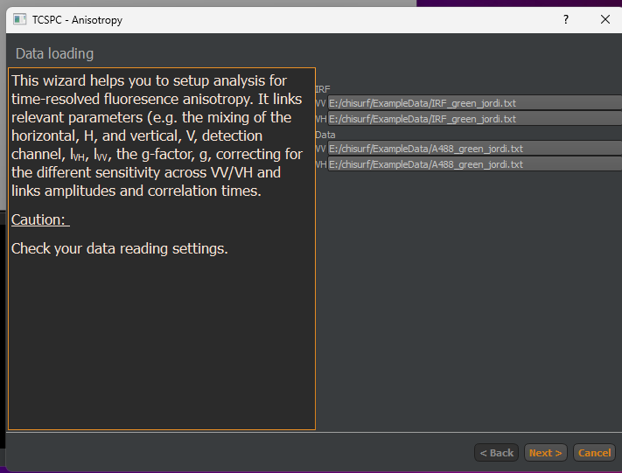
Click “next” to proceed. IN the next step, the IRF background region is defined. Note: The number in the 2nd spin box must always be largr than in the 1st box, i.e. best is to first define the end (here: 100) and then the beginning (here:180)
Define background region of IRF - empty | With correct numbers
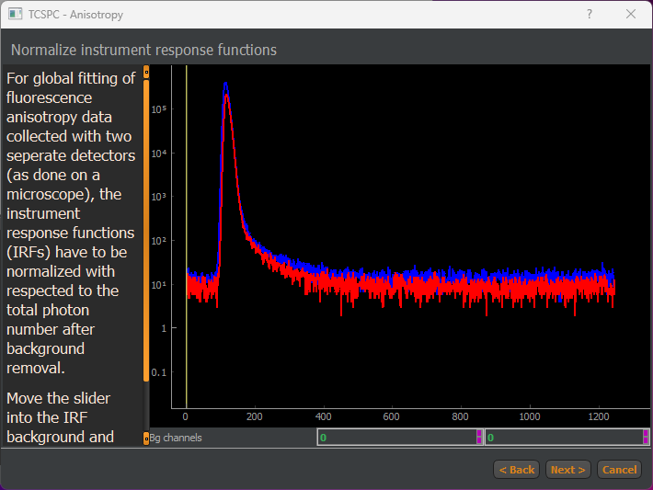 | 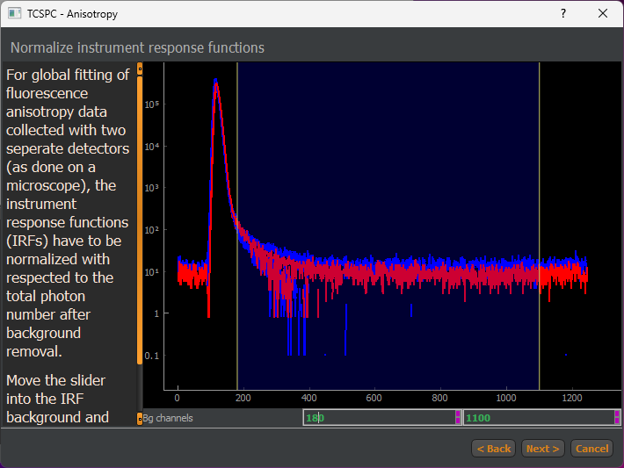

Cleck “next” to proceed. Here, the g-factor, l1 and l2 can be given (in case known) or estimates can be added.
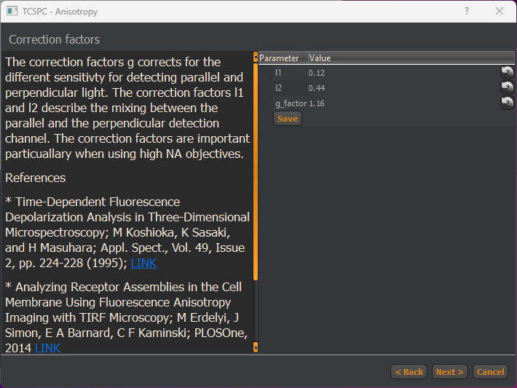
Click “next” to continue. IN this step, the fluorescence lifetimes and rotational correlation times can be added. In this step, settings can also be saved and loaded, e.g. if many similar cells need to be analysed (see also below).
Add LT & rotation - defaults | For Alexa488
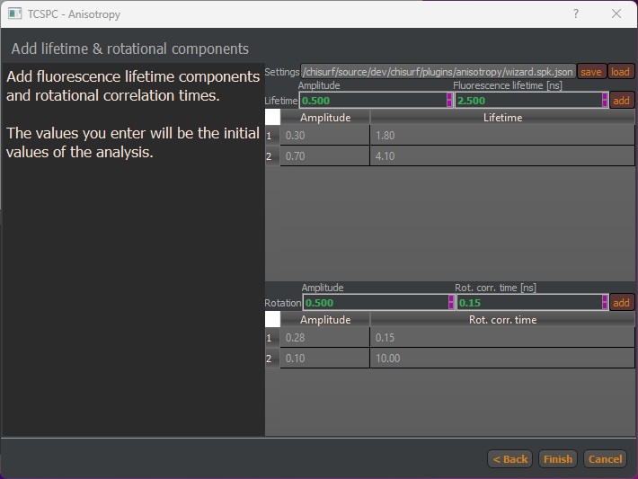 | 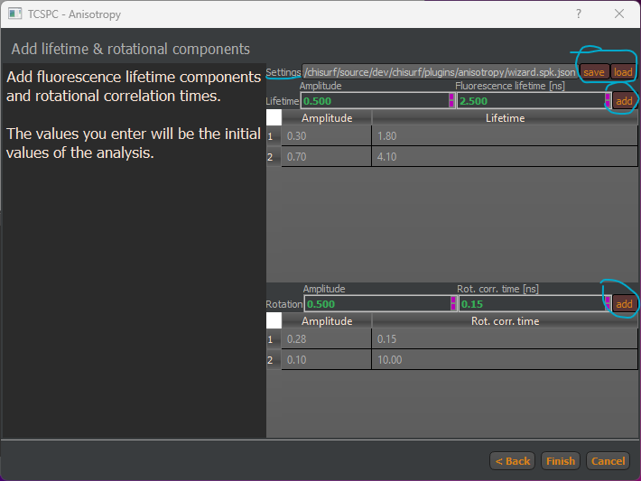

To add a fluorescence lifetime or a rotational component, adjust the values in the box below “Amplitude”, “Fluorescence Lifetime” and “Rot. Corr. Time” and press “add”.
Components can be removed by double-clicking on the entry in the table.
Please note that the amplitude sum of the fluorescence lifetime components is automatically normalized to 1, while for the anisotropy components the sum is normalized to 0.38, the fundamental anisotropy of most fluorophores.
Click “finish” to generate the joint fits in the main ChiSurf window and press the “tile windows” to distribute the windows in ChiSurf’s main window.
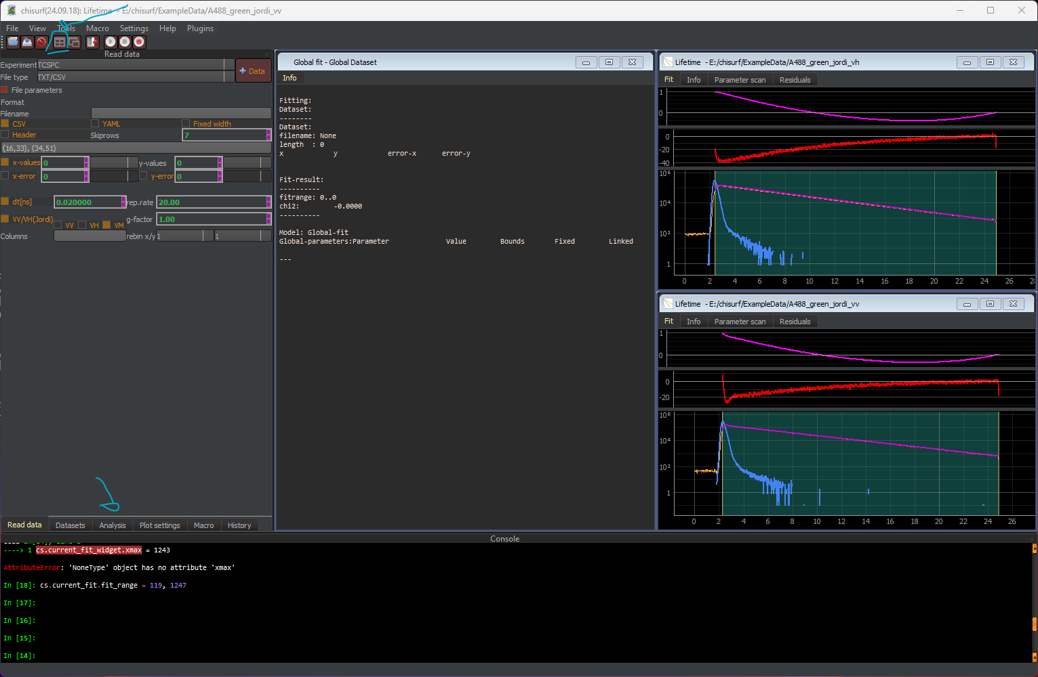
In total, three fit windows are now open. Here, the large window entitled “Global fit” hosts the connections/linking between the two individual fits open in the two smaller windows (here: top contains the perpendicular data, while bottom contains the parallel data).
Next, switch to the “analysis” ta and inspect what is displayed for the three different windows:
- Global-fit: In the top-part the fits, which are to be minimized jointly are listed, the bottom part could be used to manually link variables across different datasets listed above (not used here).
- Lifetime - _vh and Lifetime - _vv: Each of them have four different sections:
  - Convolve (top left to bottom right):
    - Datapath to the IRF
    - Convolution algorithm: e.g. exponential or periodic (selected here)
    - dt: size of a time bin in nanosecond
    - n0: total number of photons in the decay
    - start / stop: start and stop of time range
    - lb: offset of the IRF, must be zero or another small number as we background was already subtracted when setting up the experiment
    - ts: time shift between IRF and decay
    - IRF_{w}/IRF_{k}: In case an IRF cannot be measured/is missing, these parameter can be used to generate a synthetic Gaussian-shaped IRF with width IRF_{w} and skewness IRF_{k}. This option is not when (i) an IRF is loaded and (ii) the parameter are fixed (1st of the three boxes selected)
  - Generic:
    - Sc: fraction of scatter-based fluorescence, should be low in all experiments except signle-molecule
    - Bg: background/offset of the data
    - tBG/tMeas: to be filled when fitting single-molecule in “Burst-Integrated Fluorescence Lifetime” mode
    - Corrections: Ticking this box reveals option to perform a deadtime correction (pulse pile-up at high count rates) or to correct for differential non-linearities of the counting electronics (white light reference measurement required)
  - Lifetime:
    - xL,[x] are the amplitudes of the fluorescence lifetimes, normalized to a sum of 1 if the “Norm.” box is ticked. Amplitudes can also get negative (e.g. for FRET-sensitized acceptor emission data), then the box next to “Abs.” must be unticked.
    - τL,[x] are the respective fluorescence lifetime.
  - Rotational times
    - VM - VV - VH: designate the polarization of the dataset
    - r0: fundamental anisotropy of the used fluorophore
    - g: g-factor
    - l1, l2: polarization correction factors
    - b[x]: amplitudes of the rotational correlation times, normalized to r0
Global fit | Vh | vv
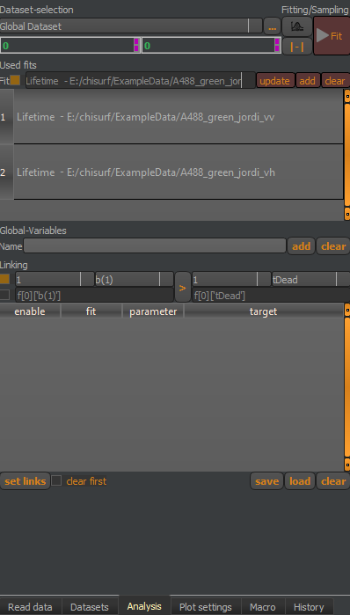 | 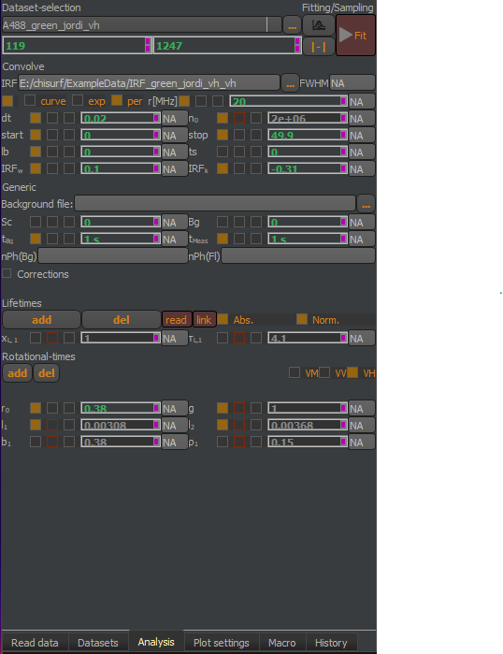 | 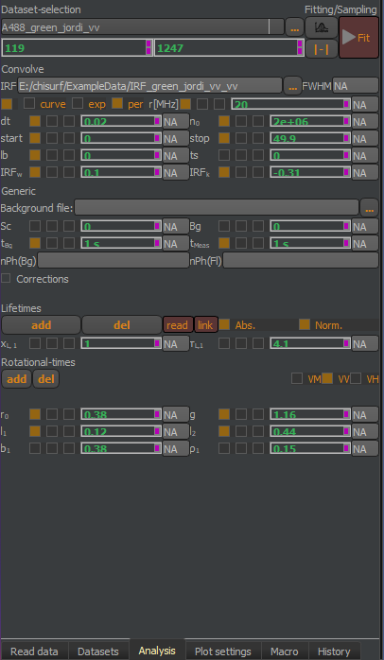
Each of the number-based parameter has three checkboxes:
- The left checkbox fixes the parameter, it will not be fit but kept constant.
- The middle checkbox is used to link parameter (via right-click -> link) and if it is filled or shown in read, this means that this parameter has been linked to another data set.
- The right checkbox can be used to define a range, in which the parameter can float, e.g. a fluorescence lifetime should not become negative.

Step 1: Approximating g-factor with small fluorophore
To start the analysis, first go to the “VV” dataset and perform a quick, individual fit of this dataset. This helps to set at least the time shifts between IRF and decay of the background/offset correctly.
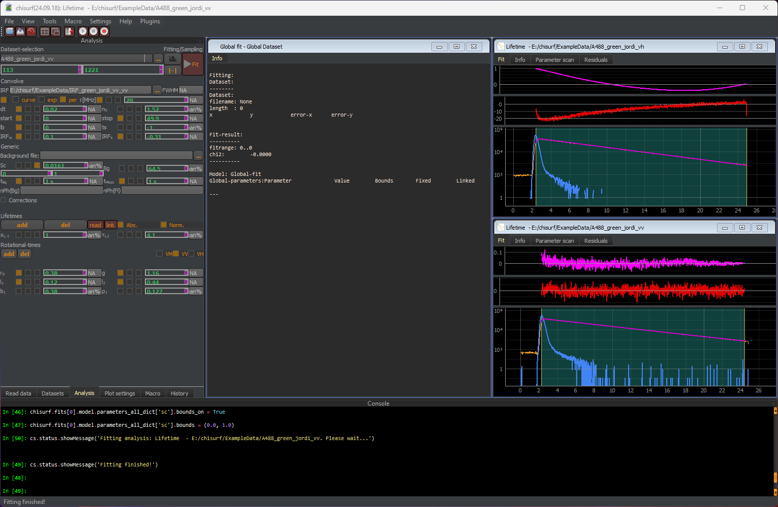
In this step, still the g-factor, l1 and l2 are fixed to the initially estimated values. Next, also perform a quick fit on the VH dataset. Important note: The fit will not be good! This only serves to initialize the parameter.

Step 2: Joint analysis to determine g-factor, l_{s} and l_{p}
In the next step, the g-factor, l1 and l2 are no longer kept fixed to the initially estimated values but will also be fit and their respective check boxes are unticked.
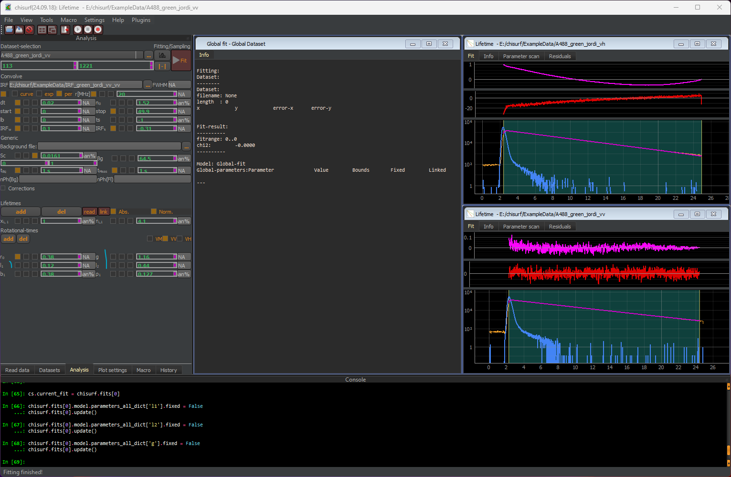
Next, switch to the “Global fit” and press the fit button for the joint fit.
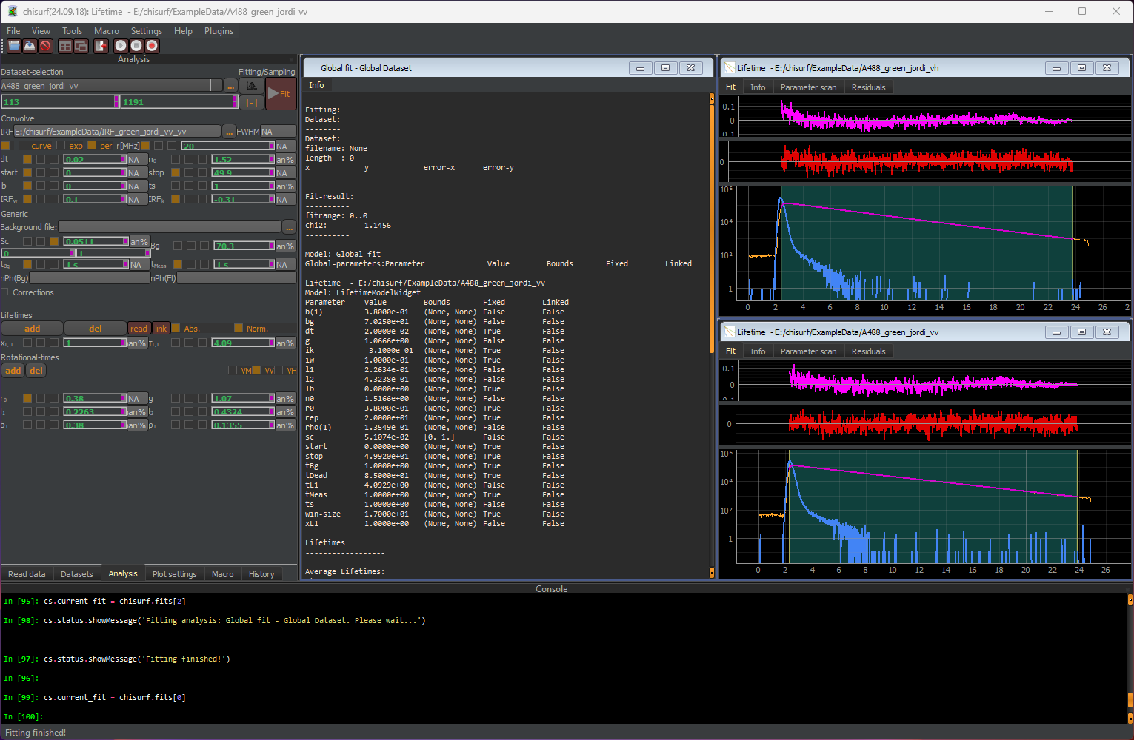
The fit is not yet good. It seems there is a component missing the in beginning of the decay. A second lifetime can be added and linked between VV and VH.
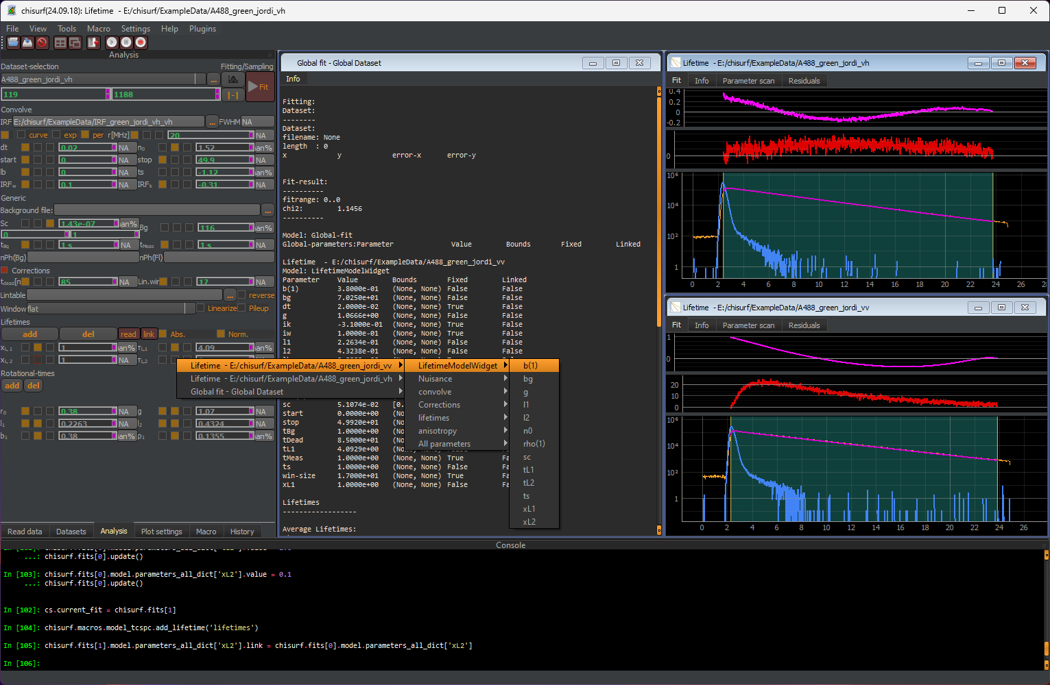
Once the modifications have been done to the VV and VH datasets, switch back to the “Global fit” and press the update button before performing a global fit again. Now, the fit looks good with flat residuals and a decaying autocorrelation function.

Loading and setting up the eGFP data set
Repeat all steps from above with the eGFP data set. Once completed, six windows should be present in ChiSurf.
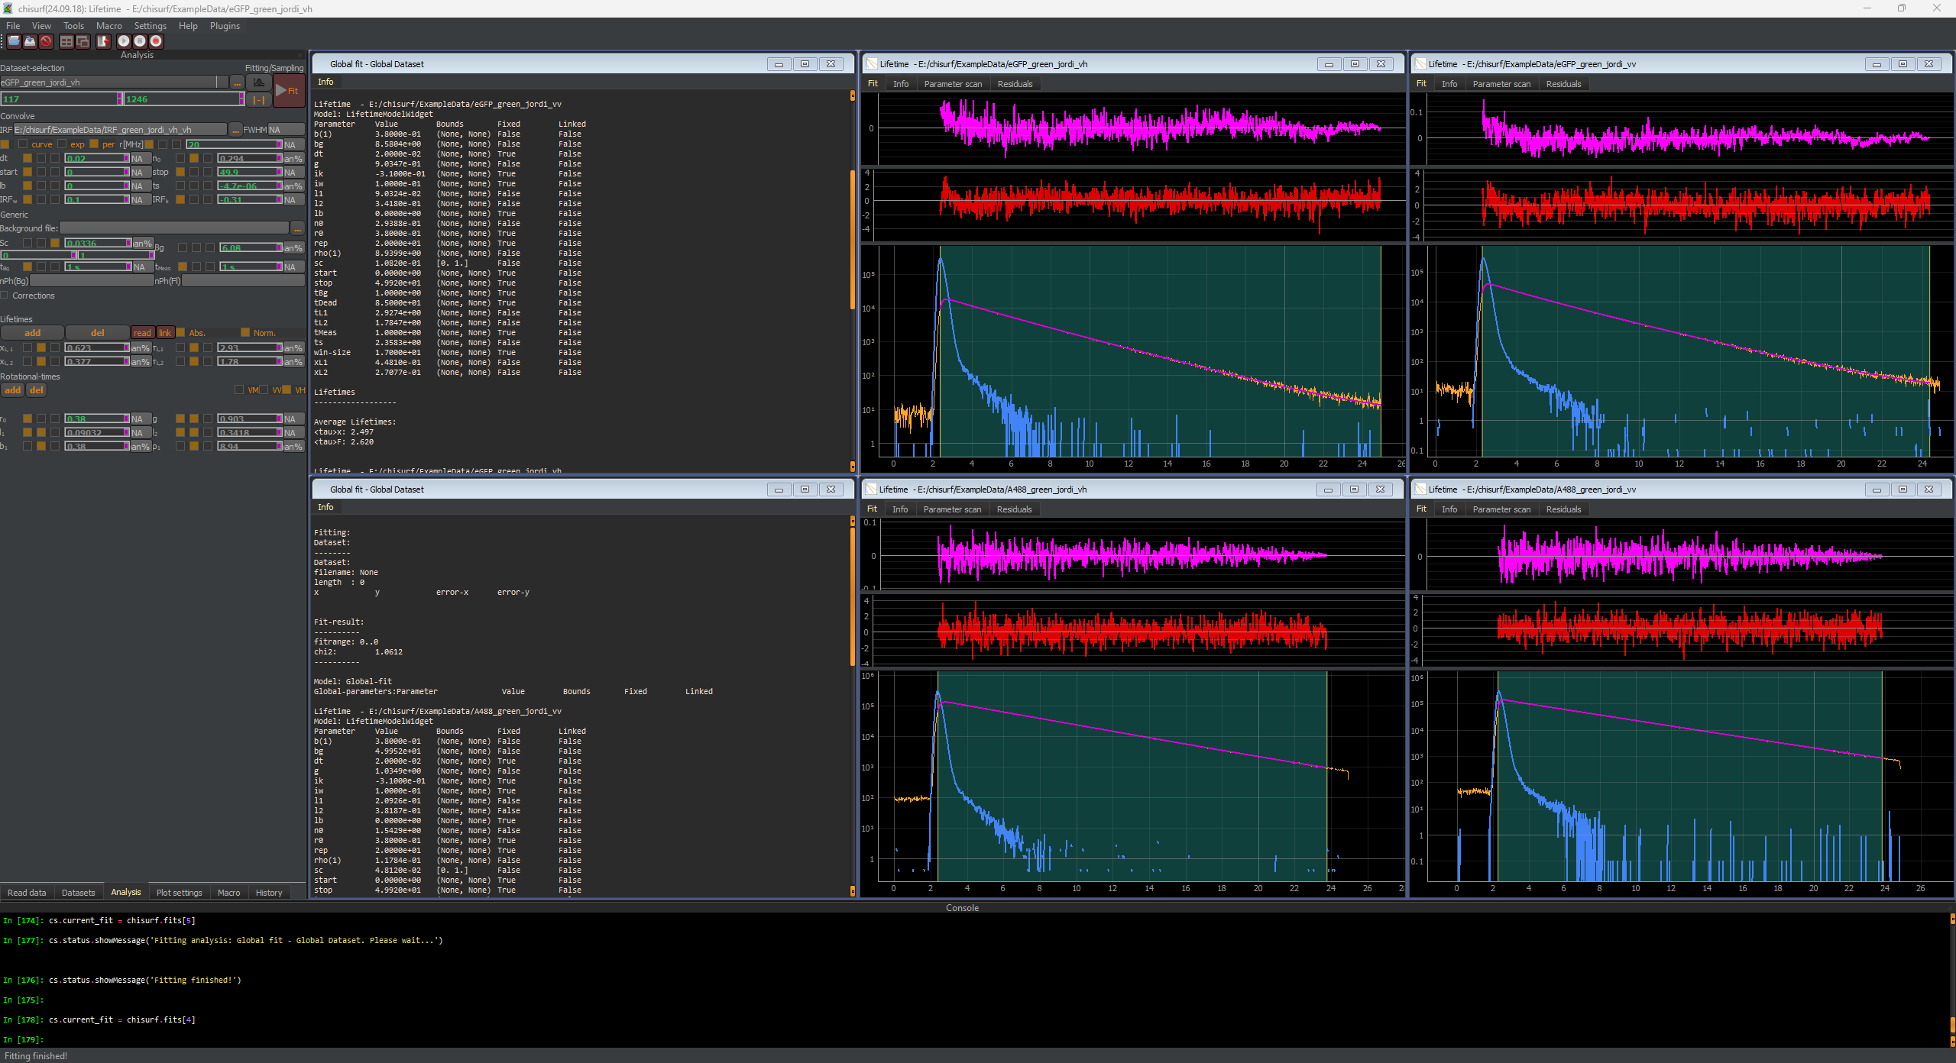
Note that as initial parameter for eGFP two lifetimes of 1.3 and 2.6 ns (~ 30:70) should be given, and a single rotational correlation time of 15 ns.

Setting up the joint global fit of A488 & eGFP
In the next step, a joint global fit of all four data sets (A488 VV, A488 VH, eGFP VV and eGFP VH) will be performed to best estimate the g-factor and the polarization correction factors.
Firstly, the g-factor, l1 and l2 from eGFP VV will be linked to the respective parameter from A488 VV. Note these parameters in A488 VH and eGFP VH are already linked to the respective VV dataset, A488 VV or eGFP VV.
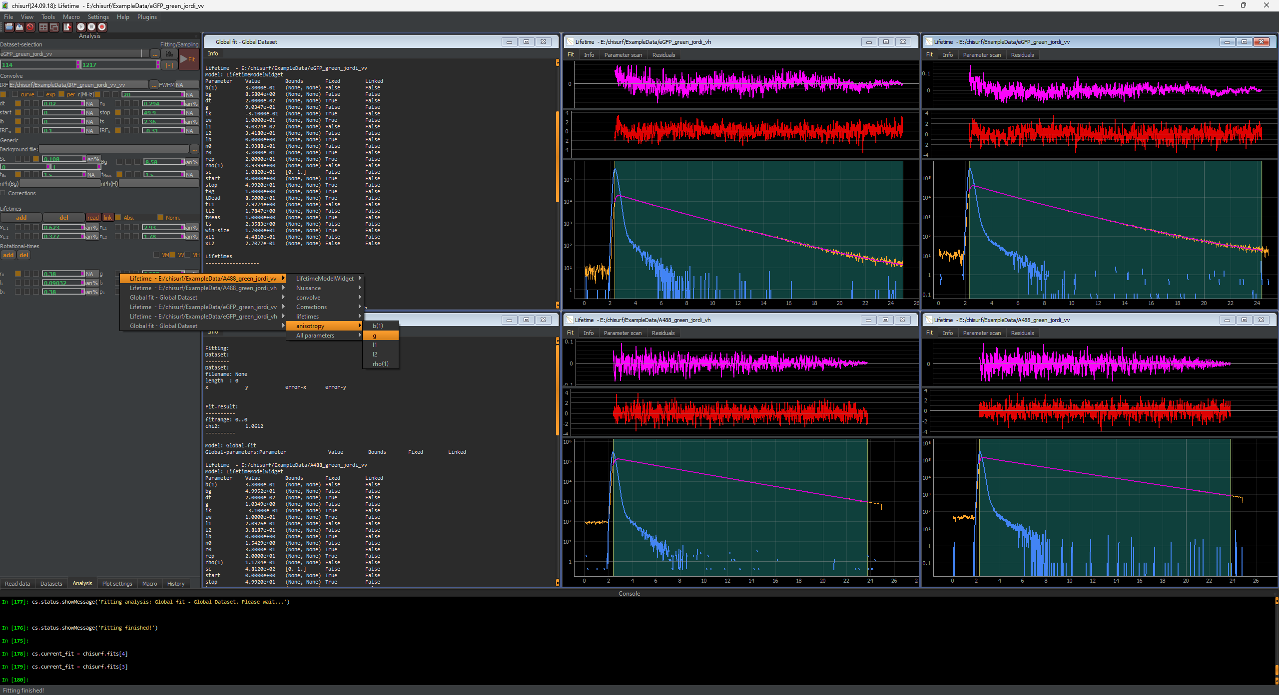
Next, a new global fit is added. Switch to the “Datasets” tab, select “Global Dataset” and press the “+ Analysis” button.
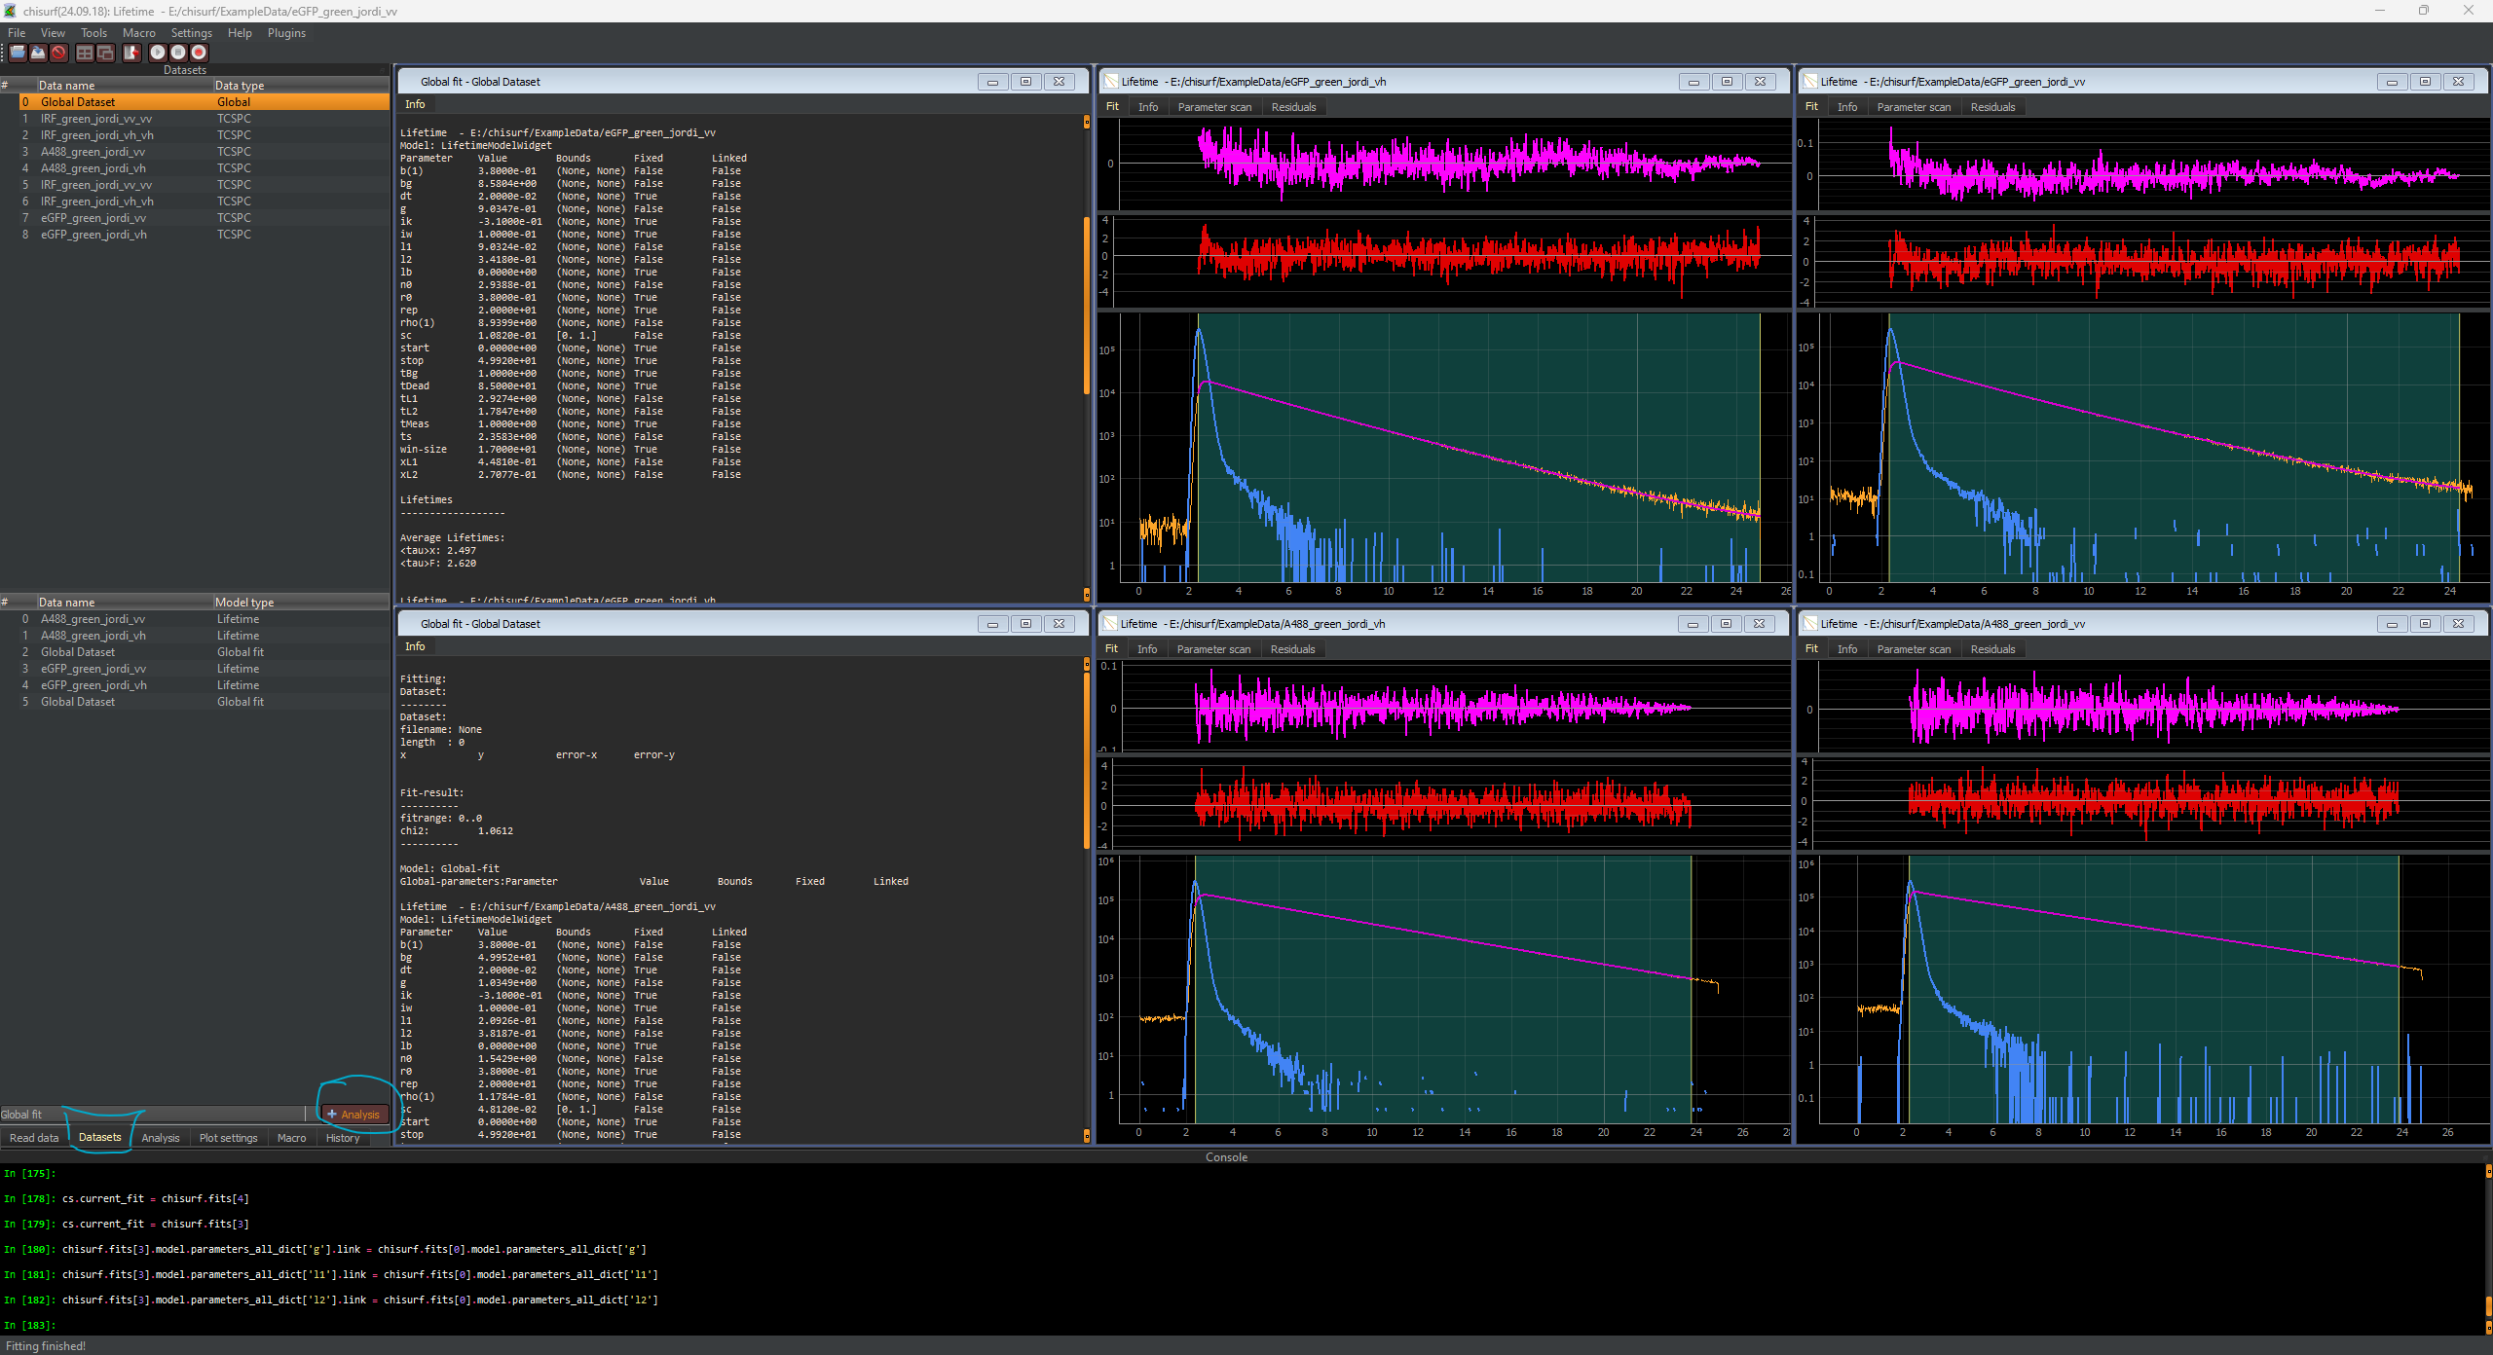
A new window will open.
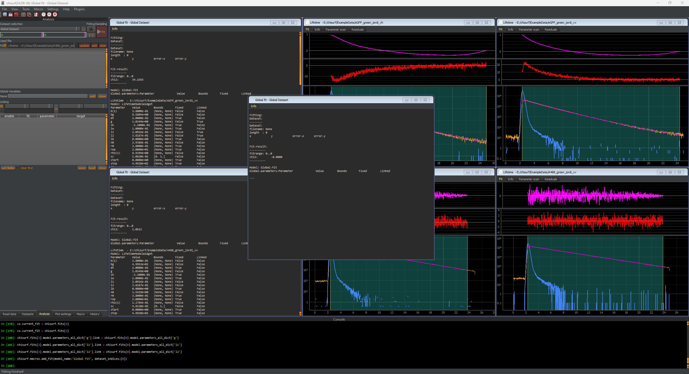
Switch back to the analysis tap and add the four relevant datasets for the joint fit to the global analysis by using the drop-down menu and the “add” button in the top left.
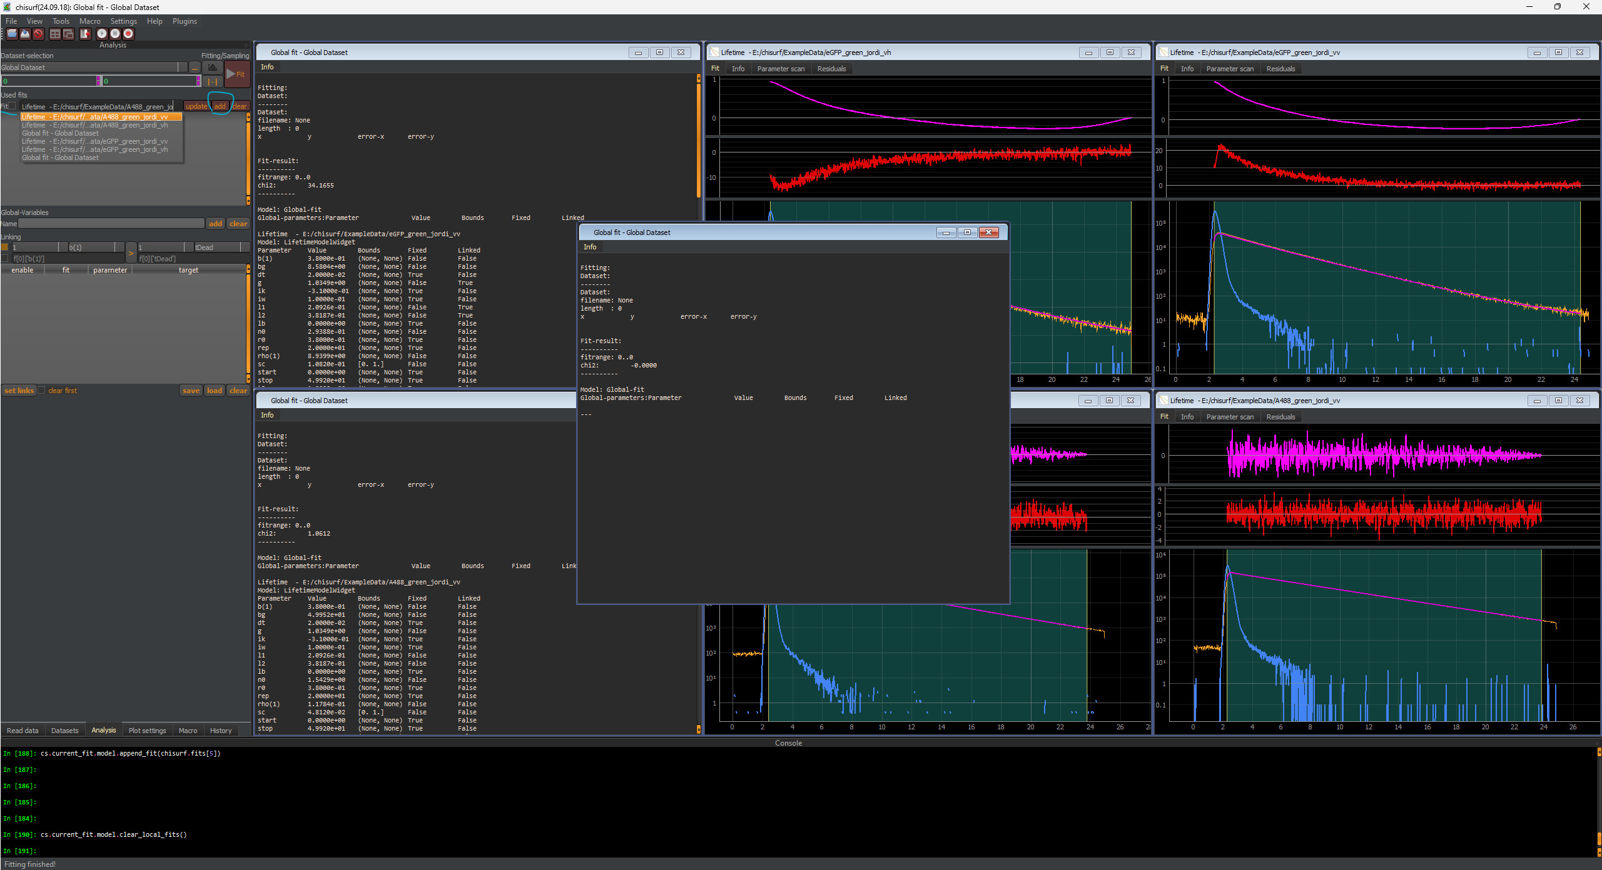
All four datasets need to be added:
- A488 VV
- A488 VH
- eGFP VV
- eGFP VH
Do not add the previous global fits!
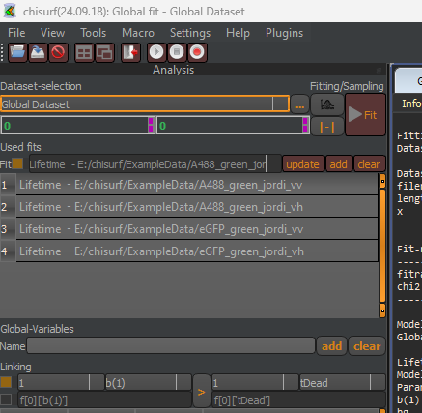
Finally, press the fit button and obtain the estimates for the g-factor and the polarization correction factor based on both data sets. Here, the following values are obtained:
- g-factor = 1.01
- l1 = 0.0437
- l2 = 0.349
@Elizabeth: We have observed that the depolarization in one polarization direction is much larger in our used 40X/NA1.2 Zeiss water objective. This might be different for other objectives.
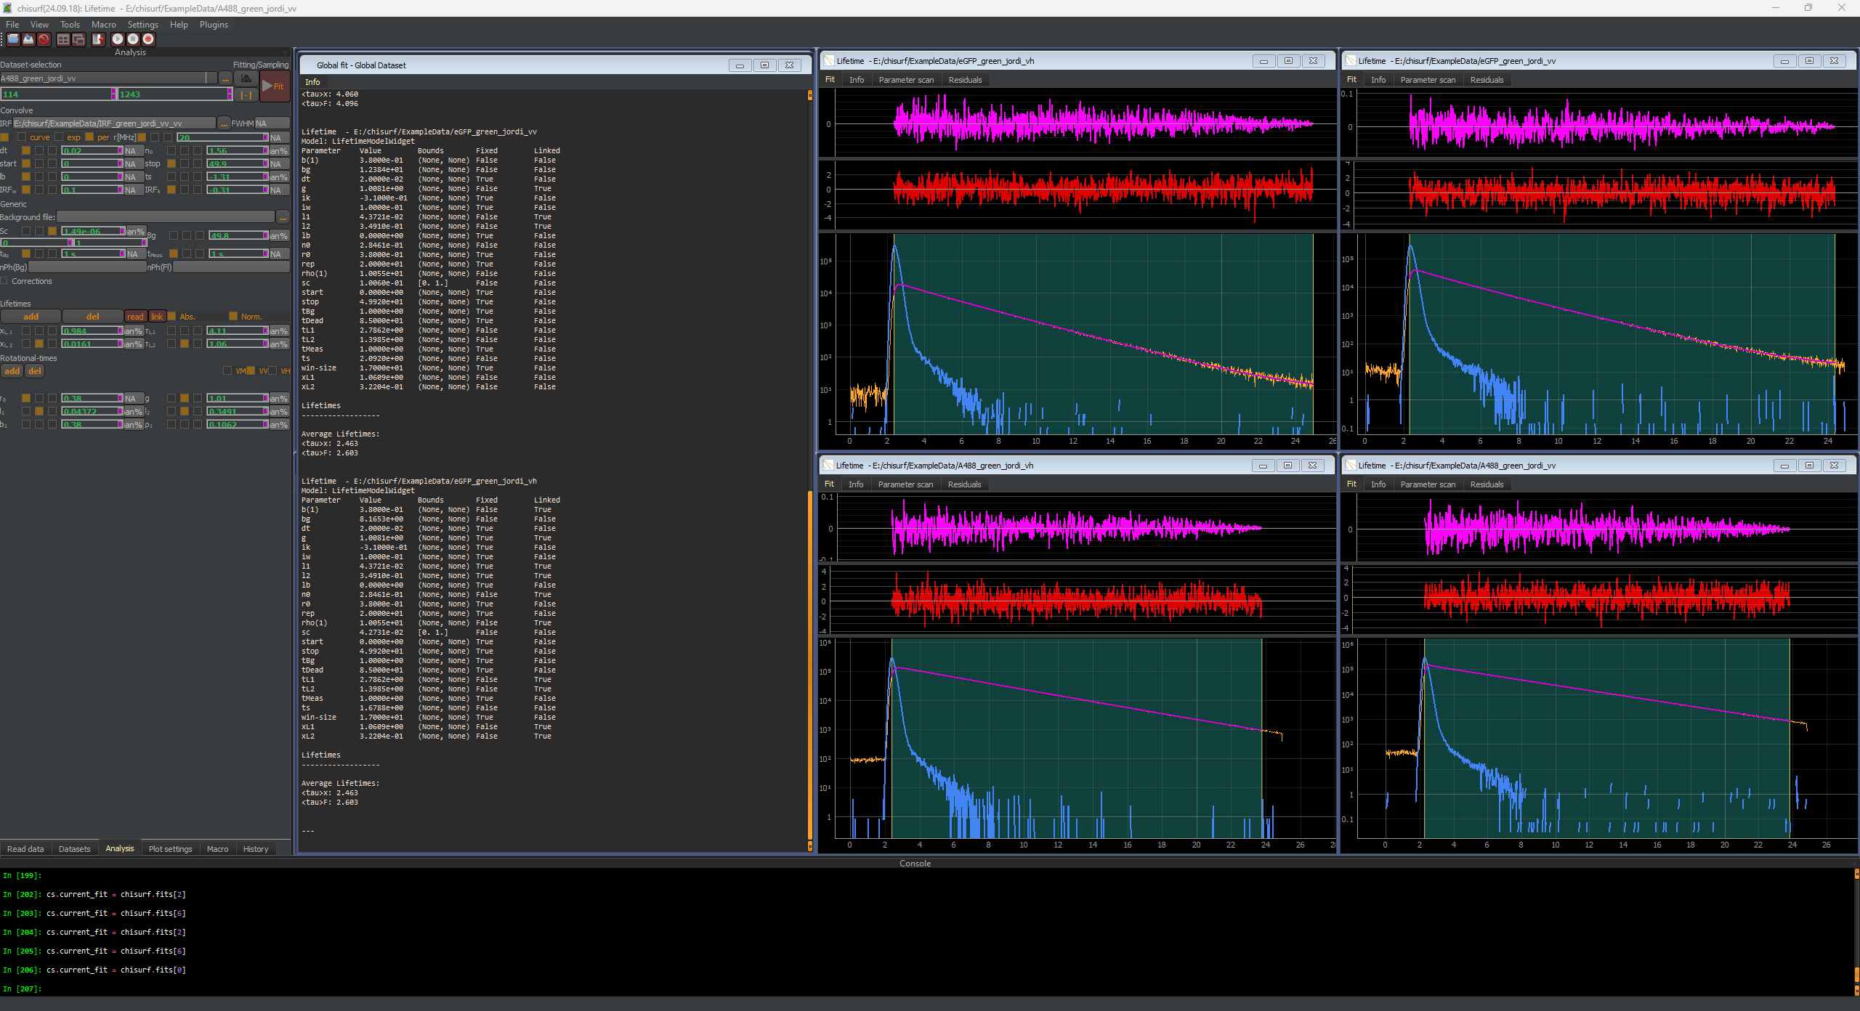

Saving & exporting the results
To save the results, either click on the respective fit window and press “Ctrl+S” or select from the main toobar at the top “File” -> “Save Fit results” -> “Current Fit”.
For each fit in total 14 files are saved:
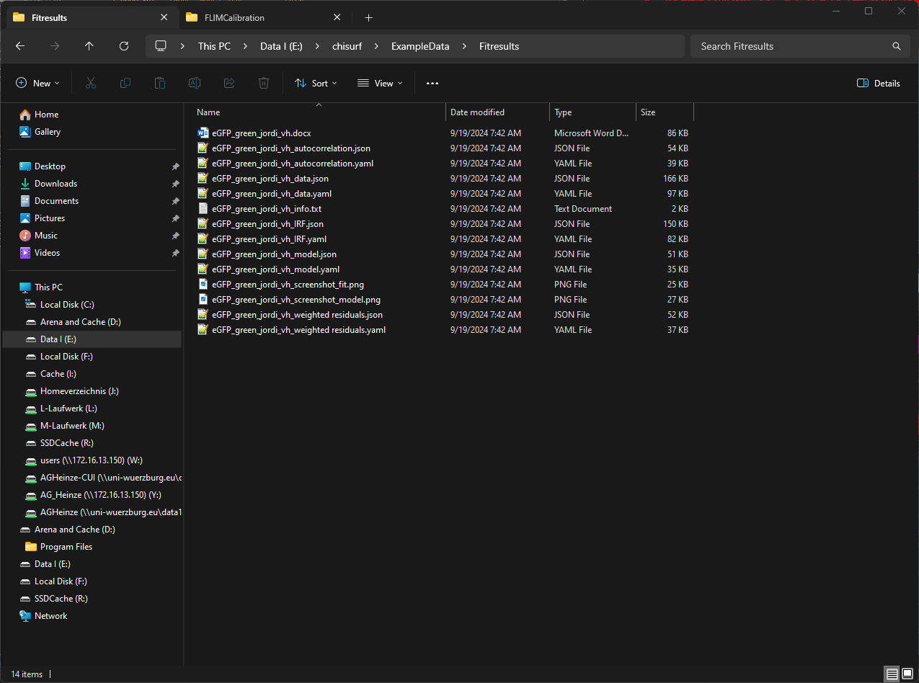
- The word-file summarizes the results in a table.
- The json and yaml files are required to open the fit results again in ChiSurf.
- The wo png files are screen shots of the fit window and analysis window.
- The Info.txt summarizes the fit results table-like in a txt file.

Re-using the parameter to analyse the actual samples
The obtained parameter can now be used to analyse the actual cell samples. Here, the example data stems from HEK293T cell transfected with cytosolic eGFP.
Firstly, verify that the reading parameter are still set correctly. Next, open the anisotropy wizard and load the cell data.
In the correction factor window, enter the obtained values and press save. In the fluorescence lifetimes and rotational correlation times window, the following components are given:
- Fluorescence Lifetime: 2.6 ns / 1.6 ns (0.7, 0.3)
- Rotational correlation times: 10 ns (0.38)
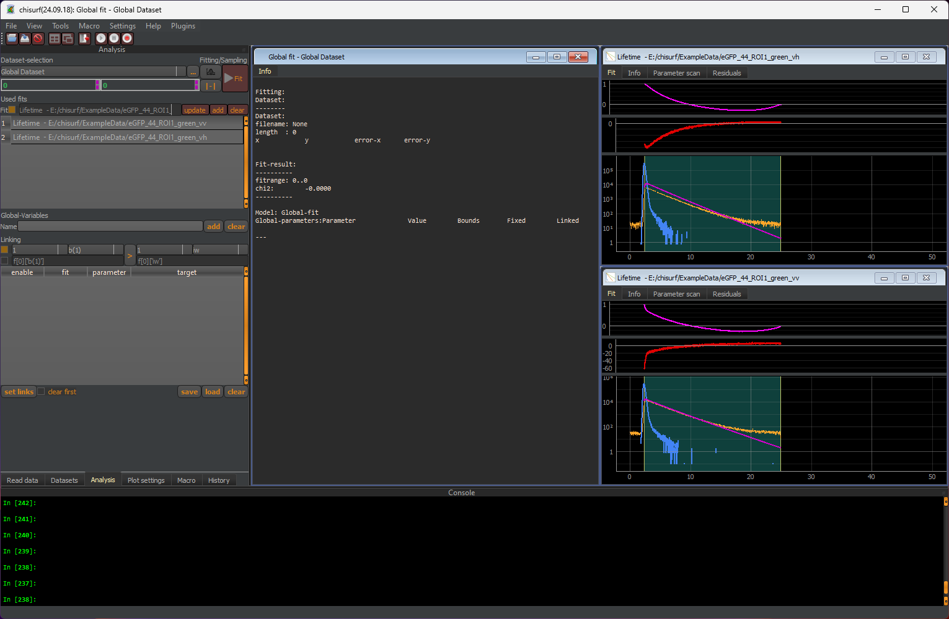
If the estimated parameter given in the fit setup are sufficiently close, one can directly proceed to the global fit window and press “Fit”.
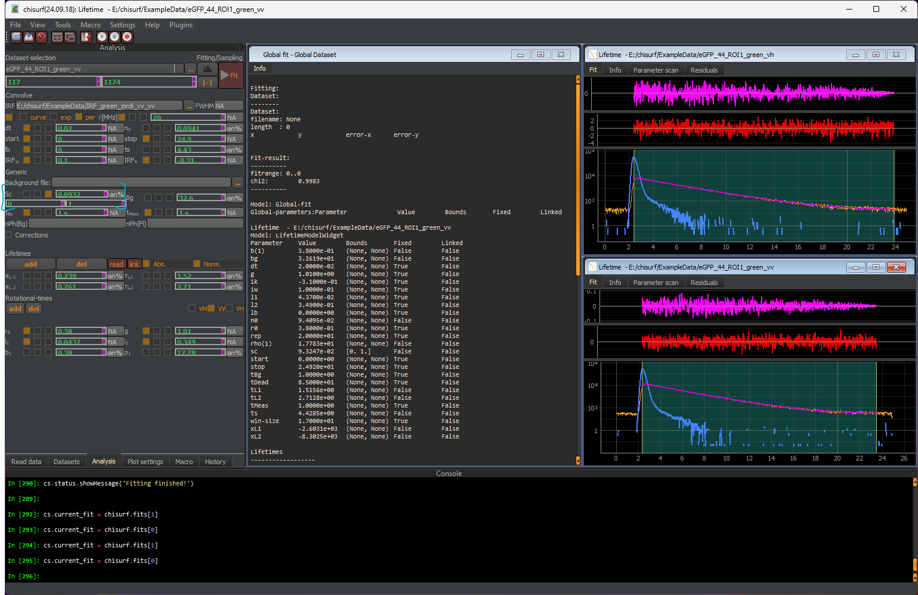
Attention! Verify that no negative scatter fraction is present. Short-lived scatter might often e mixed up with fast rotational components.
Here we obtain an average eGFP lifetime of 2.44 ns and a rotational component of 17.8 ns.

