Open ChiSurf
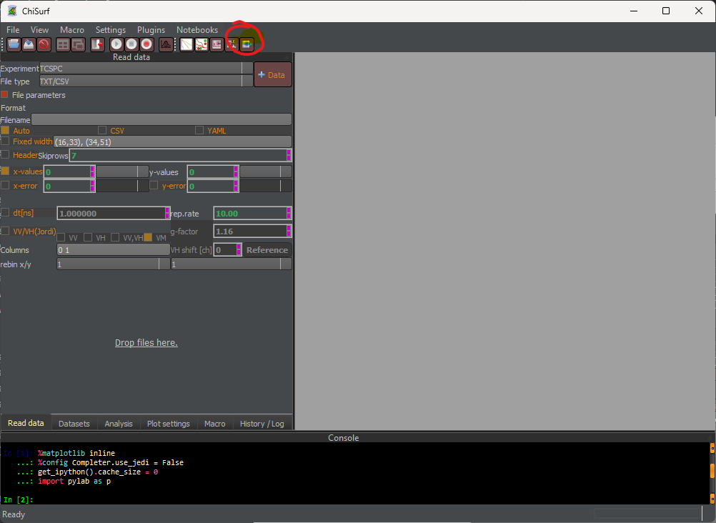
Open NDxplorer
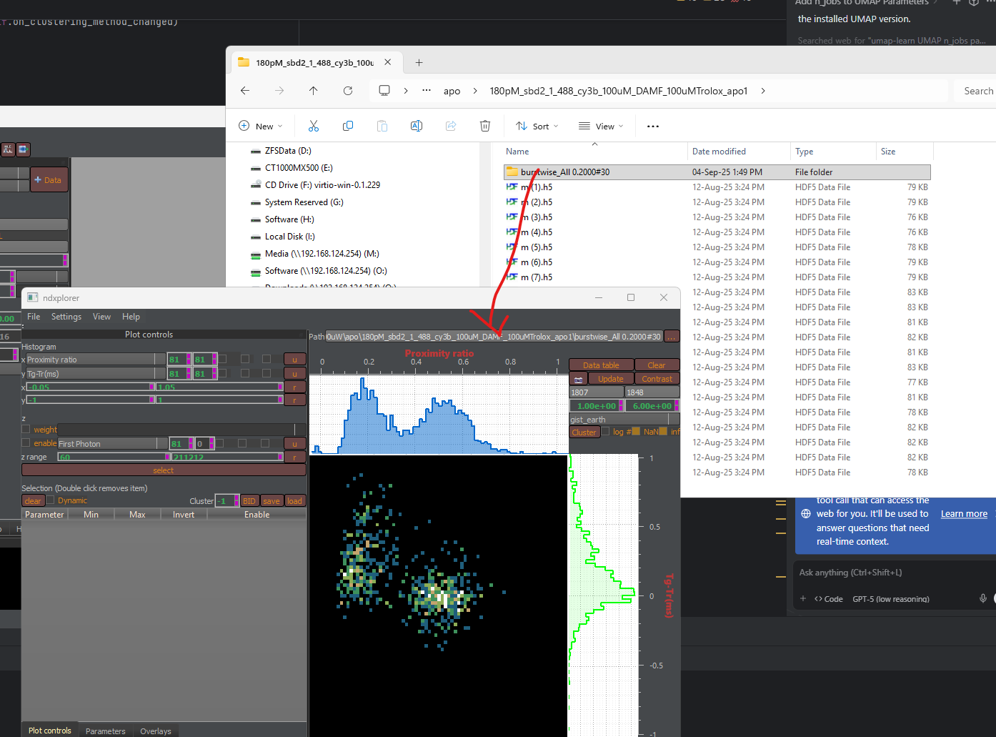
Drop analysis folder into Folder bar.
If you want to play, use a small data set first. Here I used:
S:\Projects\02_running\BrickMic\GM_250723_sbd2_comparison_+-100uM-TX-100uW\apo\180pM_sbd2_1_488_cy3b_100uM_DAMF_100uMTrolox_apo1

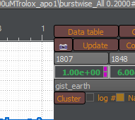
Select Cluster
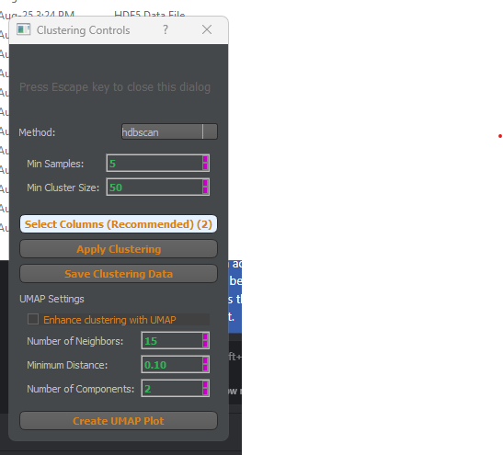
Select clusting method (either k-means or HDBscan). K means partitions based on hyper planes and can give funny lines.
Next, select which features (columns in the data table) you want to use for clustering (click on: “Select Columns”)

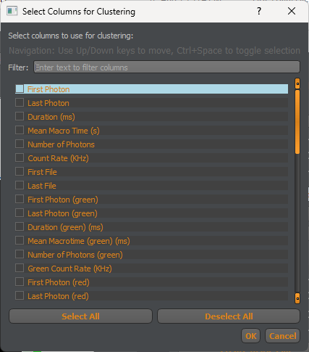
In the new window you can select data columns. Here I used Tg-Tr and Proximity ratio. Click on “OK”

Now, click on “Apply clustering”
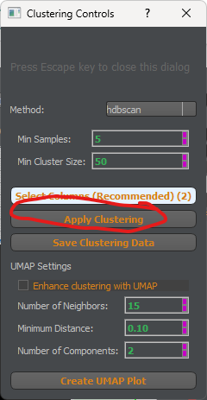
The software will perform the clustering. If the dataset is big, the software may stall and seem to hang. Be patient, it is working…
After the software performed the clustering, you can select which clyster is currently displayed with the “Cluster Spinbox”.
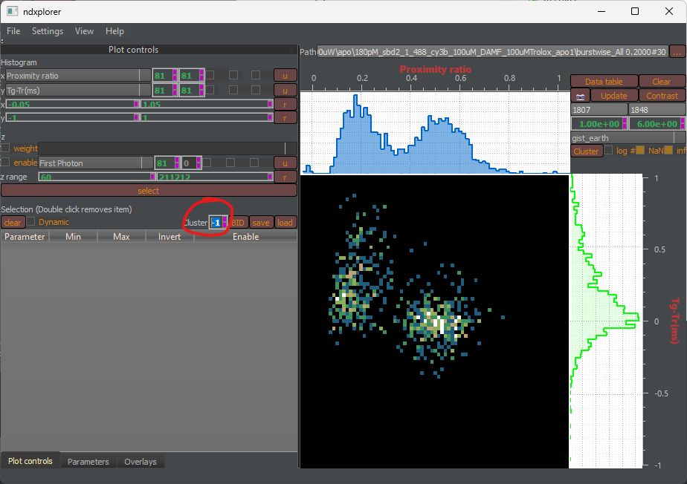
Here “-1” refer to all clusters.
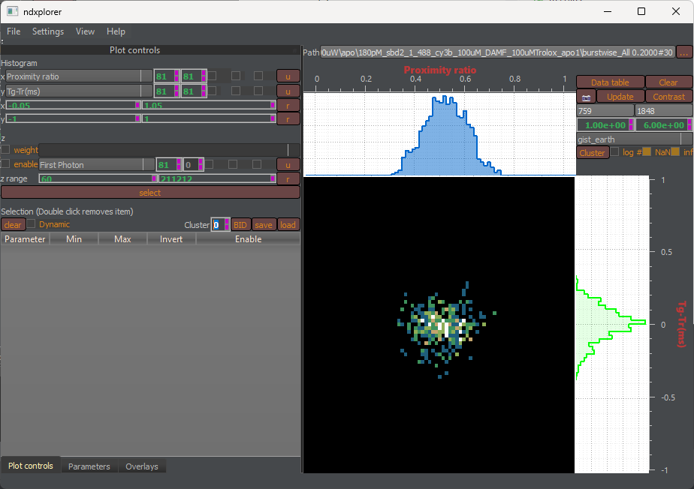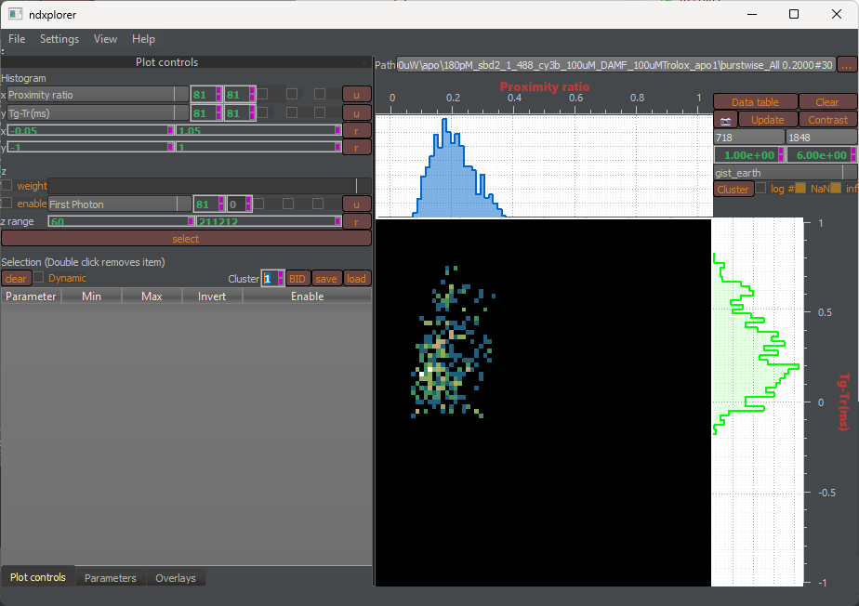
“0” is the first and “1” is the second cluster.
If you want to visualize the clusters on a UMAP, go back the cluster dialog and click on Create UMAP.
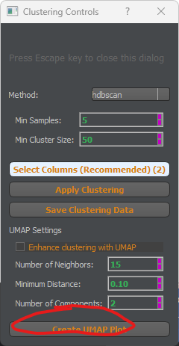
Again, for big datasets this can take a while. Do not interact with the software while it is computing (it may crash…).
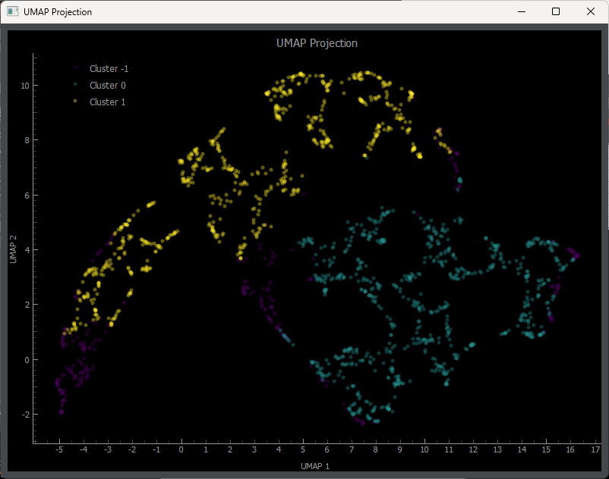
In the UMAP projection you see the clusters labels projected as colors. For this particular example, you see that UMAP identified two clusters but did not assign all bursts to clusters.

