Parse-Model - Z:\development\fluorescence-tools\chisurf\sample_data\fcs\Kristine\Kristine_with_error.cor

# Fit-Results

1. k

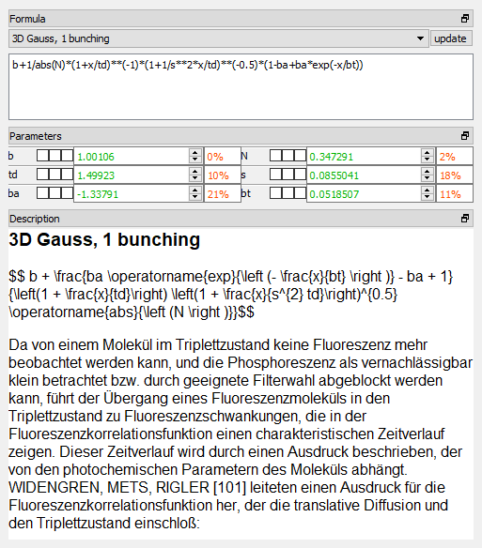

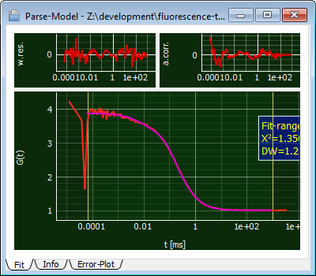

# Summary

Parameters which are fitted are given in **bold**, linked parameters in *italic.* fixed parameters are plain text.

|  |  |
| --- | --- |
| Fit-Nbr | 1 |
| N | **0.347** |
| b | **1.001** |
| ba | **-1.338** |
| bt | **0.052** |
| s | **0.086** |
| td | **1.499** |
| Chi2r | 1.3504 |