Lifetime fit - Z:\development\fluorescence-tools\chisurf\sample_data\tcspc\ibh_sample\Decay_577D.txt

# Fit-Results

1. d

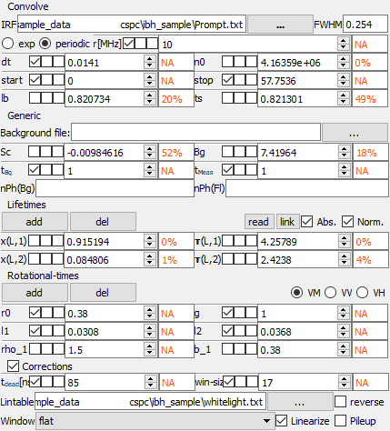

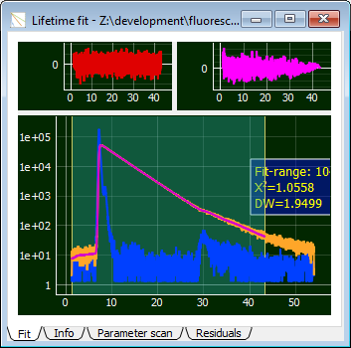

# Summary

Parameters which are fitted are given in **bold**, linked parameters in *italic.* fixed parameters are plain text.

|  |  |
| --- | --- |
| Fit-Nbr | 1 |
| b_1 | **0.380** |
| bg | **7.420** |
| dt | 0.014 |
| g | 1.000 |
| l1 | 0.031 |
| l2 | 0.037 |
| lb | **0.821** |
| n0 | **4163585.471** |
| r0 | 0.380 |
| rep | 10.000 |
| rho_1 | **1.500** |
| sc | **-0.010** |
| start | 0.000 |
| stop | 57.754 |
| tBg | 1.000 |
| tDead | 85.000 |
| tL1 | **4.258** |
| tL2 | **2.424** |
| tMeas | 1.000 |
| ts | **0.821** |
| win-size | 17.000 |
| xL1 | **0.915** |
| xL2 | **0.085** |
| Chi2r | 1.0558 |