符昕宇 202364810311
Homework: Implement Figure 3.46 by programming with Python
Python Code:
import numpy as np
import imageio.v2 as imageio
import matplotlib
matplotlib.use('Agg')
import matplotlib.pyplot as plt
import os
from scipy.ndimage import convolve

def apply_laplacian_sharpening(image, laplacian_kernel, c=-1):
"""
Applies a Laplacian filter to an image and then sharpens it
"""
laplacian_response = convolve(image_float, laplacian_kernel, mode='nearest', cval=0.0)
laplacian_image_display = np.clip(laplacian_response, 0, 255).astype(np.uint8)
sharpened_image_float = image_float + c * laplacian_response
sharpened_image = np.clip(sharpened_image_float, 0, 255).astype(np.uint8)
return laplacian_image_display, sharpened_image

if __name__ == "__main__":
input_dir = "original_image"
output_dir = "output_image"
os.makedirs(output_dir, exist_ok=True)
image_filename = "Fig0338(a)(blurry_moon).tif"
image_path = os.path.join(input_dir, image_filename)
base_name = os.path.splitext(image_filename)[0]
original_image = imageio.imread(image_path)

laplacian_kernel_a = np.array([
[0, 1, 0],
[1, -4, 1],
[0, 1, 0]
], dtype=float)

laplacian_kernel_b = np.array([
[1, 1, 1],
[1, -8, 1],
[1, 1, 1]
], dtype=float)

laplacian_img_a_display, sharpened_img_a = apply_laplacian_sharpening(original_image, laplacian_kernel_a, c=-1)
laplacian_img_b_display, sharpened_img_b = apply_laplacian_sharpening(original_image, laplacian_kernel_b, c=-1)

# Visualization
plt.figure(figsize=(15, 12)) # Adjust figure size for 2x2 layout
plt.suptitle(f'Laplacian Sharpening for {image_filename}', fontsize=16)

plt.subplot(2, 2, 1)
plt.imshow(original_image, cmap='gray', vmin=0, vmax=255)
plt.title('a) Original Blurry Moon Image')
plt.axis('off')

plt.subplot(2, 2, 2)
plt.imshow(laplacian_img_a_display, cmap='gray', vmin=0, vmax=255)
plt.title('b) Laplacian Image (Kernel a, clipped)')
plt.axis('off')

plt.subplot(2, 2, 3)
plt.imshow(sharpened_img_a, cmap='gray', vmin=0, vmax=255)
plt.title('c) Sharpened Image (Kernel a, $c=-1$)')
plt.axis('off')

plt.subplot(2, 2, 4)
plt.imshow(sharpened_img_b, cmap='gray', vmin=0, vmax=255)
plt.title('d) Sharpened Image (Kernel b, $c=-1$)')
plt.axis('off')

plt.tight_layout(rect=[0, 0.03, 1, 0.95])

combined_output_path = os.path.join(output_dir, f"{base_name}_laplacian_sharpening_results.png")
plt.savefig(combined_output_path, bbox_inches='tight')
plt.close()

Output Images:
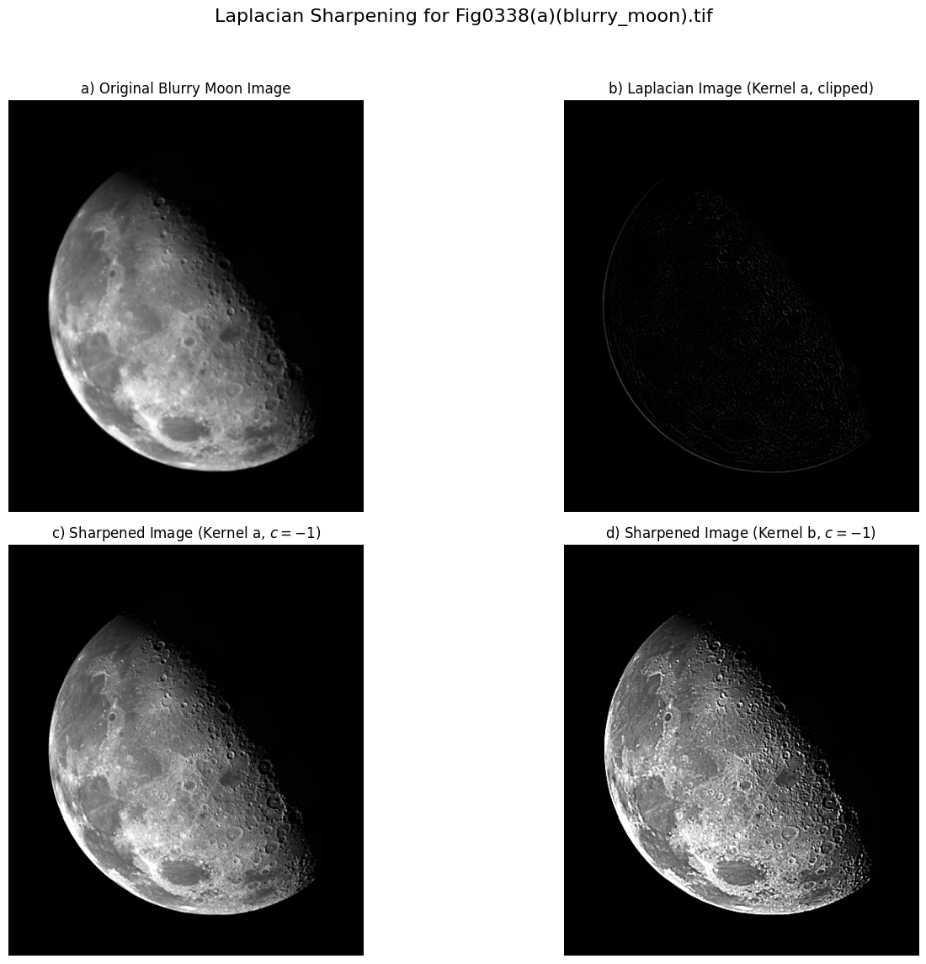

Homework: Implement Figure 3.46 by programming with Python
Python Code:
import numpy as np
import imageio.v2 as imageio
import matplotlib
matplotlib.use('Agg')
import matplotlib.pyplot as plt
import os
from scipy.ndimage import convolve

def apply_sobel_gradient(image):
"""
Applies Sobel operators to compute the gradient magnitude of an image
"""
sobel_x = np.array([
[-1, 0, 1],
[-2, 0, 2],
[-1, 0, 1]
], dtype=float)
sobel_y = np.array([
[-1, -2, -1],
[ 0, 0, 0],
[ 1, 2, 1]
], dtype=float)

image_float = image.astype(float)
Gx = convolve(image_float, sobel_x, mode='nearest')
Gy = convolve(image_float, sobel_y, mode='nearest')

gradient_magnitude = np.sqrt(Gx**2 + Gy**2)
max_val = np.max(gradient_magnitude)
if max_val > 0:
scaled_gradient_magnitude = (gradient_magnitude / max_val * 255)
else: # Handle case where image is uniform (no edges)
scaled_gradient_magnitude = np.zeros_like(gradient_magnitude)

final_gradient_image = np.clip(scaled_gradient_magnitude, 0, 255).astype(np.uint8)

return final_gradient_image

if __name__ == "__main__":
# Define input and output directories
input_dir = "original_image"
output_dir = "output_image"
os.makedirs(output_dir, exist_ok=True)
image_filename = "Fig0342(a)(contact_lens_original).tif"
image_path = os.path.join(input_dir, image_filename)
base_name = os.path.splitext(image_filename)[0]
original_image = imageio.imread(image_path)

gradient_image = apply_sobel_gradient(original_image)

# Visualization
plt.figure(figsize=(12, 6))
plt.suptitle(f'Gradient Edge Enhancement for {image_filename}', fontsize=16)

plt.subplot(1, 2, 1)
plt.imshow(original_image, cmap='gray', vmin=0, vmax=255)
plt.title('a) Original Contact Lens Image')
plt.axis('off')

plt.subplot(1, 2, 2)
plt.imshow(gradient_image, cmap='gray', vmin=0, vmax=255)
plt.title('b) Sobel Gradient Magnitude')
plt.axis('off')

plt.tight_layout(rect=[0, 0.03, 1, 0.95]) # Adjust layout to prevent title overlap
combined_output_path = os.path.join(output_dir, f"{base_name}_gradient_enhancement_results.png")
plt.savefig(combined_output_path, bbox_inches='tight')
plt.close()

Output Images”
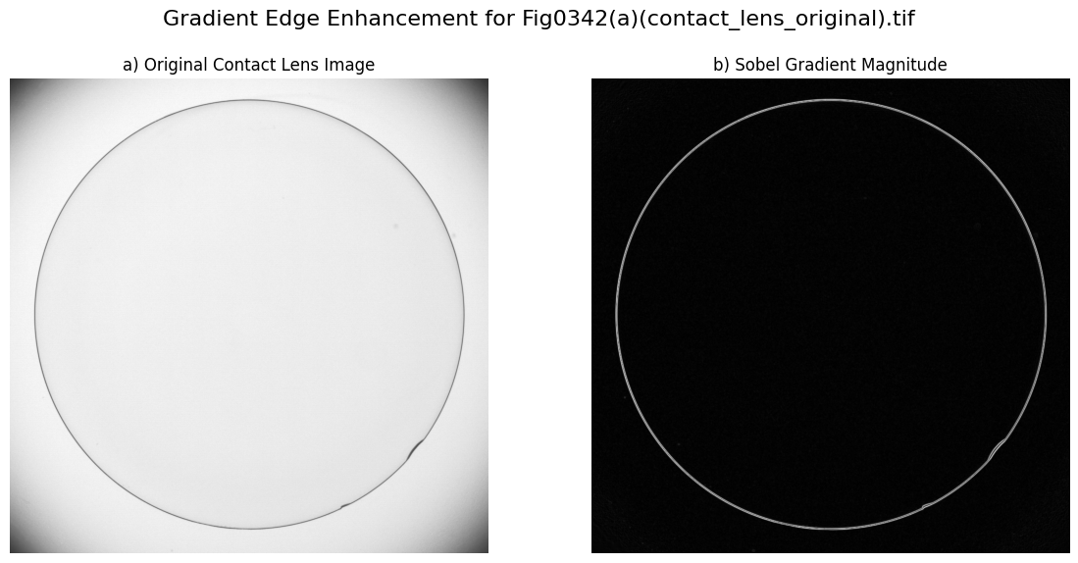

Homework: Implement Figure 3.57 by python programming.
Python Code:
import numpy as np
import imageio.v2 as imageio
import matplotlib
import matplotlib.pyplot as plt
import os
from scipy.ndimage import convolve

def normalize_to_uint8(img_float):
img = img_float.astype(float)
min_val, max_val = img.min(), img.max()
if max_val == min_val:
return np.zeros_like(img, dtype=np.uint8)
img_norm = (img - min_val) / (max_val - min_val)
return np.clip(img_norm * 255.0, 0, 255).astype(np.uint8)

def get_laplacian_response(image, laplacian_kernel):
"""
Applies a Laplacian filter to an image and returns the raw (float) response.
"""
image_float = image.astype(float)
laplacian_response = convolve(image_float, laplacian_kernel, mode='nearest', cval=0.0)
return laplacian_response

def apply_sobel_gradient(image):
"""
Applies Sobel operators to compute the gradient magnitude of an image
"""
sobel_x = np.array([[-1, 0, 1], [-2, 0, 2], [-1, 0, 1]], dtype=float)
sobel_y = np.array([[-1, -2, -1], [0, 0, 0], [1, 2, 1]], dtype=float)

image_float = image.astype(float)
Gx = convolve(image_float, sobel_x, mode='nearest')
Gy = convolve(image_float, sobel_y, mode='nearest')

gradient_magnitude = np.sqrt(Gx ** 2 + Gy ** 2)

max_val = np.max(gradient_magnitude)
if max_val > 0:
scaled_gradient_magnitude = (gradient_magnitude / max_val * 255)
else:
scaled_gradient_magnitude = np.zeros_like(gradient_magnitude)

return np.clip(scaled_gradient_magnitude, 0, 255).astype(np.uint8)

def apply_box_filter(image, kernel_size):
"""
Applies a box (average) filter to the image.
"""
if kernel_size <= 0 or kernel_size % 2 == 0:
raise ValueError("Kernel size must be a positive odd number.")
kernel = np.ones((kernel_size, kernel_size), dtype=float) / (kernel_size * kernel_size)
image_float = image.astype(float)
filtered_image_float = convolve(image_float, kernel, mode='nearest',
cval=0.0)
return np.clip(filtered_image_float, 0, 255).astype(np.uint8)

def power_law_transform(image, gamma):
"""
Applies a power-law (gamma) transformation to an 8-bit grayscale image
"""
normalized_image = image.astype(float) / 255.0
transformed_image = normalized_image ** gamma
return np.clip(transformed_image * 255, 0, 255).astype(np.uint8)

if __name__ == "__main__":
input_dir = "original_image"
output_dir = "output_image"
os.makedirs(output_dir, exist_ok=True)exist

image_filename = "Fig0343(a)(skeleton_orig).tif"
image_path = os.path.join(input_dir, image_filename)
base_name = os.path.splitext(image_filename)[0]

original_image = imageio.imread(image_path)
laplacian_kernel = np.array([
[-1, -1, -1],
[-1, 8, -1],
[-1, -1, -1]
], dtype=float)
laplacian_c = -1 # Sharpening factor for Laplacian (g = f + c*Laplacian)

avg_kernel_size = 5

gamma_value = 0.5

laplacian_response = get_laplacian_response(original_image, laplacian_kernel)
laplacian_image_display = normalize_to_uint8(laplacian_response)

sharpened_laplacian_image_float = original_image.astype(float) + laplacian_c * laplacian_response
sharpened_laplacian_image = np.clip(sharpened_laplacian_image_float, 0, 255).astype(np.uint8)

sobel_gradient_image = apply_sobel_gradient(original_image)

smoothed_sobel_gradient = apply_box_filter(sobel_gradient_image, avg_kernel_size)

sharpened_laplacian_float = sharpened_laplacian_image.astype(float)
smoothed_sobel_float = smoothed_sobel_gradient.astype(float)
smoothed_sobel_normalized = smoothed_sobel_float / 255.0

product_image_float = sharpened_laplacian_float * smoothed_sobel_normalized
product_image = np.clip(product_image_float, 0, 255).astype(np.uint8)

power_law_image = power_law_transform(product_image, gamma_value)

final_sharpened_image_float = original_image.astype(float) + power_law_image.astype(float)
final_sharpened_image = np.clip(final_sharpened_image_float, 0, 255).astype(np.uint8)

# Visualization
plt.figure(figsize=(16, 8))
plt.suptitle(f'Combined Spatial Enhancement for {image_filename}', fontsize=16)

plt.subplot(2, 4, 1)
plt.imshow(original_image, cmap='gray', vmin=0, vmax=255)
plt.title('a) Original Image')
plt.axis('off')

plt.subplot(2, 4, 2)
plt.imshow(laplacian_image_display, cmap='gray', vmin=0, vmax=255)
plt.title('b) Laplacian Image (Display)')
plt.axis('off')

plt.subplot(2, 4, 3)
plt.imshow(sharpened_laplacian_image, cmap='gray', vmin=0, vmax=255)
plt.title('c) Sharpened (Laplacian)')
plt.axis('off')

plt.subplot(2, 4, 4)
plt.imshow(sobel_gradient_image, cmap='gray', vmin=0, vmax=255)
plt.title('d) Sobel Gradient Magnitude')
plt.axis('off')

plt.subplot(2, 4, 5)
plt.imshow(smoothed_sobel_gradient, cmap='gray', vmin=0, vmax=255)
plt.title(f'e) Smoothed Sobel Gradient ({avg_kernel_size}x{avg_kernel_size})')
plt.axis('off')

plt.subplot(2, 4, 6)
plt.imshow(product_image, cmap='gray', vmin=0, vmax=255)
plt.title('f) Product Image')
plt.axis('off')

plt.subplot(2, 4, 7)
plt.imshow(power_law_image, cmap='gray', vmin=0, vmax=255)
plt.title(f'g) Power-Law Transformed ($\\gamma={gamma_value}$)')
plt.axis('off')

plt.subplot(2, 4, 8)
plt.imshow(final_sharpened_image, cmap='gray', vmin=0, vmax=255)
plt.title('h) Final Sharpened Image')
plt.axis('off')

plt.tight_layout(rect=[0, 0.03, 1, 0.95])
combined_output_path = os.path.join(output_dir, f"{base_name}_combined_enhancement_results.png")
plt.savefig(combined_output_path, bbox_inches='tight')
plt.close()

Output Images:
