符昕宇 202364810311
To access my code more easily, you can find them at my github repository:
https://github.com/Fluorine-Brian/Code-for-Digital-Image-Processing
Homework1: Implement Figure 4.53 by programming with Python
Python Code:
import numpy as np
import imageio.v2 as imageio
import matplotlib.pyplot as plt
import os

def pad_image_for_dft(image, padding_mode='reflect'):
"""Pads the image to a size suitable for DFT"""
M, N = image.shape
P, Q = 2 * M, 2 * N
pad_h = P - M
pad_w = Q - N
padded_image = np.pad(image, ((0, pad_h), (0, pad_w)), mode=padding_mode)
return padded_image, (M, N)

def create_ideal_highpass_filter(shape, D0):
"""Creates an Ideal Highpass Filte in the frequency domain"""
P, Q = shape
H = np.ones((P, Q), dtype=float)
center_u, center_v = P / 2, Q / 2
u_coords = np.arange(P) - center_u
v_coords = np.arange(Q) - center_v
U, V = np.meshgrid(u_coords, v_coords, indexing='ij')
D_uv = np.sqrt(U ** 2 + V ** 2)
H[D_uv <= D0] = 0
return H

def create_gaussian_highpass_filter(shape, D0):
"""Creates a Gaussian Highpass Filter in the frequency domain"""
P, Q = shape
H = np.zeros((P, Q), dtype=float)
center_u, center_v = P / 2, Q / 2
u_coords = np.arange(P) - center_u
v_coords = np.arange(Q) - center_v
U, V = np.meshgrid(u_coords, v_coords, indexing='ij')
D_uv_squared = U ** 2 + V ** 2
if D0 == 0:
return np.ones(shape, dtype=float)
else:
H_lp = np.exp(-D_uv_squared / (2 * D0 ** 2))
return 1 - H_lp

def create_butterworth_highpass_filter(shape, D0, n):
"""Creates a Butterworth Highpass Filter in the frequency domain"""
P, Q = shape
H = np.zeros((P, Q), dtype=float)
center_u, center_v = P / 2, Q / 2
u_coords = np.arange(P) - center_u
v_coords = np.arange(Q) - center_v
U, V = np.meshgrid(u_coords, v_coords, indexing='ij')
D_uv = np.sqrt(U ** 2 + V ** 2)
if D0 == 0:
return np.ones(shape, dtype=float)
else:
with np.errstate(divide='ignore', invalid='ignore'):
H_lp = 1 / (1 + (D_uv / D0) ** (2 * n))
H_lp[np.isinf(H_lp)] = 0
H_lp[int(center_u), int(center_v)] = 1.0
return 1 - H_lp

if __name__ == "__main__":
input_dir = "original_image"
output_dir = "output_image"
os.makedirs(output_dir, exist_ok=True)
image_filename = "characterTestPattern688.tif"
image_path = os.path.join(input_dir, image_filename)
base_name = os.path.splitext(image_filename)[0]
original_image = imageio.imread(image_path)
original_M, original_N = original_image.shape
padded_image, _ = pad_image_for_dft(original_image, padding_mode='reflect')
P, Q = padded_image.shape
dft_original = np.fft.fft2(padded_image.astype(float))
centered_dft = np.fft.fftshift(dft_original)
D0_values = [60, 160]
n_order = 2
filtered_images = []
titles = []

for D0 in D0_values:
H_ihpf = create_ideal_highpass_filter((P, Q), D0)
filtered_dft_ihpf = centered_dft * H_ihpf
idft_shifted_ihpf = np.fft.ifftshift(filtered_dft_ihpf)
filtered_image_complex_ihpf = np.fft.ifft2(idft_shifted_ihpf)
filtered_image_ihpf = np.real(filtered_image_complex_ihpf)[0:original_M, 0:original_N]
filtered_images.append(np.clip(filtered_image_ihpf, 0, 255).astype(np.uint8))
titles.append(f'IHPF (D0={D0})')

H_ghpf = create_gaussian_highpass_filter((P, Q), D0)
filtered_dft_ghpf = centered_dft * H_ghpf
idft_shifted_ghpf = np.fft.ifftshift(filtered_dft_ghpf)
filtered_image_complex_ghpf = np.fft.ifft2(idft_shifted_ghpf)
filtered_image_ghpf = np.real(filtered_image_complex_ghpf)[0:original_M, 0:original_N]
filtered_images.append(np.clip(filtered_image_ghpf, 0, 255).astype(np.uint8))
titles.append(f'GHPF (D0={D0})')

H_bhpf = create_butterworth_highpass_filter((P, Q), D0, n_order)
filtered_dft_bhpf = centered_dft * H_bhpf
idft_shifted_bhpf = np.fft.ifftshift(filtered_dft_bhpf)
filtered_image_complex_bhpf = np.fft.ifft2(idft_shifted_bhpf)
filtered_image_bhpf = np.real(filtered_image_complex_bhpf)[0:original_M, 0:original_N]
filtered_images.append(np.clip(filtered_image_bhpf, 0, 255).astype(np.uint8))
titles.append(f'BHPF (D0={D0}, n={n_order})')

plt.figure(figsize=(18, 12))
plt.suptitle(f'Highpass Filtering Comparison (Fig 4.53) - {image_filename}', fontsize=16)

for i in range(6):
plt.subplot(2, 3, i + 1)
plt.imshow(filtered_images[i], cmap='gray', vmin=0, vmax=255)
plt.title(titles[i])
plt.axis('off')
plt.tight_layout(rect=[0, 0.03, 1, 0.95])
combined_output_path = os.path.join(output_dir, f"{base_name}_highpass_filter_results.png")
plt.savefig(combined_output_path, bbox_inches='tight')
plt.close()
Processed Images:
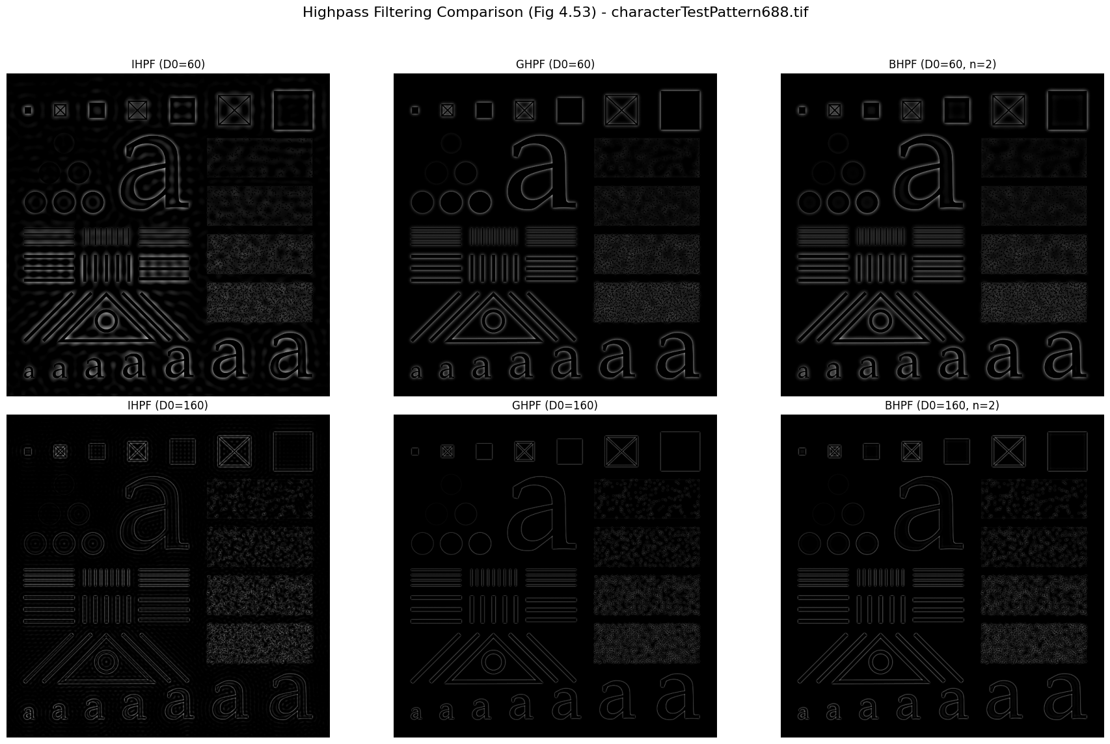
Homework2: Implement Figure 4.55 by programming with Python
Python Code:
import numpy as np
import imageio.v2 as imageio
import matplotlib.pyplot as plt
import os

def pad_image_for_dft(image, padding_mode='reflect'):
"""Pads the image to a size suitable for DFT"""
M, N = image.shape
P, Q = 2 * M, 2 * N
pad_h = P - M
pad_w = Q - N
padded_image = np.pad(image, ((0, pad_h), (0, pad_w)), mode=padding_mode)
return padded_image, (M, N)

def create_butterworth_highpass_filter(shape, D0, n):
"""Creates a Butterworth Highpass Filter in the frequency domain"""
P, Q = shape
H = np.zeros((P, Q), dtype=float)
center_u, center_v = P / 2, Q / 2
u_coords = np.arange(P) - center_u
v_coords = np.arange(Q) - center_v
U, V = np.meshgrid(u_coords, v_coords, indexing='ij')
D_uv = np.sqrt(U ** 2 + V ** 2)
if D0 == 0:
return np.ones(shape, dtype=float)
else:
with np.errstate(divide='ignore', invalid='ignore'):
H_lp = 1 / (1 + (D_uv / D0) ** (2 * n))
H_lp[np.isinf(H_lp)] = 0
H_lp[int(center_u), int(center_v)] = 1.0
return 1 - H_lp

if __name__ == "__main__":
input_dir = "original_image"
output_dir = "output_image"
os.makedirs(output_dir, exist_ok=True)
image_filename = "Fig0457(a)(thumb_print).tif"
image_path = os.path.join(input_dir, image_filename)
base_name = os.path.splitext(image_filename)[0]
original_image = imageio.imread(image_path)
original_M, original_N = original_image.shape
padded_image, _ = pad_image_for_dft(original_image, padding_mode='reflect')
P, Q = padded_image.shape
dft_original = np.fft.fft2(padded_image.astype(float))
centered_dft = np.fft.fftshift(dft_original)

D0_value = 50
n_order = 4
H_bhpf = create_butterworth_highpass_filter((P, Q), D0_value, n_order)
filtered_dft = centered_dft * H_bhpf
idft_shifted = np.fft.ifftshift(filtered_dft)
filtered_image_complex = np.fft.ifft2(idft_shifted)
highpass_filtered_float = np.real(filtered_image_complex)[0:original_M, 0:original_N]
highpass_filtered_display = np.clip(highpass_filtered_float, 0, 255).astype(np.uint8)
thresholded_image = np.zeros_like(highpass_filtered_float, dtype=np.uint8)
thresholded_image[highpass_filtered_float > 0] = 255

plt.figure(figsize=(18, 6))
plt.suptitle(f'Thumb Print Enhancement (Fig 4.55) - {image_filename}', fontsize=16)

plt.subplot(1, 3, 1)
plt.imshow(original_image, cmap='gray', vmin=0, vmax=255)
plt.title('a) Original Thumb Print')
plt.axis('off')

plt.subplot(1, 3, 2)
plt.imshow(highpass_filtered_display, cmap='gray', vmin=0, vmax=255)
plt.title(f'b) Highpass Filtered (D0={D0_value}, n={n_order})')
plt.axis('off')

plt.subplot(1, 3, 3)
plt.imshow(thresholded_image, cmap='gray', vmin=0, vmax=255)
plt.title(f'c) Thresholded Result')
plt.axis('off')

plt.tight_layout(rect=[0, 0.03, 1, 0.95])
combined_output_path = os.path.join(output_dir, f"{base_name}_enhancement_results.png")
plt.savefig(combined_output_path, bbox_inches='tight')
plt.close()
Processed Images:
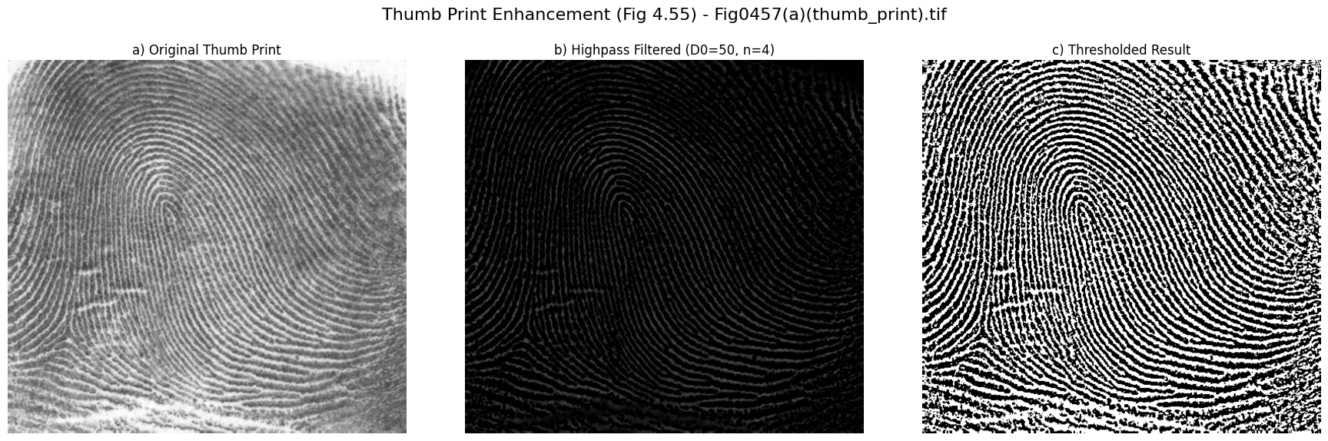

Homework3: Implement Figure 4.56 by programming with Python
Python Code:
import numpy as np
import imageio.v2 as imageio
import matplotlib.pyplot as plt
import os

def pad_image_for_dft(image, padding_mode='reflect'):
"""Pads the image to a size suitable for DFT"""
M, N = image.shape
P, Q = 2 * M, 2 * N
pad_h = P - M
pad_w = Q - N
padded_image = np.pad(image, ((0, pad_h), (0, pad_w)), mode=padding_mode)
return padded_image, (M, N)

def create_frequency_domain_laplacian(shape):
"""
Creates a Laplacian filter in the frequency domain
"""
P, Q = shape
H = np.zeros((P, Q), dtype=float)
center_u, center_v = P / 2, Q / 2
u_coords = np.arange(P) - center_u
v_coords = np.arange(Q) - center_v
U, V = np.meshgrid(u_coords, v_coords, indexing='ij')
D_uv_squared = U ** 2 + V ** 2
H = -4 * (np.pi ** 2) * D_uv_squared
return H

if __name__ == "__main__":
input_dir = "original_image"
output_dir = "output_image"
os.makedirs(output_dir, exist_ok=True)
image_filename = "Fig0458(a)(blurry_moon).tif"
image_path = os.path.join(input_dir, image_filename)
base_name = os.path.splitext(image_filename)[0]
original_image = imageio.imread(image_path)
original_M, original_N = original_image.shape

f_normalized = original_image.astype(float) / 255.0
padded_image, _ = pad_image_for_dft(f_normalized, padding_mode='reflect')
P, Q = padded_image.shape
dft_original = np.fft.fft2(padded_image)
centered_dft = np.fft.fftshift(dft_original)
H_laplacian = create_frequency_domain_laplacian((P, Q))
filtered_dft = centered_dft * H_laplacian
idft_shifted = np.fft.ifftshift(filtered_dft)
laplacian_response_complex = np.fft.ifft2(idft_shifted)
laplacian_response_unscaled = np.real(laplacian_response_complex)[0:original_M, 0:original_N]
max_abs_laplacian = np.max(np.abs(laplacian_response_unscaled))
if max_abs_laplacian > 0:
laplacian_normalized = laplacian_response_unscaled / max_abs_laplacian
else:
laplacian_normalized = np.zeros_like(laplacian_response_unscaled)
g_normalized = f_normalized - laplacian_normalized
sharpened_image = np.clip(g_normalized * 255, 0, 255).astype(np.uint8)

plt.figure(figsize=(12, 6))
plt.suptitle(f'Frequency Domain Laplacian Sharpening (Fig 4.56) - {image_filename}', fontsize=16)
plt.subplot(1, 2, 1)
plt.imshow(original_image, cmap='gray', vmin=0, vmax=255)
plt.title('a) Original Blurry Moon Image')
plt.axis('off')
plt.subplot(1, 2, 2)
plt.imshow(sharpened_image, cmap='gray', vmin=0, vmax=255)
plt.title('b) Frequency Domain Laplacian Sharpened')
plt.axis('off')
plt.tight_layout(rect=[0, 0.03, 1, 0.95])
combined_output_path = os.path.join(output_dir, f"{base_name}_freq_laplacian_sharpening_results.png")
plt.savefig(combined_output_path, bbox_inches='tight')
print(f"Combined visualization saved to: {combined_output_path}")
plt.close()
Processed Images:
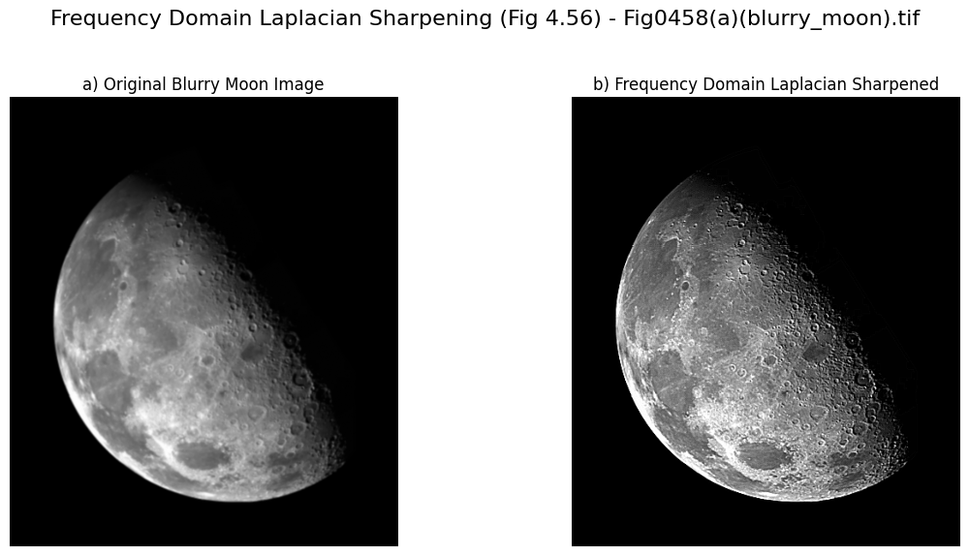

Homework4: Implement Figure 4.57 by programming with Python
Python Code:
import numpy as np
import imageio.v2 as imageio
import matplotlib.pyplot as plt
import os

def pad_image_for_dft(image, padding_mode='reflect'):
"""Pads the image to a size suitable for DFT"""
M, N = image.shape
P, Q = 2 * M, 2 * N
pad_h = P - M
pad_w = Q - N
padded_image = np.pad(image, ((0, pad_h), (0, pad_w)), mode=padding_mode)
return padded_image, (M, N)

def create_gaussian_lowpass_filter(shape, D0):
"""Creates a Gaussian Lowpass Filter in the frequency domain"""
P, Q = shape
H = np.zeros((P, Q), dtype=float)
center_u, center_v = P / 2, Q / 2
u_coords = np.arange(P) - center_u
v_coords = np.arange(Q) - center_v
U, V = np.meshgrid(u_coords, v_coords, indexing='ij')
D_uv_squared = U ** 2 + V ** 2
if D0 == 0:
H = np.ones(shape, dtype=float)
else:
H = np.exp(-D_uv_squared / (2 * D0 ** 2))
return H

def create_gaussian_highpass_filter(shape, D0):
"""Creates a Gaussian Highpass Filter in the frequency domain"""
H_lp = create_gaussian_lowpass_filter(shape, D0)
return 1 - H_lp

def create_high_frequency_emphasis_filter(shape, D0, k1, k2):
"""
Creates a high-frequency emphasis filter based on GHPF
"""
H_ghpf = create_gaussian_highpass_filter(shape, D0)
H_emphasis = k1 + k2 * H_ghpf
return H_emphasis

def histogram_equalization(image):
"""Performs histogram equalization on an 8-bit grayscale image"""
hist, _ = np.histogram(image.flatten(), bins=256, range=[0, 256])
cdf = hist.cumsum()
cdf_min = cdf.min()
cdf_max = cdf.max()
if cdf_max == cdf_min:
equalized_image = np.full_like(image, 127, dtype=np.uint8)
else:
transform_func = (cdf - cdf_min) * 255 / (cdf_max - cdf_min)
transform_func = transform_func.astype('uint8')
equalized_image = transform_func[image]
return equalized_image

if __name__ == "__main__":
input_dir = "original_image"
output_dir = "output_image"
os.makedirs(output_dir, exist_ok=True)
image_filename = "Fig0459(a)(orig_chest_xray).tif"
image_path = os.path.join(input_dir, image_filename)
base_name = os.path.splitext(image_filename)[0]
original_image = imageio.imread(image_path)
original_M, original_N = original_image.shape
padded_image, _ = pad_image_for_dft(original_image, padding_mode='reflect')
P, Q = padded_image.shape
dft_original = np.fft.fft2(padded_image.astype(float))
centered_dft = np.fft.fftshift(dft_original)

D0_ghpf = 70
D0_hfe = 70
k1_hfe = 0.5
k2_hfe = 0.75
H_ghpf = create_gaussian_highpass_filter((P, Q), D0_ghpf)
filtered_dft_ghpf = centered_dft * H_ghpf
idft_shifted_ghpf = np.fft.ifftshift(filtered_dft_ghpf)
ghpf_image_complex = np.fft.ifft2(idft_shifted_ghpf)
ghpf_image = np.real(ghpf_image_complex)[0:original_M, 0:original_N]

min_val = np.min(ghpf_image)
max_val = np.max(ghpf_image)
if max_val > min_val:
ghpf_image_display = ((ghpf_image - min_val) / (max_val - min_val) * 255).astype(np.uint8)
else:
ghpf_image_display = np.zeros_like(ghpf_image, dtype=np.uint8)

H_hfe = create_high_frequency_emphasis_filter((P, Q), D0_hfe, k1_hfe, k2_hfe)
filtered_dft_hfe = centered_dft * H_hfe
idft_shifted_hfe = np.fft.ifftshift(filtered_dft_hfe)
hfe_image_complex = np.fft.ifft2(idft_shifted_hfe)
hfe_image = np.real(hfe_image_complex)[0:original_M, 0:original_N]
hfe_image = np.clip(hfe_image, 0, 255).astype(np.uint8)
hfe_equalized_image = histogram_equalization(hfe_image)

plt.figure(figsize=(12, 12))
plt.suptitle(f'High-Frequency Emphasis Filtering (Fig 4.57) - {image_filename}', fontsize=16)

plt.subplot(2, 2, 1)
plt.imshow(original_image, cmap='gray', vmin=0, vmax=255)
plt.title('a) Original Chest X-Ray')
plt.axis('off')

plt.subplot(2, 2, 2)
plt.imshow(ghpf_image_display, cmap='gray', vmin=0, vmax=255)
plt.title(f'b) GHPF Filtered (D0={D0_ghpf})')
plt.axis('off')

plt.subplot(2, 2, 3)
plt.imshow(hfe_image, cmap='gray', vmin=0, vmax=255)
plt.title(f'c) High-Frequency Emphasis (D0={D0_hfe}, k1={k1_hfe}, k2={k2_hfe})')
plt.axis('off')

plt.subplot(2, 2, 4)
plt.imshow(hfe_equalized_image, cmap='gray', vmin=0, vmax=255)
plt.title('d) HFE Result Equalized')
plt.axis('off')

plt.tight_layout(rect=[0, 0.03, 1, 0.95])
combined_output_path = os.path.join(output_dir, f"{base_name}_hfe_enhancement_results.png")
plt.savefig(combined_output_path, bbox_inches='tight')
plt.close()
Processed Images:
