**Part 1: Design, code and validate own web project.**

**Additionally, report findings.** *K1.3, K3.6, K3.7, U3.3, U3.4, A2.1, A4.3*

**PART 1 MUST BE SUBMITTED BY NOT LATER THAN TUESDAY 05 APRIL 2022**

**[A4.3] – Coding own HTML Form** for the **Subscribe page**.

My **targeted resolution** is:

**1536x864**

[**Check my current desktop resolution (CLICK HERE)**](http://whatismyscreenresolution.net/)

**[A2.1] – Prototyping own webpages** for a chosen scenario.

**Home Page**

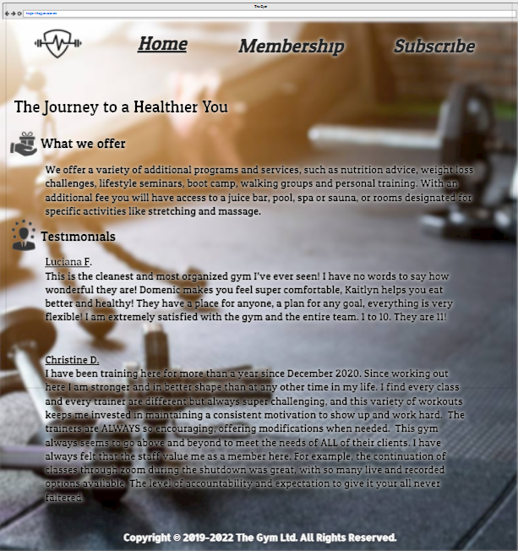

**Page 2 (Membership / Packages / Adopt / Properties / Topics / Heritage Sites)**

**[U3.4] – Mobile Responsiveness** sustains and prolongs the usability of a website.

**Home Page or Page 2**

**[K1.3] –** Explore the **Web Developer Tools**.

**Subscribe Page - Elements Panel**

**Subscribe Page - Styles Panel**

**[K3.6] –** Extract some **Code Snippets of your HTML code** produced for the form.

**Subscribe Page - HTML nodes**

**Code snippet** of the **HTML node 1** containing a **valid** **HTML mark-up** declaration:

**<h1>Gym</h1>**

**Reason** for using such **HTML node 1** in your scenario:

**To show importance to the title**

**Code snippet** of the **HTML node 2** containing a **valid** **HTML mark-up** declaration:

**<label for="name">Name</label>**

**Reason** for using such **HTML node 2** in your scenario:

**To explain what needs to be typed**

**[K3.7] –** Extract some **Code Snippets of your CSS code** produced for the form.

**Subscribe Page - CSS rules**

**Code snippet** of the **CSS rule 1** containing a **valid** **selector & declaration block**:

**.body {**

**width: 300px;**

**height: 625px;**

**background-color: crimson;**

**margin-left: auto;**

**margin-right: auto;**

**text-align: center;**

**font-family: serif;**

**font-size: 29px;**

**}**

**Reason** for using such **CSS rule 1** in your scenario:

**To make the body stand out more and not be plain.**

**Code snippet** of the **CSS rule 2** containing a **valid** **selector & declaration block**:

**.submit {**

**height: 75px;**

**width: 200px;**

**font-family: serif;**

**font-size: 23px;**

**}**

**Reason** for using such **CSS rule 2** in your scenario:

**To make the button more proportionate with the rest of the page**

**[U3.3] – Validate all of your HTML and CSS code** produced for the form.

**HTML Validator Tool (Online)**

**CSS Validator Tool (Online)**

