InDesign to ePub 3 Fixed Layout Conversion Script

Command Line Script:

User need to pass below two arguments to the Command Line Script

- Input InDesign Document Path.
  - Should have Sub Folders for Title & Cover file.
  - Cover File folder should have “_C.indd” or “_J.indd” files.
- Output Path where Final ePub file needs to be located (File Path).

Fourth Argument for this script will be passing by Cloud PHP Script.

- This information for Script Path (This will taken care by Cloud PHP Script)

Script Flow Algorithm:

Follow the same folder structure, because script will check “InDesign_Script” & “Post_Process_Script” folder in the root path of VBS Folder (3rd Argument)

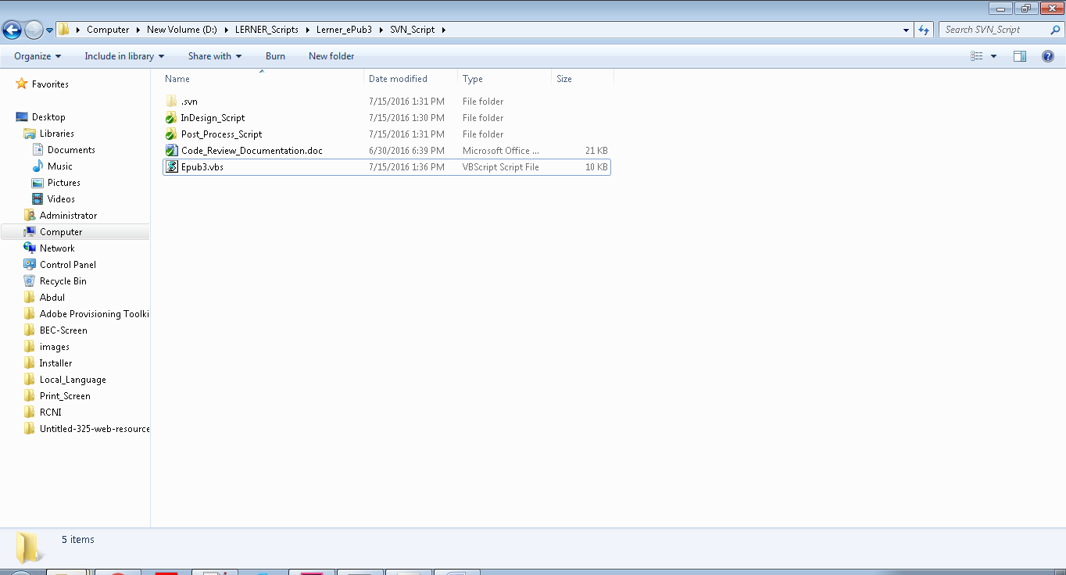

Script will create a text file on the root of the “InDesign_Script” folder, text file name “testfile.txt” and write the Interior InDesign File Path from the Input Folder by searching “_T.indd” file.

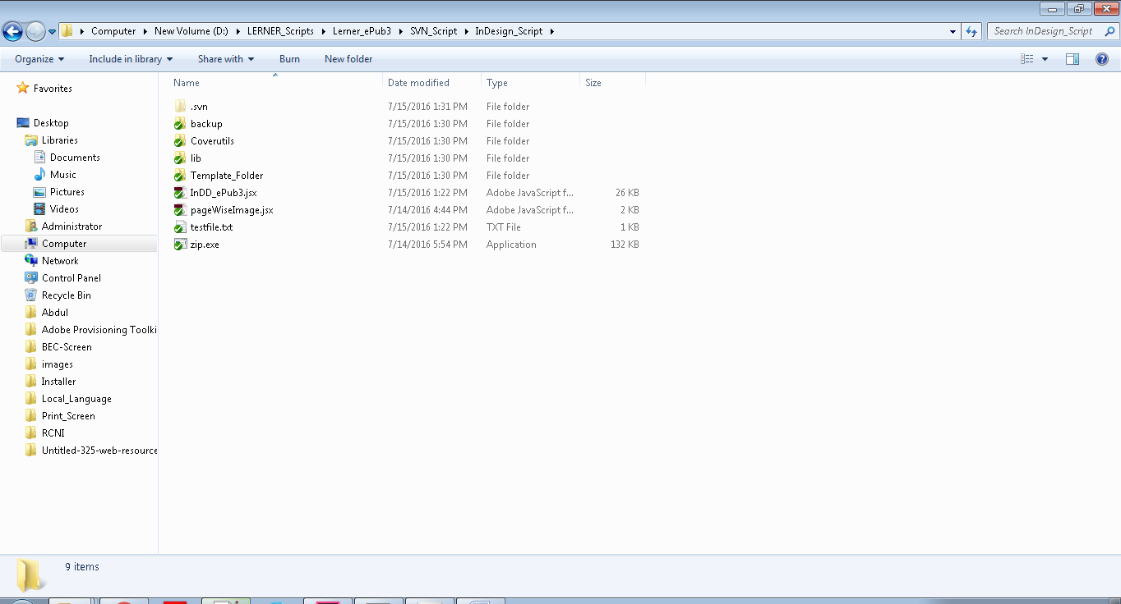

Script will create a text file on the root of the “InDesign_Script\Coverutils” folder, text file name “InputTextFile.txt” and write the Cover InDesign File Path from the Input Folder by searching “_C.indd” or “_J.indd” file and Interior Indesign File Path from the Input Folder by searching “_T.indd” file.

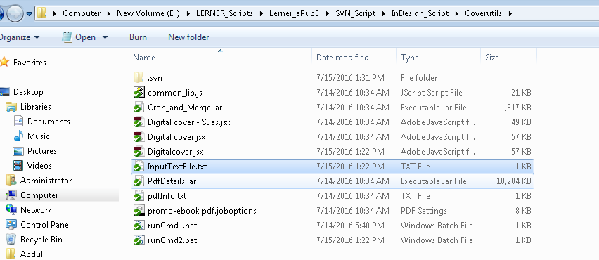

Script will first execute the “Digitalcover.jsx” internal Script to convert “_C.indd” or “_J.indd” file into the cover image. To check brief information about “Digitalcover.jsx” script, please click here.

Script will execute “InDD_ePub3.jsx” internal script after completed the above script. This script will extract content from interior InDesign file into Default html file with reflowable format. To check brief information about “InDD_ePub3.jsx” script, please click here.

Script will execute “Post Process” node js Script to clean up Reflowable HTML Files into the fixed layout ePub 3 formatted files. To check brief information about “Post Process” script, please click here.

Script will place the converted cover image from “Digitalcover.jsx” script and place it into the image folder of output folder which is generated from “Post process” script. Click here to check the logic for “Cover image Copy” method.

Script will create the content.opf file and place it in the OEBPS folder of output folder. Please check the detailed logic used to create Content OPF by click here.

Script will zip the final folder and rename it extension as ePub.

Digitalcover.jsx:

InDD_ePub3.jsx:

Post Process:

Copy Function in VB Script:

Content OPF Creation:

Zip Function in VB Script:

Digital cover.jsx

