

Computer science Project
Session: 2024-2025

A Project Report On “Snake Game”

Submitted by-
Jatan Sanjay Thanki
& Krishna Pancholi
Class – XII (Science A)
Under the Guidance of-
Mrs. Bhavnita Postaria
PGT (Computer Science)

Contents
S.No. | Description | Pg.No.
1. | Certificate | 3
2. | Acknowledgement | 4
3. | Introduction | 5
4. | Python Overview | 6
5. | Features of Python | 7
6. | Advantages of Python / How to Install Python | 8
7. | About MySQL / Installing MySQL | 9
8. | Rules of the Snake Game | 10
9. | Objective of the Project | 11
10. | Proposed System | 12
11. | Source Code | 13
12. | Introduction of Code | 14
13. | Main Code | 15
14. | Results | 14
15. | Output Screens | 14-16
16. | Limitations and Future Scope | 26
17. | Bibliography | 27
18. | Computer Software & Hardware Requirements | 28
19. | Thank You!! | 29

Certificate
This is to certify that Jatan Sanjay Thanki and Krishna Pancholi, students of class XII (Science) have successfully prepared the report on the Project entitled “Snake Game” under the guidance of Mrs. Bhavnita Postaria (PGT Computer Science). The report is the result of their efforts & endeavours. The report is found worthy of acceptance as final Project report for the subject Computer Science of class XII (Science).

Signature of Internal Examiner Signature of External Examiner
_________________________ _________________________

Signature of Principal
_________________________

Acknowledgement

We would like to express a deep sense of thanks and gratitude to our project guide Mrs. Bhavnita Postaria for guiding us immensely through the course of the project. She always evinced keen interest in our project. Her constructive advice & constant motivation have been responsible for the successful completion of this project.

Our sincere gratitude goes to Mrs.Lincy Pancholi (Principal) madam for her coordination in extending every possible support for the completion of this project.

We must thank our classmates for their timely help and support for completion of this project.

Last but not the least, We would like to thank all those who had helped directly or indirectly towards the completion of this project.

Jatan Sanjay Thanki
Krishna Pancholi
Class- XII (Science)

Introduction

The Snake Game is one of the most classic and popular arcade games ever created. In this project, I have recreated the Snake Game using Python, along with SQL database connectivity to store and manage player information such as high scores. The main objective of the game is simple: control the snake, eat food, and grow longer without hitting the walls or your own tail. Despite its simplicity, the game develops logical thinking, improves concentration, and is a great way to apply programming concepts.
This project demonstrates how traditional game logic can be combined with database management to create a more interactive and functional application. By integrating SQL, the game becomes capable of storing scores permanently, allowing multiple players to track their performance over time.

Python Overview
Python is a general-purpose high-level programming language. It is an open source language, released under a GPL-Compatible license. Python Software Foundation (PSF), a non-profit organization, holds the copy-right of python. Guido Van Rossum conceived python in the late 1980s. It was released in 1991 at Centrum Wiskunde & Informatica (CWI) in the Netherlands as a successor to the ABC language. He named this language after a popular comedy show called “Monty Python’s Flying Circus” (and not after python - the snake). In the last few years, its popularity has increased immensely. According to stackoverflow.com’s recent survey, python is in the top ten most popular technologies in 2018. It is also dynamically-typed because it carries out type-checking at run time. It does so to make sure that the type of construct matches what we except it to be. The distinctive feature of python is that it is an interpreted language. The Python IDLE (Integrated Development & Learning Environment) executes instruction one line at a time. The python programming language is one of the richest languages.

1.Easy: Python is a very easy to learn and understand; using this python tutorial, any beginner can understand the basics of python.

- Interpreted: It is interpreted (executed) line by line. This makes it easy to test and debug.

- Object Oriented: The python programming language supports classes and objects.

- Free and Open-Source: The language and its source code are available to the public for free; there is no need to buy a costly license.

- Portable: Since it is open source, we can run python on windows, mac, Linux, or any other platforms. Our programs will work without needing to the changed for every machine.

- GUI (Graphical User Interface) programming: We can use it to develop a GUI (Graphical User Interface).

- Large Library: Python provides us with a large standard library. We can use it to implement a variety of functions without needing to reinvent the wheel every time. Just pick the code we need and continue. This lets us to focus on other important tasks.

Advantages of Python- 1. Extensible 2. Portable

3. Free & Open-Source 4. Readable 5. Embeddable 6. Improved Productivity 7. Simple and Easy 8. Object Oriented 9. Interpreted 10. Extensive Libraries How to install Python-

- Point your web browser to the download page on the Python website (www.python.org)
- Select the latest Windows x86 MSI Installer and click on the link to download the .msi installer.
- Run the installer.
- Select “Install for all users” and click the Next > button.
- Keep the default option (C:\Python32\) as the destination directory and click Next > again.
- Don’t make any changes in the “Customize Python 3.2.3” dialog, just click Next > again.
- Click Yes if asked if this program should be allowed to install software on your system.
- Click the Finish button when installation completes.

About MySQL-
MySql is a fast, easy to use RDBMS (Relational Database Management System) being used for many small and big businesses. MySql is developed, marketed and supported by MySQL AB, which is a Swedish Company.
MySql is becoming is so popular because of many good reasons.
- MySql is released under an open-source language. So, we have nothing to pay to use it.
- MySql is a very powerful program in its own right. It handles a large subset of the functionality of the most expensive and powerful database packages.
- MySql uses a standard form of the well-known SQL data language.
- MySql works on many operating system and with many languages including PHP, PERL, C, C++, JAVA, etc.
- MySql works very quickly and works well even with large data sets.
- MySql is very friendly to PHP, the most appreciated language for web development.
- MySql supports large databases, up to 50 million rows or more in a table. The default file size limit for a table is 4 GB, but we can increase this (if our operating system can handle) to a theoretical limit of 8 million Tera-Bytes (TB).
- MySql is customizable. The open-source GPL license allows programmers to modify the MySql software to fit their own specific environments. For installing MySQL-

1.For Python 2.7 or lower, install using pip as pip install mysql. connector
2. For Python 3 or higher version, install using pip3 as pip3 install mysql. Connector

Advantages of “Tic Tac Toe Game”-
The Snake Game offers several advantages that make it both educational and entertaining. It helps improve a player's concentration, reflexes, and hand–eye coordination as the snake moves faster and requires quick decisions. For students and developers, creating a Snake Game is a great way to learn important programming concepts such as game loops, event handling, collision detection, and graphical interface design. When combined with database connectivity, it also teaches practical skills like storing and retrieving data, managing high scores, and integrating Python with SQL. Overall, the Snake Game is simple yet effective in enhancing logical thinking, problem-solving skills, and programming knowledge.
- Encourage spontaneous interest in learning various computer-based languages.



Rules of the game-

The Snake Game follows a few basic rules that guide how the player interacts with the game. The player controls the snake using arrow keys, and the snake must move continuously without stopping. The main goal is to eat the food that appears on the screen, which increases the snake’s length and the player’s score. However, the game ends immediately if the snake collides with the boundary walls or runs into its own body. The player cannot move the snake in the opposite direction instantly (for example, moving directly from left to right). As the snake grows longer, controlling it becomes more challenging, making the game progressively harder and more exciting.
Hope users have fun!!

Objective of the project-

- To develop a simple yet engaging game using Python.
- To understand fundamental game development concepts such as:
  - Graphics rendering
  - Event handling
  - Collision detection
  - Game loops




- To implement SQL connectivity for storing and retrieving high scores.
- To gain hands-on experience in combining Python programming with database management.
- To create a user-friendly project suitable for academic demonstration.

Proposed System

The aim of our project is to make a snake game in python language. This project shows that Python is simple, easy to learn syntax, easy to use and fast to develop.
The python interpreter and the extensive standard library are available in source or binary form without charge for all major platforms, and can be freely distributed.
One has to use the data management software. Many software products working are now in markets, which have helped in making the data easier and efficiently. Now only this software has to be loaded on the computer and work can be done. And MySQL has helped us a lot to make and store data of our game.
And this prevents a lot of time and money. The work becomes very easy with the help of MySQL.
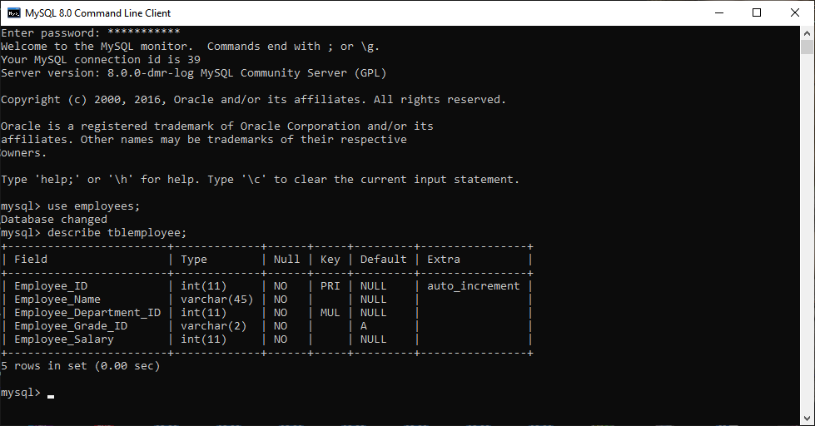



SOURCE CODE

Output Screens

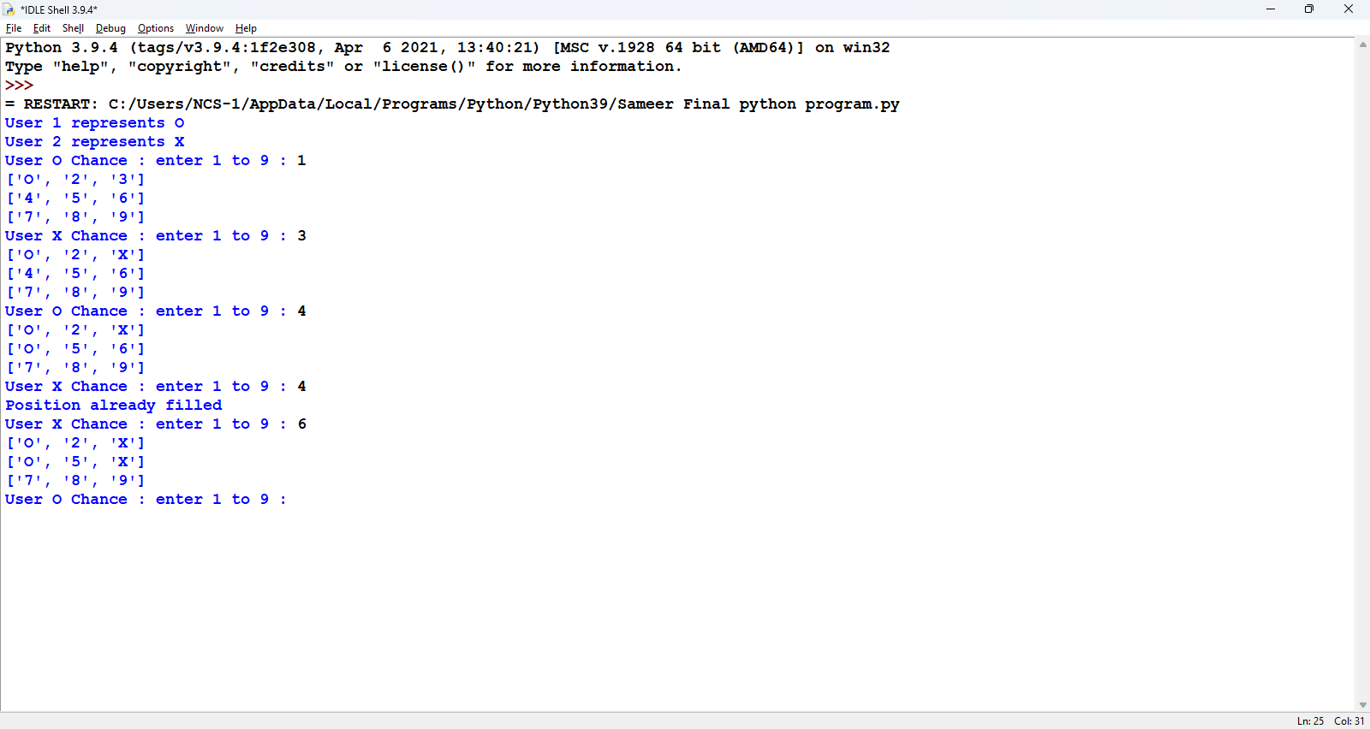
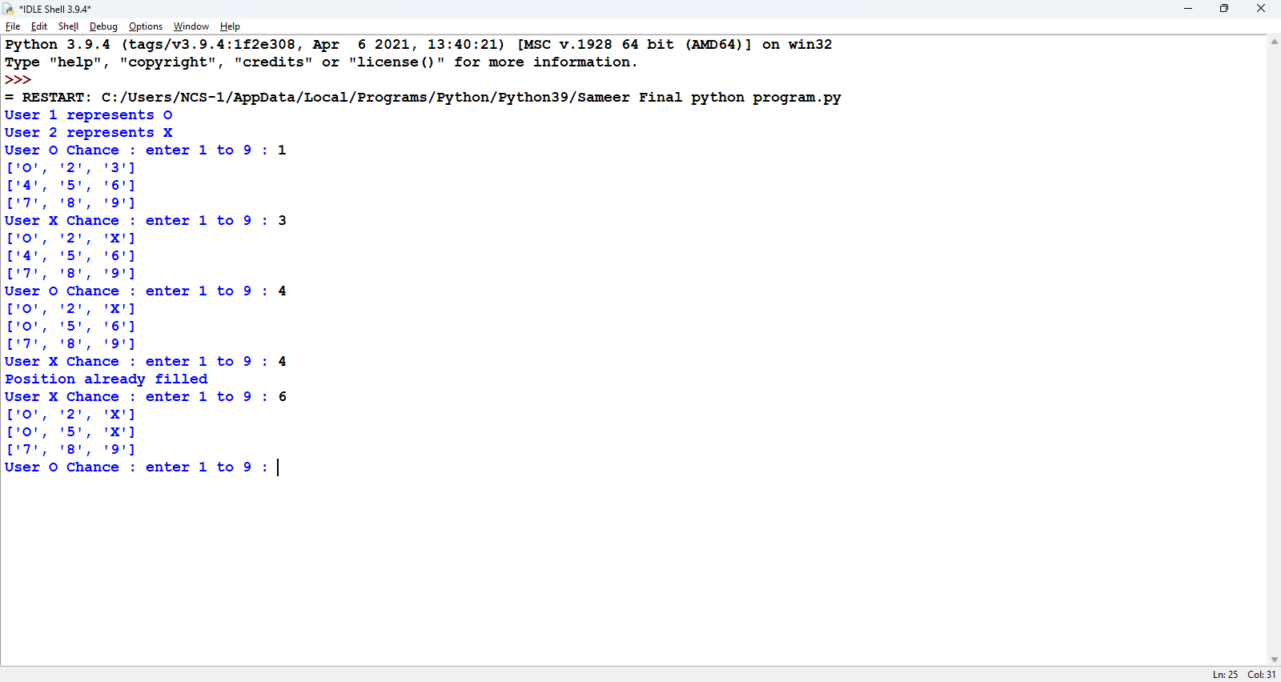

Scope

Limitations: -
- Two players can play at a time.
- Registration of players cannot be done.
- Score of players cannot be saved.
- It does not provide timing system.

Future Scope: -
- Registration of players can be done.
- Score of players can be saved.
- Timing system can be provided.

Bibliography

- IDLE Python 3.8.5
- www.scribd.com
- cbsepython.in
- www.google.com
- Computer Science with Python by Sumita Arora Class XIIth(Book)

Computer Software & Hardware Requirements

Hardware required: -
Windows 10 or 11
64-bit operating system, x64-based processor
Intel(R) Core (TM) i3-10100 CPU @ 3.60GHz 3.60 GHz)
Printer for printing project

Software required: -
Windows 11 Pro
MS word, for preparing documentation
Python 3.8.5 (tags/v3.8.5:580fbb0, Jul 20 2020, 15:57:54) [MSC v.1924 64 bit (AMD64)] on win32

THANK YOU!!

