Summer Course on Fluxes and Modeling
“Paper and Pencil” Exercise

Familiarize yourself with the entire document, before attempting to answer the questions below. All the required equations are listed at the end of the document, along with the variable definitions.

The data in the file ts_data.dat (10 records) was collected at 10 Hz by an IRGASON (colocated sonic anemometer and open-path gas analyzer with common electronics), slow response temperature/humidity probe, and a datalogger. The bandwidth of the sonic/IRGA was selected to be 20Hz, which leads to a fixed instrument delay of 200 ms or two datalogger measurement scans. The temperature/humidity probe has no instrument delay.

The sonic anemometer measures three dimensional wind, Ux, Uy , & Uz, and sonic temperature, Ts. The gas analyzer measures the densities of CO₂ and H₂O and pressure, press. The temperature/humidity probe measures the ambient air temperature, t_hmp, and vapor pressure, e_hmp. The units for each measured variable are in the header of the data file.

For this exercise, the raw data file has already been loaded and saved as an excel file called ts_data.xls. For convenience various constants needed for calculations have also been entered into the upper left hand side of this spreadsheet. Launch Excel, open the file, save locally on your PC as new file name, and enable editing (if needed). You will notice that the default formatting of the first column, the timestamp, is not properly set. To fix this, do the following: Highlight the appropriate cells, right-click, then select format cells. Navigate to Number | Custom. Then input the desired format such as mm/dd/yy hh:mm:ss.00.

Looking at the raw data, answer the questions below:

1) In order to align data from all sensors, does any of the data need be lagged/unlagged? Why or why not?

Which data must be lagged/unlagged?

Will the data be lagged or unlagged?

By how much will the data be lagged/unlagged?

2) Is there any other reason that data would be lagged or unlagged? In this example, how important or significant do you think perfectly aligned data are?

3) If the data are aligned, how many useful records will remain in the file?

4) Regardless of significance, apply the appropriate lags/unlags so that the timestamp indicates the moment when each measurement actually took place. Then compute the following for each record…

T_{c} – fast response air temperature using sonic temperature, Ts, and water vapor density from the gas analyzer, H2O. Label the result Tc_irga. Note: when calculating vapor pressure, e, use slow response air temperature, t_hmp, as the input for T. (See equations 1 and 2.)

T_{c} – fast response air temperature using sonic temperature, Ts, and vapor pressure from the temperature/humidity probe, e_hmp. Label the result Tc_hmp.

Χ_{c} - CO₂ molar mixing ratio (Remember this is a fast response measurement, so you need to use fast response gas density and fast response air temperature for inputs!)

Χ_{v} - H₂O molar mixing ratio;

5) What is the % error of T_{c_hmp} relative to T_{c_irga}? Explain possible reasons for this difference, and why the temperature corrected with the temp/RH probe might be higher.

6) Why might someone prefer to deal with gas units of molar mixing ratio rather than mass density? Are there any cons or concerns about using molar mixing ratios in this example?

7) If you were to leave gas units in mass density, what extra consideration would need to be made when calculating fluxes?

8) Compute the mean and standard deviation for …

U_{x}, U_{y} , & U_{z} (w) - the three components of wind;

T_{s} - sonic temperature;

T_{c_irga} - air temperature using sonic temperature and humidity from the gas analyzer;

Χ_{c} - CO₂ molar mixing ratio;

Χ_{v} - H₂O molar mixing ratio;

press - atmospheric pressure.

9) Compute …

- The 10Hz deviation from the mean for the following variables: Uz, Tc, Xc, and Xv. In other words, create new columns that show Uz’, Tc’, Xc’, and Xv’.

- The covariance at each point; that is, compute Uz’Tc’, Uz’Xc’, and Uz’Xv’. (Hint: For convenience, copy and paste the Uz’, Tc’ Xc’, and Xv’ data into a new table below the main one and then calculate covariances for each record.)

Below these data, compute the means for Uz’, Tc’, Xc’, Xv’, Uz’Tc’, Uz’Xc’, and Uz’Xv’
(i.e. find 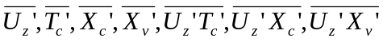)

10) Do the mean values for Uz’, Tc’, Xc’, and Xv’ make sense? Why or why not?

11) Use the Excel function CoVar(Series1, Series 2), where series 1 is Uz and series 2 is Tc, Xc, or Xv, to find covariances. How do these compare with the mean covariances you calculated in step 9?

12) Use the mean covariances from step 11 and appropriate constants to calculate final fluxes:

H - sensible heat flux (W/m²).

F_{c} - carbon dioxide flux (mg/(m³ s); and

LE - latent heat flux (W/m²).

13) Did you apply the WPL (1980) correction? Why or why not?

14) Are there any other processing procedures or corrections that would be appropriate to apply to these data? Why or why not?

15) Does a negative flux mean uptake or emission from the ecosystem? Based on the fluxes, what kind of ecosystem do you think this could be?

Bonus Question: Suppose you are measuring the energy balance terms. You measure 950 W/m² for net radiation and -30 W/m² for the ground surface heat flux. What is your percent energy closure? Why is closure not 100%?
Exercise Equation List

Sonic Temperature to Temperature

From Kaimal and Gaynor, 1991; eq (3)

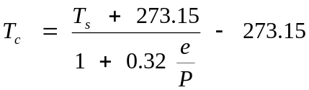 (1)

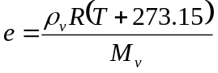 (2)

Mass Density to Molar Mixing Ratio

From Leuning, 2004; eq. (6.23)

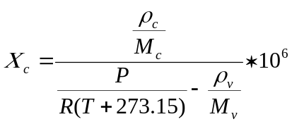 (3)

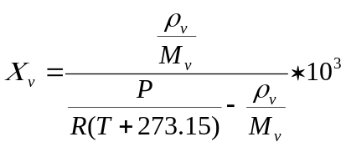 (4)

Computational Form

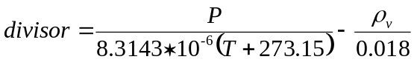 (5)

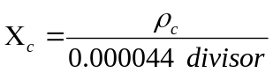 (6)

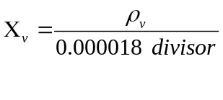 (7)
Error
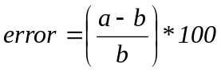 (8) (kjlkjlkjlk

Mean

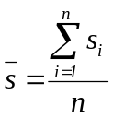 (9)

Variance

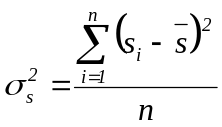 (10)

Standard Deviation

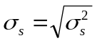 (11)

Covariance
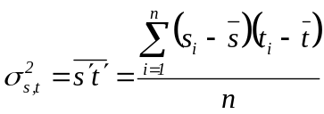 (12)

Converting Covariance Units

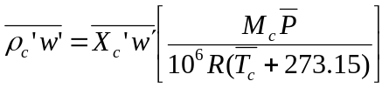 (13)

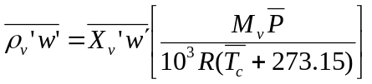 (14)

Sonic Sensible Heat Flux

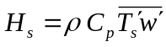 (15)

Sensible Heat Flux

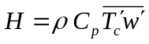 (16)

Carbon Dioxide Flux

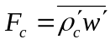 (17)

Latent Heat Flux

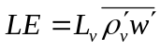 (18)

Webb, Pearman, and Leuning (1980) term

From Webb et al. (1980); eq. (24, 25)

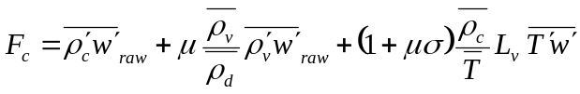 (19)
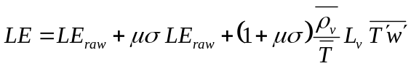 (20)

Variable Definitions

Τ_{c} - temperature computed from sonic temperature and gas analyzer humidity [C];

Τ_{s} - sonic temperature [C];

P - pressure [kPa];

e - vapor pressure [kPa];

ρ_{v} (H2O) - mass density of H₂O in vapor phase [g/m^3];

R - Universal gas constant [8.3143e-6 kPa m^3/(K mmol)];

L_{v} – latent heat of vaporization (assume 2440 J/g for this exercise)

C_{p} – heat capacity of air (assume 1005 J/(kg K) for this exercise)

Μ_{v} - molecular weight of H₂O [0.018 g/mmol];

Τ - ambient temperature [C];

Χ_{c} - CO₂ molar mixing ratio (concentration of CO₂ relative to dry air) [umol/mol];

ρ_{c} (CO2) - mass density of CO₂ [mg/m^3];

Μ_{c} - molecular weight of CO₂ [44 mg/mmol];

Χ_{v} - H₂O molar mixing ratio (concentration of H₂O relative to dry air) [mmol/mol].

w (Uz) - vertical wind [m/s].

σ - ratio of the density of water vapor to the density of dry air (ρ_{v}/ρ_{d});

ρ - air density (nominally 1.1 kg/m^3)

ρ_{d} - mass density of dry air [g/m^3]; and

μ - ratio of the molecular weight of dry air to that of water vapor (29/18);

