CSCI3230 / ESTR3108 2023-24 First Term Assignment 1

I declare that the assignment here submitted is original except for source material explicitly acknowledged, and that the same or closely related material has not been previously submitted for another course. I also acknowledge that I am aware of University policy and regulations on honesty in academic work, and of the disciplinary guidelines and procedures applicable to breaches of such policy and regulations, as contained in the following websites. University Guideline on Academic Honesty: http://www.cuhk.edu.hk/policy/academichonesty/ Faculty of Engineering Guidelines to Academic Honesty: http://www.erg.cuhk.edu.hk/erg-intra/upload/documents/ENGG_Discipline.pdf

Student Name: Fong Long Wai

Student ID : 1155177220

1a’s figure.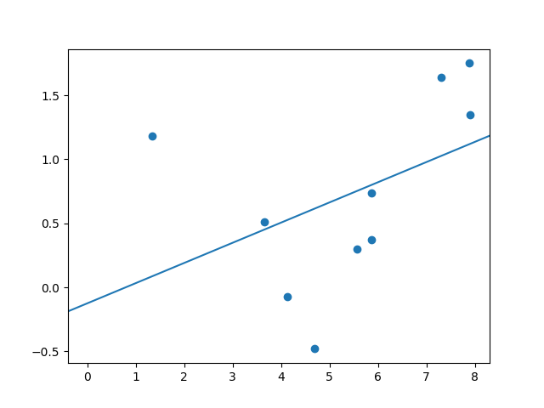

1b’s figure.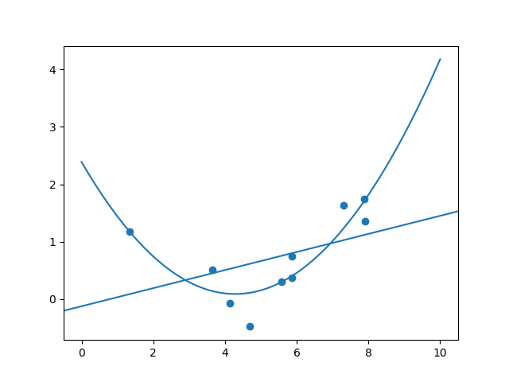

1c’s figure.