ESP Visualization
Method, Parameter Study and Results
Background to the workflow documented in README.md
Practical Bioinformatics Project — Visualization of Molecular Electrostatic Potentials
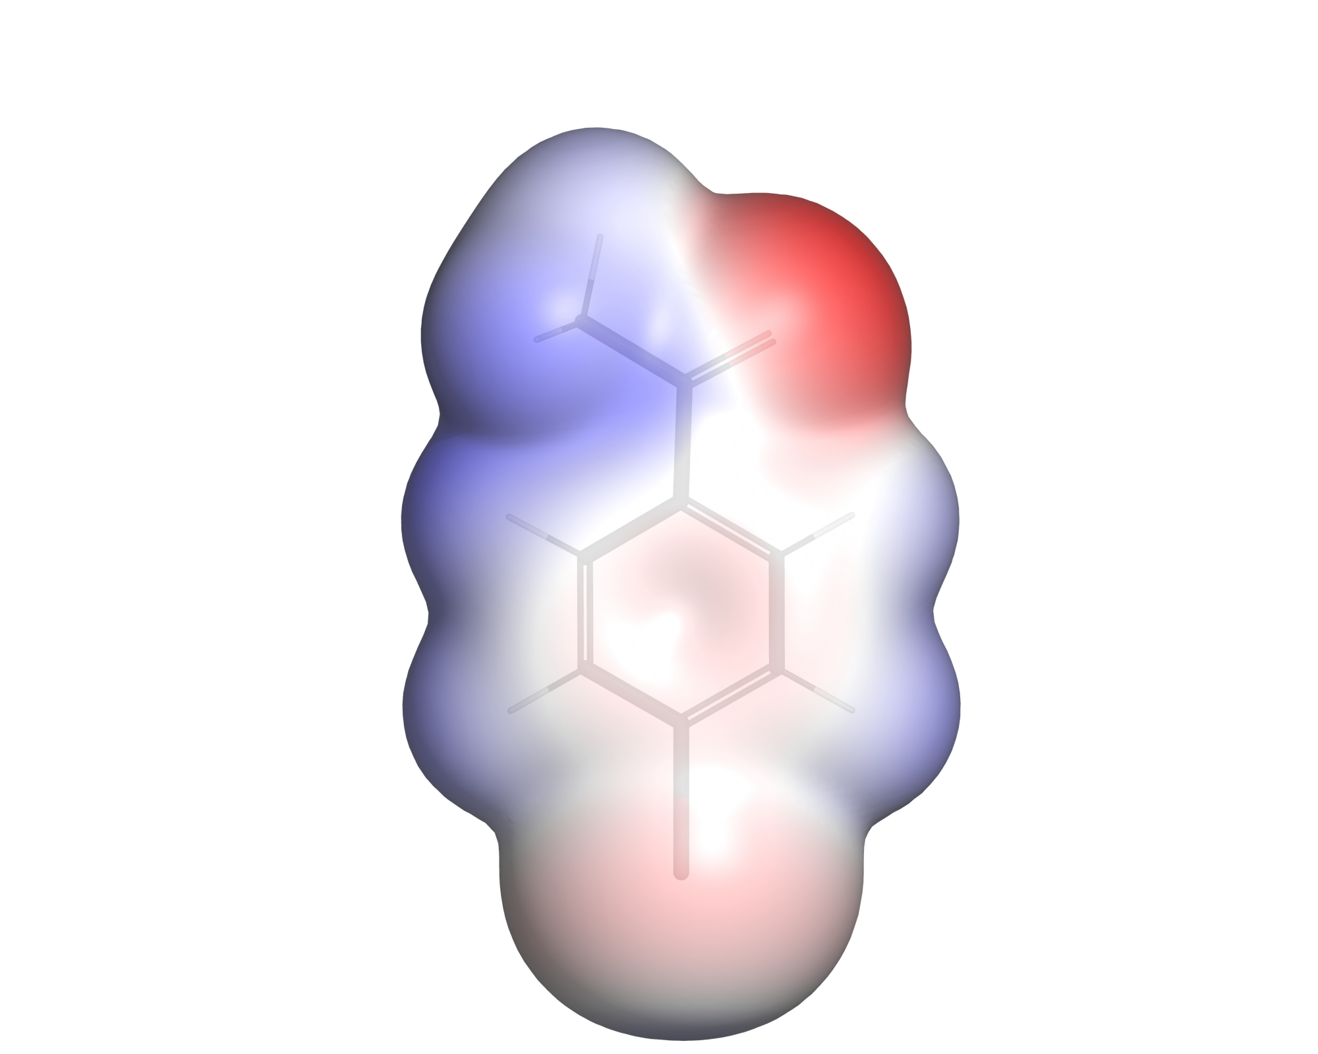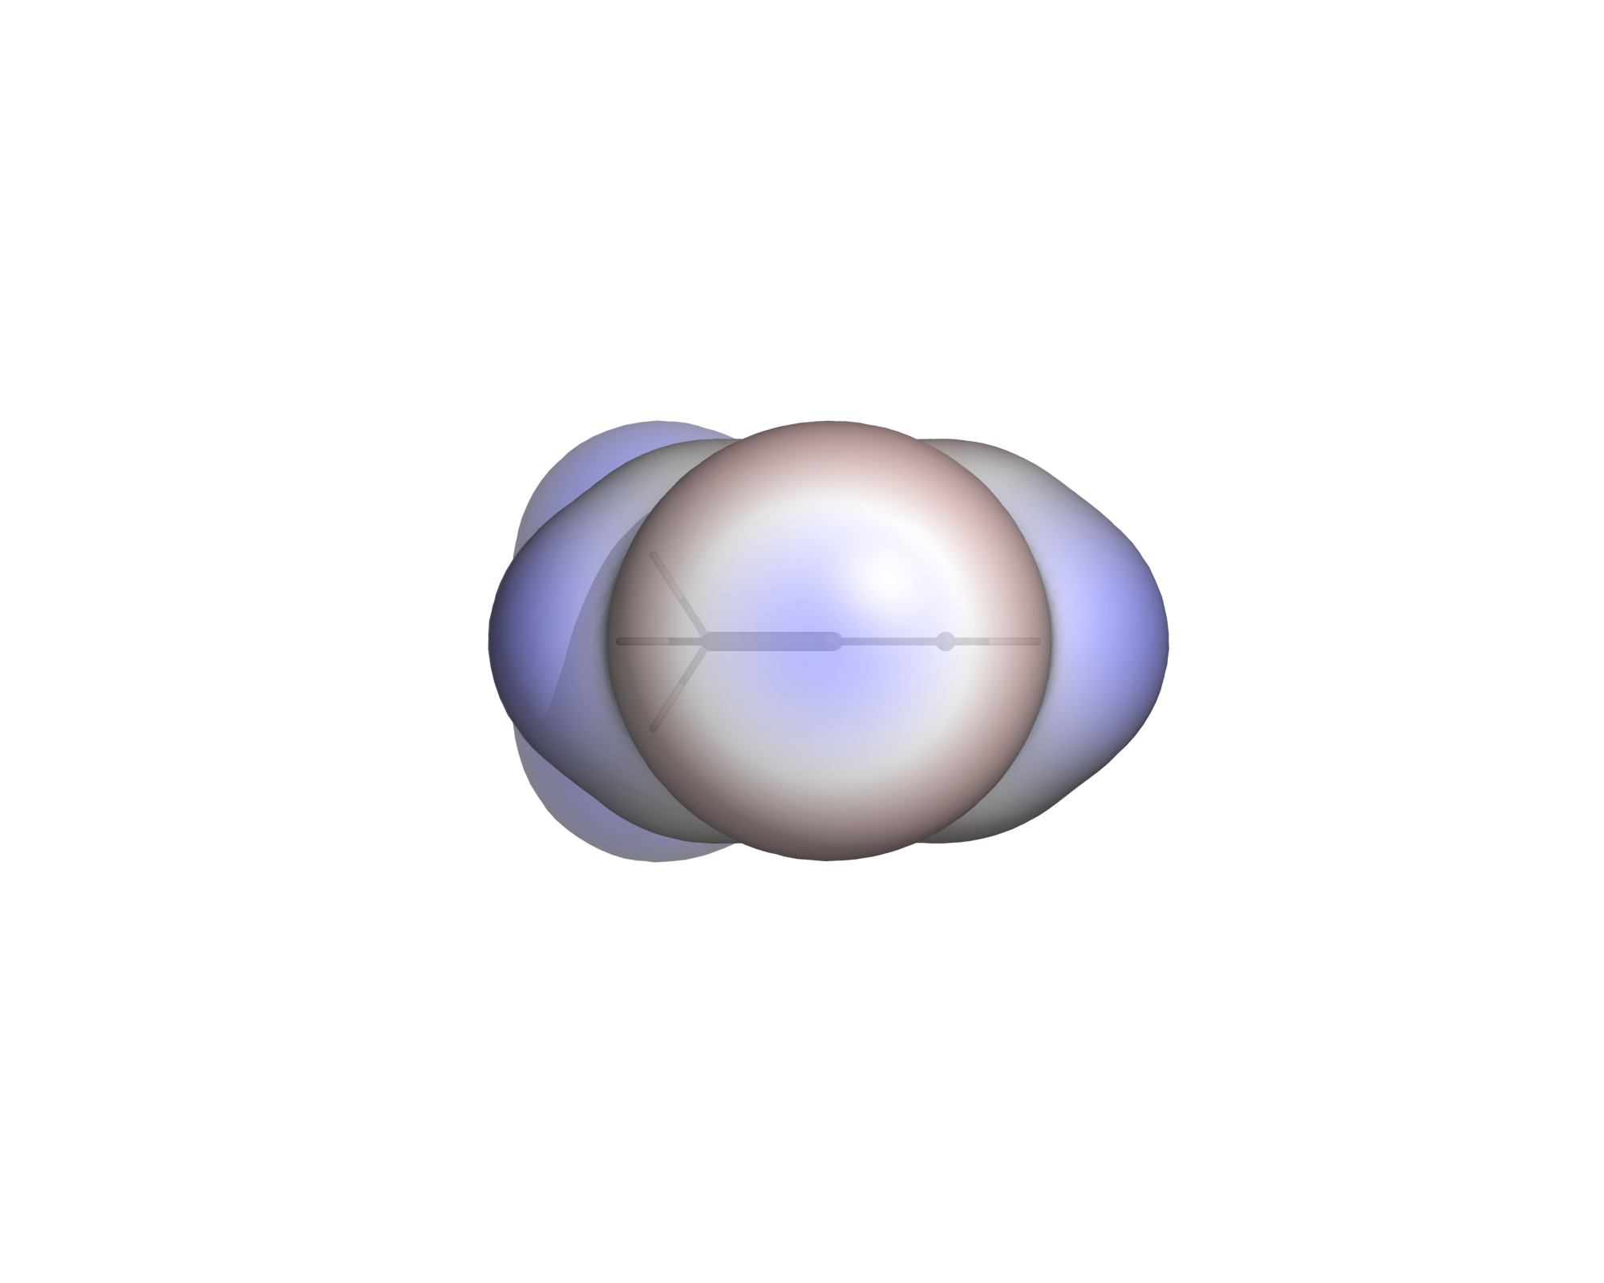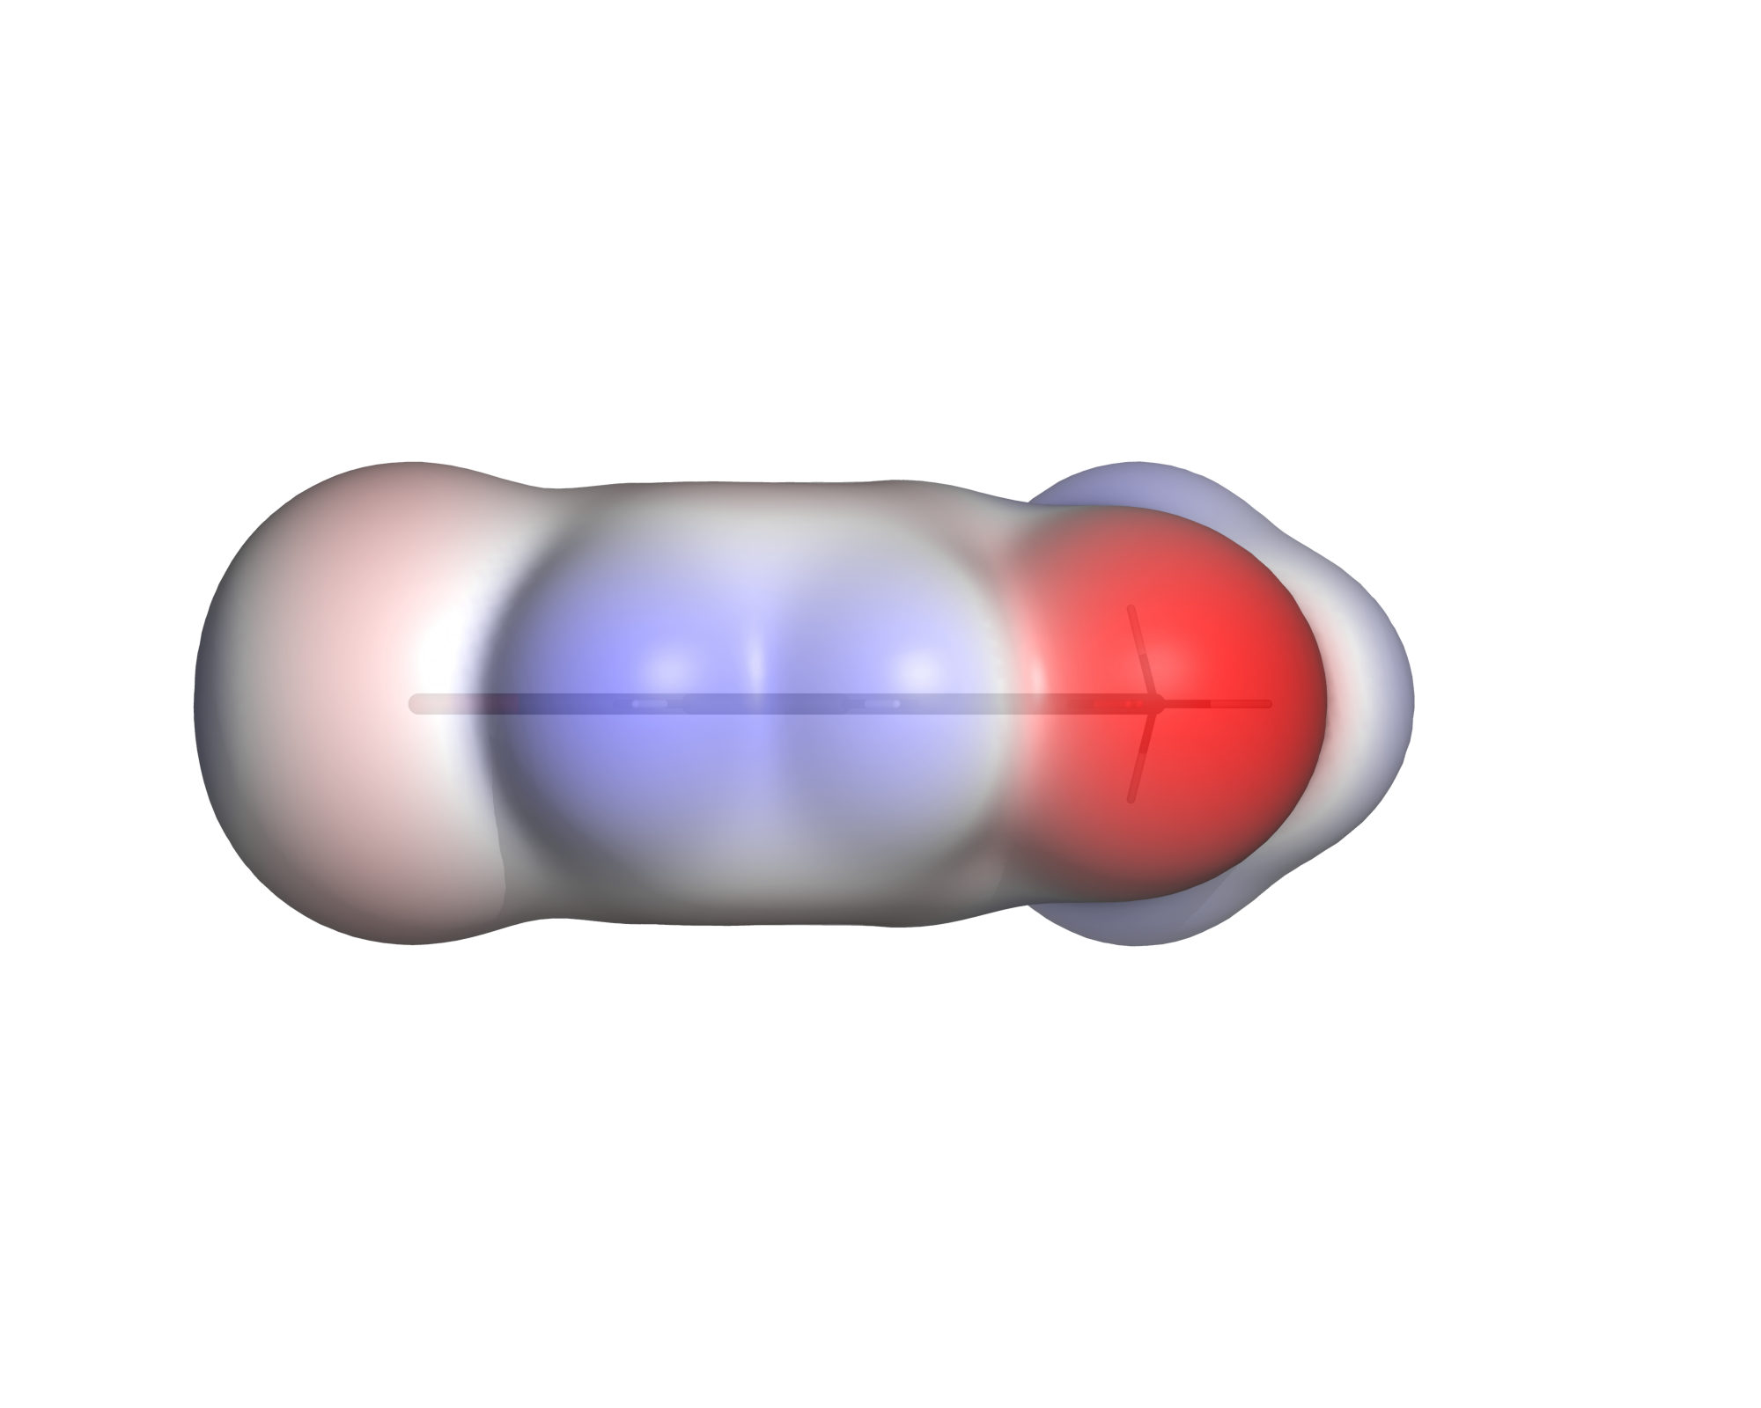
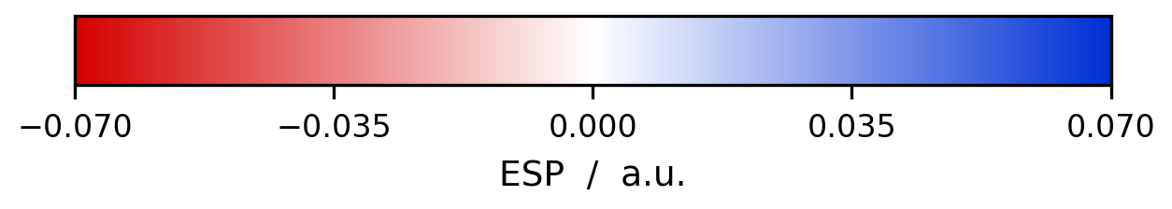
4-Bromoacetophenone. Left: π face, with the carbonyl oxygen as the deep red region at the top. Centre: view along the C–Br axis — the blue σ-hole cap inside the red belt. Right: in-plane profile. One molecule showing both features the workflow has to get right: a strongly negative functional group and an anisotropic halogen.
This document holds the background of the workflow: the conventions behind the images, which number actually describes a σ-hole, why every default is what it is, and the results the project delivers. Installation, execution and the full parameter reference are in `README.md` — this document explains nothing about how to run the scripts.

Contents
In Word: right-click the table below and choose "Update Field" to populate it.

1 Why these images look the way they do
Two conventions are worth stating up front, because they are what make the images comparable between molecules and defensible in a report.
The surface is the ρ = 0.001 a.u. electron-density isosurface, not a van-der-Waals surface built from tabulated radii. This is the convention introduced by Politzer, Murray and co-workers: it encloses roughly 96–97 % of the electronic charge, it responds to the actual electronic structure of the particular molecule, and it is defined by a single number rather than by a table of element radii that different programs disagree about.
The colour is the ESP on that surface, in atomic units (Hartree/e). Red is negative (electron-rich, attracts electrophiles), blue is positive. The scale is symmetric around zero so that white always means "neutral".
For a bromoarene this pair of conventions makes one specific feature visible: the σ-hole. The potential on the bromine is not isotropic — it is negative in a belt perpendicular to the C–Br bond and positive in a cap on the extension of that bond. That positive cap is what allows a halogen bond, and no single partial charge on the bromine can represent it. The _sigma view exists specifically to show it.
Measured values for the included example, 4-bromoacetophenone:
quantity | on | a.u. | kcal/(mol·e) | kJ/(mol·e)
V_{S,min} | carbonyl O | −0.0653 | −41.0 | −171.5
V_{S,max} | a ring H | +0.0476 | +29.9 | +125.0
σ-hole | Br, on the C–Br axis | +0.0230 | +14.5 | +60.5
halogen belt | Br, perpendicular | −0.0167 | −10.5 | −43.9

Note that all four are different places on the same surface, and that neither global extremum sits on the bromine — see §2.

2 Which number describes the σ-hole

2.1 Not V_{S,max}
On an aryl halide the global maximum of the surface potential sits on the ring hydrogens, not on the halogen. Compare chlorobenzene, bromobenzene and iodobenzene, all from the full 251³ grid:
 | chlorobenzene | bromobenzene | iodobenzene
σ-hole (cap on the C–X axis) | +0.0078 a.u. (+4.9 kcal/mol) | +0.0162 a.u. (+10.2) | +0.0255 a.u. (+16.0)
ring hydrogens = global V_{S,max} | +0.0313 a.u. (+19.6) | +0.0315 a.u. (+19.8) | +0.0317 a.u. (+19.9)
halogen belt = global V_{S,min} | −0.0190 a.u. (−11.9) | −0.0188 a.u. (−11.8) | −0.0169 a.u. (−10.6)

The three global maxima agree to within 0.4 % — because all three are the same aromatic C–H. Use them to compare halogen-bond donors and you conclude that chlorine, bromine and iodine have equally strong σ-holes, which is wrong: the σ-holes span a factor of 3.3, in the expected order Cl < Br < I.
render_esp.py therefore reports both. It names the atom the global extremum belongs to, and gives the local values in the halogen regions:
V_S,max = +0.0312 a.u. = +19.6 kcal/(mol*e) auf H5
Lokal am Halogen (Br):
sigma-Loch = +0.0126 a.u. = +7.9 kcal/(mol*e) [144 Punkte]
Guertel = -0.0188 a.u. = -11.8 kcal/(mol*e) [836 Punkte]
! V_S,max liegt auf H5, nicht auf dem Halogen
Both values also go into *_settings.txt and into the sigma_hole_au / belt_min_au columns of summary.csv.

2.2 The σ-hole is not read off grid points
It is a peak on the C–X axis, and whether a grid point happens to sit both on that axis and inside the thin ρ = 0.001 shell is luck. On a decimated bromobenzene grid the best cap point was 1.14 Bohr off the axis, which measured the flank instead of the summit.
The script therefore casts rays from the halogen into a cone around the axis, locates where ρ crosses the isovalue along each ray by interpolation, and evaluates V there — both trilinearly interpolated. That removes the dependence on grid alignment:
grid | spacing | point-based | ray-based (used)
42³ | 0.72 Bohr | +2.1 kcal/mol | +9.4
126³ (--stride 2) | 0.24 Bohr | +7.9 | +10.1
251³ (full) | 0.12 Bohr | +11.0 | +10.2

Measured on bromobenzene. The point-based value spans a factor of five across these grids; the ray-based one varies by 8 %. The two also differ on the same grid, and not by accident: the point-based method takes the best grid point within a shell of |ρ − 0.001| < 0.00012, and the inner edge of that shell sits closer to the nucleus where V is higher. For bromobenzene, ρ = 0.00112 gives +10.9 kcal/mol and ρ = 0.00088 gives +9.3 — the ray method evaluates at exactly 0.00100 and returns +10.2. A residual underestimate remains on very coarse grids because the interpolated density itself smooths the isosurface, so the script warns whenever the spacing exceeds 0.30 Bohr. summary.csv records which method produced each value in the sigma_method column.

2.3 Molecules with more than one halogen
Two halogens in the same molecule are usually not equivalent. Triazolam is the obvious example: one chlorine sits on the fused benzodiazepine ring, the other on the pendant phenyl, and they see completely different electronic environments. An earlier version of the script simply took the first halogen in the atom list — which halogen that was depended on nothing but the ordering in the structure file, and the second one was silently dropped.
Every halogen with a bonded carbon is now evaluated separately: its own C–X axis, its own ray cone, its own belt. The console prints one block per halogen, sorted by σ-hole strength, and marks the one the σ view looks along:
Lokal an Br1: <- Achse der sigma-Ansicht
sigma-Loch = +0.0086 a.u. = +5.4 kcal/(mol*e) [interpoliert, 2.9 Grad zur Achse]
Guertel = -0.0362 a.u. = -22.7 kcal/(mol*e) [224 Punkte]
Lokal an Cl4:
sigma-Loch = -0.0040 a.u. = -2.5 kcal/(mol*e) [interpoliert, 2.2 Grad zur Achse]
Guertel = -0.0362 a.u. = -22.7 kcal/(mol*e) [157 Punkte]
The labels are symbol + 1-based atom number, so they can be matched against the structure file directly. *_settings.txt gets one line per halogen and records which one defined the view. In summary.csv, sigma_hole_au remains the strongest σ-hole so the column stays sortable across a batch; sigma_hole_on names the atom it belongs to, n_halogens how many there are, and sigma_holes_all lists every one of them as label:value pairs, e.g. Br1:0.00862;Cl4:-0.00398. Nothing is lost. The summary table at the end of a batch run appends Br1 of 2 to make clear the printed value is one of several.
Sanity checks: on p-dichlorobenzene, where the two chlorines are related by symmetry, both come out at +0.0074 a.u. On 1-bromo-2-chloroethane they differ as chemistry demands — Br +5.4, Cl −2.5 kcal/mol, the alkyl chlorine having no σ-hole worth the name. Molecules with a single halogen are unaffected: the values and the console output are identical to before.
One caveat for small molecules: the belt region is defined relative to its own halogen, and if two halogens sit within a few bonds of each other the belts overlap, so both report the same minimum — visible above, where both belt values are −0.0362. On molecules where the halogens are far apart, as in triazolam, this does not arise.

2.4 The cone must not reach the rest of the molecule
Triazolam exposed a second problem, and this one was not specific to having two halogens — it had simply never been triggered by the flat test molecules. The ray method walked outward from the halogen and took the outermost crossing of ρ = 0.001. Triazolam is folded: the cone around the C–Cl21 axis points at the methyl group on the triazole ring, roughly 4 Å away. The rays left the chlorine surface, crossed vacuum, and struck the methyl — and its surface was reported as the σ-hole:
 | before | after
Cl21 σ-hole | +0.0299 a.u. (+18.8 kcal/mol), 29.0° off axis | +0.0171 a.u. (+10.7), 3.8°
Cl21 belt | −0.0670 a.u. (−42.0) — actually the triazole N3/N4 lone pairs | −0.0184 (−11.5)

+18.8 kcal/mol for an aryl chloride was the tell: chlorobenzene gives +4.9, and no substituent pattern triples that. The two symptoms in the printed output are the off-axis angle (29° is nearly the cone edge — a real σ-hole peaks within a few degrees of the axis) and the cap radius, which came out at 3.94 Å instead of the ~2.0 Å a chlorine surface sits at.
Two changes fix it:
- the ray takes the first downward crossing of ρ = 0.001, not the last. The ray starts deep inside the halogen’s own density, so the first place it drops through the isovalue is that halogen’s own surface, whatever lies beyond.
- both the ray search and the grid-point cap are cut off at 1.6 × the Bondi van der Waals radius of the halogen. The ρ = 0.001 surface sits at roughly 1.1–1.2 vdW radii, so this leaves plenty of room and excludes everything else.
Single-halogen molecules are unaffected — for 4-bromoacetophenone the σ-hole moves from +0.02304 to +0.02303 a.u. and the belt is unchanged, because on a convex molecule the first and the last crossing are the same point. The rendered images are bit-identical; only the numbers changed.
The lesson is worth keeping: three flat halobenzenes cannot test a method that assumes the space beyond the halogen is empty. A folded drug molecule can. The same holds for the σ view: the projection of the C–X axis into the fitted plane was harmless on every planar test molecule and wrong on the first non-planar one.

2.5 The colour scale can hide a correct σ-hole
Worth knowing before concluding an image is broken. With --esp-range auto the scale is set by the global extremes — for triazolam the triazole nitrogens at −0.084 a.u. On that scale a σ-hole of +0.017 is 20 % of full blue, i.e. almost white, even though the view is aimed correctly. Rendering the same molecule with --esp-range 0.035 makes the cap and its surrounding belt plainly visible. The number in the console is the evidence for a σ-hole; the picture at the automatic scale is not necessarily.

2.6 Orientation: two versions of the C–X axis
The three views are oriented from the molecular geometry: the plane normal comes from the principal axes of the heavy atoms, the second axis is the carbon–halogen bond. If the molecule carries more than one halogen, the axis is the C–X bond of the one with the strongest σ-hole.
Two versions of that axis exist, and the difference matters. The π and edge views need an axis that lies exactly in the fitted plane, so the three views form a clean orthogonal triple; the raw C–X vector is projected into the plane for them. The σ view must not use that projection — it has to follow the actual bond. On a planar molecule the two coincide (4-bromoacetophenone: 0.001°) and the distinction is invisible. On triazolam the C–Cl21 bond sticks 42.9° out of the fitted plane, and the σ view was aiming 42.9° past the σ-hole: the picture showed the molecule roughly edge-on with the chlorine off to the side. Since the fix, molecular_frame() returns both vectors and the σ view uses the unprojected one. When the tilt exceeds 15°, the console says so.
For molecules without a halogen there is no C–X axis, and the script falls back to the longest principal axis of the heavy atoms. The three views stay a proper orthogonal triple, but *_sigma.png then looks down the long axis of the molecule rather than at a σ-hole — for paracetamol, for instance, from the phenol end through the ring towards the acetamido group. The file name is kept for consistency across an image set; read it as "axial view" in that case.

3 Choosing the colour scale
This is the one decision that cannot be automated away, because it depends on what the figure is for.
One molecule, maximum detail → --esp-range auto. The range is derived from the ESP actually present on the ρ = 0.001 shell and rounded up to a clean value.
Several molecules to be compared → one fixed range for all of them. A red patch in figure A must mean the same potential as a red patch in figure B, otherwise the comparison is misleading. --two-pass does this for you; manually, run once with auto, take the largest reported value and re-run everything with --esp-range <value>.
Whatever you choose, state the range in the figure caption and ship *_colorbar.png with the figures. An ESP figure without its scale is uninterpretable.
For the halobenzenes the automatic range comes out at ±0.035 a.u. (±92 kJ/(mol·e)), stable across grid resolutions; 4-bromoacetophenone needs ±0.070 because of the carbonyl oxygen.
Do not put a common colour scale across data of different provenance. --two-pass gives every molecule in the run the same scale, which is only meaningful if they were computed the same way — same geometry optimisation, same method, same basis set. Mixing the provided Turbomole data with grids generated by tools/CreateTpTdFromSmiles.py in one --two-pass run would imply a comparability that does not exist. There is a practical side as well: the halobenzenes need ±0.035 a.u., paracetamol ±0.090. On a shared scale the halobenzenes would come out almost colourless — a σ-hole of 0.0070 is 8 % of a ±0.090 range.

3.1 The rainbow ramp
--rainbow switches the colour ramp from red–white–blue to a rainbow. It works on all three scripts.
ramp | levels | colours
default | −rng, 0, +rng | red, white, blue
--rainbow | −rng, −rng/2, 0, +rng/2, +rng | red, yellow, green, cyan, blue

The convention is deliberately not inverted. Red stays negative and blue stays positive in both ramps; the rainbow only inserts yellow, green and cyan in between. Some programs run the rainbow the other way round (blue = negative), which makes the two image sets impossible to place side by side — the point of having the option at all.
When to use which. Red–white–blue spends almost no colour resolution near zero: everything weakly polar comes out white. The rainbow resolves exactly that region, which is useful for looking at the π face of an aromatic ring or at a saturated backbone.
The price is that a rainbow is not perceptually uniform. The eye reads the yellow–green and green–cyan transitions as edges even where the potential changes smoothly, and green in the middle looks like a state of its own rather than "neutral". For quantitative statements — σ-hole, belt, V_{S,min}, V_{S,max} — red–white–blue is the more honest picture, and it is also what the ESP literature uses. Recommended practice: red–white–blue as the main figure, rainbow alongside where fine structure is the point.
*_settings.txt records the ramp in a Farbrampe line, and summary.csv has a colormap column with redblue or rainbow, so a figure can always be traced back to the ramp that produced it.

4 Parameter study
Every default in this pipeline was chosen against a measurement, not by taste. This section collects those measurements so the choices can be checked, and so it is clear which parameters are cosmetic and which change the result.
The short version: the isovalue is the only parameter that changes the physics. Grid resolution costs accuracy slowly, the colour range and transparency change nothing but the picture, and the σ-hole search parameters matter only through the two failure modes described in §2.

4.1 Isovalue ρ — the one that decides the answer
4-Bromoacetophenone, full 114×86×80 grid, everything else at defaults:
ρ / a.u. | shell points | V_{S,min} | V_{S,max} | σ-hole | kcal/mol | belt
0.0005 | 4901 | −0.0596 | +0.0408 | +0.0159 | 10.0 | −0.0151
0.0008 | 4925 | −0.0640 | +0.0463 | +0.0203 | 12.7 | −0.0162
0.0010 | 4707 | −0.0653 | +0.0476 | +0.0230 | 14.5 | −0.0167
0.0015 | 4743 | −0.0703 | +0.0539 | +0.0293 | 18.4 | −0.0176
0.0020 | 4666 | −0.0730 | +0.0584 | +0.0354 | 22.2 | −0.0179
0.0040 | 4490 | −0.0816 | +0.0748 | +0.0568 | 35.7 | −0.0171

From 0.0005 to 0.004 the σ-hole grows by a factor of 3.6. That is not noise — a larger isovalue means a surface closer to the nuclei, where the positive nuclear contribution has been screened less. Every value on such a surface is larger in magnitude, on both signs.
The consequence is that a σ-hole value without its isovalue is meaningless, and two values computed at different isovalues cannot be compared at all. This is why 0.001 a.u. is not a tunable here: it is the Bader/Politzer convention (§1) and the only value the rest of the literature can be read against. --iso exists to reproduce someone else’s choice, not to improve on this one.
Note that the shell point count barely moves across the whole range. The count is therefore no indication that anything changed — a convergence check that looks at "enough points" would have passed at every one of these settings.

4.2 Grid resolution — --stride
Same molecule, isovalue fixed at 0.001, cubes rebuilt from the same pointval files at increasing decimation:
--stride | grid | Δ / Bohr | cubes | V_{S,min} | V_{S,max} | σ-hole | kcal/mol | belt
1 | 114×86×80 | 0.25 | 20.7 MB | −0.0653 | +0.0476 | +0.0230 | 14.5 | −0.0167
2 | 57×43×40 | 0.50 | 2.6 MB | −0.0636 | +0.0462 | +0.0224 | 14.1 | −0.0166
3 | 38×29×27 | 0.75 | 0.8 MB | −0.0638 | +0.0469 | +0.0221 | 13.9 | −0.0159
4 | 29×22×20 | 1.00 | 0.3 MB | −0.0634 | +0.0428 | +0.0214 | 13.4 | —

Cost falls by a factor of 70 across this table; the σ-hole falls by 7 %. The degradation is smooth and one-sided — always low, never high — because the interpolated density smooths the isosurface. At stride 4 the belt can no longer be measured at all: fewer than five surface points survive in the belt region, and the script prints a dash rather than a number.
Two things make this table look better than it should. First, these are ray-based values; the point-based method on the same grids spans a factor of five (§2.2). Second, this molecule is small — for the 251³ bromobenzene grids the full-resolution cubes are 205 MB and stride 2 is what makes the workflow usable at all.
Practical rule: stride 2 for looking, stride 1 for numbers that go in a table. The script warns above 0.30 Bohr spacing for exactly this reason.

4.3 Colour range — visual only
--esp-range never touches a computed value; it only maps numbers to colours. It is in this section because getting it wrong makes a correct calculation look wrong. Ranges the automatic mode selects:
molecule | range | set by
halobenzenes | ±0.035 | the halogen belt
4-bromoacetophenone | ±0.070 | the carbonyl oxygen
triazolam | ±0.085 | the triazole nitrogens
paracetamol | ±0.090 | the phenol oxygen

A σ-hole of +0.017 is 49 % of full blue at ±0.035 and 20 % at ±0.085 — visible in the first case, nearly white in the second, from identical data. Whenever the molecule carries a group far more polar than the halogen, the automatic range is set by that group and the halogen region is washed out. See §3 for when a common scale is legitimate.

4.4 σ-hole search parameters
parameter | value | why
cone half-angle | 36.9° (cone_cos = 0.80) | wide enough that the maximum is found interior to the cone, narrow enough to exclude the belt. A maximum near the edge is a warning sign, not a result — the console prints the off-axis angle for this reason
rays per halogen | 400, Fibonacci spiral | even coverage of the cap without the pole clustering of spherical coordinates
step along a ray | 0.02 Bohr | far below the grid spacing; the crossing radius is then refined by linear interpolation anyway
radius cut-off | 1.6 × Bondi vdW | the ρ = 0.001 surface sits at 1.1–1.2 vdW radii; beyond that the ray is looking at another part of the molecule
belt half-angle | ±69.5° (belt_cos = 0.35) | the belt is broad; a narrow band would sample only its rim
belt radius | 1.5 × mean cap radius | keeps the belt on its own halogen — with the caveat for adjacent halogens noted in §2.3

The first two of these were tuned; the rest follow from the geometry. What actually cost the most work was not any of these numbers but the two structural mistakes — taking the outermost isosurface crossing, and projecting the C–X axis into the fitted plane — both of which are documented where they arose.

4.5 Rendering
parameter | value | note
transparency | 0.15 | enough to see the stick model through the surface, little enough that the colour still reads. Purely a visual judgement; no number depends on it
transparency_mode | 2 | PyMOL’s back-face-aware mode; without it the far side of the surface bleeds through and the colours mix
surface_quality | 1 | the isosurface triangulation, not the data
orthoscopic | on | no perspective, so two molecules rendered at the same zoom are directly comparable
image size | 2000 × 1600, 300 dpi | large enough for a full-width figure in a report at ~17 cm

4.6 Test-data generator
tools/CreateTpTdFromSmiles.py has its own parameters, documented with their reasoning in tools/README.txt. The one measurement worth repeating here is the cost scaling, because it decides what is practical: triazolam (35 atoms, 390 basis functions) at the default 0.25 Bohr and 3.5 Å margin needs 1.41 million grid points and about 26 minutes for the grid evaluation, against roughly 4 minutes for 4-bromoacetophenone. The two factors multiply — 1.8× more points and 4× more work per point. --spacing 0.30 --margin 2.5 brings that back to about 10 minutes, at the price of landing at the grid-spacing warning threshold.

5 Results
results/ holds the image sets that this project actually delivers — seven molecules, each with the three standard views, its colour bar and its *_settings.txt. Unlike sandbox/, this folder is committed: the images are the deliverable, and *_settings.txt next to each one is the record of how it was made.
folder | molecule | data source
chlorbenzol/ | chlorobenzene | provided Turbomole data
brombenzol/ | bromobenzene | provided Turbomole data
iodbenzol/ | iodobenzene | provided Turbomole data
chlormethan/ | chloromethane | generated, tools/CreateTpTdFromSmiles.py
4-bromacetophenon/ | 4-bromoacetophenone | generated, tools/CreateTpTdFromSmiles.py
paracetamol/ | paracetamol | generated, tools/CreateTpTdFromSmiles.py
halcion/ | triazolam | generated, tools/CreateTpTdFromSmiles.py

5.1 Surface ESP values
All at ρ = 0.001 a.u.; σ-hole and belt from the ray method. Atom labels are 1-based indices into the respective structure file.
molecule | grid | Δ/Bohr | range | V_{S,min} | V_{S,max} | σ-hole | kcal/mol | belt
chlorobenzene | 251³ | 0.12 | ±0.035 | −0.0190 (Cl12) | +0.0313 (H9) | +0.0078 | +4.9 | −0.0190
bromobenzene | 251³ | 0.12 | ±0.035 | −0.0188 (Br12) | +0.0315 (H7) | +0.0162 | +10.2 | −0.0188
iodobenzene | 251³ | 0.12 | ±0.035 | −0.0169 (I12) | +0.0317 (H5) | +0.0255 | +16.0 | −0.0169
chloromethane | 40×38×38 | 0.40 | ±0.035 | −0.0283 (Cl1) | +0.0323 (H3) | −0.0083 | −5.2 | −0.0283
4-bromoacetophenone | 114×86×80 | 0.25 | ±0.070 | −0.0653 (O3) | +0.0476 (H14) | +0.0230 | +14.5 | −0.0167
triazolam | 132×101×106 | 0.25 | ±0.085 | −0.0843 (N4) | +0.0543 (H27) | +0.0171 (Cl21) | +10.7 | −0.0184
" |  |  |  |  |  | +0.0144 (Cl11) | +9.0 | −0.0110
paracetamol | 122×67×86 | 0.25 | ±0.090 | −0.0737 (O3) | +0.0898 (H20) | — | — | —

What the set is meant to show:
- The halobenzene series is the trend Cl < Br < I, a factor of 3.3 across the three — while their global V_{S,max} agree to within 0.4 %, because that maximum is the same aromatic C–H in all three. This is the central argument of §2.1.
- Chloromethane is the negative control: an alkyl chloride has no σ-hole at all. The value on the C–Cl axis is −5.2 kcal/mol — still negative. The σ-hole is a property of the C–X bond’s electronic environment, not of the halogen alone.
- 4-Bromoacetophenone separates the belt from the global minimum for the first time: V_{S,min} sits on the carbonyl oxygen at −41.0, the belt on the bromine at −10.5. In the halobenzenes those two lines were always the same number.
- Paracetamol is the halogen-free case — no σ-hole block, orientation from the principal axes, dash in the table.
- Triazolam is the two-halogen case, and the two chlorines differ by 19 % despite being the same element: +10.7 on the pendant 2′-phenyl chlorine against +9.0 on the fused-ring one.

5.2 What these numbers may and may not be compared with
The first three rows and the last four are not comparable with each other. Chlorobenzene, bromobenzene and iodobenzene come from the provided Turbomole calculation. The other four were generated with tools/CreateTpTdFromSmiles.py at HF/def2-SVP on an MMFF94 geometry — a different method, a different basis set, and a force-field geometry rather than an optimised one. Any of those three differences moves V_{S,min} and V_{S,max} by more than the effects being discussed. See tools/README.txt, section "LIMITATIONS".
Within each group the comparison is sound: the three halobenzenes were computed identically, and the four generated sets share method, basis and grid spacing.
The colour scales tell the same story. All four molecules at ±0.035 can be compared by eye; 4-bromoacetophenone, triazolam and paracetamol each carry their own range because a shared one would render the halogen regions colourless. Always read the colour bar shipped with the image, never the colours alone.
Two further caveats:
- Chloromethane’s grid is 0.40 Bohr, above the 0.30 Bohr threshold at which the script warns. Per §4.2 that biases the value low by a few percent. It does not affect the conclusion — the sign is what matters here, and −5.2 is nowhere near zero.
- The maximum density value in the provided data suggests bromine was treated all-electron while iodine used an effective core potential. That is a question for the supervisor; if so, the Br/I step in the table is not a pure basis-set-consistent comparison.

5.3 Provenance of the images
chlorbenzol/, chlormethan/ and iodbenzol/ were rendered with an earlier version of render_esp.py — their *_settings.txt still uses the single-halogen layout (sigma-Loch (Cl) and a separate Halogenguertel line) rather than the per-halogen one. The numbers are unaffected: all three molecules carry one halogen and are planar or axially symmetric, so neither the outermost-crossing fix nor the true-axis fix changes anything for them, and the values above match a current run. Still, a deliverable set should come from one script version. Re-rendering them is one command and the cube files are unchanged.
python run_all.py --root ../sandbox --only chlorbenzol chlormethan iodbenzol

6 References
Method / convention
- F. A. Bulat, A. Toro-Labbé, T. Brinck, J. S. Murray, P. Politzer, Quantitative analysis of molecular surfaces: areas, volumes, electrostatic potentials and average local ionization energies, J. Mol. Model. 16 (2010) 1679–1691. doi:10.1007/s00894-010-0692-x
- J. S. Murray, P. Politzer, The electrostatic potential: an overview, WIREs Comput. Mol. Sci. 1 (2011) 153–163. doi:10.1002/wcms.19
Software
- PyMOL — The PyMOL Molecular Graphics System, Schrödinger, LLC. Open-source build: https://github.com/schrodinger/pymol-open-source
Workflow documentation
- README.md in the repository root — installation, execution, complete parameter reference, example commands, troubleshooting.
- tools/README.txt — the test-data generator, its parameters and its limitations.

