Visualization of Molecular
Electrostatic Potentials
Two reproducible pipelines from Turbomole grid output to publication figures,
and a measurement of what actually moves the result
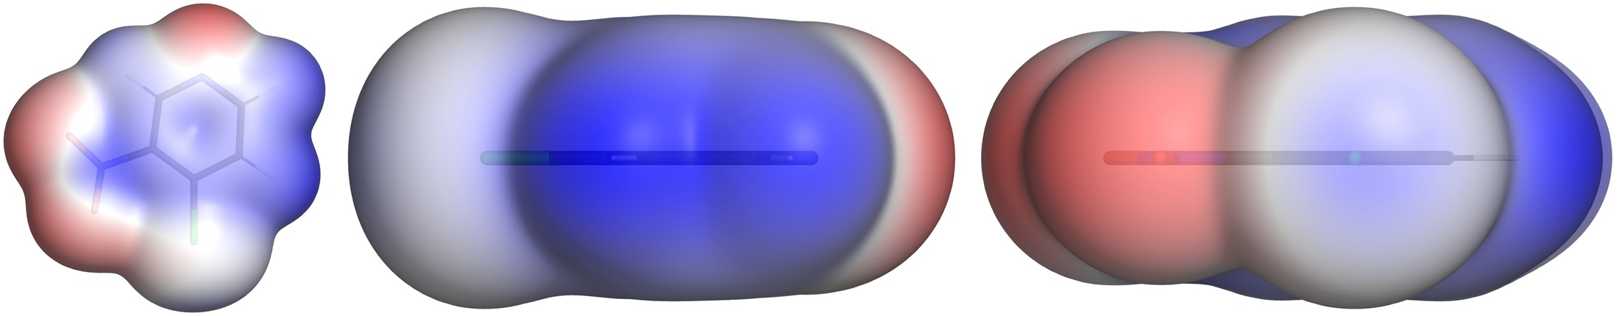
Figure 1 — 4-Chloro-3-nitropyridine at ρ = 0.001 a.u. Left: the π face, with the nitro oxygens as the deep red region. Centre: the in-plane profile. Right: the view along the C–Cl axis, with the blue σ-hole cap in the middle of the chlorine. Colour scale ±0.0600 a.u., PyMOL pipeline.
Practical Bioinformatics Project · Frontiers of Applied Drug Design
August 2026

Content
1 Introduction 4
1.1 Electrostatics as a recognition principle 4
1.2 Aim and scope 4
2 Theoretical background 5
2.1 The molecular electrostatic potential 5
2.2 Why ρ = 0.001 a.u. 5
2.3 V_{S,min} and V_{S,max} 5
2.4 The σ-hole 5
2.5 Atomic units 6
3 Data 6
3.1 Quantum-chemical input 6
3.2 The molecule set 6
4 Methods 7
4.1 Overview of the two pipelines 7
4.2 From pointval to cube 7
4.3 Surface statistics 8
4.4 Locating the σ-hole 8
4.5 Where the σ-hole is computed, and where it is not 8
4.6 Reproducibility 9
5 Results 10
5.1 Surface ESP values 10
5.2 The halobenzene series 10
5.3 The pyridine series 11
5.4 Comparison with published values 11
5.5 The image sets 12
5.6 Where the two pipelines agree, and where they do not 13
5.7 The rainbow ramp 15
6 Parameter selection 16
6.1 Isovalue — the parameter that matters 16
6.2 Grid resolution 16
6.3 Evaluation method: rays against grid points 17
6.4 σ-hole search parameters 17
6.5 Colour range — visual only 17
6.6 Rendering parameters 18
6.7 Ranking the sources of uncertainty 18
7 Robustness and failure modes 18
7.1 More than one structure file 18
7.2 Structure and grid do not belong together 18
7.3 The ray leaving its own halogen 19
7.4 Renderer behaviour 20
8 Discussion 21
8.1 What is viewer-dependent and what is not 21
8.2 Which pipeline for what 21
8.3 Limitations 21
9 Outlook 22
9.1 Electrostatic complementarity 22
9.2 A third viewer 22
9.3 The missing axis 22
Appendix A Repository layout 23
Reproducing the results 23
11 References 23
Method and convention 23
σ-hole values used in the literature comparison (§6.4) 23
Software 24
Workflow documentation 24

1 Introduction

1.1 Electrostatics as a recognition principle
Non-covalent recognition between a ligand and its target is, to a first approximation, electrostatic. The molecular electrostatic potential on the surface of a molecule is therefore one of the more directly interpretable quantities in structure-based design: it says where a molecule is electron-rich and where it is electron-poor, in units that can be compared between molecules.
The halogen bond is the case where this matters most visibly. A covalently bound halogen carries an anisotropic potential: negative in a belt perpendicular to the C–X bond and positive in a cap on its extension. That positive cap referred to as the σ-hole is what allows a chlorine, bromine or iodine to act as an electrophile towards a carbonyl oxygen or a backbone nitrogen and it grows down the group as the halogen becomes more polarizable.
This is not an academic point. Halogen bonds appear in a substantial share of medicinal-chemistry optimization campaigns, and the design question if it is worth to replace a chlorine with a bromine? Is answered by a number that this workflow computes: the potential at the maximum of the σ-hole.

Aim and scope
The goal of the project is to implement a reproducible workflow to turn Turbomole pointval input data into a standard set of ESP figures and a live scene within the designated visualization tool. As used visualization tools, PyMol and VMD was chosen, as explained in the /docs/SoftwareEvaluation.pdf file. Additionally, the designated value for the sigma-hole is at the halogen is computed.

2 Theoretical background

2.1 The molecular electrostatic potential
The electrostatic potential V(r) at a point r is the energy a unit positive test charge would feel there. It has two contributions of opposite sign: the nuclei, which are positive and concentrated, and the electrons, which are negative and diffuse. Where the electron density outweighs the nuclear contribution, the potential is negative; where it does not, positive. Both are computed by the quantum-chemical program and delivered on a regular grid.
Two grids are therefore needed and they answer different questions. The density ρ determines where the surface lies (shape). The potential V determines what colour a point on it gets (the property). This is why the workflow always handles a pair of cube files, and why a viewer must be able to colour the isosurface of one dataset by the values of a second (requirement R2 in the SoftwareEvaluation.pdf file).

2.2 Why ρ = 0.001 a.u.
The surface used throughout the implementation is the electron-density isosurface at ρ = 0.001 a.u. This is the convention introduced by Bader and adopted by Politzer and Murray: it encloses roughly 96–97 % of the electronic charge.
The surface used within the tool is changeable via the --iso option described in the designated /README.mds

2.3 V_{S,min} and V_{S,max}
The two conventional descriptors are the most negative and most positive values of the potential on that surface, written V_{S,min} and V_{S,max}. They are global extrema over the whole molecular surface, and for the molecules studied here that global character is the first thing that has to be qualified, see §3.4.

2.4 The σ-hole
On an aryl halide the global maximum of the surface potential does not sit on the halogen. It sits on the ring hydrogens. The three halobenzenes make the point cleanly, all measured on the same 251³ grid at ρ = 0.001 a.u.:
 | chlorobenzene | bromobenzene | iodobenzene
σ-hole (cap on the C–X axis) | +0.00786 a.u.  +4.9 kcal/(mol·e) | +0.01629 a.u.  +10.2 | +0.02559 a.u.  +16.1
ring hydrogens = global V_S,max | +0.03129 a.u.  +19.6 | +0.03154 a.u.  +19.8 | +0.03168 a.u.  +19.9
halogen belt = global V_S,min | −0.01896 a.u.  −11.9 | −0.01882 a.u.  −11.8 | −0.01685 a.u.  −10.6
Table 5 — The three global maxima agree to within 1.3 %, because all three are the same aromatic C–H. The σ-holes span a factor of 3.3 in the expected order Cl < Br < I.
The consequence for the workflow is that the σ-hole must be located as a local maximum in a cone around the extended C–X axis, not read off the global extremum. Its counterpart, the halogen belt, is the minimum in a band perpendicular to that axis. Together the two numbers describe the anisotropy that makes a halogen bond directional: positive ahead, negative to the side.

2.5 Atomic units
Atomic units throughout: 1 Bohr = 0.5292 Å, 1 Hartree = 2625.50 kJ/mol = 627.51 kcal/mol. A potential is therefore quoted per elementary charge and Turbomole writes in these units already, so only the structure file, which is in Ångström, has to be converted (§5.2).

3 Data

3.1 Quantum-chemical input
All grids were produced with Turbomole data and was provided by the supervisor. Each molecule comes as a pair of pointval files: td.xyz holding the electron density and tp.xyz holding the electrostatic potential, on the same grid, plus a structure file in .mol or .xyz format.

3.2 The molecule set
The provided data for the pipelines, consisted of one set of halogen-benzenes and one set of pyridine derivates, it follows the two questions the report asks of the chemistry. The halobenzenes vary the halogen with everything else held constant, which isolates the polarizability trend. The pyridines vary the substituent with the ring held constant, which isolates the electronic effect on the lone pair.

Folder | Molecule | Role in the set
Pyridine | pyridine | reference point for the substituent series
Me-Pyr | 4-methylpyridine | electron-donating substituent
CN-Pyr | 4-cyanopyridine | electron-withdrawing substituent
NO2-Pyr | 4-nitropyridine | strongly electron-withdrawing substituent
I-Pyr | 3-iodopyridine | halogen on an electron-poor ring
Cl-NO2-Pyr | 4-chloro-3-nitropyridine | halogen with an adjacent nitro group
chlorbenzol | chlorobenzene | homologous halobenzene series
brombenzol | bromobenzene | homologous halobenzene series; the reference molecule of the project
iodbenzol | iodobenzene | homologous halobenzene series
Table 6 — The nine molecules. The first six are the provided pyridine derivates, the next three the halobenzene series.

4 Methods

4.1 Overview of the two pipelines
The comparison is end to end, not through a shared intermediate. Each pipeline reads the same raw Turbomole grids, writes its own cube files with its own converter, derives its own surface statistics and colour scale, and renders its own images. The only thing shared is the raw data. Anything the two agree on has therefore been computed twice by two independent implementations.
The complete overview of the pipelines are found in the designated READMes.

4.2 From pointval to cube
Three things have to be right in the conversion, and each of them was a source of error at some point in development.
Units. The Turbomole header reads delta 0.120000, which looks like Ångström and is Bohr.
Index order. Turbomole varies x fastest; the Gaussian cube format varies z fastest. The values arrive as one long vector and the interpretation is decided by the shape it is given, so the conversion is a reshape followed by a transpose. Getting this wrong does not produce an error, it produces a mirrored or scrambled molecule that still looks like a molecule.
Origin. The #origin line stays at zero and the offset sits in the #grid start values. Adding both places the grid twice as far from the origin as the atoms, which is the classic “molecule floating beside its own surface” failure.
The converter also handles decimation (--stride, §7.2) and writes the cube atomically — to <name>.cube.part, renamed only on completion. A full cube is about 200 MB and takes minutes. An interrupted write would otherwise leave a half file with a valid header, which the next run accepts as complete and renders as an isosurface with its back half missing.

4.3 Surface statistics
The isosurface is not an exact surface but a band of grid points around the isovalue:
mask = |rho - iso| < iso * 0.12
if mask.sum() < 50: # too thin -> widen
mask = |rho - iso| < iso * 0.30
V_{S,min} and V_{S,max} are the extremes of the potential over that band, and the colour range is the larger of the two magnitudes rounded up to a multiple of 0.005 a.u. Both pipelines implement this identically, which is why the values in §6.1 agree exactly. The widening rule exists for decimated grids, where a 12 % band can contain too few points to be meaningful.

4.4 Locating the σ-hole
The σ-hole is a peak on the C–X axis. Whether a grid point happens to sit on that axis and inside the thin ρ = 0.001 shell at the same time is luck, and on a 126³ grid the best available point for bromobenzene was 1.14 Bohr off the axis, returning a value 28 % too low.
The method used instead is ray marching with trilinear interpolation:
- Determine the C–X axis of every halogen from the geometry.
- Cast 400 rays from the halogen into a cone around that axis, distributed evenly in cos θ on a Fibonacci spiral, with the first ray exactly on the axis.
- Step outwards along each ray in 0.02 Bohr increments, interpolating ρ trilinearly at every step.
- Take the innermost downward crossing of ρ = 0.001, interpolate the crossing radius linearly, and read V there, again trilinearly.
- The maximum over all rays is the σ-hole; the angle at which it was found is reported alongside it.
The reported angle is the quality control. 0° means the maximum sits on the axis, the normal case. A few degrees means the σ-hole is tilted by a neighbouring group. A value at the rim of the cone (≈36.9° at the default opening) means there is no maximum inside the cone at all, which is how fluorine reports, reliably, that it has no σ-hole.
The halogen belt is the counterpart and is read from grid points rather than rays, because it is not a peak on a known axis: it is the minimum of the potential over the surface points within ±69.5° of the perpendicular to the C–X axis.

4.5 Where the σ-hole is computed, and where it is not
The two pipelines do not carry this calculation in the same place, and the asymmetry is a design decision rather than an oversight. In the PyMOL pipeline the σ-hole is part of the rendering workflow: render_esp.py locates it for every halogen of every molecule in the same pass that produces the images, so the value reaches the summary CSV and the settings file beside each figure without a separate command. In the VMD pipeline the rendering workflow computes only what the picture needs, V_{S,min} and V_{S,max} for the colour scale, the σ-hole lives in a tool of its own, tools/SigmaHoleCalc.py, which the batch driver never calls. Details on how to use that script are documented in the tools/README.md.

 | PyMOL pipeline | VMD pipeline
V_S,min / V_S,max | grid points in the ρ = iso ± 12 % band | the same rule, the same numbers
σ-hole | located per halogen inside the render pass | tools/SigmaHoleCalc.py, run separately
Halogen belt | reported with every figure | reported by the same separate tool
Which atom carries the extremum | reported (VS_max_on, VS_min_on) | not determined
Several halogens in the same molecule | all evaluated and ranked, strongest first | not evaluated, view takes the first found halogen
Units in the summary | a.u., kcal/(mol·e), kJ/(mol·e) | a.u., kJ/(mol·e)
Table 7 — What each pipeline reports as part of a normal run. The first row is not a difference: both take the surface extrema from the same band by the same rule, which is why the values in §6.6 agree exactly.
Three reasons for keeping it out of the VMD render loop. The scene needs a colour scale and nothing else, so inside the render pass the measurement would be work the picture does not use, additionally the sigma hole calculation increases the runtime of the pipeline, so the VMD pipeline is faster than the PyMol implementation.
For the reader of the results this has one practical consequence. Every σ-hole, belt and angle in §6 comes from the PyMOL pipeline, and the VMD figures in the same section carry no σ-hole number of their own, which is also why §9.2 recommends quoting quantities from one pipeline while reading images from either of them.
One consequence is visible in the images. Because the VMD scene has no σ-hole values available when it is written, it orients the axial view on the first halogen in the atom list, while the PyMOL pipeline orients it on the strongest. For every single-halogen molecule that is the same atom. For triazolam it is not: PyMOL looks down C–Cl21, the stronger of the two at +0.01709 a.u., and VMD down C–Cl11 at +0.01440. The two axial images of that molecule therefore show different chlorines and must not be read as a rendering difference, but a limitation within the VMD pipeline.

4.6 Reproducibility
- Every run writes a *_settings.txt beside the images recording every parameter that produced them, including which render pass produced which view (VMD pipeline).
- Every batch writes a time-stamped summary CSV (summary_HH-MM_DD-MM-YYYY.csv), so a later run cannot silently overwrite an earlier one.
- Both repositories carry a committed reference dataset, a decimated bromobenzene, shipped as raw pointval files rather than cubes so that a self test exercises the converter as well. Running the batch driver without arguments processes it and writes to separate _check names, leaving the committed reference untouched.
- The σ-hole tool in the VMD repository pins itself to the PyMOL implementation: run without arguments it measures the reference dataset and compares against the value the other pipeline obtains on the same cubes, failing loudly if the two have drifted apart.

5 Results

5.1 Surface ESP values
All values at ρ = 0.001 a.u. Atom labels are element symbol plus the 1-based index into the respective structure file. σ-hole and belt from the ray method, the angle is the deviation of the σ-hole maximum from the C–X axis.
Molecule | Grid | Shell  points | V_S,min  (a.u.) | V_S,max  (a.u.) | σ-hole  (a.u.) | kcal/  (mol·e) | Angle | Belt  (a.u.)
pyridine | 251³ | 12447 | −0.06500  (N7) | +0.03959  (H6) | — | — | — | —
4-methylpyridine | 251³ | 14641 | −0.06779  (N10) | +0.03647  (H12) | — | — | — | —
4-cyanopyridine | 251³ | 14505 | −0.05927  (N3) | +0.05025  (H8) | — | — | — | —
4-nitropyridine | 251³ | 14452 | −0.04712  (N2) | +0.04487  (H12) | — | — | — | —
3-iodopyridine | 251³ | 16843 | −0.05638  (N8) | +0.04594  (H10) | +0.03441  (I7) | +21.6 | 0.0° | −0.01147
4-chloro-3-nitro-  pyridine | 251³ | 16332 | −0.04545  (O8) | +0.05825  (H12) | +0.02508  (Cl10) | +15.7 | 6.4° | −0.03091
chlorobenzene | 251³ | 35592 | −0.01896  (Cl12) | +0.03129  (H9) | +0.00786  (Cl12) | +4.9 | 0.0° | −0.01896
bromobenzene | 251³ | 38010 | −0.01882  (Br12) | +0.03154  (H7) | +0.01629  (Br12) | +10.2 | 0.0° | −0.01882
iodobenzene | 251³ | 41631 | −0.01685  (I12) | +0.03168  (H5) | +0.02559  (I12) | +16.1 | 0.0° | −0.01685
triazolam | 132×101  ×106  self-generated | 8146 | −0.08429  (N4) | +0.05432  (H27) | +0.01709  (Cl21)  +0.01440  (Cl11) | +10.7  +9.0 | 3.8°  1.3° | −0.01836  −0.01095
Table 8 — Complete result set, from the batch run of 31 August 2026. Both pipelines produce the V_S columns; the σ-hole, angle and belt columns come from the PyMol implementation.

5.2 The halobenzene series
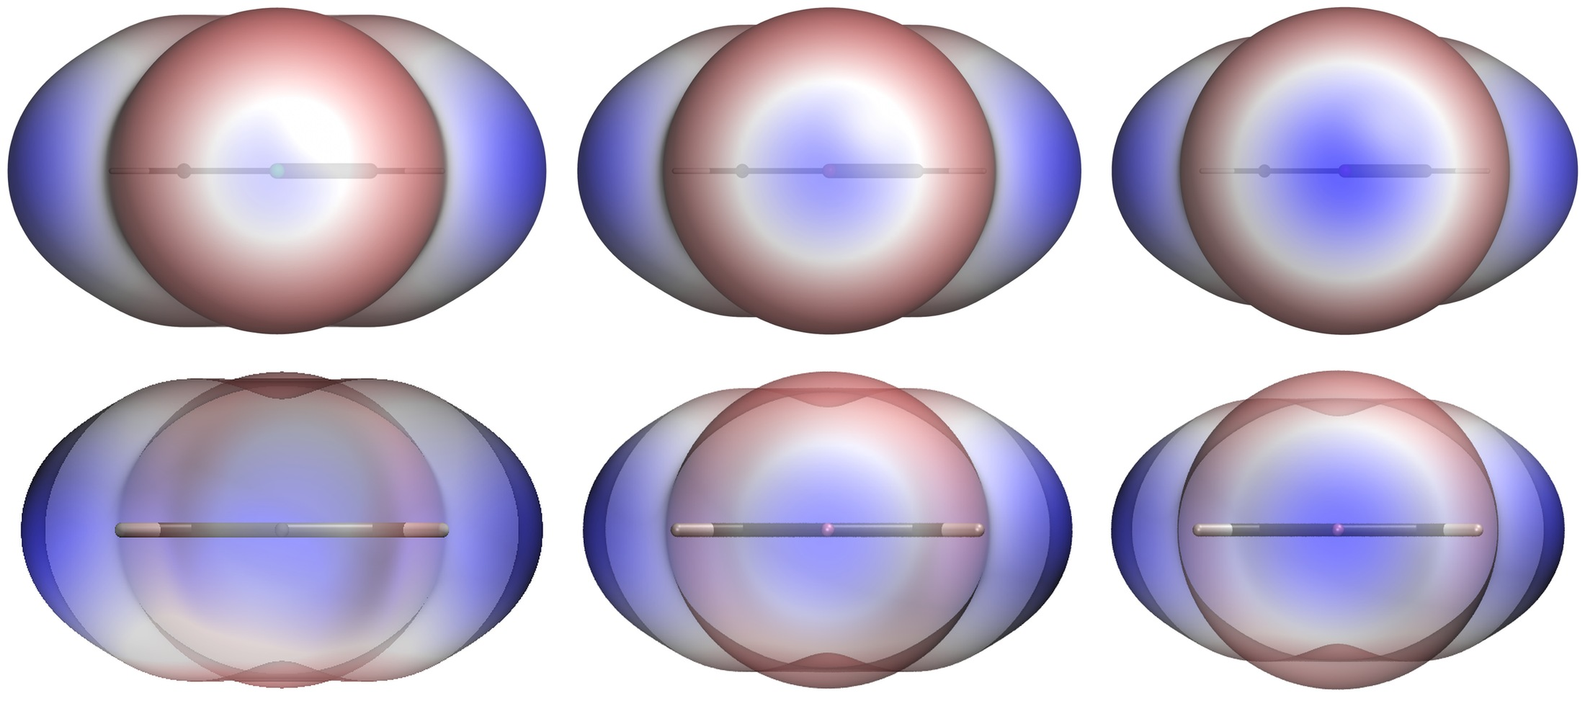
Figure 2 — The view along the C–X axis for chlorobenzene, bromobenzene and iodobenzene. PyMOL above, VMD below, identical data, identical isovalue, identical ±0.0350 a.u. scale throughout. The σ-hole grows from a pale centre through a defined blue disc to a large saturated cap.
The series behaves exactly as the polarizability argument predicts: +4.9, +10.2 and +16.1 kcal/(mol·e) for chlorine, bromine and iodine, a factor of 3.3 across the three. The heavier the halogen, the more its electron density is drawn towards the bond and the more of the nuclear charge is exposed on the far side.
The belt moves in the opposite direction and by much less: −0.01896, −0.01882 and −0.01685 a.u. — becoming slightly less negative as the halogen gets heavier and more polarizable. The anisotropy of the halogen therefore increases in both senses at once, but the σ-hole is by far the more sensitive of the two.

5.3 The pyridine series
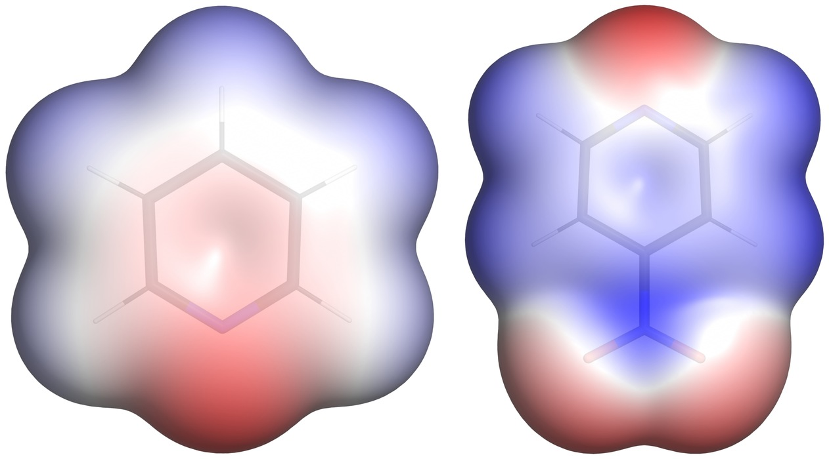
Figure 3 — The π face of pyridine (left, scale ±0.0700 a.u.) and 4-nitropyridine (right, ±0.0500 a.u.). The ring nitrogen is the deep red lone pair at the top left of each; the nitro group of the right-hand molecule pulls density out of the ring, and the lone pair becomes measurably less negative. Note that the two colour scales differ — the images must be read with their colour bars, not against each other.
In five of the six pyridines VS,min sits on the ring nitrogen — on the lone pair, not on the π system. The substituent shifts it in the expected direction and by a large amount: methyl −0.06779, unsubstituted pyridine −0.06500, cyano −0.05927, nitro −0.04712 a.u. That is a span of 0.0207 a.u., 54 kJ/(mol·e), or 31 % of the unsubstituted value, from changing one substituent at the far end of the ring.
The exception is 4-chloro-3-nitropyridine, where VS,min has moved off the ring nitrogen onto a nitro oxygen (O8). With two electron-withdrawing groups the lone pair is depleted enough that the nitro oxygens become the most negative site on the molecule.
The ring carries over to the σ-hole, and this is the most useful design observation in the set. 3-Iodopyridine reaches +0.03441 a.u. (+21.6 kcal/(mol·e)) against +0.02559 (+16.1) for iodobenzene: the same C–I bond on an electron-poorer ring is 34 % stronger. 4-Chloro-3-nitropyridine is more dramatic still — its chlorine reaches +0.02508 against +0.00786 on chlorobenzene, more than three times as much, so that a chlorine in the right electronic environment produces a σ-hole comparable to an iodine in a neutral one. For a medicinal chemist that is the actionable result: the ring matters as much as the halogen.
It is also the only σ-hole in the set that is not on the bond axis. Its maximum sits 6.4° off, pushed there by the neighbouring nitro group; every other halogen here reports 0.0° or, in triazolam, a few degrees.

5.4 Comparison with published values
The values above are internally consistent, but internal consistency is not correctness. The halobenzenes are the right molecules for an external check, because they are among the most frequently computed σ-hole systems in the literature.
Molecule | This work | Riley 2011  B3PW91/6-311G* | Devore 2024  M06-2X/aug-cc-pVDZ(-PP) | Heidrich 2019 | Literature  range
chlorobenzene | +4.9 | +5.3 | +4.1 | ≈5.0 | 4.1 – 5.3
bromobenzene | +10.2 | +12.2 | +10.9 | ≈10.0 | 10.0 – 12.2
iodobenzene | +16.1 | +17.3 | +16.1 | ≈15.7 | 15.7 – 17.3
Table 9 — σ-hole V_S,max in kcal/(mol·e), all on the ρ = 0.001 a.u. surface. The Heidrich values were published in atomic units and converted here; that paper does not state its level of theory. Sources in §11.
All three values fall inside the published range. The spread among the literature sources themselves is 1.2, 2.2 and 1.6 kcal/(mol·e) for Cl, Br and I — roughly ±10–20 % relative — across functionals from B3PW91/6-311G* to M06-2X/aug-cc-pVDZ-PP, and the values obtained here sit comfortably within that band. The agreement with the M06-2X/aug-cc-pVDZ(-PP) results is close enough (+4.9 vs +4.1, +10.2 vs +10.9, +16.1 vs +16.1) to suggest a similar level of theory, though without the provenance of the Turbomole calculations that remains an inference rather than a statement.
The isosurface matters far more than the method, and this is the trap the comparison had to avoid. The same three molecules computed on the ρ = 0.002 a.u. surface give +10.1, +18.7 and +25.5 kcal/(mol·e) — between 1.5 and 2.2 times the 0.001 values. A comparison drawn against those numbers would make the present calculation look wrong by a factor of two when nothing is wrong at all. Any quoted σ-hole is meaningless without its isosurface, which is the same conclusion the parameter study reaches from the other direction (§7.1).

5.5 The image sets
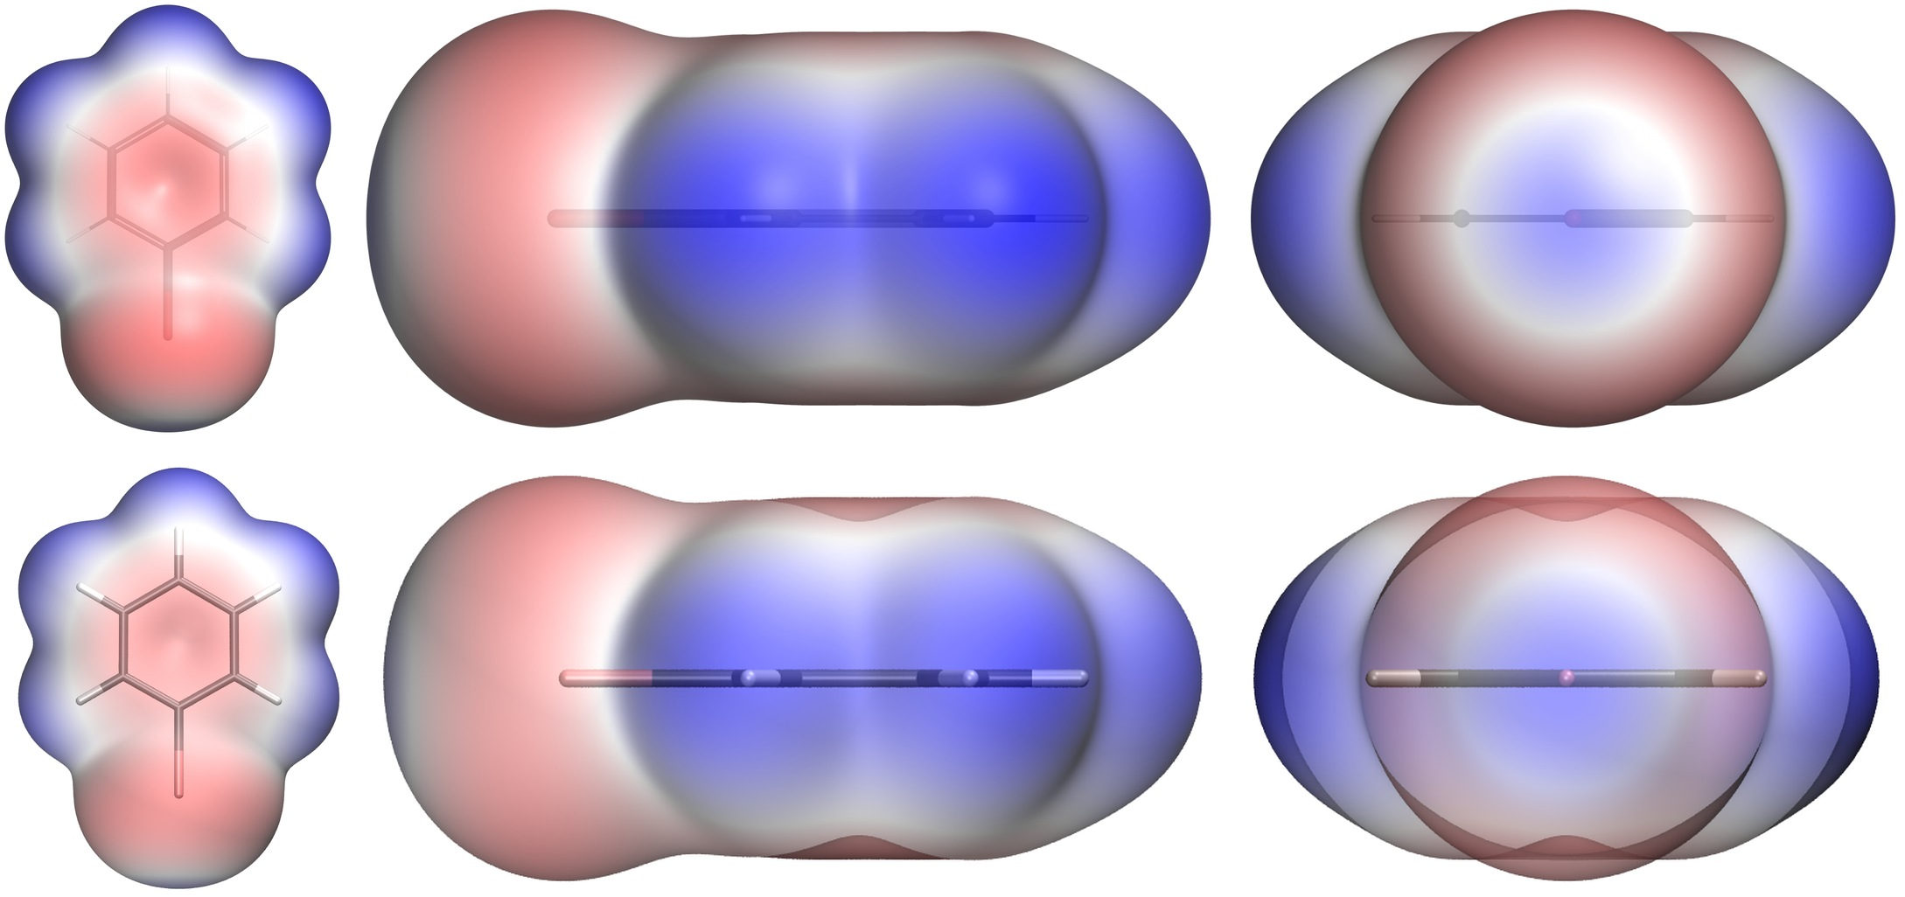
Figure 4 — Bromobenzene, the three standard views: π face, in-plane profile, and the axial view down the C–Br bond. PyMOL above, VMD below, both at ±0.0350 a.u. The potential maps agree; the differences are in the rendering — VMD draws the more readable skeleton, PyMOL the more saturated surface.
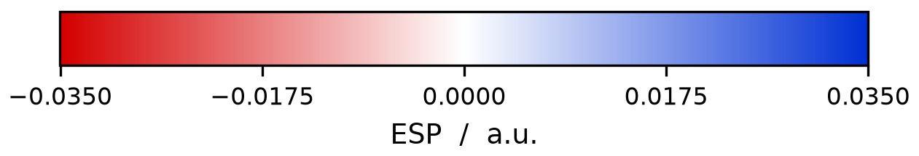
The colour bar shipped with every image set. Red is negative, blue positive, white at zero, and the end points are the numeric range of that particular figure — which is why images from different molecules must not be compared without them.
Each molecule is delivered as three views plus a colour bar and a settings file. The three views are computed from the geometry rather than assumed: the ring normal comes from the principal axis of smallest extent over the heavy atoms, and the axial view follows the true, unprojected C–X axis.

5.6 Where the two pipelines agree, and where they do not
Molecule | V_S,min PyMOL | VMD | V_S,max PyMOL | VMD | Shell points  PyMOL / VMD
pyridine | −0.06500 | −0.06500 | +0.03959 | +0.03959 | 12447 / 12447
4-methylpyridine | −0.06779 | −0.06779 | +0.03647 | +0.03647 | 14641 / 14640
4-cyanopyridine | −0.05927 | −0.05927 | +0.05025 | +0.05025 | 14505 / 14504
4-nitropyridine | −0.04712 | −0.04712 | +0.04487 | +0.04487 | 14452 / 14452
3-iodopyridine | −0.05638 | −0.05638 | +0.04594 | +0.04594 | 16843 / 16840
4-chloro-3-nitropyridine | −0.04545 | −0.04545 | +0.05825 | +0.05825 | 16332 / 16330
chlorobenzene | −0.01896 | −0.01896 | +0.03129 | +0.03129 | 35592 / 35592
bromobenzene | −0.01882 | −0.01882 | +0.03154 | +0.03154 | 38010 / 38008
iodobenzene | −0.01685 | −0.01685 | +0.03168 | +0.03168 | 41631 / 41629
triazolam | −0.08429 | −0.08429 | +0.05432 | +0.05432 | 8146 / 8145
Table 10 — All twenty surface extrema are identical to every printed digit, and so are all ten colour scales. The two pipelines share no code and no intermediate file.
The agreement extends to the σ-hole, and there it carries more weight, because the two values come from two separately written implementations rather than from one calculation reported twice: render_esp.py inside the PyMOL render pass, and tools/SigmaHoleCalc.py in the VMD repository (§5.5).
Molecule | Halogen | σ-hole PyMOL  (a.u.) | σ-hole VMD  (a.u.) | kcal/(mol·e)
chlorobenzene | Cl12 | +0.00786 | +0.00786 | +4.9
bromobenzene | Br12 | +0.01629 | +0.01629 | +10.2
iodobenzene | I12 | +0.02559 | +0.02559 | +16.1
3-iodopyridine | I7 | +0.03441 | +0.03441 | +21.6
4-chloro-3-nitropyridine | Cl10 | +0.02508 | +0.02508 | +15.7
triazolam | Cl21 | +0.01709 | +0.01709 | +10.7
triazolam | Cl11 | +0.01440 | +0.01440 | +9.0
Table 11 — The σ-hole of every halogen in the set, measured independently by the two projects on the same cube files. Identical to five decimals throughout, including both chlorines of triazolam, which the two find and rank separately.
The only measurable disagreement is in the shell point counts, which differ by 0 to 3 out of 12 000 to 42 000 — at most 0.02 %. The cause is the data type: one converter holds the grid in float32 and the other in float64, so a handful of points sitting exactly on the edge of the ρ = iso ± 12 % band fall on different sides of it. No extremum is affected, because those edge points are never the extreme ones.
One value deserves a footnote. VS,min of bromobenzene is −0.018825 — exactly on the rounding boundary at five decimals. Early in development the two pipelines reported −0.01882 and −0.01883 for it, which looked like a real discrepancy and was a display artefact: the value is stamped into the cube header and was being rounded once on writing and again on reading. Stamping it with eight decimals instead of six moved it far enough from the boundary that the second rounding cannot disagree with the first.
What this establishes. The two pipelines see the same surface, with the same values, on the same scale. Every difference between the two rows of Figures 2, 4 and 7 is therefore attributable to the viewer — to how it triangulates the isosurface, how it interpolates the potential onto the vertices, and how it composites transparency — and to nothing else. The numbers are viewer-independent; the images are not.
Two further image pairs show what the viewer does contribute, and they separate the two mechanisms that cause it.
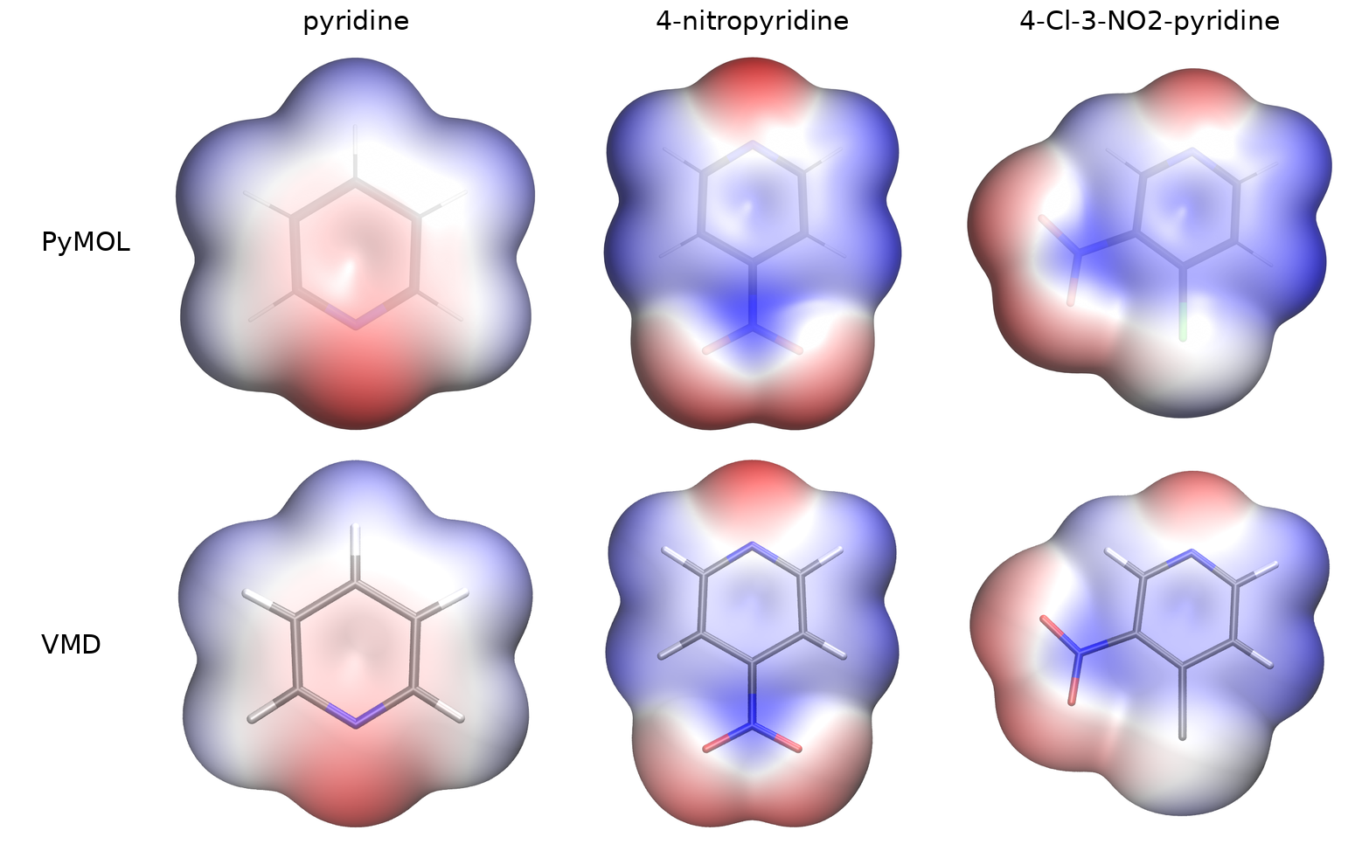
Figure 5 — The π face of pyridine, 4-nitropyridine and 4-chloro-3-nitropyridine, PyMOL above and VMD below. Scales ±0.0700, ±0.0500 and ±0.0600 a.u. respectively, so the rows may be read against each other but the columns may not.
Here the balance tips towards VMD. The potential maps agree closely — ring nitrogen and nitro oxygens red, ring face blue, the same gradients — but VMD draws the more legible skeleton. Its sticks carry element colours through the surface, so nitrogen, oxygen and the hydrogens stay identifiable, where PyMOL's are a faint grey outline at the same transparency setting. For a figure whose job is to show where on a molecule a potential sits, that is an advantage, and it is the one place in this comparison where the second pipeline produces the better picture.
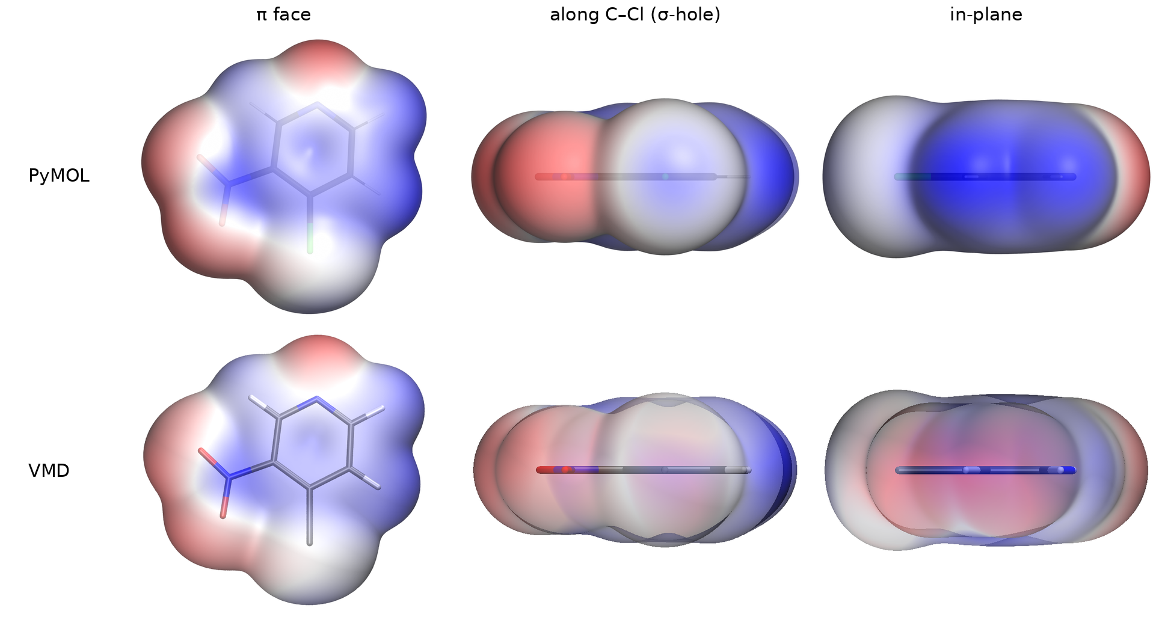
Figure 6 — 4-Chloro-3-nitropyridine, the three standard views, PyMOL above and VMD below, ±0.0600 a.u. The control case: VMD's ray tracer completed all three of these views at full quality, so nothing here fell back to a window capture.
This molecule is the clean test. Because no view fell back, every difference in the row is transparency alone. The π face repeats the finding of Figure 5 — the maps agree and VMD's coloured skeleton makes the substitution pattern readable. The axial view repeats the finding of Figure 2 — PyMOL resolves the pale σ-hole on the chlorine inside its red belt, VMD flattens the same surface into an even wash. Both are full-quality renders of identical data, which rules out the ray tracer and leaves the transparency weighting (§8.4) as the only remaining cause.

5.7 The rainbow ramp
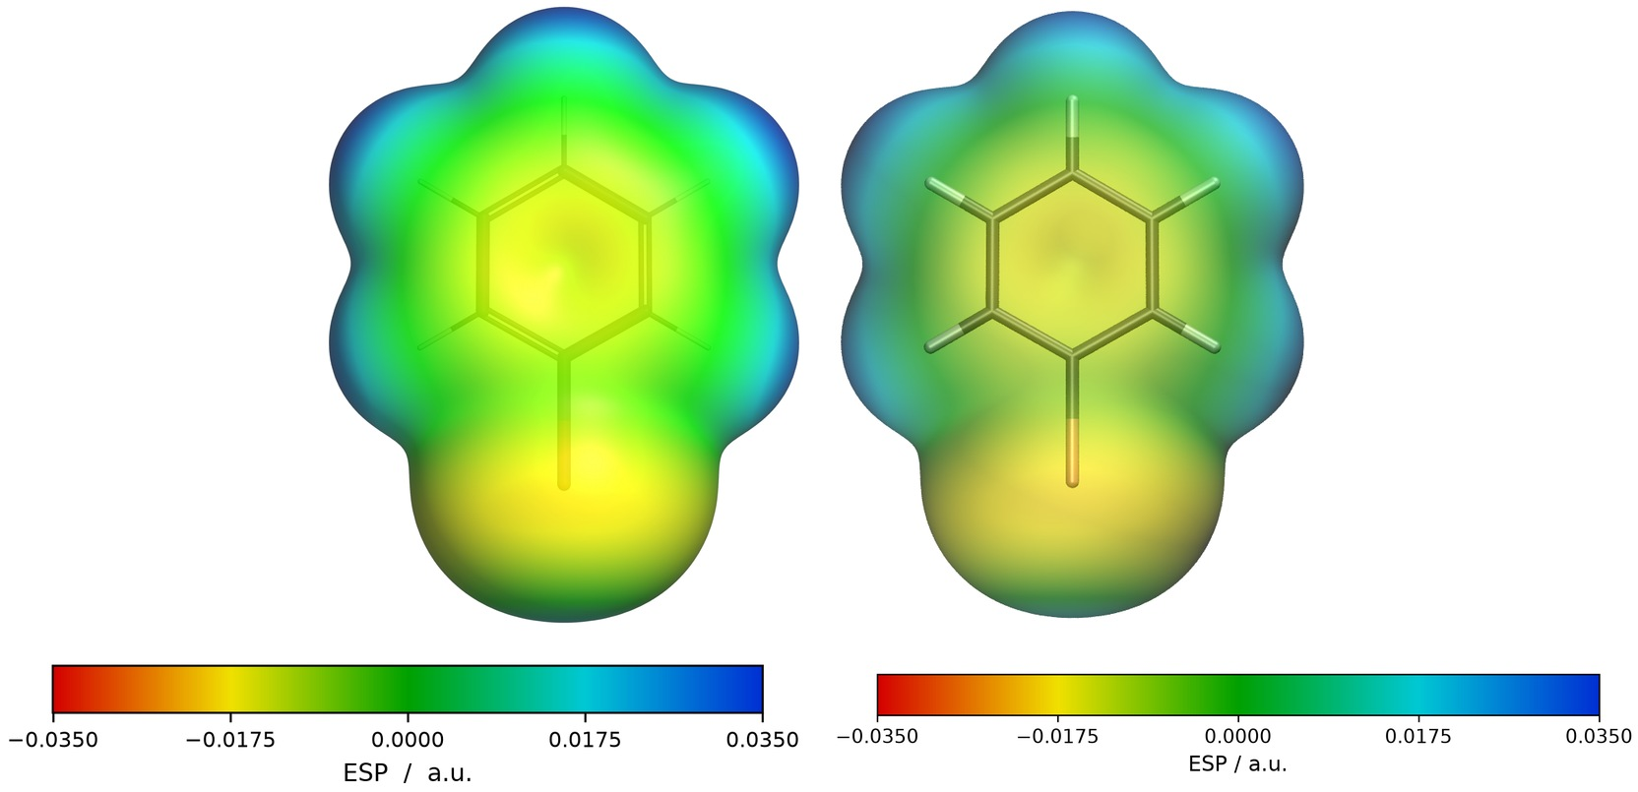
Figure 7 — Bromobenzene with the rainbow ramp, PyMOL left and VMD right, each with the colour bar its own pipeline generated. Scale ±0.0350 a.u.
Both pipelines offer a five-stop ramp: red-yellow-green-cyan-blue as an alternative to red-white-blue, and both write it as a separate image set so the standard one survives. The mechanisms could hardly be more different: PyMOL creates a ramp object with five explicit anchor levels, while VMD has no ramp object at all and the effect has to be produced by rewriting 1024 entries of its global colour table. That the two produce the same colours at the same places is the useful negative result of the comparison.
The asymmetry is worth one more sentence, because it is the sharpest illustration of how little the two share. PyMOL's ramp_new takes the five colours and the five values and interpolates between them internally, in one call. VMD has no ramp object at all, only a fixed 1024-entry colour table, so the generated scene walks all 1024 entries, works out which of the four segments between the five anchor colours each entry falls in and how far along it, and mixes R, G and B linearly between the two neighbouring anchors. The Python side only converts the five hex colours into RGB triples; the interpolation itself happens in Tcl, inside the scene file. Both routes put the same colour at the same value.
When to use which. Red–white–blue spends almost no colour resolution near zero, so everything weakly polar comes out white; the rainbow resolves exactly that region. The price is that a rainbow is not perceptually uniform. The eye reads the yellow–green and green–cyan transitions as edges even where the potential changes smoothly. For a quantitative claim, red–white–blue remains the more honest depiction. The convention is deliberately not inverted in either ramp: red stays negative and blue stays positive, so the two sets can be laid side by side.

6 Parameter selection
Every default in the workflow was chosen against a measurement rather than by convention. This section collects those measurements, and it is the part of the report that generalises beyond this particular dataset. The short version: the isovalue is the only parameter that changes the physics.

6.1 Isovalue — the parameter that matters
Bromobenzene on the full 251³ grid at 0.12 Bohr spacing, everything else at defaults:
ρ / a.u. | Shell points | V_S,min | V_S,max | σ-hole | kcal/(mol·e) | Belt
0.0005 | 43009 | −0.0175 | +0.0248 | +0.0098 | +6.2 | −0.0175
0.0008 | 39451 | −0.0185 | +0.0292 | +0.0139 | +8.7 | −0.0185
0.0010 | 38010 | −0.0188 | +0.0315 | +0.0163 | +10.2 | −0.0188
0.0015 | 35283 | −0.0191 | +0.0377 | +0.0217 | +13.6 | −0.0191
0.0020 | 33771 | −0.0191 | +0.0424 | +0.0265 | +16.6 | −0.0191
0.0040 | 30320 | −0.0173 | +0.0615 | +0.0434 | +27.2 | −0.0173
Table 12 — From 0.0005 to 0.004 the σ-hole grows by a factor of 4.4.
A larger isovalue means a surface closer to the nuclei, where less of the positive nuclear contribution has been screened by the electrons. But the isovalue does not simply rescale the surface: over the same range the global maximum on the ring hydrogens grows by a factor of 2.5 while the belt around the bromine barely moves and then reverses. Different features respond differently, which is precisely why a σ-hole value quoted without its isovalue is meaningless, and why two values computed at different isovalues cannot be compared at all. §6.4 shows the same effect from the literature side.
The shell point count falls by 30 % across the range while the σ-hole grows 4.4-fold, so the count is no indication of what happened to the values. The --iso option exists to reproduce someone else’s choice, not to improve on 0.001.

6.2 Grid resolution
Same molecule, isovalue fixed at 0.001, the same grid decimated by an increasing stride during conversion:
--stride | Grid | Δ / Bohr | Cube size | V_S,min | V_S,max | σ-hole | kcal/(mol·e)
1 | 251³ | 0.12 | 201.1 MB | −0.0188 | +0.0315 | +0.0163 | +10.2
2 | 126³ | 0.24 | 25.4 MB | −0.0188 | +0.0312 | +0.0161 | +10.1
3 | 84³ | 0.36 | 7.5 MB | −0.0188 | +0.0312 | +0.0160 | +10.1
4 | 63³ | 0.48 | 3.2 MB | −0.0188 | +0.0311 | +0.0158 | +9.9
6 | 42³ | 0.72 | 0.9 MB | −0.0188 | +0.0312 | +0.0149 | +9.4
8 | 32³ | 0.96 | 0.4 MB | −0.0187 | +0.0296 | +0.0135 | +8.4
Table 13 — Cost falls by a factor of 480 across this table; the σ-hole falls by 17 %.
The degradation is smooth and one-sided, because the interpolated density smooths the isosurface outwards and the potential there is less positive. VS,min is essentially immune it is a broad, flat feature while the σ-hole, a sharp peak, is the sensitive one. Practical rule: stride 2 for looking, stride 1 for numbers that go in a table. The converter warns above 0.30 Bohr spacing for exactly this reason.

6.3 Evaluation method: rays against grid points
The same six grids, the same isovalue, the same molecule, only the way the σ-hole is read off differs:
Grid | Spacing | Point-based | Ray-based (used)
42³ | 0.72 Bohr | +2.1 kcal/(mol·e) | +9.4 kcal/(mol·e)
126³ | 0.24 Bohr | +7.9 | +10.1
251³ | 0.12 Bohr | +11.0 | +10.2
Table 14 — Bromobenzene. The point-based value spans a factor of five across these grids; the ray-based one varies by 8 %.
Triazolam makes the same point on a single grid rather than across several. Its Cl21 σ-hole is +10.7 kcal/(mol·e) by rays and +16.8 by grid points — a 57 % difference from identical data. The point-based method is not merely noisier; on a coarse grid it is biased low, because the probability of a grid point falling near the axis and inside the thin shell decreases as the shell gets relatively thinner.

6.4 σ-hole search parameters
The search itself is governed by six settings: a cone half-angle of 36.9°, 400 rays on a Fibonacci spiral with the first ray exactly on the axis, a 0.02 Bohr step, a radius cut-off at 1.6 × the Bondi van der Waals radius (§8.3), and a belt half-angle of ±69.5° at 1.5 × the mean cap radius. The first two were tuned; the rest follow from the geometry, and all six are documented with their reasoning in the code.

6.5 Colour range — visual only
The colour range never touches a computed value; it only maps numbers to colours. It appears in this section because getting it wrong makes a correct calculation look wrong.
Molecule | Automatic range | Set by
halobenzenes | ±0.035 | the halogen belt
4-chloro-3-nitropyridine | ±0.060 | the ring hydrogens
pyridine, 4-methylpyridine | ±0.070 | the ring nitrogen lone pair
triazolam | ±0.085 | the triazole nitrogens
Table 15 — The automatic range is set by whichever feature of the molecule is most extreme, which is rarely the feature under discussion.
A σ-hole of +0.017 a.u. is 49 % of full blue at ±0.035 and 20 % at ±0.085 — clearly visible in the first case and nearly white in the second, from identical data. Triazolam is the cautionary example: its triazole nitrogens push the automatic range out to ±0.085 and a correctly computed σ-hole but it disappears from the picture. A common scale is required whenever two figures are compared, and a common scale is meaningless across data of different provenance.

6.6 Rendering parameters
None of the rendering settings changes a computed value: transparency 0.15 in PyMOL against opacity 0.50 in VMD (§8.4), a 0.10 Å stick radius, cast shadows off in both, orthoscopic projection, and 2000 × 1600 px at 300 dpi in PyMOL against 1600 × 1061 in VMD, where the image is capped at window size. Every value that produced a figure is recorded in the *_settings.txt beside it, which is the reproduction record — not this paragraph.

6.7 Ranking the sources of uncertainty
Collecting the four measurements above gives the result that generalises beyond this dataset. All figures are for the σ-hole of bromobenzene, the most sensitive quantity in the workflow:
Rank | Parameter | Effect on the reported σ-hole | Reference
1 | Isovalue ρ | factor 4.4 over 0.0005–0.004 a.u. | §7.1, Table 12
2 | Evaluation method | up to factor 1.6 on a coarse grid; 57 % on triazolam at full resolution | §7.3, Table 14
3 | Grid spacing | 17 % over a 480-fold cost range | §7.2, Table 13
4 | Quantum-chemical method | roughly ±10–20 % between published functionals | §6.4, Table 9
5 | Visualization program | none — zero to five decimal places | §6.6, Table 10
Table 16 — The ranking. The parameter most often left unstated in publications is the one at the top of this list.
This is the central result of the report. The choice of visualization program — the decision that consumed most of the evaluation effort in §1 and that a reader would most readily suspect of biasing a figure — contributes nothing measurable. The isovalue, which is frequently reported as an afterthought or not at all, moves the answer by more than a factor of four. A σ-hole value is therefore only meaningful when quoted together with its isosurface and its evaluation method; the program that drew the picture is irrelevant to the number, and relevant only to the picture.

7 Robustness and failure modes
A workflow that fails loudly is better than one that fails quietly, and every defect described here produced a plausible-looking figure before it was caught. They are reported in full because in a software evaluation they are results, not embarrassments.

7.1 More than one structure file
A molecule folder holds the two grids and a structure file. If it holds two structure files that are not simply the same geometry in a second format, the batch driver used to take the first in sort order. A left-over file that happens to sort first then pairs the wrong geometry with the grids silently — “Halcion - Kopie.mol” next to “Halcion.mol” is enough. Both pipelines now abort, name every candidate they found, and ask for the folder to be cleaned up. There is nothing to choose from, so nothing is chosen.

7.2 Structure and grid do not belong together
The more serious version of the same problem. A cube file marries two things from different sources: the atom block comes from the structure file, the grid from the quantum chemistry. Nothing in the format forces them to describe the same geometry, and when they do not, the molecule floats beside its own isosurface. This failure does not announce itself: there is a round, coloured surface in every direction, and one takes the far side for the σ-hole.
It surfaced on triazolam, where a left-over structure file from an earlier run put all 35 nuclei in vacuum. The centroids of the two geometries agreed and no permutation of the axes repaired it, so the difference was a rotation — the one error a glance at the picture will not catch.
The guard is one line of physics. Where a nucleus sits the electron density is enormous; where none sits it is near zero. The check looks up the density at every heavy nucleus and takes the median of the largest value in the 3×3×3 neighbourhood of each:
Grid spacing | Median ρ at the heavy nuclei | Interpretation
0.12 Bohr | 64 | full resolution
0.25 Bohr | 27 | typical production run
0.60 Bohr | 5 | the decimated reference dataset
— | 0.03 | the broken case: structure from a different run
Table 17 — The threshold is set at 1.0, a factor of five below the coarsest healthy case and thirty above the broken one. A coarse grid depresses the value because the nucleus then sits further from the nearest grid point and the density peak falls off steeply.
Three details of that check are not obvious, and all three were established by measurement:
- The median rather than the minimum. Iodine is described by an effective core potential, so its core electrons are not in the density at all and its nucleus carries about 0.26 a.u. on a perfectly healthy molecule — less than a hydrogen. A minimum-based rule would reject every iodine compound in the set.
- The largest value in the 3×3×3 neighbourhood rather than trilinear interpolation. The density has a cusp at a nucleus and linear interpolation can only cut a cusp off — measured at 46 % too low on the coarse grid. This is the same interpolation that is correct on the smooth isosurface (§5.4).
- The cheaper alternative — checking that all atoms lie inside the grid box — would have been useless here: of 2000 random rotations of triazolam, not one pushed an atom out of the box. The error is a rotation about the common centroid and stays geometrically inconspicuous.
In a batch the two failures are treated differently, and deliberately so. Ambiguous structure files stop the whole run, because nothing can be chosen. A structure/grid mismatch is local to one folder: at several minutes per molecule, failing a ten-molecule run over one bad folder would be waste, so the molecule is skipped, named again at the end, and the exit code is 1 — visible to whatever called the script, without the other nine image sets being lost.

7.3 The ray leaving its own halogen
Triazolam exposed a second defect, and this one was not about having two halogens — it had simply never been triggered by flat molecules. The ray method originally took the outermost crossing of ρ = 0.001. In a folded molecule the cone around one C–X axis does not point into empty space but at another part of the molecule, so the ray passed through the halogen’s own surface, through the gap, and measured the surface of the methyl group on the triazole ring beyond it.
 | Before | After
Cl21 σ-hole | +18.8 kcal/(mol·e), 29.0° off the axis | +10.7, 3.8°
Cl21 belt | −42.0 (in fact the triazole nitrogens) | −11.5
Table 18 — +18.8 for an aryl chloride was the clue: chlorobenzene gives +4.9, and no substituent pattern triples that.
Two changes fixed it, and both are now defaults:
- The ray takes the innermost downward crossing. It starts deep inside the halogen’s own density, so the first drop through the isovalue is that halogen’s own surface.
- Both the ray search and the grid-point cap are cut off at 1.6 × the Bondi van der Waals radius of the halogen.
Single-halogen molecules are unaffected — bromobenzene stays at +0.01629 a.u. and −0.01882 for the belt, identical to every digit before and after. The lesson generalises: three flat halobenzenes cannot test a method that assumes the space beyond the halogen is empty. The same molecule also revealed that the axial view was being computed from the C–X axis projected into the best-fit plane, which for a non-planar molecule looked 42.9° past the σ-hole. Both defects were invisible on the model compounds and obvious on a real drug molecule.

7.4 Renderer behaviour
Three properties of the VMD renderer had to be worked around, and they are documented because they affect what the images can be used for.
Transparency does not translate between the programs, and the two settings are not even on the same scale. PyMOL is set by transparency, where 0 is opaque and the pipeline uses 0.15; VMD is set by the opacity of its Transparent material, where 1 is opaque and the pipeline uses 0.50. PyMOL's 0.15 transparency is therefore an opacity of a = 0.85, and a value copied from one program into the other means close to its opposite.
Converting is not enough either. The isosurface is closed, so a line of sight enters at the front and leaves at the back, and at opacity a only (1 − a)² of what lies behind survives: 25 % at VMD's a = 0.50, and 2 % at PyMOL's a = 0.85. By that arithmetic PyMOL's images should be solid, and they are not — the stick model shows through clearly, because transparency_mode 2 treats the back faces of the surface differently from a naive two-layer product. VMD applies no such correction and empirically needs roughly a = 0.30, which is 49 % transmission, before the axial view gives a comparable impression. The two programs do not merely label the setting differently, they weight it differently, and no single value makes one pipeline's images reproduce the other's.
One setting cannot serve all three views. The axial view crosses the most layers of surface and would need the lowest opacity to read like the others; at that value the π and in-plane views, which cross fewer, turn so faint that their colour can no longer be read. The pipeline therefore keeps a single value per run, so that the three images of one molecule stay mutually comparable, and the cost is paid uniformly across every VMD panel: the red belt separates less clearly from the blue cap.
The ray tracer fails unpredictably on stacked transparency. In the axial view every line of sight crosses many transparent layers, and TachyonInternal aborts there — on Windows with exit code 0xC0000374, heap corruption, and no error message. The same nine molecules were rendered twice from identical data with identical settings: nine of twenty-seven views fell back to a window capture in the first run and seven in the second, with the set almost completely exchanged. Iodobenzene lost all three views in the first run and none in the second; bromobenzene lost one and then two. The failure is therefore not a property of the molecule, and it is not reproducible. The pipeline renders in passes and keeps whatever each pass produced, recording per view which pass produced it. PyMOL’s ray tracer rendered all twenty-seven without a single failure, in both runs.
Image size is capped by the screen. TachyonInternal renders at window size and Windows clamps the window to the display, so a request for 1600 × 1280 yields 1600 × 1061 on a 1080-line screen. The VMD image sets are correspondingly smaller than the PyMOL ones.

8 Discussion

8.1 What is viewer-dependent and what is not
The separation established in §6.6 is clean and, as far as this dataset goes, complete. Surface extrema, colour ranges, σ-holes and belts are properties of the data and the convention; they came out identical from two implementations that share no code. Everything that differs between the two rows of Figures 2, 4 and 7 — the saturation of the surface, the visibility of the skeleton, the apparent size of the molecule, the smoothness of the triangulation — is the viewer.
That has a practical consequence for reading the literature. A published ESP figure carries no information about the program that made it, and needs none. What it must carry is the isovalue and the colour range, because those are what the ranking in Table 16 says actually matter. A figure without a labelled colour bar cannot be read at all, and this workflow ships one with every image for that reason.

8.2 Which pipeline for what
- For quantities, use the PyMOL pipeline. Not because its V_S values are better, they are identical, but because it is the one that locates the σ-hole, names the atom carrying each extremum, and handles several halogens per molecule.
- For the π face, either. The maps agree and VMD draws the more readable skeleton.
- For the axial view, PyMOL. This is the view that carries the σ-hole argument and the one VMD renders worst. Partly through the transparency mechanics, partly because it is the view its ray tracer is most likely to abandon.
- The second pipeline nevertheless earned its place. It confirmed the surface statistics of the first from an independent implementation, on ten molecules, to five decimal places. No amount of internal testing of a single implementation could have produced that.

8.3 Limitations
- One level of theory. All grids come from a single set of Turbomole calculations whose method and basis set were not supplied. The literature comparison in §6.4 suggests they are consistent with a modern hybrid functional and a polarised double-zeta basis with ECP, but that is an inference. The ±10–20 % method sensitivity in Table 16 is taken from published values, not measured here.
- The σ-hole tool in the VMD repository is a port of the PyMOL routine, not an independent derivation. Its self test proves the two copies are still the same code; it does not independently confirm the method. The genuine independent confirmation in this report is the surface statistics of §6.6, which were written twice.
- Two grid geometries. The pyridines were computed on a wider box at coarser spacing than the halobenzenes. Table 13 indicates the effect on V_S is negligible at these spacings, but the two groups are not strictly a single dataset.
- Avogadro 2 and GaussView 6 were assessed from documentation only (§1.5).
- The delivered image sets and the parameter study were produced on the same data but at different times; the tables in §7 come from the bromobenzene study and were not repeated for every molecule.

9 Outlook

9.1 Electrostatic complementarity
The natural extension is from one molecule to an interface: comparing the potential on a ligand surface with the potential the protein presents at the same place, so that a red patch facing a blue one scores as complementary. Several components of this workflow transfer directly — the cube handling, the shell band, the surface statistics and the rendering. Three things would have to be added: an electrostatics model for the protein, which is a different computational problem (Poisson–Boltzmann, or partial charges with a distance-dependent dielectric); a quantitative definition of what “complementary” means as a number; and a validation case for which the answer is already known. The last of these is the hard one, and it is why this was scoped out rather than attempted.

9.2 A third viewer
ChimeraX would take the evaluation from two data points to three at low marginal cost: the cube files and the analysis already exist, only a scene script and an image set would be new. On the evidence of §6.6 the numbers would agree; the open question is whether its OpenGL-only rendering produces a comparable axial view, which is the one view where the two existing pipelines genuinely differ.

9.3 The missing axis
The ranking in §7.7 has four measured rows and one taken from the literature. Repeating a single molecule at two levels of theory would close that gap with a number of this project's own, which is the most valuable single addition the work could still receive.

Appendix A Repository layout
Two repositories, one per pipeline, each self-contained and independently clonable: Pymol_esp_visualization holds the converter, the renderer, the batch driver and the parameter studies; VMD_esp_visualization holds the same chain for VMD plus the σ-hole tool. The standard operating procedures — installation, execution, the complete parameter reference, worked examples and troubleshooting — live in the README.md of each repository and are deliberately not reproduced here.
Large files are deliberately untracked: a full-resolution cube is about 200 MB, so cubes and raw grids are excluded by .gitignore and regenerated by the converters. The one exception is the reference dataset, which ships as decimated raw pointval files rather than as cubes, so that a fresh clone exercises the whole chain including unit conversion and index reordering.

Reproducing the results
# self test on the committed reference dataset (Smoketest)
cd scripts && python run_all.py
# the full result set, both pipelines
python run_all.py --root ../sandbox --two-pass
python run_allVMD.py --root ../sandbox --esp-range 0.0850
# the sigma hole of one molecule, outside the rendering workflow
cd tools && python SigmaHoleCalc.py --folder ../sandbox/brombenzol --csv

11 References

Method and convention
- R. F. W. Bader, M. T. Carroll, J. R. Cheeseman, C. Chang, Properties of atoms in molecules: atomic volumes, J. Am. Chem. Soc. 109 (1987) 7968–7979. doi:10.1021/ja00260a006
- F. A. Bulat, A. Toro-Labbé, T. Brinck, J. S. Murray, P. Politzer, Quantitative analysis of molecular surfaces: areas, volumes, electrostatic potentials and average local ionization energies, J. Mol. Model. 16 (2010) 1679–1691. doi:10.1007/s00894-010-0692-x
- J. S. Murray, P. Politzer, The electrostatic potential: an overview, WIREs Comput. Mol. Sci. 1 (2011) 153–163. doi:10.1002/wcms.19
- P. Politzer, J. S. Murray, T. Clark, Halogen bonding and other σ-hole interactions: a perspective, Phys. Chem. Chem. Phys. 15 (2013) 11178–11189. doi:10.1039/C3CP00054K
- G. Cavallo, P. Metrangolo, R. Milani, T. Pilati, A. Priimagi, G. Resnati, G. Terraneo, The Halogen Bond, Chem. Rev. 116 (2016) 2478–2601. doi:10.1021/acs.chemrev.5b00484

σ-hole values used in the literature comparison (§6.4)
- K. E. Riley, J. S. Murray, J. Fanfrlík, J. Řezáč, R. J. Solá, M. C. Concha, F. M. Ramos, P. Politzer, Halogen bond tunability I: the effects of aromatic fluorine substitution on the strengths of halogen-bonding interactions involving chlorine, bromine and iodine, J. Mol. Model. 17 (2011) 3309–3318. doi:10.1007/s00894-011-1015-6
- D. P. Devore, T. L. Ellington, K. L. Shuford, Elucidating the role of electron-donating groups in halogen bonding, J. Phys. Chem. A 128 (2024) 1477–1490. doi:10.1021/acs.jpca.3c06894
- J. Heidrich, L. E. Sperl, F. M. Boeckler, Embracing the diversity of halogen bonding motifs in fragment-based drug discovery — construction of a diversity-optimized halogen-enriched fragment library, Front. Chem. 7 (2019) 9. doi:10.3389/fchem.2019.00009
- M. A. A. Ibrahim et al., Type I–IV halogen···halogen interactions: a comparative theoretical study in halobenzene···halobenzene homodimers, Int. J. Mol. Sci. 23 (2022) 3114. doi:10.3390/ijms23063114 [the ρ = 0.002 a.u. values]
- P. R. Varadwaj, A. Varadwaj, H. M. Marques, K. Yamashita, Can combined electrostatic and polarization effects alone explain the F···F negative–negative bonding in simple fluoro-substituted benzene derivatives?, Computation 6 (2018) 51. doi:10.3390/computation6040051 [fluorobenzene]
- M. H. Kolář, P. Carloni, P. Hobza, Statistical analysis of σ-holes: a novel complementary view on halogen bonding, Phys. Chem. Chem. Phys. 16 (2014) 19111. doi:10.1039/C4CP02621G

Software
- The PyMOL Molecular Graphics System, Schrödinger, LLC. Open-source build: github.com/schrodinger/pymol-open-source
- W. Humphrey, A. Dalke, K. Schulten, VMD — Visual Molecular Dynamics, J. Mol. Graph. 14 (1996) 33–38. doi:10.1016/0263-7855(96)00018-5
- E. C. Meng et al., UCSF ChimeraX: tools for structure building and analysis, Protein Sci. 32 (2023) e4792. doi:10.1002/pro.4792
- M. D. Hanwell et al., Avogadro: an advanced semantic chemical editor, visualization and analysis platform, J. Cheminform. 4 (2012) 17. doi:10.1186/1758-2946-4-17
- GaussView 6, Gaussian Inc. gaussian.com/gaussview6

Workflow documentation
- README.md in each repository: installation, execution, complete parameter reference, worked examples, troubleshooting. These are the standard operating procedures and are the authoritative reference for running the pipelines.
- tools/README.txt: the test-data generator, its parameters and its limitations.

