Elaboration of the project to develop a workflow to visualize ESP surfaces of a molecule
Felix Laufer
Frontiers in applied drug design
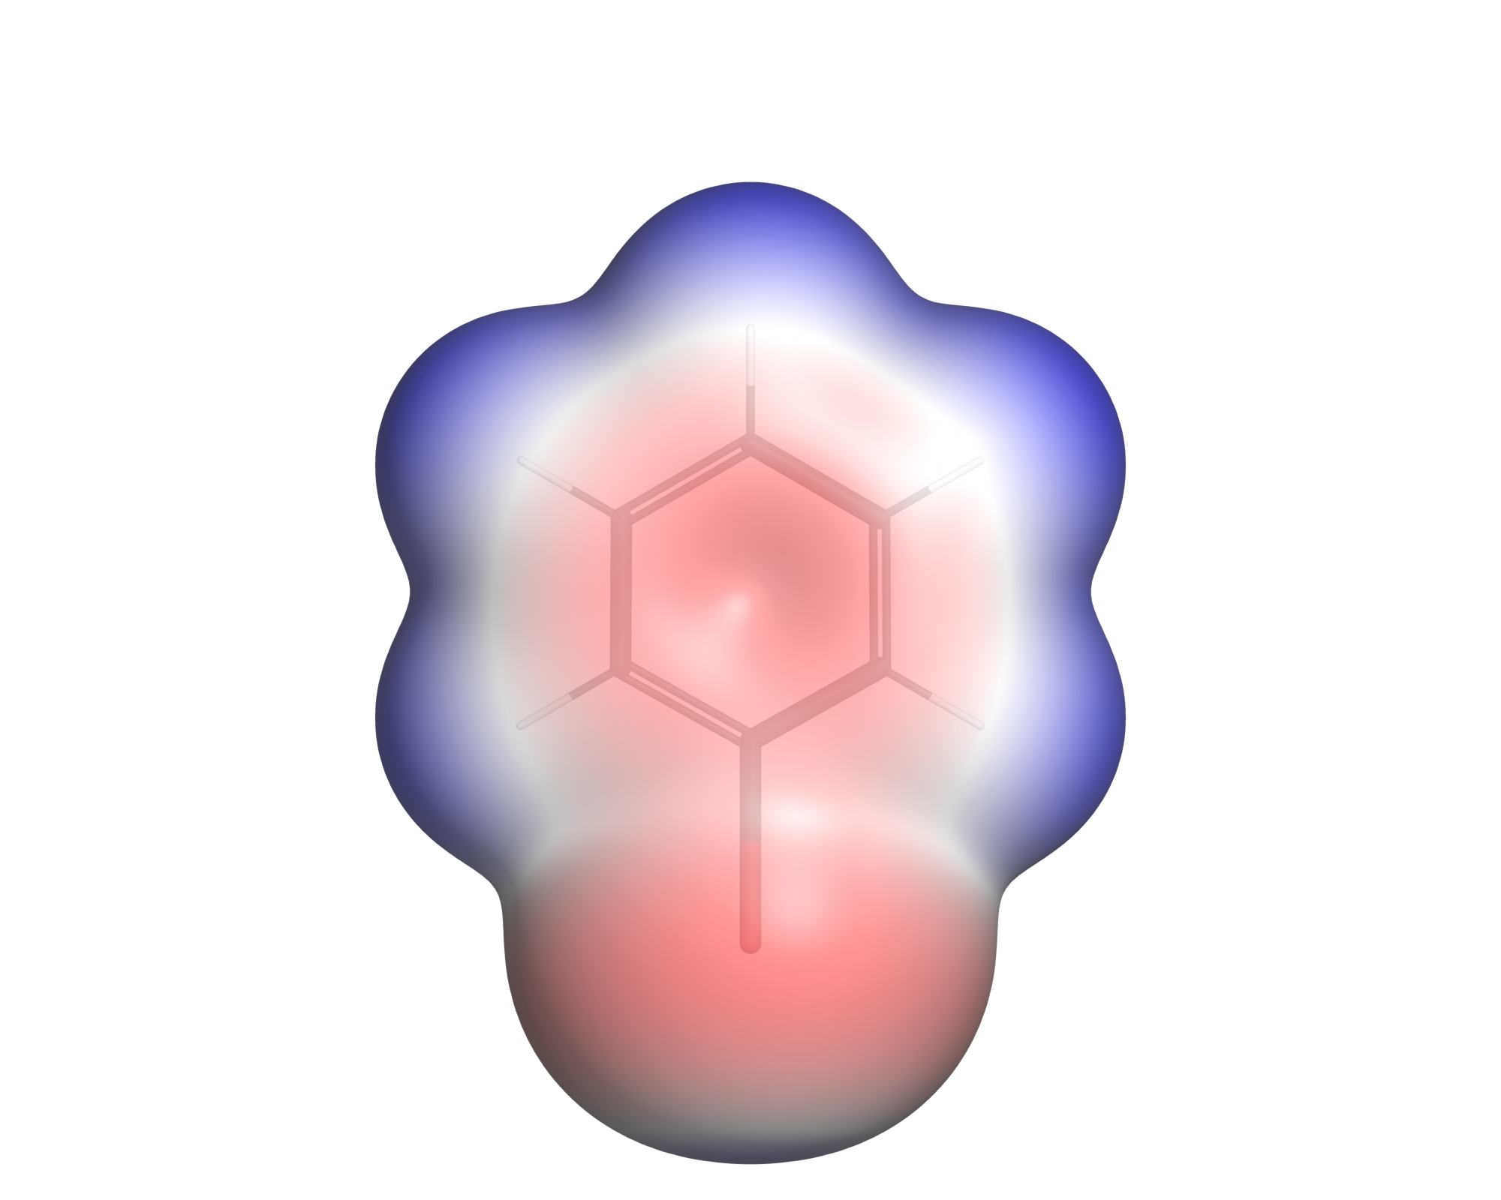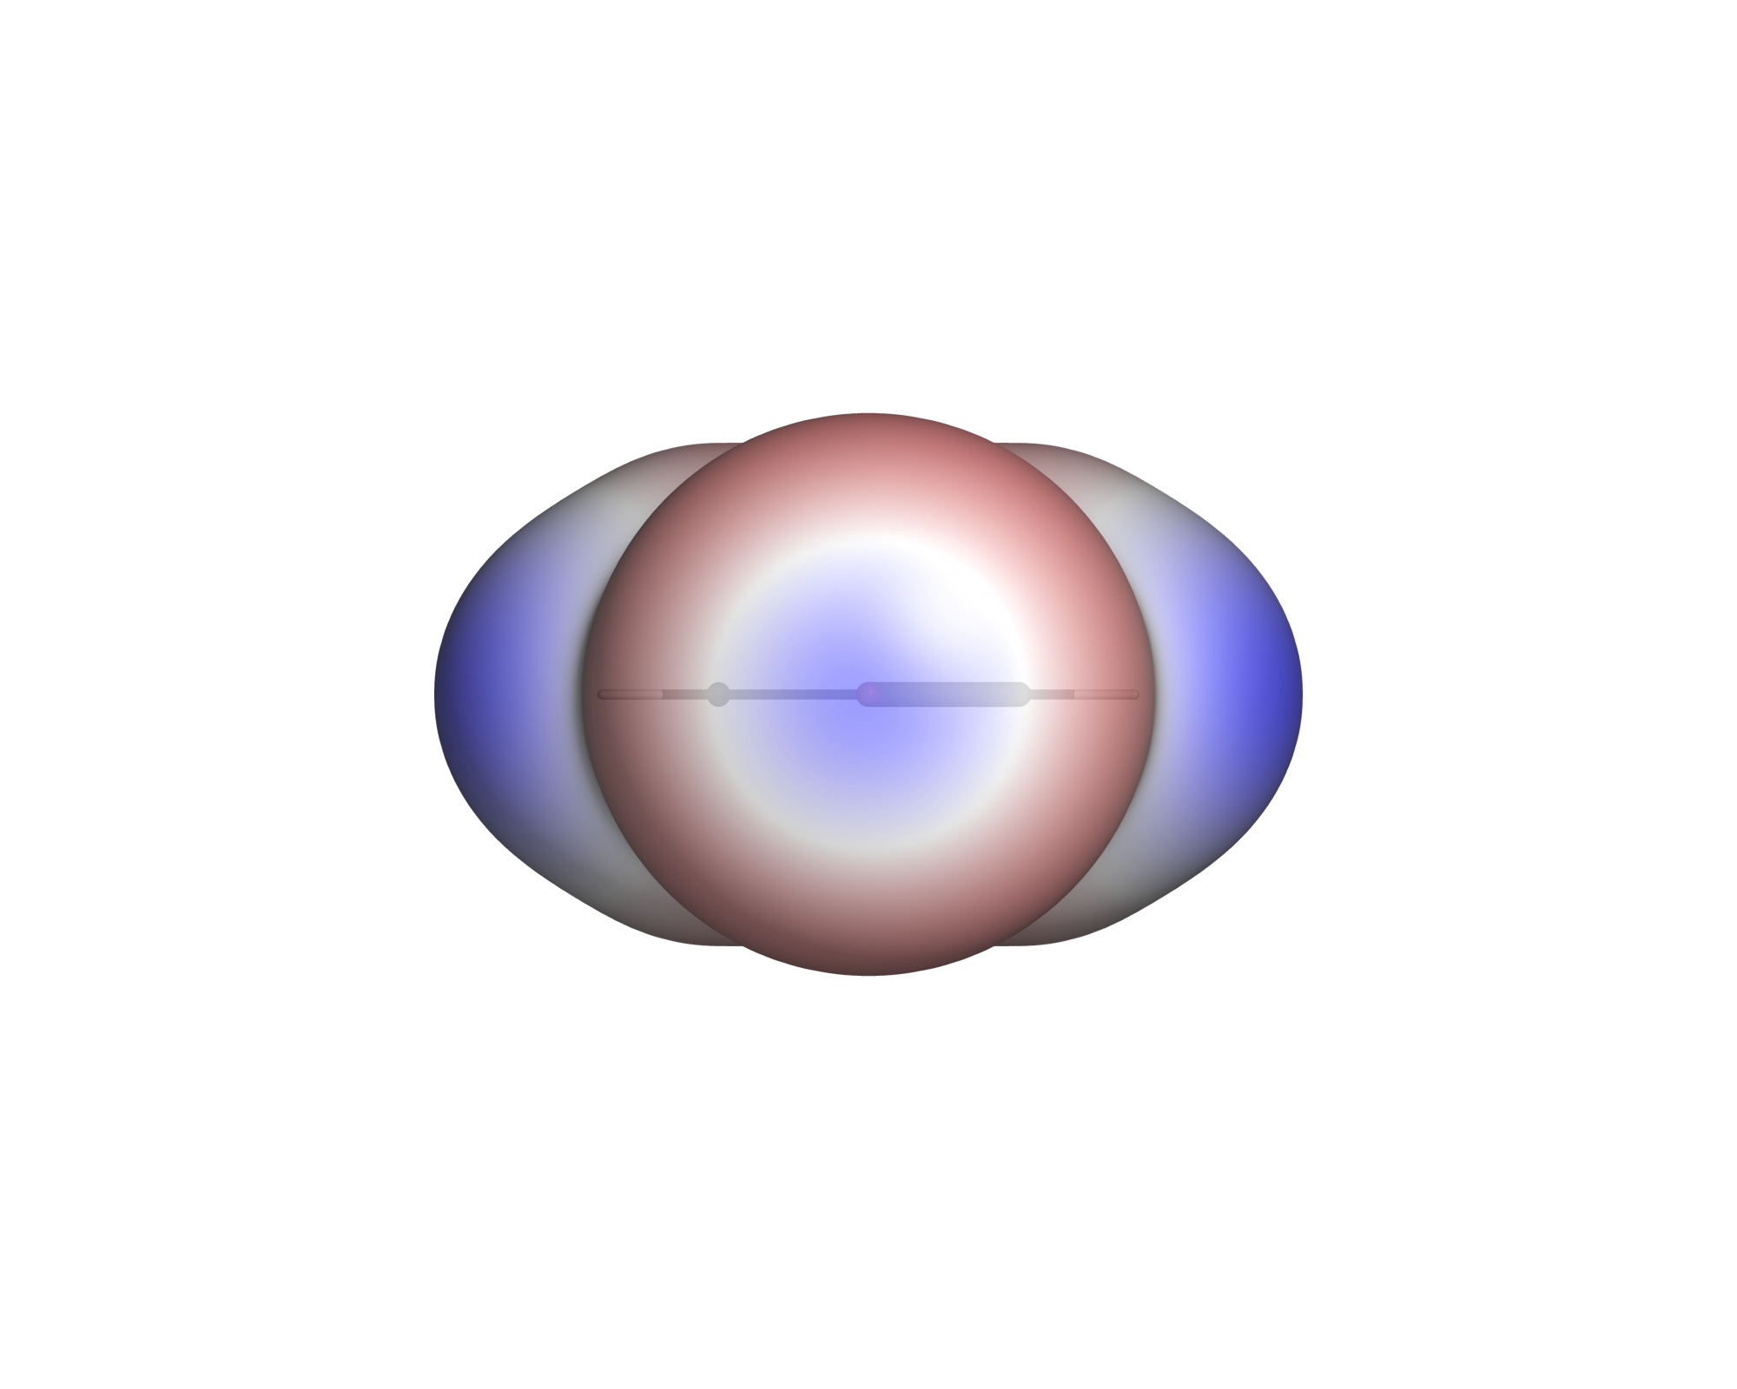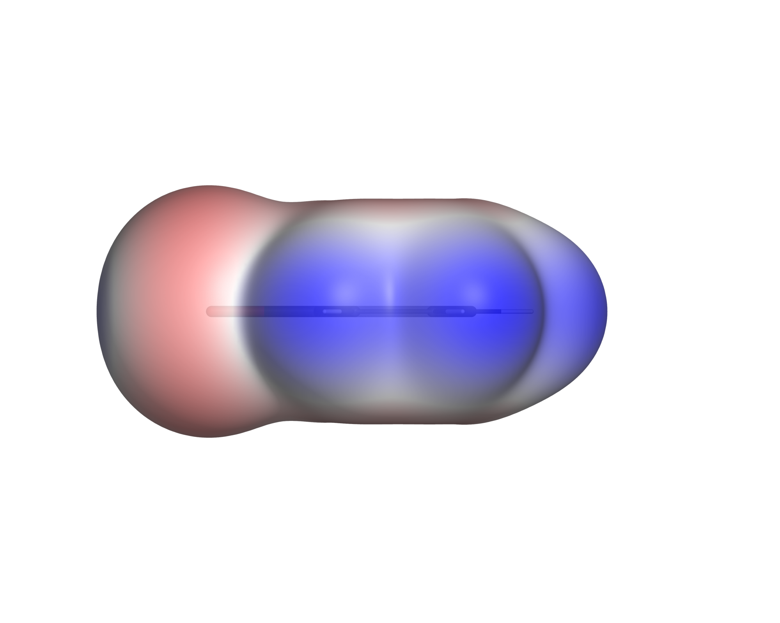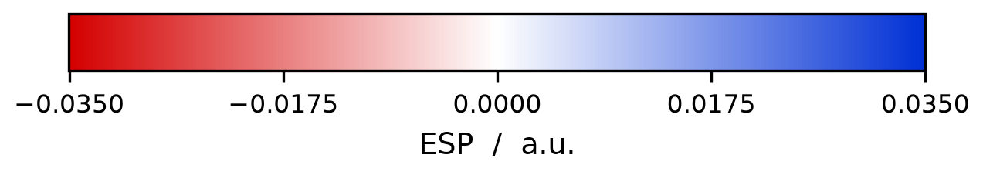
Figure 1: Visualization of Bromobenzene with the PyMol pipeline at ρ = 0.001 a.u, left is the view from the top, centre the axial presentation of the Halogen, and on the right side in-plane profile
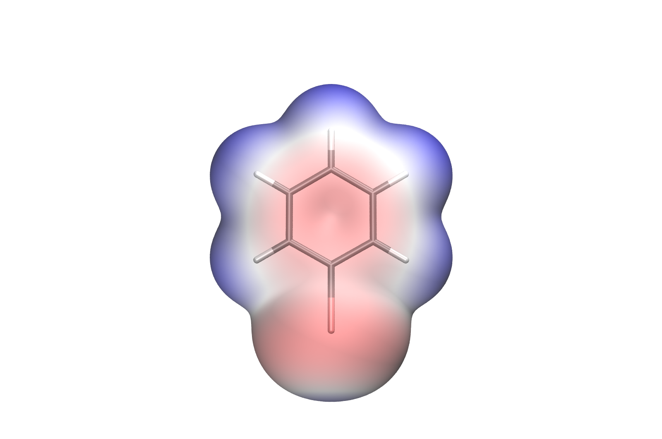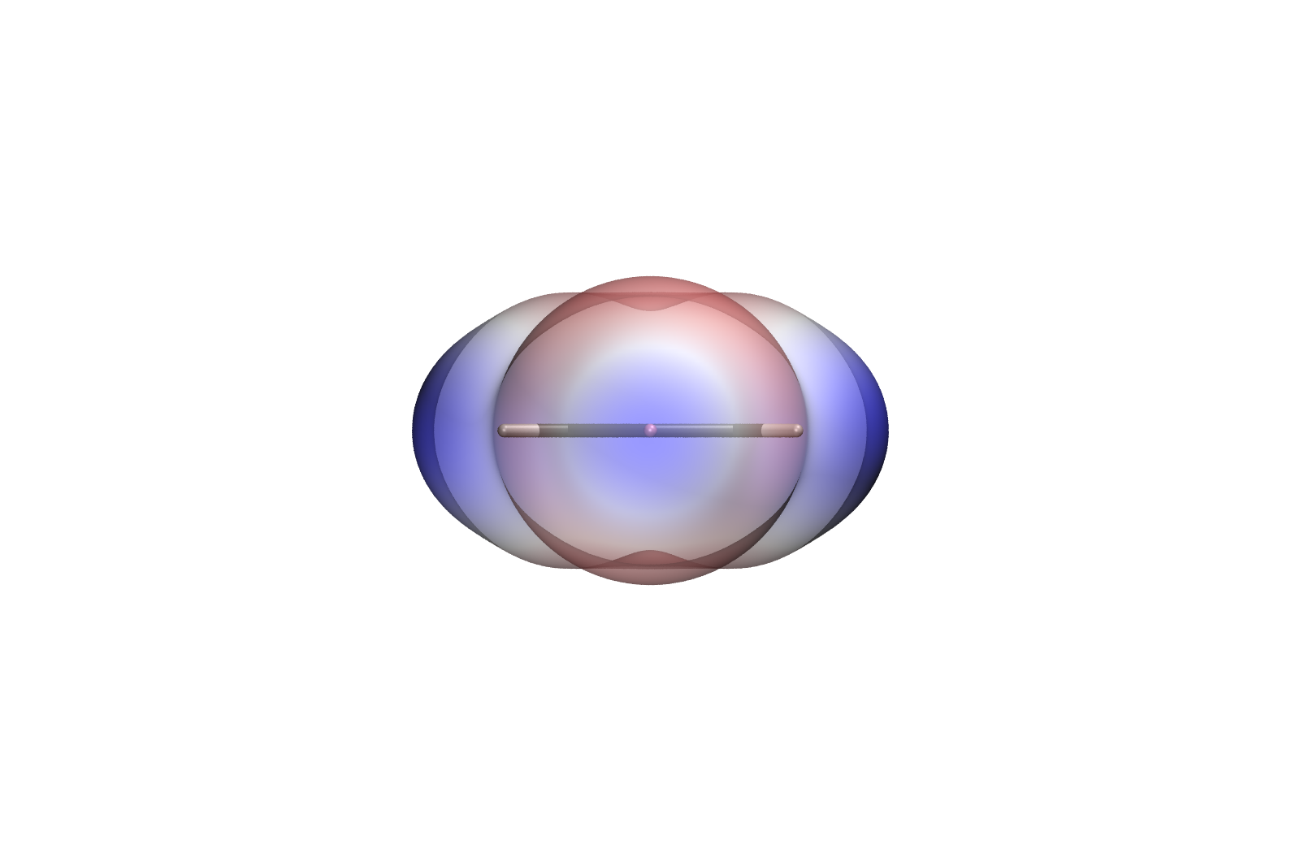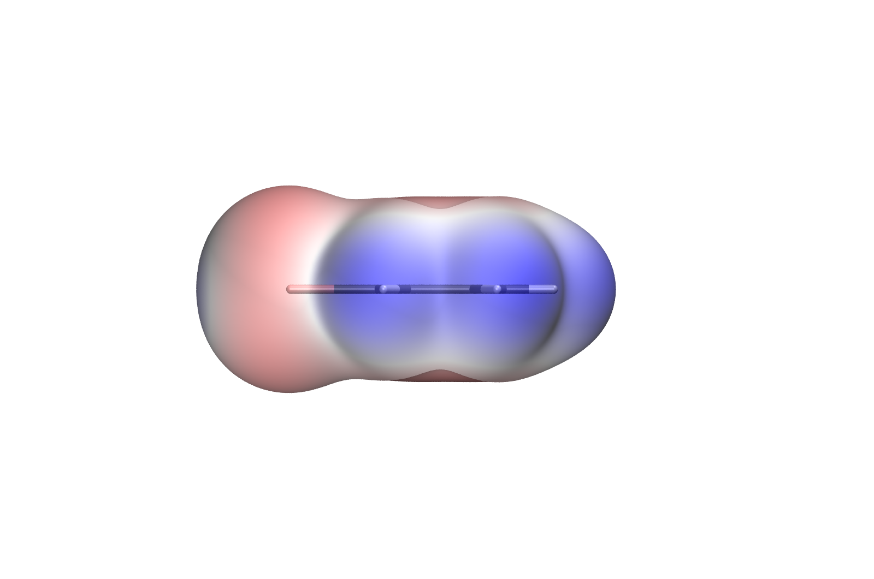

Figure 2: Visualization of Bromobenzene with the VMD pipeline at ρ = 0.001 a.u, left is the view from the top, centre the axial presentation of the Halogen, and on the right side in-plane profile

Contents

1. Introduction
Halogens are important for determining ligand-protein bindings, they increase the affinity

2. PyMol pipeline
As stated in the SoftwareEvaluation.pdf document, for convenience reasons I started to implement an ESP visualization pipeline within PyMol, it was already installed and I had a brief introduction via the introduction tasks. I then used Claude Cowork it as a software developer, while Ive been testing the implementation and adaptions that were executed.
As the provided electron density td.xyz and electrostatic potential files are not practicable for the visualization, they needed conversion into a shorter format, the Gaussian cube (.cube) format. That’s the main purpose of the xyzToCube.py script
2.1 xyzToCube.py
Within this script the magic for converting the turbomole pointval grid files to the .cube format is conducted. The provided tp and td.xyz files carry the information about the electron density and the potential at each point in the grid, stored with the full coordinates of the grid.
The grid in the provided benzene (bromobenzene, iodobenzene and chlorobenzene) files ranges from -15,-15,-15 to 15,15,15 with a step size of 0.12 Bohr. For every grid point all three coordinates are exclusively stored, which makes up to 15.813.251 lines and a file size of 1.25GB. A cube file therefor only saves the important values (density and potential) with an implicit grid.
The grid in the provided pyridine derivate files ranges from -20,-20,-20 to 20,20,20 with a step size of 0.16 Bohr. Which also makes up to 15.813.251 lines and a file size of 1.25GB.
The conversion to Gaussian cube files, storing the grid implicitly saves of the coordinates and therefor shrinks the file size to 205 MB.
2.1.1 Converting units
Another point that this script resolves, is that the most structure files come in Ångstrom, therefor they need a conversion constant from ANGSTROM_PER_BOHR, which is outsourced to a second constants.py script, where they are imported from.
The workflow was implemented with all 3 common types of structural formats. The .mol, the .sdf and the .xyz file formats are accepted and the pipeline can handle them. The provided .xyz structural files come in Ångstrom, so they need this conversion, if someone uses different structure files in the Bohr format, they are not converted and left untouched. Line 201-250 in the script.
2.1.2 Reading the Turbomole grid file
From line 251 the reading of the Turbomole file starts, it essentially reads in the file as chunks of data (16MB at once, defined with the CHUNK_BYTES constant). It first parses the header to get the needed information for the generated .cube file header and then reads in the values of the density and the potential.
2.1.3 Writing the cube file
For security reasons, the file is named .cube.part until the .cube file is completely done. If a run crashes at the point of generating the cube file, it is indicated by the .part suffix, so no incomplete .cube is used for the subsequent pipeline. In the end the .cube file as stated stores the gird implicitly and only the values are kept in the same order. The first 251 values therefore range from -20,-20,-20 to -20,-20,20 for the pyridnes and for -15,-15,-15 to -15,-15,15 for the benzene files. The next 251 values than range from -20,-19.84,-20 to 20,-19.84,-20 for the pyridines and from -15,-14.88,-15 to 15,-14.88,-15 and so on, reducing the file size to 1/6 of the original file size.
The cube file additionally stores the atoms with their atomic numbers and their corresponding atom cooredinates.
2.1.4 Shell calculation & ESP statistics
From line 477 on, the shell of the molecule is determined. Therefor a tolerance factor of 0.12 is used, so if you run the workflow on an iso surface value of 0.001 (Politzer Convention) the shell points are the defined values where the density ρ ranges from 0.00088 to 0.00112. If the minimum amount of points (SHELL_MIN_POINTS = 50) is not reached the tolerance is expanded to 0.3.
This function returns a Boolean array (the mask) in the same form of the grid, this functions as a template for the potential values, extracting only the needed potential values on the iso surface.
Afterwards the esp_statistics are calculated with the mask to determine the V_{S,min} and V_{S,max} and the total points that are located on the grid. With these values the scale is determined and the max of V_{S,min} and V_{S,max} is determined to create a symmetrical scale around 0.
2.1.5 Safety Measurement
From line 531 on a fallback scenario is implemented, in order to determine if the density files match the atoms, with this implementation, the program will stop rendering if a mismatch is detected, hence the molecule and the ESP data mismatches. Therefor the median electron density at the supposed atomic nuclei is computed and checked for correctness. If a conversion error occurred or the wrong structure file is appended to the .xyz data it is detected Throughout this measurement.
2.1.6 Generating the PyMol script
From line 620 on, the PyMol Script is implemented to create the visual 3D ESP Visualization, two colouring ramps are introduced the normal red-white-blue and the advanced rainbow ramp, ranging from red -yellow-green-cyan-blue. A string for the template is implemented with place holders for the actual values. Subsequently the PyMol scene is created with the the .cube files, creating the scene is than implemented by Pymol, with cmd.isosurface the iso surface of the molecule is determined by a marching cubes mechanism. Subsequently the surface is coloured, determined by the colour ramp.
2.1.7 Main program
From line 742 the main program is implemented, with all the options that are pointed out in the Pymol_ESP_Visualization/README.md

2.2 render_esp.py
The render_esp.py script is the place where the standard images are created, 3 views are standardized and always created in the same manner. One from the top looking at the pi-ring system, one from the side and one looking directly at the C-X axis pointing out the σ-hole. Within the Pymol implementation, if a molecule carries more than one halogen, the halogen with the biggest sigma hole is taken for the C-X axis view. Therefor the electrostatic potential at the sigma holes need to be calculated, this is done by trilinear interpolation.
2.2.1 Read cubes & calculate the statistics
The script starts by reading the .cube files and determine the shell with the same tolerance factor (0.12) the xyzToCube.py script also uses.
2.2.2 Determine the halogens and their corresponding values
From line 112 to line 380 the halogens are determined and the local extrema is calculated for each one. The implementation is done by searching for all halogens in the molecule that are bound to a carbon atom. From there on the local extrema for the molecule is calculated, the script calculates the extrema and where they are located. Additionally the electrostatic potential is calculated at the sigma holes via trilinear interpolation, trilinear interpolation is used, as there is probably never a shell point exactly at the C-X axis. For that a cone is implemented via a Fibonacci spiral, that goes from the C-X axis to 36.87° away from it, along every one of these rays the script than marches outward from the halogen and looks for the radius at which the density ρ crosses the isovalue and only there the potential is evaluated. So two values are trilinearly interpolated per ray, the crossing radius out of the density cube and the potential at that radius out of the potential cube, and the maximum over all rays is where the sigma-hole sits. This calculation takes a feelable increase in the computing time of the script and the reason it was left out in the image generation within the VMD Pipeline. There it is implemented in a separate script to decrease the runtime that comes with a cost of not showing the sigma hole with the halogen and its biggest sigma hole when there are two halogens in a molecule.
2.2.3 Rendering the images
From line 415 the image creation starts, for that the atomic numbers are reverse translated in their symbol again and a molecular frame is defined. The frame is taken from the geometry itself and not from the order of the atoms in the file. Via a singular value decomposition over the heavy atoms the three principal axes are determined, the axis with the smallest extent is the normal of the best fit plane of the ring system. Together with the C-X axis this spans a right handed frame, out of which the three views are built as rotation matrices that are handed over to PyMol with set_view.
Two versions of the C-X axis are kept, the true bond axis and the same axis projected into the plane. For planar molecules both are identical and the projection is pure cosmetics. For non-planar molecules that ensures the correct image creation.
The zoom is done on the atoms and not on the iso surface, the surface object carries the extent of the whole grid box with it and the molecule would end up as a postage stamp in the middle of the image. The room the surface needs beyond the nuclei is therefor added by hand with BUFFER_ANGSTROM = 2.4, the ρ = 0.001 surface sits about 1.7 to 2.1 Å outside the outermost nuclei and 2.4 covers that with a narrow margin. The projection is set to orthoscopic, so there is no perspective distortion and the images stay comparable between molecules.
2.2.4 Creating the PyMol scene
From line 690 on the scene itself is put together. The structure file and both .cube files are loaded, the skeleton is shown as sticks with the stick radius that comes from --stick-size (0.1 Å by default) and the carbons are coloured grey20, so the skeleton does not compete with the surface. With cmd.isosurface the ρ = 0.001 surface is generated out of the density cube by a marching cubes mechanism, than a colour ramp is created with cmd.ramp_new on the potential cube and hung onto the surface with surface_color. The ramp object itself is disabled afterwards, otherwise PyMol would draw its own colour bar into the image.
Two interpolations happen here as well and it is worth keeping them apart. Marching cubes interpolates linearly along the edges of every grid cell to find where the density crosses the iso value, that gives the position of the surface vertices. The colour of each of these vertices is than the potential at that position, which PyMol trilinearly interpolates out of the ESP cube. So the geometry of the surface comes from the density and the colour from the potential.
The rest are the render settings. The transparency is 0.15 by default, PyMol counts 0 as fully opaque. Transparency_mode 2 makes the back faces of the surface visible, two_sided_lighting lights them, and specular and ambient are kept low so the surface does not glare. Cast shadows are switched off with ray_shadows 0, on a transparent surface the shadow of the skeleton reads as a dark patch of potential and competes with the colour that carries the information, the VMD pipeline switches them off as well, so both image sets are lit the same way and a comparison measures the viewer and not the lighting. Than for every background colour and every one of the three views cmd.ray renders the image at 2000 x 1600 px and cmd.png writes it out with 300 dpi.
2.2.5 Colour bar and settings file
The colour bar is deliberately not rendered into the image but written as a separate PNG from line 843 on with matplotlib, out of the same hex colours the ramp in PyMol uses.
Additionally a <prefix>_settings.txt is written next to the images. It records the three input files, the grid, the iso value, VS,min and VS,max with the atoms they sit on, one line per halogen with its sigma hole and its belt, the grid spacing, the colour range and whether it was fixed or determined automatically, the ramp, the transparency, the background, the image size and the rendered views. So every image can be traced back to the parameters it was made with, without having to remember the command line that produced it.
2.2.6 Main program
From line 883 the main program is implemented, with all the options that are pointed out in the Pymol_ESP_Visualization/README.md. If --density, --esp or --struct are not given, they are auto detected in the current folder (td.cube, tp.cube and the first .mol, .sdf or .xyz file), and the prefix of the image names is derived from the name of the structure file.

