PyMOL and VMD output compared
Same data, two viewers
Companion to VMD_esp_visualization and Pymol_esp_visualization
Two pipelines turn the same Turbomole pointval output into the same standard set of ESP figures, one through PyMOL and one through VMD. This document puts the two outputs next to each other and separates what agrees from what does not, and why.

1. What is compared
The comparison is end to end, not a shared intermediate. Each pipeline reads the same raw Turbomole grids, writes its own cube files with its own converter, derives its own colour scale, and renders in its own viewer. Nothing is passed from one to the other. If the results match, the agreement is evidence about the data rather than about a shared code path.
Held identical by construction, so that any difference is attributable:
- Surface: the electron density isosurface at ρ = 0.001 a.u. (Politzer/Murray).
- Colour convention: red negative, blue positive, white at zero.
- Colour scale: derived per molecule from V_S,min and V_S,max on the shell, rounded up to a multiple of 0.005 a.u. Both pipelines ran in this automatic mode, so every pair below is on the same scale.
- Views: ring normal for the π face, the true C–halogen axis for the axial view, computed from the geometry by the same calculation in both projects.
- Data: nine molecules, six pyridines and three halobenzenes, all from Turbomole calculations on a 251³ grid. The delivered image sets under results/ were afterwards trimmed to seven, one halobenzene instead of three, because as a deliverable the three were near-duplicates. Chlorobenzene and iodobenzene are still shown here, because the comparison is what they are good for.

2. The numbers agree
Molecule | V_S,min PyMOL | VMD | V_S,max PyMOL | VMD | scale ±
CN-Pyr | −0.05927 | −0.05927 | +0.05025 | +0.05025 | 0.0600
Cl-NO2-Pyr | −0.04545 | −0.04545 | +0.05825 | +0.05825 | 0.0600
I-Pyr | −0.05638 | −0.05638 | +0.04594 | +0.04594 | 0.0600
Me-Pyr | −0.06779 | −0.06779 | +0.03647 | +0.03647 | 0.0700
NO2-Pyr | −0.04712 | −0.04712 | +0.04487 | +0.04487 | 0.0500
Pyridine | −0.06500 | −0.06500 | +0.03959 | +0.03959 | 0.0700
bromobenzene | −0.01882 | −0.01883 | +0.03154 | +0.03154 | 0.0350
chlorobenzene | −0.01896 | −0.01896 | +0.03129 | +0.03129 | 0.0350
iodobenzene | −0.01685 | −0.01685 | +0.03168 | +0.03168 | 0.0350

Seventeen of the eighteen values are identical, and all nine colour scales are. The single exception is V_S,min of bromobenzene, −0.01882 against −0.01883, and it is not a disagreement: the true value is −0.018825, exactly on the rounding boundary. PyMOL rounds the full float once; the VMD side stores six decimals in the cube header, reads them back and rounds again, and the second rounding of an exact half can fall the other way.
The counts of grid points inside the ρ = iso ± 12 % band differ by 0 to 3 out of 12 000 to 42 000, at most 0.02 %. The cause is the data type: the PyMOL converter holds the grids in float64, the VMD one in float32, so a handful of points sitting exactly on the edge of the band fall inside on one side and outside on the other. The extrema are far from that edge and are unaffected.
Consequence for the rest of this document. The two pipelines see the same surface with the same values on the same scale. Every difference in the pictures below is the renderer.

3. The images
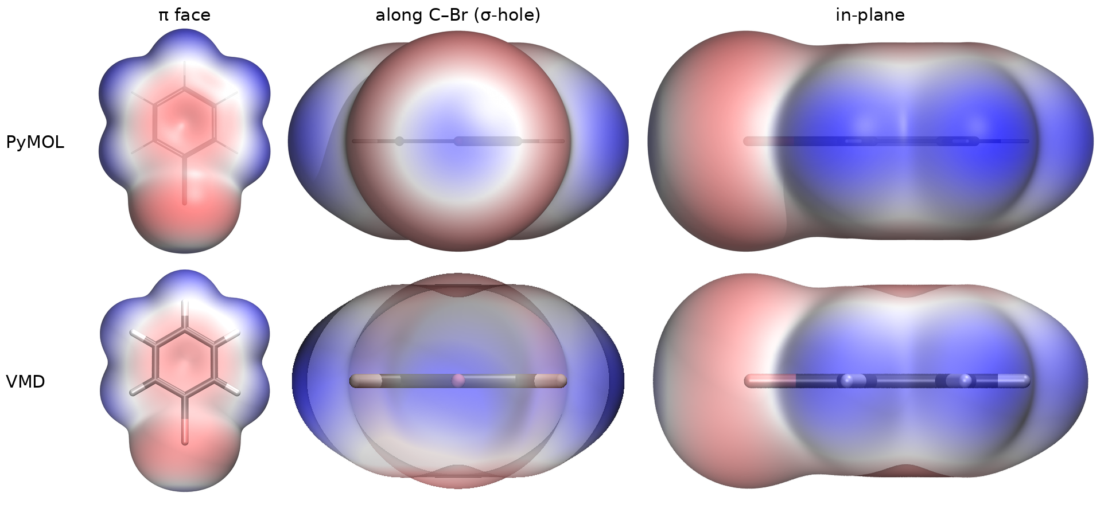
Figure 1. Bromobenzene, the three standard views, PyMOL above and VMD below. Same data, same isovalue, same ±0.0350 a.u. scale.
The π face (left) is the same picture in both: the red ring centre, the blue rim of the CH bonds, the same extent. The in-plane view (right) also matches. The axial view (centre) does not.
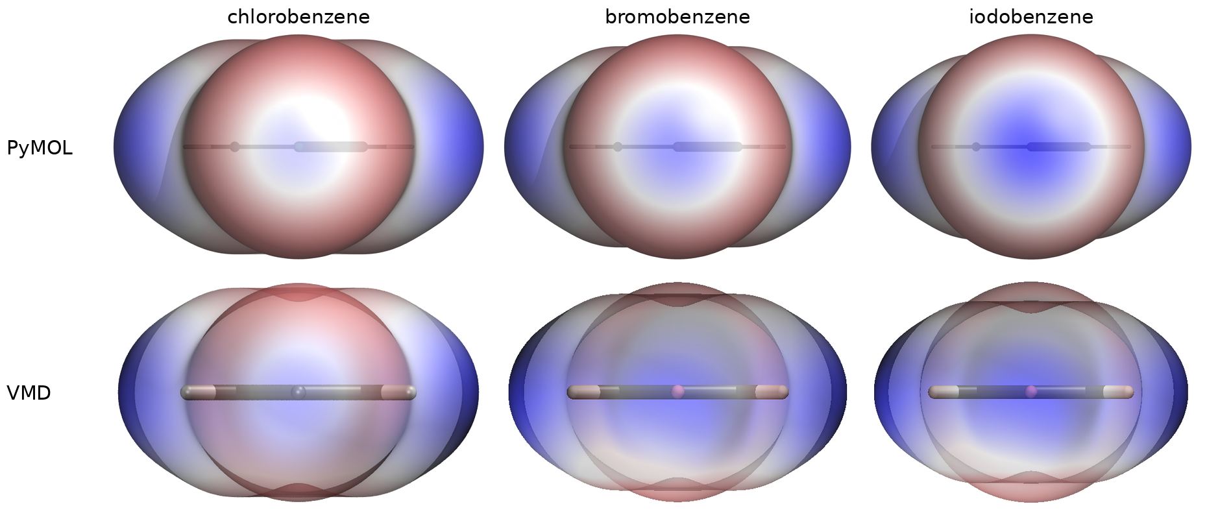
Figure 2. The axial view down the C–X bond for the three halobenzenes, PyMOL above, VMD below. Scale ±0.0350 a.u. throughout.
This is the substantive finding. In the PyMOL row the σ-hole grows visibly from chlorine through bromine to iodine: a pale centre, then a defined blue disc, then a large saturated cap, each inside a red belt. That trend is the chemistry the figure exists to show, and it can be read off the image without consulting a number. In the VMD row the same three molecules look nearly alike and washed out, and the trend is not readable.
Two causes stack here, and both are explained in section 4: the axial view is where the line of sight crosses the most transparent surface, and it is also the view where VMD's ray tracer fails most often and falls back to a window capture.
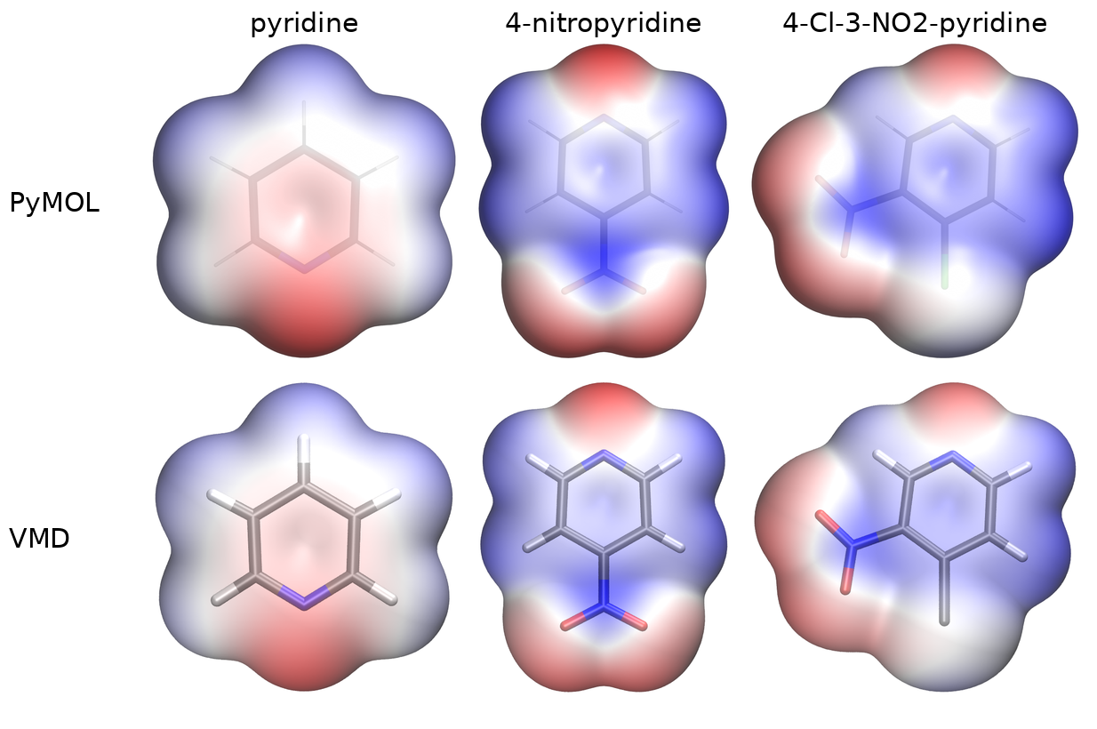
Figure 3. The π face of three pyridines, PyMOL above, VMD below. Scales ±0.0700, ±0.0500 and ±0.0600 a.u. respectively.
Here the balance tips the other way. The potential maps agree closely, with ring nitrogen and nitro oxygens red, ring face blue and the same gradients, but VMD draws a far more legible skeleton. Its sticks carry element colours through the surface, so nitrogen, oxygen and the hydrogens stay identifiable; PyMOL's sticks are a faint grey outline at the same transparency setting. For a figure whose job is to show where on the molecule a potential sits, that is an advantage.
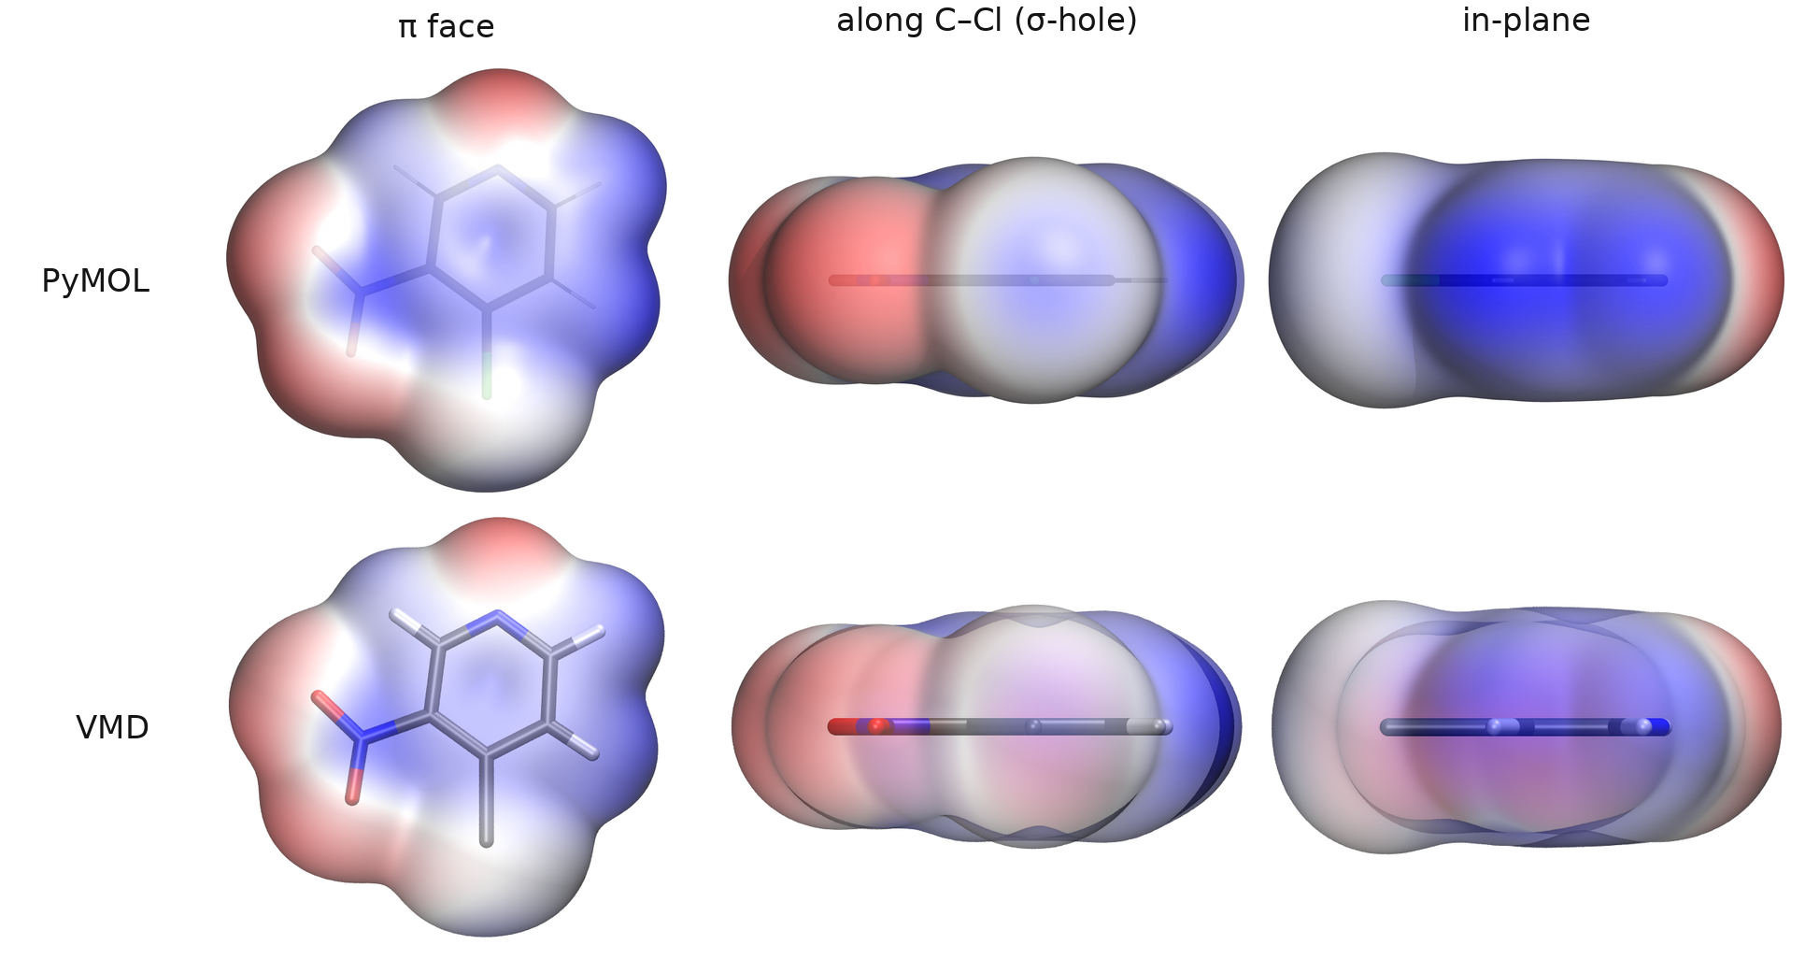
Figure 4. 4-chloro-3-nitropyridine, the three standard views, PyMOL above and VMD below. Scale ±0.0600 a.u. The most substituted molecule of the set, and the one that separates the two causes of section 4.
This molecule is the clean test, because VMD's ray tracer rendered all three of its views at full quality. Nothing here fell back to a window capture, so every difference in the row is transparency alone. The π face repeats the finding of Figure 3: the two maps agree, the nitro oxygens and the ring nitrogen red, the ring face and the chlorine rim blue, and VMD's coloured skeleton makes the substitution pattern readable where PyMOL's grey sticks do not. The axial view repeats the finding of Figure 2: PyMOL resolves the pale σ-hole on the chlorine inside its red belt, VMD flattens the same surface into an even wash. Both views are full-quality renders of identical data, which rules out the ray tracer and leaves the transparency weighting as the cause.

The rainbow ramp: different mechanism, same picture
Both tools offer --rainbow, a five-stop ramp of red, orange, green, cyan and blue instead of red-white-blue, and both write it as a second image set so the standard one survives. The two implementations have nothing in common. PyMOL has a ramp object: ramp_new takes the five colours and the five values and interpolates between them. VMD has no ramp object at all, only a fixed colour scale, so the five stops are interpolated in Python and written into the 1024 entries of VMD's colour table one at a time.
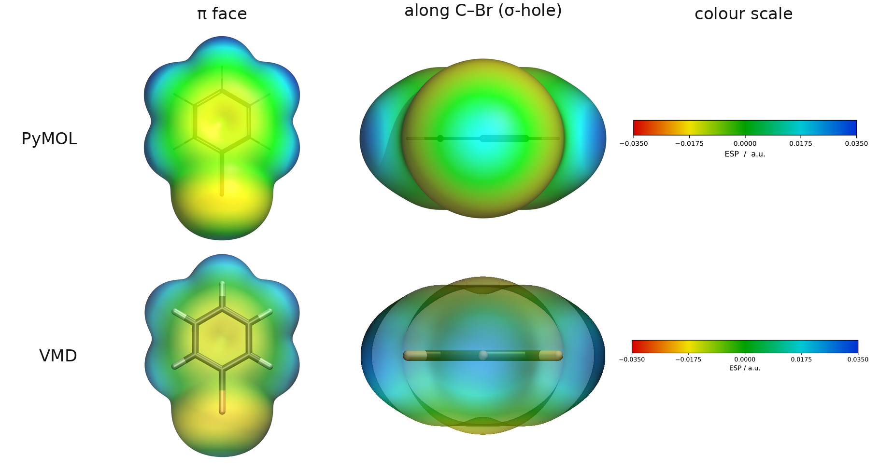
Figure 5. Bromobenzene with --rainbow, PyMOL above and VMD below, with the colour bar each pipeline generated for it. Scale ±0.0350 a.u.
The two colour bars are the same bar and the two maps carry the same colours at the same places. This is the useful negative result of the comparison: a mechanism that differs completely between the programs still produces the same figure, which means the differences in Figures 2 and 4 are not just "two programs are two programs" but have specific causes.

4. Where the differences come from

Transparency does not translate between the programs
The isosurface is closed, so a line of sight enters at the front and leaves at the back. At opacity a only (1−a)² of what lies behind survives: at a = 0.6 that is 16 %. The axial view is the worst case, because there the surface of the halogen, the surface of the ring and the belt all overlap along the viewing direction.
The two programs weight the setting differently. PyMOL renders at transparency 0.15 and still shows the sticks; VMD needs about 0.30 for the same impression and is run at 0.50 for the delivered set. Identical parameter values do not give identical images, and there is no conversion factor that makes them equal, only a value chosen per program.

VMD's ray tracer fails on a third of the views
TachyonInternal aborts when many transparent layers stack, on Windows with exit code 0xC0000374, heap corruption, and without an error message. The only symptom is a missing file. The pipeline renders in passes and keeps whatever each pass produced: full quality first, then the missing views as an OpenGL window capture, which preserves the transparency but is visibly less fine, and only then as an opaque surface. Across the nine molecules:
Molecule | Views that fell back to the window capture
chlorobenzene | 0 of 3
Cl-NO2-Pyr | 0 of 3
NO2-Pyr | 0 of 3
bromobenzene | 1 of 3
I-Pyr | 1 of 3
Me-Pyr | 1 of 3
Pyridine | 1 of 3
CN-Pyr | 2 of 3
iodobenzene | 3 of 3

Nine of twenty-seven views, exactly one third. Iodobenzene lost all three, which is why its axial view in Figure 2 is the flattest of the row. PyMOL's ray tracer rendered all twenty-seven without a single failure. Which pass produced which view is recorded per view in the *_settings.txt next to the images and in the views column of summary.csv, so a figure made the fallback way is never silently mixed in with the others.

Image size is capped by the screen
TachyonInternal renders at window size, and Windows clamps the window to the display. A request for 1600 × 1280 yields 1600 × 1061 on a 1080-line screen, so the VMD set is shorter than asked for. PyMOL's ray tracer renders to an off-screen buffer and delivered the full 2000 × 1600.

5. What the PyMOL pipeline does and this one does not
The VMD repository draws pictures. The sister project draws pictures and measures the surface. The gap is deliberate: a second implementation of the measurement would be a duplicate.

Quantities
Only the PyMOL pipeline locates and reports the σ-hole.
 | PyMOL | VMD (here)
V_S,min / V_S,max | grid points in the ρ = iso ± 12 % band | the same, same code, same numbers
Which atom carries the extremum | reported (VS_max_on, VS_min_on) | not determined
σ-hole potential | located per halogen, ray-based or point-based | not computed
Halogen belt minimum | reported | not computed
Several halogens | all evaluated and ranked, the strongest drives the σ view | the first halogen drives the σ view
Units in the summary | a.u., kcal/(mol·e), kJ/(mol·e) | a.u., kJ/(mol·e)

The first row is not a difference: both pipelines take V_S,min and V_S,max from the grid points whose density falls inside ρ = iso ± 12 %, which is why the table in section 2 agrees to five decimals.
Trilinear interpolation happens in the sister project only for the σ-hole, along rays from the halogen. It is needed there because the σ-hole is a peak on one axis: whether a grid point happens to sit both on that axis and inside the thin shell is luck. For bromobenzene the best grid point lay 1.14 Bohr off the axis and came out 28 % low. A global extremum over a large surface does not have that problem, which is why nothing is interpolated for V_S in either project.
Neither the shell band nor the interpolation feeds the picture. Both viewers build the isosurface themselves and interpolate the potential onto their own vertices: cmd.isosurface plus ramp_new and surface_color in PyMOL, the Isosurface representation coloured by Volume in VMD.

Workflow
PyMOL has --two-pass, which renders once to find the common colour scale and again to use it. In the VMD pipeline that is a printed recommendation and a second command started by hand.

Supporting material
The sister project also carries the parameter studies (tools/iso_sweep.py, tools/stride_sweep.py), the test-data generator that builds Tp.xyz, Td.xyz and a structure file from a SMILES notation, and the background document with method, results and references. Both projects deliver the same image sets under results/: six pyridines, bromobenzene, and bromobenzene again with the rainbow ramp.

6. Assessment
For quantities, quote PyMOL. Not because its V_S values are better, they are the same, but because it is the only one of the two that locates the σ-hole, the halogen belt and the atom each extremum sits on. The VMD pipeline computes what a colour scale needs and stops there, on purpose.
For the π face, either. The maps agree, and VMD's skeleton is the more readable of the two.
For the axial view, PyMOL. This is the view that carries the σ-hole argument, and it is the one VMD renders worst, partly by the transparency mechanics, partly because its ray tracer fails there most often.
The second pipeline still earned its place. It confirmed the surface statistics of the first from an independent implementation, to five decimals on nine molecules, which no single-viewer study could have done. It also produces figures in the tool most of the published literature uses, which matters for anyone who wants to reproduce the images rather than trust them. What it does not do is replace PyMOL for the figure the σ-hole argument rests on.

