Group Three
XBRL Project Database User Interface
Data Communiqué
Gino Gervasio | Theodora Kampelou | Nathalie Neptune | Anand Patil | James Wu
May 5th, 2010

Table of Contents
1. Executive Summary 4
2. Introduction 6
3. Client Organization and Description 7
4. Project Team 8
5. Problem Statement 10
6. Testing Strategy 11
6.1. Testing Results 12
7. Process Methodology 14
8. IS/IT Design 15
8.1. System Overview 15
8.2. Requirements 15
8.2.1. Functional Requirements: 15
8.2.2. Non-Functional Requirements: 15
8.2.3. Data Model Requirements: 16
8.2.4. Usability Requirements: 16
8.3. User Interface Information Architecture 17
8.3.1. Primary Audience: 17
8.3.2. User Interface: 17
8.4. Data Model 20
8.4.1. General Data Model Design: 20
8.4.2. Data Model Architecture: 23
8.5. Software Engineering Specifications 23
9. Financial and Cost-Benefit Analysis 24
9.1. Financial Analysis: 24
9.1.1. Risk-Adjusted Approach: 24
9.1.2. Non-Risk-Adjusted Approach: 25
9.2. Costs: 26
9.2.1. Risk-Adjusted Approach: 26
9.2.2. Non-Risk-Adjusted Approach: 27
9.3. Benefits: 28
9.4. Cost Savings: 29
9.4.1. Risk-Adjusted Approach: 29
9.4.2. Non- Risk-Adjusted Approach: 29
9.5. Return on Investment and Payback: 30
9.5.1. Risk-Adjusted Approach: 30
9.5.2. Non-Risk-Adjusted Approach: 30
9.6. Results: 31
10. Project Management 32
10.1. Project Management Approach 32
10.2. Project Schedule 32
10.3. Project Budget 34
10.4. Project Challenges 35
11. Transition Plan 36
12. Results 37
12.1. Qualitative Results 37
12.2. Quantitative Results 37
13. Summary and Conclusion 38
14. Appendices 39

Executive Summary

While XBRL is increasingly being accepted as a standard for storing and transmitting financial data, many businesses have yet to become familiar with it, let alone adopt it, despite its proven efficiency.

One of the hindrances to widespread adoptability could be attributed to the tedium involved. When working with XBRL data, the user is often left with the cumbersome task of examining multiple XML documents. The XBRL Project Database User Interface addresses this problem by providing a web application that extracts, aggregates, labels, displays and exports the information in a user-friendly format.

The project is undertaken by graduate students from the Department of Information Technology at Rensselear Polytechnic Institute and is commissioned by Data Communiqué, a leading content management and communications solutions provider.

The project commenced in February 2010 and was implemented using the Unified Software Development Process framework. Due to the novelty of XBRL to the team, the members decided to use a methodology that promoted multiple iterations of development and testing. The project was sub-divided into several 2-week long, deliverables-based iterations. By doing so, the team and the client had multiple milestones and decision-points, allowing both parties to stay agile in terms of establishing development strategies and project scope.

As mentioned, the project is a stand-alone web application developed using a traditional Model-View-Controller design pattern in Java. However, in place of a relational database, the actual XBRL instance document and taxonomy files were used as the data model. For the user interface, the team elected to use DHTML instead of Java Server Pages while the controllers were simple Servlets. Instead of creating XML streams or complex data transport objects, however, the team decided to use JavaScript Object Notation (JSON) for data transport to ensure speedier transmissions, reduce complexity and to conserve resources.

Development concluded in April 2010 when all specific requirements, enhancements and quality metrics were met. Acceptable quality was measured in page loading times, which the group pegged at 1 second as appropriate for the amount of data being loaded. Initially, page loading times were as much as 32 seconds but were eventually trimmed to roughly 100 milliseconds, roughly 0.3125% of the original load times.

The group conducted various measurements throughout the project such as Earned Value Analysis (EVA), Return on Investment (ROI), Net Present Value (NPV) and Internal Rate of Return (IRR) for completeness. The profitability of the project was measured through financial and cost benefit analyses. Two different approaches were used for the calculation of the NPV, ROI and IRR – a more optimistic non-risk-adjusted model and a more conservative risk-adjusted model. The latter model resulted in costs of approximately $96,600 a Net Present Value of $1,000,000, a Return on Investment and an Internal Rate of Return of around 800% and 341%, respectively, which are still favorable figures. The team used both optimistic and conservative models so as to lead in more accurate and forecasting cost-benefit analysis results. Moreover, at the end of the project, the group's earned value analysis resulted into favorable results as well, being slightly over-budget but completed on time.

Overall, the project was a success despite various challenges throughout the lifecycle. One significant challenge was effective management of client expectations, especially because our client liaison changed midway. Another was the unanticipated architectural change from standard Java libraries to an open-source third-party library, which introduced a steeper learning curve that created the budget disparity. Still, the application was able to deliver all the features required by the client while meeting, and even exceeding, various quality measures such as data accuracy of 99.999% and page loading times of 100 milliseconds.

Introduction
The “XBRL Project Database User Interface" project aims to address the need for a web-based, user friendly interface that would be effective for analyzing XBRL documents. The goal of the project is not only to provide a web-based, user friendly interface for viewing the XBRL data, but also to provide a solution that is scalable and flexible to changes in the future if needed.

Thus, the development of the project results in the enhancement of the user experience and also fits into the overall end-to-end solution by Data Communiqué. Moreover, the project contributes to the reduction of the time needed to analyze XBRL data. From a financial point of view, the project will be beneficial and it will contribute to the mission of Data Communiqué which is to provide technologies and support services which enable maximum control over data and communications.

Client Organization and Description

The client, Data Communiqué, the North American technology arm of Havas (Euronext Paris: HAV.PA), is the leading provider of content management solutions and communications processes for the financial services, pharmaceutical, health care and insurance industries. Data Communiqué’s mission is to provide clients with a wide range of tools, expertise, technologies and support services to enable maximum control over data and communications.

Since opening its doors more than three-quarters of a century ago, Data Communiqué has evolved from its origins as a traditional commercial printer and fulfillment house into a leading innovator of automated technology solutions.

Data Communiqué’s relationship with Havas, a global advertising group, enables it to commit its capital to research, development, and the acquisition of new technologies, further strengthening its legacy as a provider of ground-breaking communications solutions.

Project Team
The team is a diverse group composed of experienced professionals and senior students who are familiar with both the technical and the business aspects of information systems design and implementation. The team also has significant industry experience in Java-based, XML-driven projects. The team members are:

Anand Patil
Project Manager
Mr. Patil received his bachelor's degree in IT at Rensselaer Polytechnic Institute in 2005. Since then he has worked as a CGI professional. His primary responsibilities included being a lead developer focusing on ETL and Batch Scripting and most recently being a team lead with extensive experience as a project manager. He comes to the team fresh off of a large successful project in New York City.

Gino Gervasio
Developer
Mr. Gervasio is from the Philippines. He earned his bachelor's degree in Computer Science from De La Salle University in 2005. He has had industry experience earned from his work as a Software Engineer and later as a Software Architect in a Manila-based IT consulting firm from 2005 - 2009. One of the projects that he was involved in designing and developing was an XML-based and XML schema-driven tool that parsed and interpreted log files from various credit card processors.

Theodora Kampelou
Developer
Ms. Kampelou is from Greece and her background is in Electrical Engineering. She is proficient in database design and has significant experience in developing in several programming languages. She has developed an algorithmic program based on C++ for her personal diploma thesis.

Nathalie Neptune
Application Designer
Ms. Neptune is from Haiti and she has an excellent background in software development having both industry and academic experience. Ms. Neptune has over 6 years of experience working with Oracle database management systems designing and implementing information management systems for commercial firms and public institutions.

James Wu
Developer
Mr. Wu is a co-terminal Computer Science/Information Technology student in his final semester at Rensselaer Polytechnic Institute. He is a very proficient front and back-end developer who specializes in Ruby on Rails and has also worked with the jQuery JavaScript library.

Full resumes can be found in the Appendices of this deliverable.

Problem Statement
Businesses are facing an increasing need for reporting tools that allow them to exchange and analyze information in an automated and standardized manner. Regulators as well as an increasing number of consumers of financial information are requiring that reporting be done using XBRL, which is a language for electronic communication of business and financial data used around the world. While XBRL is set to become the standard for financial information recording, storing and transmitting, its value is not yet widely recognized and many businesses are not yet aware of it or of how using it can help them reduce cost and become more efficient in handling financial information.

The project team’s goal is to develop a web-based interface for the client to analyze data from XBRL documents and convert them into a human readable format. In doing this the team will be providing an interface that can be used by businesses and other entities interested in XBRL to become familiar with XBRL and realize its strength and flexibility.

The “XBRL Project Database User Interface” developed by the team was to be user-friendly and allow the user to export XBRL documents to a spreadsheet, using DHTML and Java/J2EE.

Testing Strategy
The team’s testing objectives were to ensure that it produced a quality product that met Data Communiqué’s expectations and requirements. Three documents are associated with the testing effort. All three deliverables can be found in the Appendices. However, high-level overviews of the results are discussed in this section.
- Testing Plan – The objective of the deliverable is to lay out the strategy and testing goals as well as listing out the resources that are required to conduct the testing scenarios. A full list of the test cases and scheduled execution phases are also included. (This deliverable can be found in the Appendices)
- Testing Specifications – The objective of the deliverable is to detail each of the testing cases mentioned in the test plan and how the team plans on executing them. Listing out step-by-step procedures, preconditions data setup, and expected results. Steps are evaluated as pass/failed. If failed, they will be documented and sent back to be investigated. Once they are corrected, they will be retested in the next iteration. (This deliverable can be found in the Appendices)
- Test Results – The objective of the deliverable will to be to list documentation results for each of the test cases and each separate instance of execution (i.e. one test case may be executed multiple times). The results document will be in Microsoft Excel Spreadsheet (.xls) format. (This deliverable can be found in the Appendices)

Testing Results
The Testing Strategy only consisted of Unit, Integration and non-industry standard Performance Testing. Further extensive testing (Regression, User Acceptance, and industry standard Performance Testing) fell out of the scope and capabilities of the team with the schedule and resources available.

During integration testing, two issues were discovered that required re-development work. These two issues have been documented (See Testing Results Appendix) and both defects have been retested successfully.

Below is a quick overview of the testing results and associated graphs.

 |  | Test Steps
Test Phases |  | Total | Executed |  | N/S | Fail | Pass
1 | Unit Testing | 22 | 22 | 100% | - | - | 22
2 | Integration Testing | 36 | 36 | 100% | - | - | 36
 |  | 58 | 58 | 100% | - | - | 58
 |  |  |  |  | 0% | 0% | 100%
Table 1: Testing Results

 |  | Incidents Logged |  |  |  |  | Incidents Retested |  |  |  |  | Incidents Open
Test Phases |  | 1- Crit | 2-Ser | 3-Mod | 4-Mi | Total | 1- Crit | 2-Ser | 3-Mod | 4-Mi | Total | 1- Crit | 2-Ser | 3-Mod | 4-Mi | Total
1 | Unit Testing | - | - | - |  | - | - | - | - |  | - | - | - | - |  | -
2 | Integration Testing | - | - | 2 |  | 2 | - | - | 2 |  | 2 | - | - | - |  | -
 |  | - | - | 2 | - | 2 | - | - | 2 | - | 2 | - | - | - | - | -
 |  | 0% | 0% | 100% | 0% |  | 0% | 0% | 100% | 0% |  | 0% | 0% | 0% | 0%
Table 2: Incident Metrics

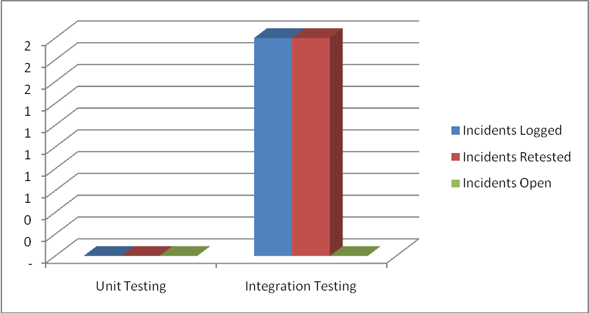
Figure 1: A total of 2 reported issues were found and retested successfully during integration testing.

Process Methodology

The team used the Unified Software Development Process, an iterative and incremental software development process framework, to implement this project. This framework ensured timely development, testing and deployment. The project was sub-divided into deliverable-based iterations where each was two weeks long. This sub-division allowed the team to respond quickly to each issue encountered. Deliverables were submitted to the client for review and later revised by the team for the final deliverable.
The team made extensive use of online collaboration tools such as Dropbox, Etherpad and Skype. Dropbox allowed the team to house all relevant project files in a central location that was accessible at all times. In addition, the files were accessible without requiring an Internet connection and were automatically kept in version control. Etherpad allowed the team to collaborate on written documents in real time, providing an extremely tight feedback loop. As team members made changes to files, other team members could immediately comment on or modify the changes. Skype enabled the group to provide the client with audio-visual off-site demos of the project, making it extremely convenient for both parties. As a plus, the audio-visual demonstration enabled the group to step through the actual code with the client, allowing detailed discussion on process flows that would otherwise not be possible via teleconference. The extensive use of collaboration tools allowed the team to easily complete project deliverables on time by avoiding duplication of work, getting timely feedback from and providing immediate assistance to the client.
As the project required the team to undertake design and development of a new product for the client, cost-benefit analyses were performed as part of the financial justification process. The process was crucial in determining the project's financial returns by estimating costs and cost-saving opportunities for the client.
Project management methodology was used efficiently to ensure that the team delivered a quality product on time and within reasonable costs while maintaining excellent communications and rapport with the client and within the team.

IS/IT Design

System Overview
The XBRL Project Database User Interface is a stand-alone, web-based user interface that is designed to logically view and analyze XBRL files. The project does not have any hardware or networking requirements. Upon completion, the project will be transitioned to the client and will be hosted on their servers.

Requirements

Functional Requirements:
- The application will provide the ability to export the information to a Microsoft Excel spreadsheet.
- The application will provide a user friendly interface.
- The application will have an interface with the look and feel of XBRL International's website.
- The application will provide informative feedback to the user (i.e. a 'Processing' statement on the interface as XBRL is being generated).

Non-Functional Requirements:
The system will be delivered as a self-contained web application archive (WAR) that will be used to distribute the collection of XHTML pages, servlets, Java classes that constitute the web application.

Development Environment
- Language: Java (JDK 1.6)
- Web Server: Apache Tomcat
- Operating System(s): Mac OS, Windows Vista
- Integrated Development Environment (IDE): Eclipse Europa
- Text Editor: TextMate
- Source Code Version Control: Git

User Interface
The user interface for the application will be developed using XHTML 1.0, and CSS 2.0. Additional interactive effects will be added using the jQuery JavaScript library. The look and feel of the user interface will be similar to the website of XBRL International.

Data Model Requirements:

Data Model
The data model includes four files – an instance document and the taxonomy:

- Instance Document
  - XBRL (XBRL file)
This document contains business reporting data that is marked up based on the taxonomy elements specified in the taxonomy.

- Taxonomy
The taxonomy provides descriptions and classifications of the concepts of financial statements or business reporting documents. It serves two main purposes – defining concepts and defining relationships between concepts. Taxonomies are composed of several files – a schema and linkbases.

  - XBRL schema (XSD file)
This document defines the concepts of the XBRL Instance Document.
  - Linkbases
Linkbases are files that define the relationships between and add more information to concepts. There are two kinds of Linkbases – Relational Linkbases and Resource Linkbases. The Relational Linkbase includes the Presentation, Calculation and Dimension/definition Linkbases while the Resource Linkbase includes the Label and Reference Linkbases. For this project specifically, the team will be dealing with a Presentation Linkbase and a Label Linkbase.
    - Presentation Linkbase Document (XML file)
This document defines presentation hierarchies of concepts (i.e. parent, child, siblings).
    - Label Linkbase Document (XML file)
This document adds label information to concepts.

Usability Requirements:
The usability requirements for the XBRL Project Database User Interface coincide with the functional requirements defined in the Systems Requirement Document.
- The look and feel of the interface must be similar to that of the XBRL International's website
- The Interface has to be user-friendly
- Feedback must be provided to the user and it has to be informative
- The application has to provide the user with the ability to export the information to a Microsoft Excel spreadsheet.

User Interface Information Architecture
The following sections consist of the information architecture of the XBRL Project Database User Interface accompanied by sections on the primary audience, usability requirements, screenshots and explanations for the design decisions made by the team.

Primary Audience:
The primary audience for the XBRL Project Database Interface consists of existing and potential clients of Data Communiqué or generally users interested in XBRL.

User Interface:
The XBRL Project Database Interface consists of a single webpage. This webpage includes two different components. The first one includes the selection-of-a-project steps (Project label, tabs of projects, and loading signal). The second one includes all the information about the project that was selected. The users have the ability to select from among five different projects. In addition, all the XBRL information can be exported into Excel files.

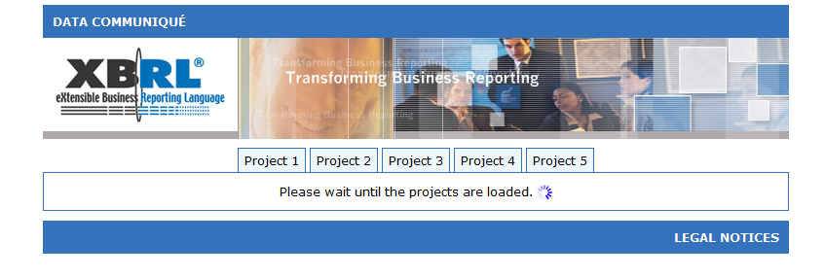
Figure 2: The Main Page

As specified in the requirements, the XBRL Project Database User Interface was required to match the look and feel of the XBRL International website. Thus, the team decided to use the blue color scheme and flash banner found on the XBRL International website.
The XBRL Project Database User Interface was also required to provide a user friendly interface, which is why the team decided to use components such as Ajax activity indicators, tabbed navigation, HTML lists, and intuitive icons.
The blue animated GIF in this screenshot represents the Ajax activity indicator. It continues to animate and only disappears upon completion of loading the project data. In addition, the message displayed to the left of it changes from "Please wait until the projects are loaded." to "Please select a project." between the two system states. This component does not require a page reload and allows the user to assess the system state at a glance.
In addition, the tabbed navigation shows that no project is currently selected due to fact that all tabs still have their bottom borders.

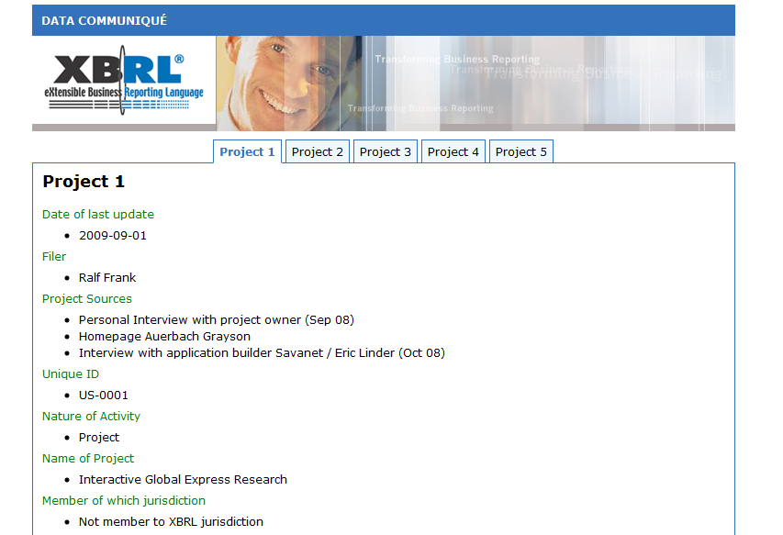
Figure 3: Project Selected

This screenshot shows the result of selecting a project such as "Project 1". The selection is reflected in the interface by changing the visual appearance of the appropriate tab. In this state, the "Project 1" tab utilizes bold text of a different color than the rest of the tabs and has dropped its bottom border. In addition, the background color of the selected tab has also changed to match the background color of the area below, giving it the appearance that it is attached to the area.
The team decided to represent the data using lists due to the nature of the data. The use of a table is not appropriate because each label is not constrained to having one value; instead, each label may have multiple values. A table or grid-like layout would show many empty cells due to the structure of the data. Moreover, users have become conditioned to vertical scrolling and rarely expect or appreciate horizontal scrolling. The list format allows the data to extend down the page vertically and eliminates the risk of frustrating the users due to horizontal scrolling.

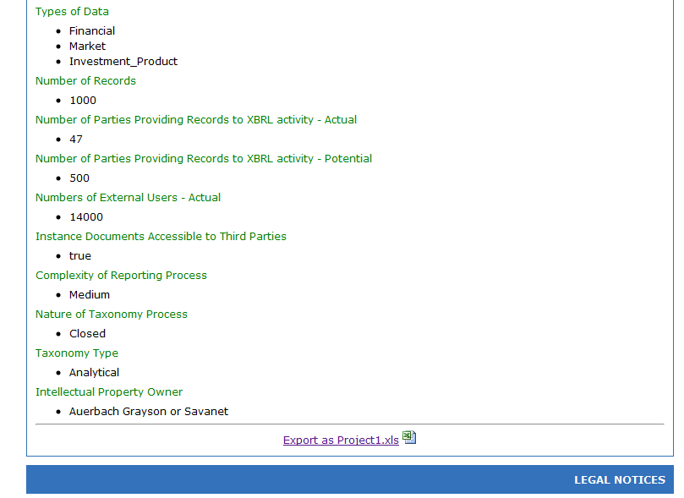
Figure 4: Export to Microsoft Excel

Provided at the end of each project is a link which allows the user to export the project data to a Microsoft Excel document. A small Excel icon is also displayed to the right of the link. The icon allows users to immediately recognize that clicking on the link will provide them with an Excel document rather than another HTML page.

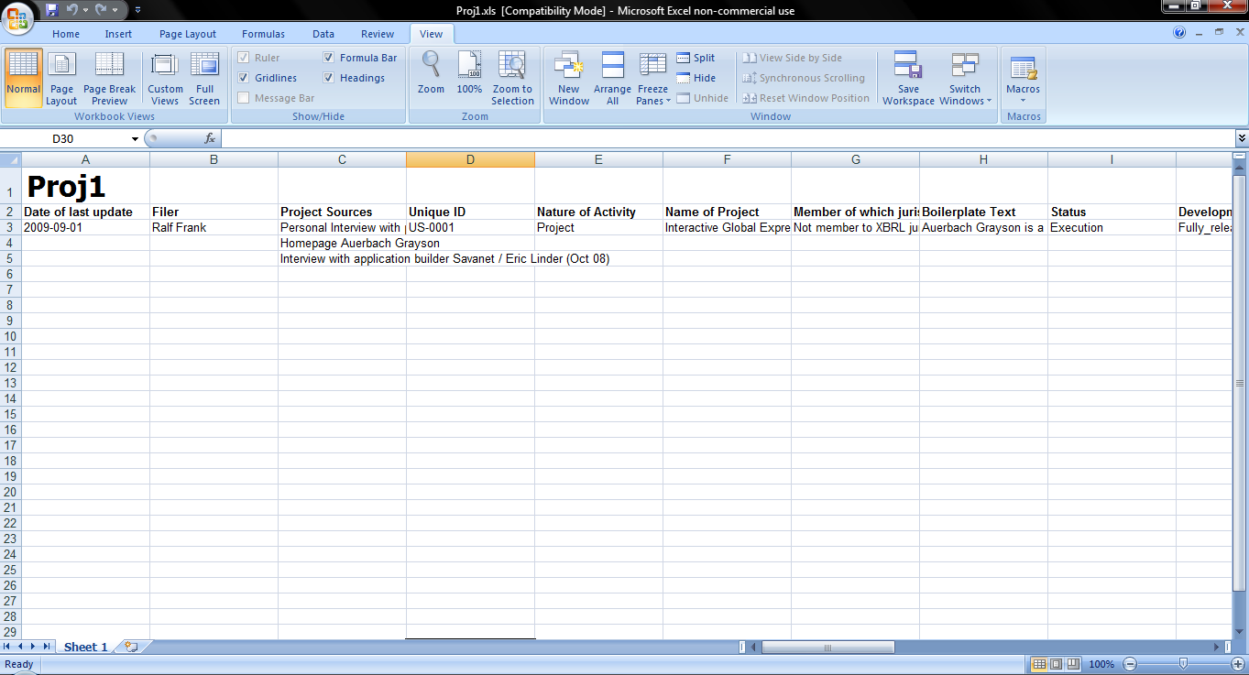
Figure 5: Microsoft Excel Spreadsheet

The exported Excel document contains the data for a particular project displayed in an easily readable format.

Data Model
XBRL Project Database User Interface is entirely dependent and compliant to the XBRL specifications. In line with this, its data model is appropriately represented in XML rather than in a relational database (RDBMS). A relational data model is not the optimal representation for such a data model where strict hierarchical relationships are expressed. A possible data representation could have been an XML Database, using Oracle Berkeley's DB XML product or a similar offering. However, since the XBRL files are stored locally and the project does not require complex views, the information can be extracted through data streams. Hence, a database is not required at the moment but could be employed in the future.

General Data Model Design:
The data dictionary is the taxonomy which consists of a schema and linkbases. The business concepts are defined in the taxonomy while the tagged data are stored in XBRL instance documents. The taxonomy schema contains the metadata that describe the data in the XBRL instance documents referencing the schema, while the linkbases provide information about relationships between elements and link them with specified external resources.

For the XBRL Project Database User, the taxonomy schema (xiii-proj-2009-09-30.xsd) references a label linkbase (xiii-proj-2009-09-30-label.xml) and a presentation linkbase (xiii-proj-2009-09-30-presentation.xml).
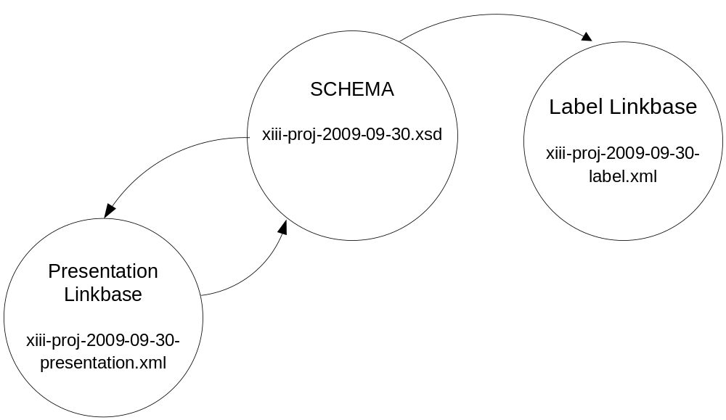Figure 6: Taxonomy

There are unidirectional arrows to the label linkbase and bidirectional ones to the presentation linkbase as the label linkbase connects elements to external resources, while the presentation linkbase provides descriptions of relationships between elements.² The complete documentation of the elements included in the taxonomy can be found in the Appendices.

The taxonomy schema imports concept definitions from other schemas. The figure below shows the package dependencies of all the schemas. The imported schemas are identified by their namespace identifier.

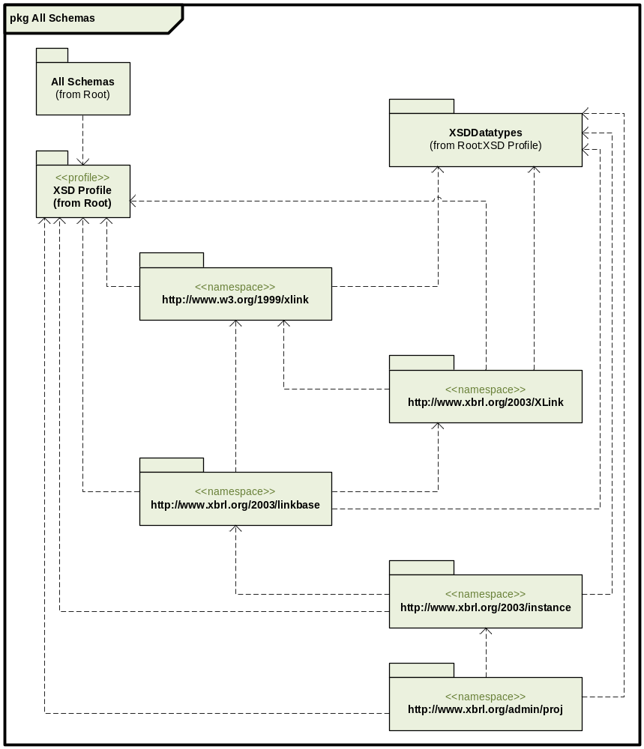
Figure 7: Package Dependencies

Data Model Architecture:

XBRL Specification

As mentioned previously, the XBRL framework splits business reporting information into two components: XBRL instances and taxonomies. XBRL instances contain information to be reported and the taxonomies define the concepts being communicated by the facts.

XBRL Taxonomy

The XBRL taxonomy is comprised of an XML Schema(s) and all of the linkbases related to the schema. In XBRL, all business concepts are defined in the taxonomy schema as elements each with a concrete name and type, an element may also have a set of attribute specifications. Each concept is a definition of a reporting term. The type refers to the data type of the concept. For example, a “cash” concept would typically have a monetary type. This declares that when cash is reported, its value will be monetary. In contrast, an “accountingPoliciesNote” concept would typically have a string type so that, when the “accountingPoliciesNote” is reported in an XBRL instance, its value would be interpreted as a string of characters. Namespaces are used to distinguish between elements across schemas. A set of taxonomies that can be discovered from one entry point schema is called a Discoverable Taxonomy Set (DTS).

The linkbases in taxonomy express relationships between concepts and relate concepts to their documentation. There are five different kinds of extended links used in taxonomies to document concepts: definition, calculation, presentation, label and reference. The first three types of extended link express inter-concept relationships, and the last two express relationships between concept and their documentation.

The linkbases may be embedded in the taxonomy schema or contained in a separate document. When a linkbase is in a separate document, a linkbaseRef between the schema and the linkbase is required.

Software Engineering Specifications
The software engineering of the project includes a section on the main activity of the project, its use case specification as well as lower level designs. In addition, an automatically generated Java API documentation is also included. A more detailed discussion on software engineering is available in the Appendix.

Financial and Cost-Benefit Analysis

Financial Analysis:
Upon completion, the XBRL Project Database User Interface will be immediately transitioned to Data Communiqué and will contribute to performance gains. The application was analyzed over a three-year payback period starting with the year of implementation (year 0). Both the non-risk-adjusted and risk-adjusted approaches have been used for the calculation of the Return on Investment (ROI) and the total cost for the three year duration of the project. More detailed calculations are provided in the Appendix.

Risk-Adjusted Approach:
The risk- adjusted model is used so as to measure how much risk is involved in calculating the three different types of costs (overhead, labor and training). For each type of cost calculation three different risk levels are used: low, likely and high.

The costs, benefits and returns from Year 0 to Year 3 according to the risk-adjusted model are shown in the figure below.

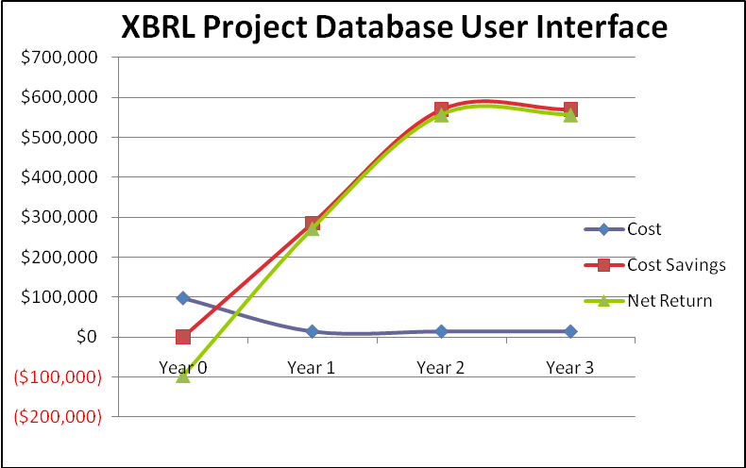
Figure 8: Cost, Benefits, and Net Return of Risk-Adjusted Approach

Non-Risk-Adjusted Approach:
All the calculations of costs, NPV, ROI, and IRR are done without including any kind of risk. No risks are assumed.

The costs, benefits and returns from Year 0 to Year 3 according to the non-risk-adjusted model are shown in the figure below.

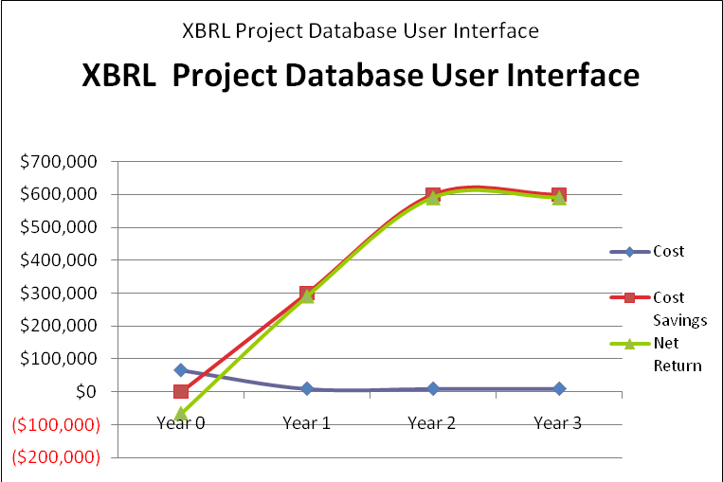
Figure 9: Cost, Benefits, and Net Return of Non-Risk-Adjusted Approach

Costs:
The costs are divided into three different categories: overhead costs, labor costs and training costs. The team has made a few assumptions regarding cost. First, the team assumes the role of an external consultant therefore rates are billed to be inclusive of overhead costs. Second, the team assumes that only a third of the billable rate is associated with labor and two thirds of the costs are associated with overhead costs. More detailed calculations are available in the Appendix.
- Overhead
This includes all other costs associated with team members (i.e. utilities, office space, etc.). Overhead costs represent two thirds of the hourly rate of each team member in the project plan.

- Labor
This includes the fixed hourly rate of approximately $50 for each team member during project development (year 0). As mentioned, $50 represents a third of the hourly rate of each team member in the project plan.

- Training
This is a one-time four-hour long training of the client that includes project packaging, deployment and execution for the systems administrator and training for the end user.

Risk-Adjusted Approach:
Overhead Costs
 | Year 0 | Year 1 | Year 2 | Year 3 | Total | Present Value
Total Cost | $53,400 | $2,700 | $2,700 | $2,700 | $61,500 | $60,000
Table 3: Overhead Costs

Labor Costs
 | Year 0 | Year 1 | Year 2 | Year 3 | Total | Present Value
Total Cost | $38,000 | $10,800 | $10,800 | $10,800 | $70,400 | $65,000
Table 4: Labor

Training Costs
 | Year 0 | Year 1 | Year 2 | Year 3 | Total | Present Value
Total Cost | $5,200 | $- | $- | $- | $5,200 | $5,200
Table 5: Training Costs

Non-Risk-Adjusted Approach:
Overhead Costs
 | Year 0 | Year 1 | Year 2 | Year 3 | Total | Present Value
Total Cost | $36,000 | $2,000 | $2,000 | $2,000 | $42,000 | $41,000
Table 6: Overhead Costs

Labor Costs
 | Year 0 | Year 1 | Year 2 | Year 3 | Total | Present Value
Total Cost | $25,000 | $7,000 | $7,000 | $7,000 | $46,000 | $43,000
Table 7: Labor

Training Costs
 | Year 0 | Year 1 | Year 2 | Year 3 | Total | Present Value
Total Cost | $5,000 | $- | $- | $- | $5,000 | $5,000
Table 8: Training Costs

Benefits:
Listed below are the potential benefits that the team identified. Several concepts such as cost-savings opportunities and ROI are discussed in greater detail in the following sections. More detailed calculations could also be found in the Appendices.

- Reduction in travel expenses:
Studies suggest that the user interface will reduce XBRL analysis time. The percentage of reduction of the time in analyzing the XBRL documents is 60%. Thus, for a total annual cost of $1,000,000 for business analysts’ salaries, the total cost reduction is $600,000. More detailed calculations are discussed in the next section.

- The return on investment:
Given the reduction of XBRL analysis time, the ROI (return on investment) is 791% and 1285% based on the risk-adjusted and non-risk-adjusted approach respectively over three years. As discussed below, the total risk-adjusted cost for the three year period amounts to $137,000 and $93,000 for the risk-adjusted and non-risk-adjusted respectively.

- Positive net revenues:
The combination of high cost savings (reduction in travel expenses) and low overhead, labor and training costs per year results in positive net revenues and a payback period of five months and 3 months for the risk-adjusted and non-risk adjusted model respectively. Moreover the biggest net cash flow at the last year, third year, of the project rises to $1,407,000.

Cost Savings:

Risk-Adjusted Approach:
The primary source of cost savings is incurred through the time savings that business analysts accrue by using the XBRL Project Database User Interface. The team estimates that the user interface will reduce the time it takes to analyze XBRL documents by 57%. Assuming Data Communiqué employs 10 business analysts who spend a significant amount of their time analyzing XBRL documents. We approximated the average hourly rate for business analysts to be $52. Hence, the computations for cost savings are as follows:

 | Year 0 | Year 1 | Year 2 | Year 3 | Total
Total Cost Reduction |  | $285,000 | $570,000 | $570,000 | $1,425,000
Total Benefits | $0 | $285,000 | $570,000 | $570,000 | $1,425,000
Table 9: Cost Savings

Non- Risk-Adjusted Approach:
For the calculation of the cost savings for the non-risk- adjusted model, a 60% reduction in XBRL document analysis times are assumed. Hence, calculations are as follows:

 | Year 0 | Year 1 | Year 2 | Year 3 | Total
Total Cost Reduction |  | $300,000 | $600,000 | $600,000 | $1,500,000
Total Benefits | $0 | $300,000 | $600,000 | $600,000 | $1,500,000
Table 10: Cost Savings

Return on Investment and Payback:

Risk-Adjusted Approach:
The return on investment over a three year period is 791% based on a risk adjusted model. The total cost for the three year period for the risk adjusted model is $137,100. Moreover, the IRR is calculated as 341%.

 | Year 0 | Year 1 | Year 2 | Year 3 | Total | NPV
Costs | ($96,600) | ($13,500) | ($13,500) | ($13,500) | ($137,100) | ($130,000)
Cost Savings | $0 | $285,000 | $570,000 | $570,000 | $1,425,000 | $1,158,000
Net Return | ($96,600) | $271,500 | $556,500 | $556,500 | $1,287,100 | $1,028,000
Table 11: Return on Investment

Non-Risk-Adjusted Approach:
The return on investment over a three year period is 1285%. The total cost for the three year period for the non-risk adjusted model is $93,000. Moreover, the IRR is calculated as 513%.

 | Year 0 | Year 1 | Year 2 | Year 3 | Total | NPV
Costs | ($66,000) | ($9,000) | ($9,000) | ($9,000) | ($93,000) | ($83,000)
Cost Savings | $0 | $300,000 | $600,000 | $600,000 | $1,500,000 | $1,220,000
Net Return | ($66,000) | $291,000 | $591,000 | $591,000 | $1,407,000 | $1,130,000
Table 12: Return on Investment

Results:
According to both non-risk-adjusted and risk- adjusted models, the net revenues for each year is positive and both the ROI and the IRR are high. The decreased percentage for ROI and IRR in the risk-adjusted model is explained by the 57% reduction in XBRL analysis times as opposed to the 60% reduction in the non-risk-adjusted model. Furthermore, the risk-adjusted method is used for the calculations of the three types of costs. Overall, the project appears to be profitable.

Project Management

Project Management Approach
As mentioned above the team used the Unified Software Development Process for the project. The process ensured timely development, testing and deployment. Deliverables were revised by the group and made available to the client for review as well.

The team setup weekly client status meetings with Data Communiqué. This was an opportunity to address issues and concerns from both parties and provide an update on progress. Meeting minutes were taken during each meeting and made available.

Transparency was an important goal that the team wanted to put in place during the project lifecycle. This insured that expectations were aligned and addressed quickly and early if not. To do this, the team provided document deliverables and meeting minutes to a secured online repository that only client and the team could access.

Project Schedule
Below is the schedule of activities within each phase/iteration.

Project Phases and Major Deliverables: *
Inception Phase (01/27/2010 - 02/09/2010)
Iteration01 - 01/27/2010 - 02/09/2010
Project Proposal

Elaboration Phase (02/10/2010 - 02/23/2010)
Iteration02 - 02/10/2010 - 02/23/2010
Mini-Strategic Plan
Requirements
Cost Benefit Analysis
Project Plan

Construction Phase (02/24/2010 - 04/06/2010)
Iteration03 - 02/24/2010 - 03/09/2010
Project Construction

Iteration04 - 03/10/2010 - 03/23/2010
Project Construction
Database Design
Software Engineering Design

Iteration05 - 03/24/2010 - 04/06/2010
Project Construction
HCI Design
Network Design

Transition Phase (04/07/2010 - 05/05/2010)
Iteration06 - 04/07/2010 - 04/20/2010
Draft of Final Report

Iteration07 - 04/21/2010 - 05/05/2010
Final Report
Final Presentation

Table 13: Project schedule to iteration-level with major deliverables outlined.
*Details can be found in the Microsoft Project Plan in the Appendices of this deliverable.

Gantt Chart View:
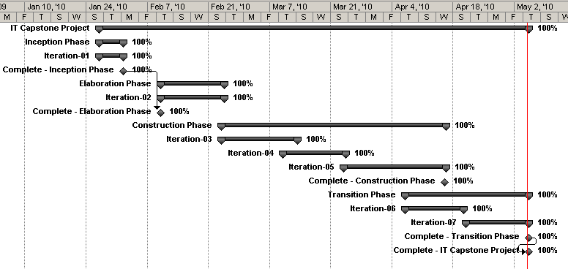
Figure 10: Current Gantt View of Project. Project is currently 100% complete.

Project Budget
The approach to the project was from a perspective of an independent consulting company. The charge rate of $150 per hour per member takes into account the member's salary and all other cost expense related to the project (i.e. laptops, working space, etc).

Overall, the project was slightly over budget by approximately $6,750.00 but was completed on time. This was mostly due to the higher learning curve involved in using the UBmatrix XBRL libraries during the construction phase of the project. This additional effort required more hours to be put in and expanding the construction deadline by a week. The earned value analysis is depicted below.

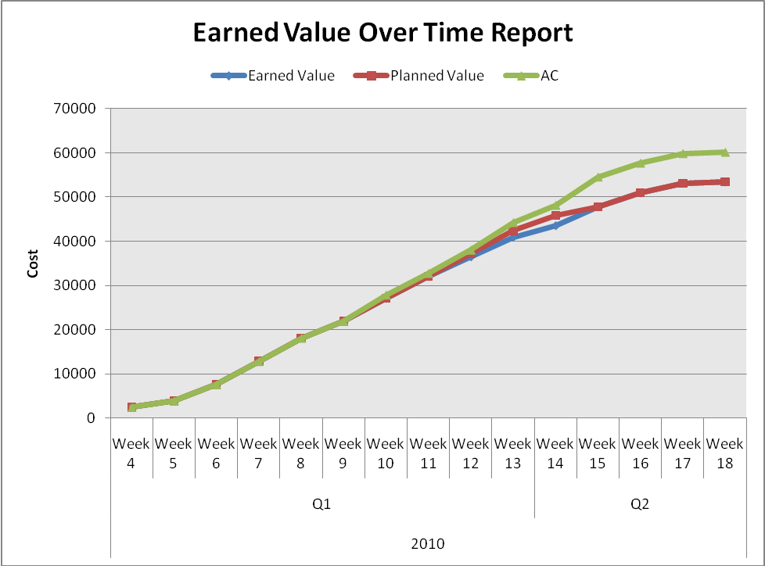
Figure 11: Earned Value Analysis of Project as of 05/05/2010. The Project is slightly over budget then planned, but was on time.

Project Challenges
As mentioned, above the project ran approximately 12.6% over budget. Cost overruns were seen during the Construction Phase. The team had a higher learning curve than was projected at inception. The use of UBmatrix querying language required more time and effort from the development team.

The project manager was able to identify and apply additional slack in the project plan earlier for such challenges to minimize cost overruns. In addition, the other deliverables during that time were not impacted, as the project plan was loosely coupled with the development effort. Thus, no additional cost overruns were seen outside of the construction/development.

The team valued time and quality over cost. Thus, these additional hours that were required were necessary to providing a quality product on time. Proper management and the use of the Unified Development Process contributed to the minimized impact on the project.

Transition Plan
The project was fully transitioned to the client on May 5th, 2010, exactly one week after the final sign-off meeting. As mentioned in the Testing Plan (Section 6), user acceptance testing, regression testing and automated performance testing were outside of the scope of the project but are highly recommended to be completed by Data Communiqué.
The transition plan includes two documents – installation and user training that ensure a seamless and pain-free transition of the project to the client. A high level discussion of each of the components is provided below. A more thorough discussion on each of the sections could be found in the Appendices.
    - Installation – The document aims to provide the client with a reference by which they can either replicate the development and implementation environment. It provides descriptions of the steps involved in replicating the environment for future development and the process of deploying the web archive in a web-application server for basic implementation.
    - User Training – The document aims to provide detailed descriptions of available user actions and possible outcomes. The user training document could also serve as a user's manual.

Results
The client was generally satisfied with the team's performance and agreed to sign the project closure report, which is attached as an Appendix. Listed below are qualitative and quantitative results that were uncovered by the team during testing.

Qualitative Results
The XBRL Project Database User Interface successfully provides a user-friendly interface to analyze the XBRL framework. Previously, in order to gather data from the XBRL framework, the user had to read the instance document and constantly refer to the schema and any of the linkbases the document referenced. The isolation of data was compounded by the fact that the fields were unordered as well. The project addresses these problems by aggregating the data, ordering the fields and displaying the contiguous information.

Quantitative Results
An important aspect of the project was the amount of time required to analyze and load the XBRL files into the appropriate data structures. The team agreed that a page load time of 1 second was the acceptable amount of time for the amount of data being processed and SLA statistics.
Initially, the application required roughly 32 seconds to parse the XBRL files and the application was unusable during this period. The team then decided to implement a Singleton with regards to the data structure, which held the XBRL information to avoid constant reloading of the XBRL files and reduce the page load times. After implementing the design pattern, subsequent page load times were lowered to roughly 100 milliseconds, or about 0.3125% of the original load time.
However, the first user to access the page after a fresh server startup would still have to wait roughly 8 seconds before being able to select a project, no matter how long ago the server was started. The team then decided to load the XBRL files into the data structure upon the server's startup. This change resulted into an average page load time of 100 milliseconds.

Summary and Conclusion

The team’s use of the Unified Software Development Process proved to be an accurate methodology for the scope and project dynamics. The project management techniques kept the project on time and ensured that quality deliverables were being produced; communications were open among all members and the client; expectations aligned; and kept the team motivated throughout the endeavor. The process also allowed the team to react quickly and decisively to unexpected issues.

The team managed to communicate regularly with the client through the use of weekly conference calls. An initial concern was that the team's first client contact person, Debapriya Banerjee, would only be available for the first month or so of the semester due to expected childbirth.

The team had not had much contact with Mrs. Banerjee’s replacement, Harsh Choudhary, until roughly three quarters of the way through the development process, which presented new issues in itself. Firstly, Mr. Choudhary needed to be debriefed about the project and its current status. Secondly, after getting debriefed, Mr. Choudhary had a different set of expectations than Mrs. Banerjee. Although the overarching requirements of the project were well established and understood by both parties, Mr. Choudhary presented different design and implementation specific expectations than Mrs. Banerjee. The issues were quickly resolved through constant communication and both parties were able to reach commonality in terms of expectations and objectives. In addition, the group was agile enough such that they were able to adjust to the modified scope and still finish on time.

Collaboration tools played a prominent role in the communications process. The various tools allowed the group to regularly talk to the client and submit the due deliverables. These tools also allowed the client to instantly provide the team with feedback while giving the team the means to assist the client as if the team were on site.

The group encountered issues regarding project development as well. Firstly, as XBRL is XML-based, the initial assumption of the group was that the project will use standard Java libraries for XML parsing like JAXP, SAX and JAXB. However, through research and dialogs with the client, the group decided to use XBRL specific libraries. Consequently, the group implemented a third-party XBRL library from UBmatrix, which also introduced its own set of challenges. One, the library was intended for a stand-alone Java-based desktop application, requiring the group to selectively use features appropriate for the project. Second, the UBmatrix library used a proprietary query language for parsing the XBRL instance document, requiring significant research and learning by the group.

The project was officially completed on May 5th, 2010. Overall, both the client and the team saw the XBRL Project Database User Interface as a successful implementation as it provides a user-friendly interface to analyze the XBRL framework. The interface presents the XBRL information in a human-readable format, performs well, and provides the user with Microsoft Excel export features.

Appendices

Appendix ID | Appendix Name
A | Group_Three_Appendix-A – Team_Resumes
B | Group_Three_Appendix-B – Testing_Plan
C | Group_Three_Appendix-C – Testing_Specifications
D | Group_Three_Appendix-D – Testing_Results
E | Group_Three_Appendix-E – Taxonomy_I
F | Group_Three_Appendix-F – Taxonomy_II
G | Group_Three_Appendix-G – Software_Engineering_Specifications
H | Group_Three_Appendix-H – Calculations-Discounted_Cash_Flow-ROI
I | Group_Three_Appendix-I – IT_Capstone_Project_Plan
J | Group_Three_Appendix-J – Installation_Plan

Fundamentals - http://www.iasb.org/XBRL/Resources/Fundamentals.html
Extensible Business Reporting Language (XBRL) 2.1 - http://www.xbrl.org/Specification/XBRL-RECOMMENDATION-2003-12-31+Corrected-Errata-2008-07-02.htm#_3

