XBRL Project Database User Interface for Data Communiqué

Group Three Database Design

March 17, 2010

Group Three:
Gino Gervasio
Theodora Kampelou
Nathalie Neptune
Anand Patil
James Wu

Information Technology Masters Capstone
ITEC-6800

Prof. Gregory Hughes

Data Model Requirements

Client Requirements

XBRL Project Database User Interface is entirely dependent and compliant to the XBRL specifications. In line with this, its data model is appropriately represented in XML rather than in a relational database (RDBMS). A relational data model is not the optimal representation for such a data model where strict hierarchical relationships are expressed. A possible data representation could have been an XML Database, using Oracle Berkeley's DB XML product or a similar offering. However, since the XBRL files are stored locally and the project does not require complex views, the information can be extracted through data streams. Hence, a database is not required at the moment but could be employed in the future.

General Data Model Design

The data dictionary is the taxonomy which consists of a schema and linkbases. The business concepts are defined in the taxonomy while the tagged data are stored in XBRL instance documents. The taxonomy schema contains the metadata that describe the data in the XBRL instance documents referencing the schema, while the linkbases provide information about relationships between elements and link them with specified external resources.

For the XBRL Project Database User, the taxonomy schema (xiii-proj-2009-09-30.xsd) references a label linkbase (xiii-proj-2009-09-30-label.xml) and a presentation linkbase (xiii-proj-2009-09-30-presentation.xml).
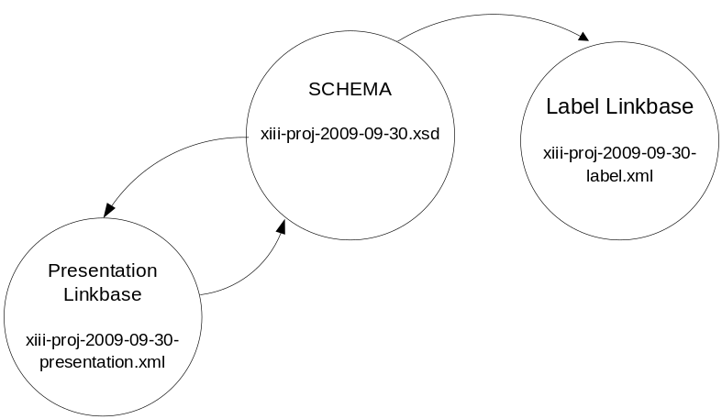
Figure 1. Taxonomy

There are unidirectional arrows to the label linkbase and bidirectional ones to the presentation linkbase as the label linkbase connects elements to external resources, while the presentation linkbase provides descriptions of relationships between elements.² The complete documentation of the elements included in the taxonomy can be found in Appendix I.
The taxonomy schema imports concept definitions from other schemas. Figure 2 below shows the package dependencies of all the schemas. The imported schemas are identified by their namespace identifier.

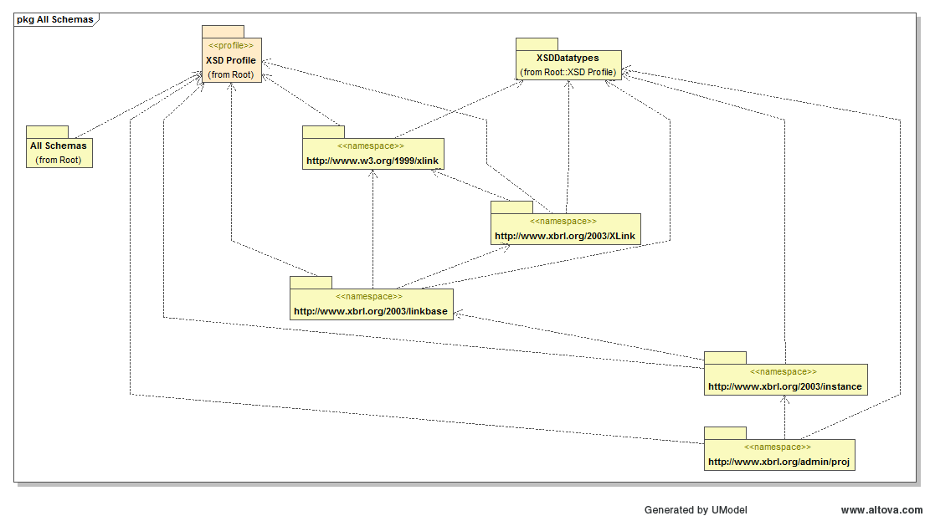
Figure 2

Data Model Architecture

XBRL Specification

As mentioned previously, the XBRL framework splits business reporting information into two components: XBRL instances and taxonomies. XBRL instances contain information to be reported and the taxonomies define the concepts being communicated by the facts.

XBRL Taxonomy

The XBRL taxonomy is comprised of an XML Schema(s) and all of the linkbases related to the schema. In XBRL, all business concepts are defined in the taxonomy schema as elements each with a concrete name and type, an element may also have a set of attribute specifications. Each concept is a definition of a reporting term. The type refers to the data type of the concept. For example, a “cash” concept would typically have a monetary type. This declares that when cash is reported, its value will be monetary. In contrast, a “accountingPoliciesNote” concept would typically have a string type so that, when the “accountingPoliciesNote” is reported in an XBRL instance, its value would be interpreted as a string of characters. Namespaces are used to distinguish between elements across schemas. A set of taxonomies that can be discovered from one entry point schema is called a Discoverable Taxonomy Set (DTS).

The linkbases in a taxonomy express relationships between concepts and relate concepts to their documentation. There are five different kinds of extended links used in taxonomies to document concepts: definition, calculation, presentation, label and reference. The first three types of extended link express inter-concept relationships, and the last two express relationships between concept and their documentation.

The linkbases may be embedded in the taxonomy schema or contained in a separate document. When a linkbase is in a separate document, a linkbaseRef between the schema and the linkbase is required.

Fundamentals - http://www.iasb.org/XBRL/Resources/Fundamentals.html
Extensible Business Reporting Language (XBRL) 2.1 - http://www.xbrl.org/Specification/XBRL-RECOMMENDATION-2003-12-31+Corrected-Errata-2008-07-02.htm#_3

