Commerce on Rails™ for newline Creations, LLC

HCI Assignment

April 3, 2006

Group Six:
Rachel Messham
Lukasz Karapuda
Dick Granberg
Michael Mayer

Information Technology Masters Capstone
ITEC-6800

Prof. Hughes
User Interface Components

Three distinct components constitute the Commerce on Rails web application:
- Default storefront web interface
- Commerce Manager web interface
- Web services application programming interface (API)

The users of each component are distinct and therefore each component has different user interface requirements.

The users of the default storefront web interface are website visitors who visit a vendor’s online store in order to browse the product catalog and make a purchase. A vendor who chooses to deploy Commerce on Rails (COR) as their e-commerce platform will be unlikely to release their online store to production with the default COR storefront web interface that is shipped with each COR installation. Instead, the vendor will customize the storefront web interface by modifying the default CSS style sheets and XHTML templates that constitute the COR storefront. The vendor has complete control over the look and feel of the store, the layouts and the data displayed on the screen. Hence the responsibility for providing an adequate user interface lies mostly in the vendor’s hands.

The user of the Commerce Manager web interface is the administrator of the online store (usually an employee of the vendor). The default user interface for the Commerce Manager is not designed to be adjustable by the vendor or their web developer. The primary requirements for the interface are:
- Consistency in the look and feel of page elements (consistent formatting of input forms, tables and other page elements);
- Consistency in usage patterns (e.g. similar steps required to “add a product” and “add a product category”);
- Expected (obvious) organization of the navigation;
- Understandable error messages;
- Effective user input validation.

The user of the web services API is the vendor’s web developer. The purpose of the API is to allow the web developer the ability to transparently integrate COR with a website. The API allows the web developer to utilize COR functionality within the website they develop as if they actually programmed the functionality into the website itself. If the API is used to integrate COR into a website, the visitors are not redirected to the storefront web interface shipped with COR. Instead, they remain in the realm of the website at all times, while the website communicates with COR in the background.

The web services API is an interface and also has usability requirements albeit of a different, less visible nature. The API is composed of methods. The naming of the methods needs to be explicit and descriptive. Method signatures (argument list, return values) as well as the specific configuration parameters required to access the API must be fully documented. In addition, suggestions could be provided for the API users on how to display data retrieved via the API on the website they develop (content snippets).

Usability Requirements

Web Interface Requirements

The Commerce on Rails web interface has specific requirements that differ from the requirements for the API. This is because the web interface will be accessed by a different user group, one with different needs and varying levels of experience – users who will not likely have significant technical knowledge or could have specific needs or even disabilities. The best way to make the web interface accessible and usable by users of varied skill levels is to adhere to industry standards and appeal to user knowledge and familiarity.

The pages must adhere to the major suggestions of the Web Accessibility Initiative (WAI). The major guidelines can be found at http://www.w3.org/TR/WCAG10/#Guidelines. The group will verify that the website adheres to these standards in some part by validating the XHTML and CSS with the World Wide Web Consortium (W3C) validator. Some of the guidelines to be implemented include:
- Navigation must be clear and consistent – e.g. links underlined
- Different page sections must be marked by clear divisions or labeled
- Page coloring - no bright, distracting colors
  - Research on color theory and effects of color on user perception and thought processes suggests that the color blue invokes feelings of trust, confidence and intelligence in the user that appear to be appropriate for an ecommerce site (http://www.color-wheel-pro.com/color-meaning.html)
- All image elements and anchor elements must be titled
API Requirements
The API has slightly different requirements. It does not have to strictly adhere to the guidelines of the WAI as the web interface does. The two most important requirements to be implemented are:
- API function names must be descriptive
- API documentation must be clearly written

Front-End Architecture

The following are screen shots of some important components of the Commerce on Rails application with explanations of the front-end architecture choices we made.

Default Storefront – Main Page

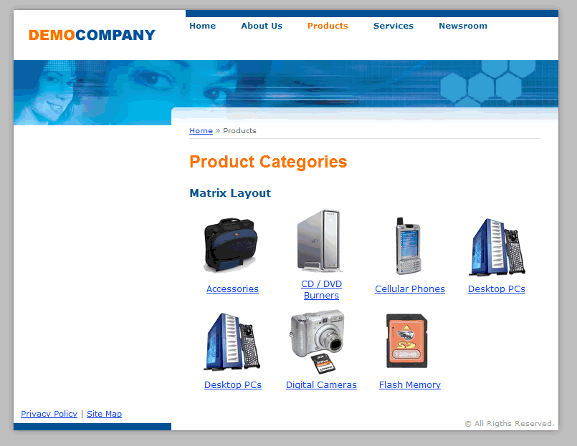

For the main page, the first architecture choice was to include breadcrumb navigation, located above the page title. This allows the user to quickly and easily see where they are within the product catalog and avoid getting lost within the application.

A matrix layout is used for the root product categories (i.e. Accessories, CD/DVD Burners, etc. in the screenshot above). This layout provides a quick overview of the main product categories in the store.

Category images are provided for each product category to appeal to users who are more graphically minded. The images give visual cues about the contents of each category and allow users to get a good idea of what each contains before actually selecting one.

Commerce Manager – Product Category – Category List

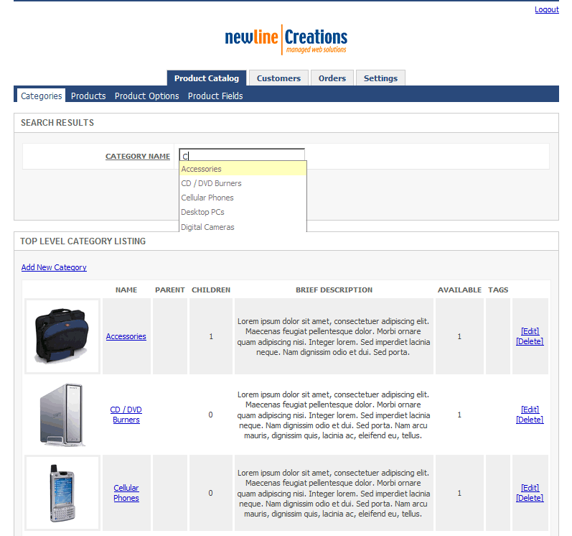

For the category list page, a search box is provided at the top of the page so that users can quickly find categories by name without having to look through a list. Search boxes are so common and are utilized so often that users often get frustrated if they are not present – particularly in a more complex web application such as Commerce on Rails. The box supports wildcard search. In addition, as mentioned later in this paper, it makes suggestions based on the users’ input of the first letters of the category name.

Navigation and sub-navigation are separated at the top to help clarify to the user where they are in the site and how to get out if need be. The navigation tabs clearly highlight the currently active screens. In addition, the two major sections of the screen are visually separated into different boxes – search and category listing. This helps the user to accomplish their specific task.

Thumbnail pictures are shown for each category, again assisting in more efficient use and appealing to those who are graphically-minded. All image and anchor elements are titles.
Commerce Product Manager – Product Catalog – Category Edit

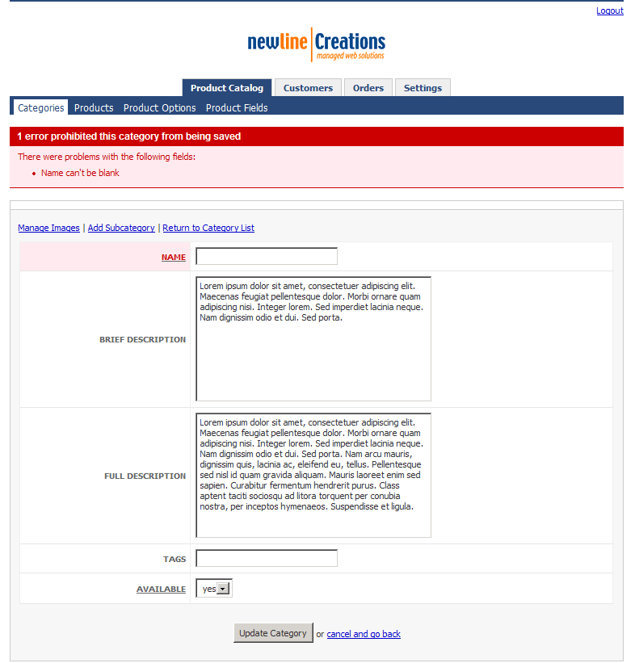

One of the most common tasks that users find frustrating is filling out a simple form. Often, the reason for this frustration is that required information fields and formats are not clearly labeled, and there is not adequate feedback reporting completion errors. In the category edit form, this design includes required fields that are clearly marked with the field labels underlined. If form input is not valid, an error message is displayed on top and the fields with the invalid input are highlighted. In addition, input is stored and remains displayed on the page so the user does not need to re-enter it all.

Commerce Manager – Product Catalog – Category Images

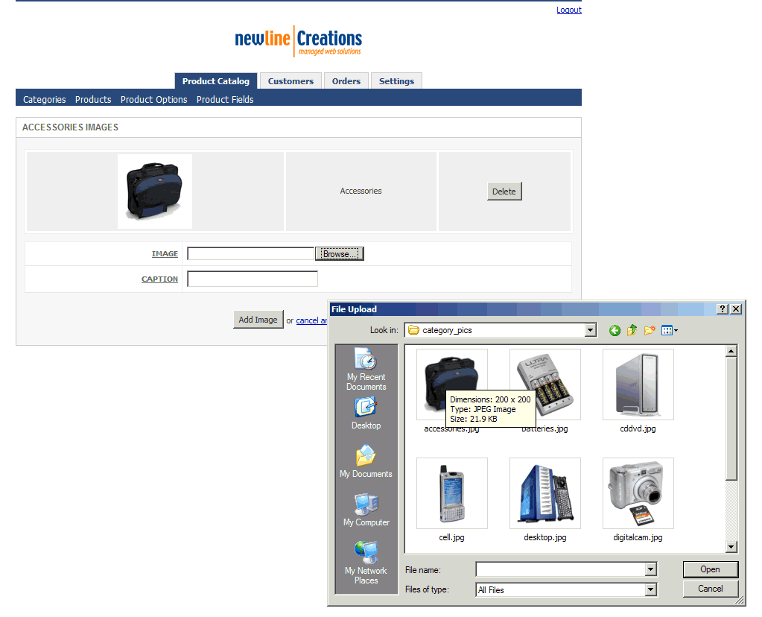

Important front-end architecture decisions were also incorporated in the design of category image uploading capability. Images are automatically resized upon uploading so the user does not have to prepare images before uploading them into the store. In addition, the system checks to make sure that the uploaded file is a valid image and has an acceptable extension.

Finally, multiple images can conveniently be uploaded from this screen in sequence. There is no separate screen for uploading and listing images, again increasing ease and efficiency for the user.

Design Details Workshop

Teaching It

As an ecommerce application, the project will definitely require a certain level of knowledge in order for users to implement it for their specific needs. Since the majority of the design work is on the back-end of the Commerce on Rails system, it is these customers that need to be considered when making design choices and deciding how to help users learn and understand the system. Because of the complexity of the system and the fact that it is a web application, reliance is placed on “teaching it” to the users, rather than making it transparent or automating it. Ultimately, customers will be running the application themselves, and so they must learn and understand it. Simply guiding them through steps and not teaching them to do it themselves will not be sufficient.

Documentation and help will be provided by newline. It will be created by the company according to their specifications, and is not a part of our project. However, as part of the project, design details allowing users to accomplish their specific tasks to reach desired outcomes without trouble or frustration were specifically included. As described above, the front-end was created keeping users’ knowledge in mind, making use of their mental schemas and models.

Although use of the back-end will require a learning mechanism, the design helps by automating certain features. For example, automatic assistance is built into the “search” box when a user is trying to search for a product (see screenshot below). Similar to Google, when the user types the first letter(s) of their search terms, suggested options will be displayed that they can select from. This eases the mental load of the user, as they do not have to remember the entire search term that they are looking for. This also eliminates potential errors, such as spelling errors, and provides immediate feedback so that the user knows they are doing the correct thing.

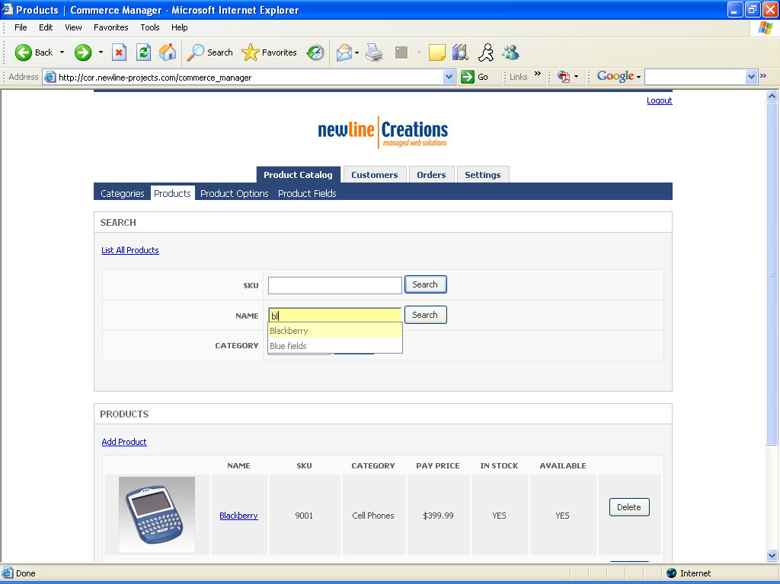

Increasing Transparency

As mentioned previously, it is difficult to make a lot of the back-end design transparent due to the nature of the Commerce on Rails application. However, one place where it was possible to increase the transparency and bring its manifest model closer to the users’ mental model is in editing of a product category. Currently, the design of this feature is that the user must manually edit a category in order to change the order that the categories appear on the screen in the catalog. On the ‘edit category’ screen, they must alter the integer corresponding to the category’s position in the list. However, reexamination of this feature showed that it is not as intuitive as it could be. One possible improvement was to make categories draggable, allowing the user to simply drag the category to its new and correct place in the list. Not only would this be easier and eliminate the middle step of having to edit the category, it would also relate to the users’ mental model of categories in a catalog. For example, when a company is creating a draft of a hardcopy catalog, they will likely change the order of categories several times before it is finalized and the catalog is printed and distributed. Depending on the medium of the category itself, they will probably have the different categories on different pages or pieces of paper, and can physically rearrange them. They can continue to do this until the categories are in the desired order. Therefore, the users’ mental model probably includes the physical moving and shifting of one piece of paper, or one category, in exchange with another. The concept of draggable categories on the interface, therefore, would appeal to that mental model and make the system more intuitive.

