Commerce on Rails™ for newline Creations, LLC

Software Engineering

March 27, 2006

Group Six:
Rachel Messham
Lukasz Karapuda
Dick Granberg
Michael Mayer

Information Technology Masters Capstone
ITEC-6800

Prof. Hughes
Use Case Specification

Use Case UC1: Add a Product

Scope: Commerce on Rails Web Application
Level: user goal
Primary Actor: Store Owner
Stakeholders and Interests:
- Store Owner: The store owner wants to successfully add a product, its options and corresponding description to the catalog.
- Customer: Customers want to be able to purchase products from the store product catalog.
Preconditions: None.
Success Guarantee (Postconditions): The added product is available in the product catalog.
Main Success Scenario:
- Store owner requests the product addition form.
- System returns the product addition form.
- Store owner enters all required data.
- Store owner submits a product addition request.
- System processes the request.
- Store owner closes the application if finished.
Extensions (Alternate Flows):
The application fails:
- Store owner gets an error message stating that they should retry.
If the product exists:
- The store owner is informed that the product already exists.
- The store owner chooses whether to update the current product, to add a new product or to quit.
Add Product Use Case Diagram 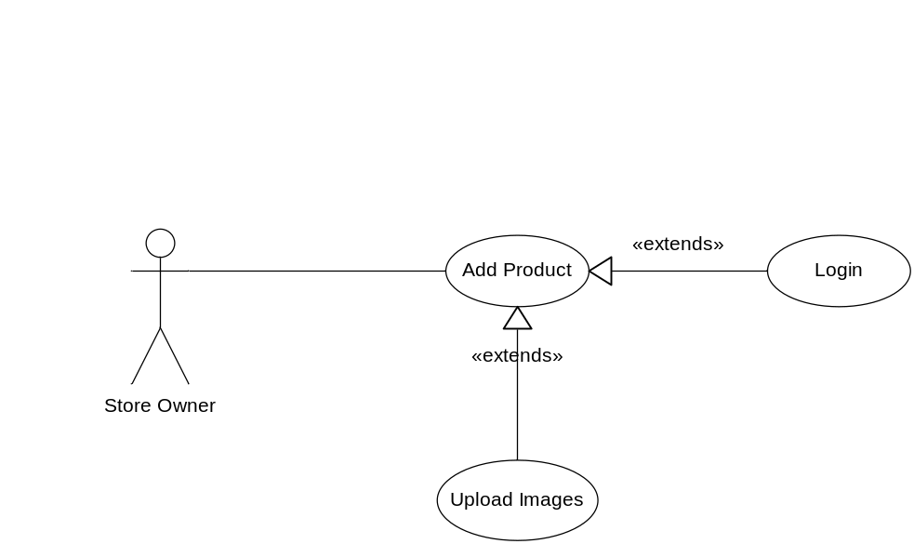
System Use Case Diagram
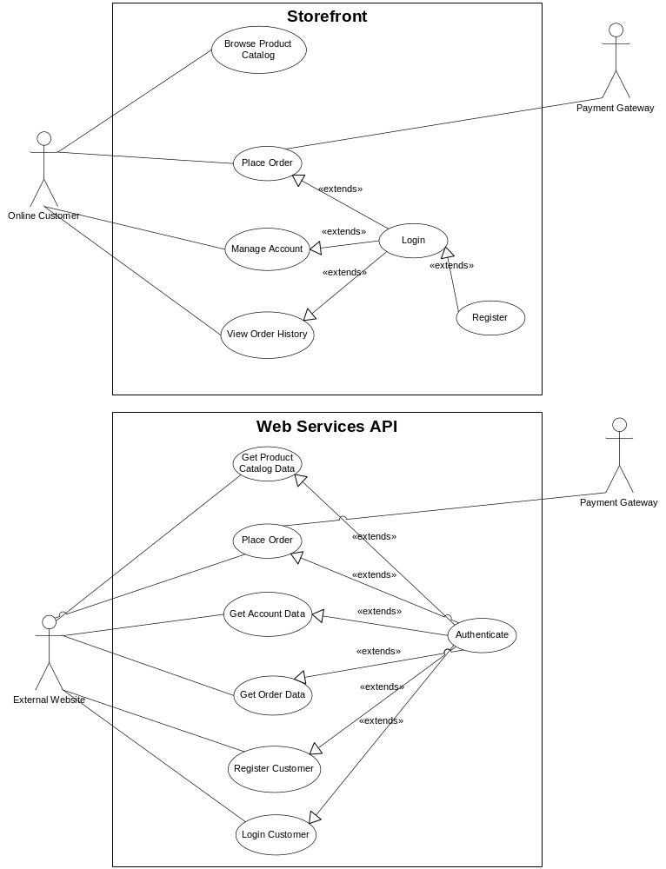
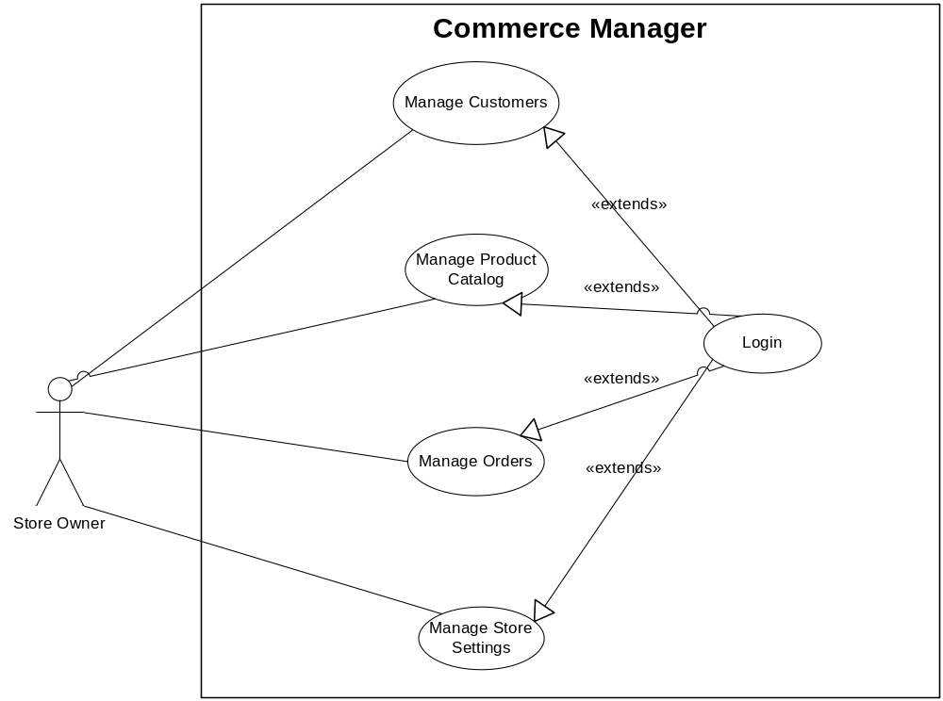
Activity Diagram
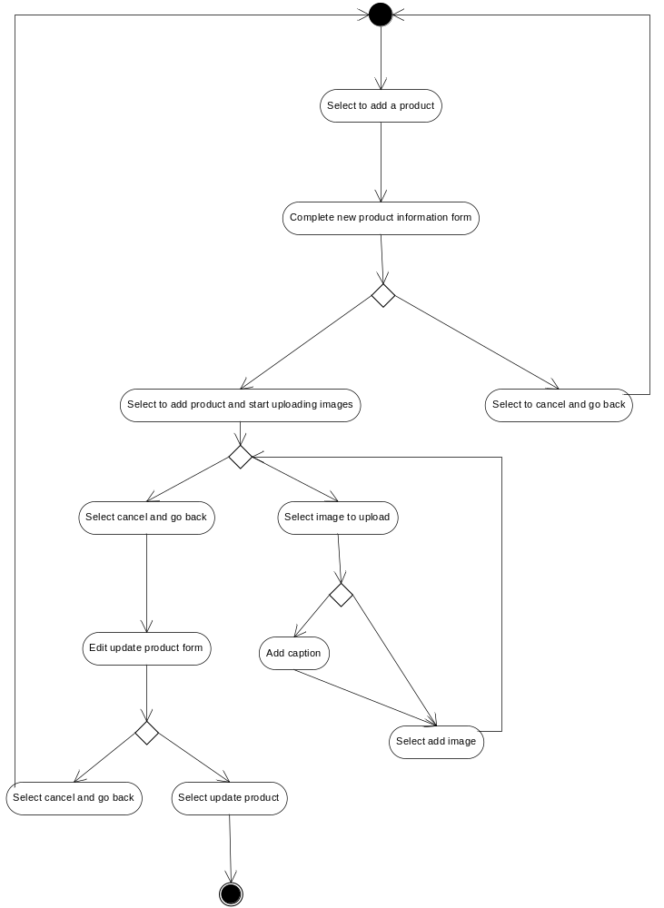
Sequence Diagram

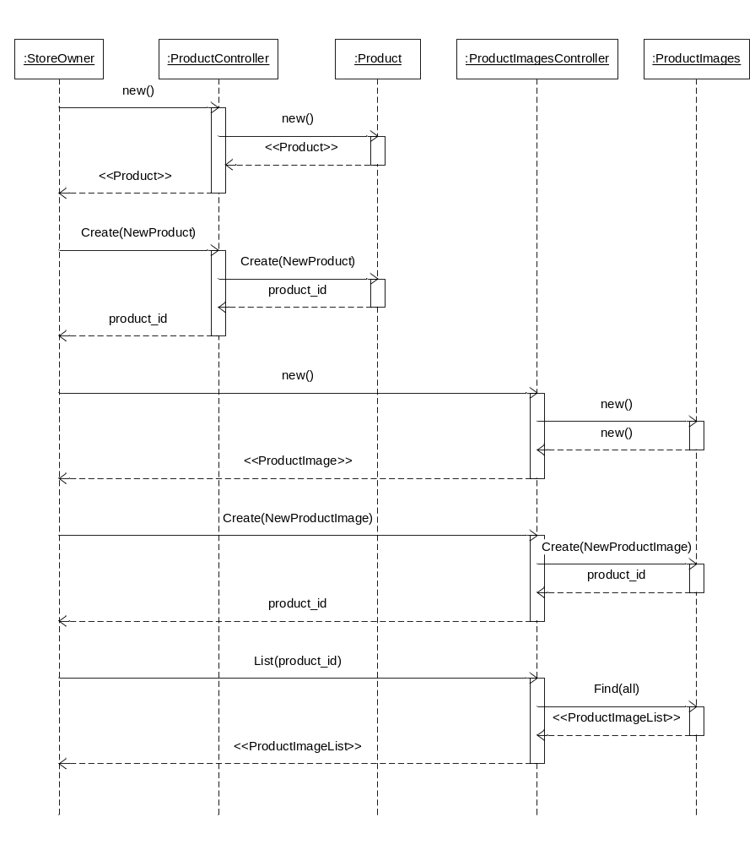
Component Diagram

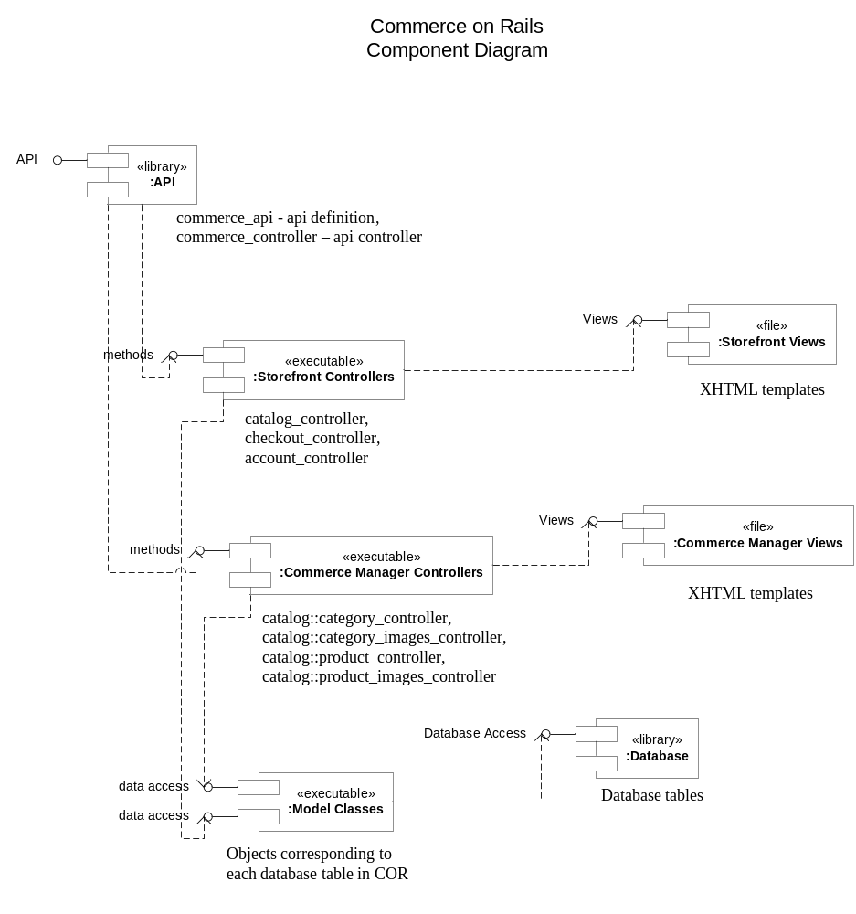
Deployment Diagram

