XBRL Project Database User Interface for Data Communiqué

Group Three Cost Benefit Analysis

February 24, 2010

Group Three:
Gino Gervasio
Theodora Kampelou
Nathalie Neptune
Anand Patil
James Wu

Information Technology Masters Capstone
ITEC-6800

Prof. Gregory Hughes

Financial Analysis
Upon completion, the XBRL Project Database User Interface will be immediately transitioned to Data Communiqué and will contribute to performance gains. The application was analyzed over a three-year payback period starting with the year of implementation (year 0). Studies suggest that the user interface will reduce XBRL analysis time by 60%. Given these performance gains, the return on investment is 791% based on a risk-adjusted model over three years. As discussed below, the total risk-adjusted cost for the three year period amounts to $136,997. This results in positive net revenues every year and a payback period of five months.

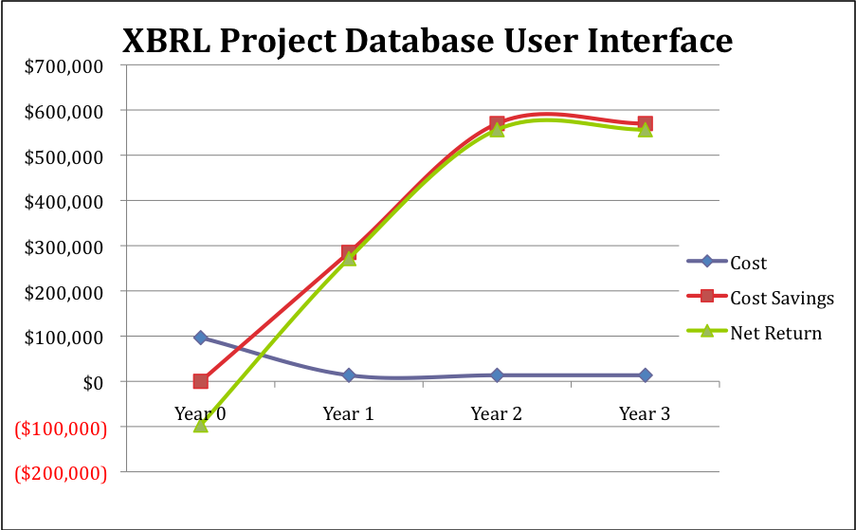
Figure 1
Costs
The group has made a few assumptions regarding cost. First, the group assumes the role of an external consultant therefore rates are billed to be inclusive of overhead costs. Second, the group assumes that only a third of the billable rate is associated with labor and two thirds of the costs are associated with overhead costs. The project consists of three types of costs:
- Labor
This includes the fixed hourly rate of approximately $50 for each team member during project development (year 0). As mentioned, $50 represents a third of the hourly rate of each team member in the project plan.

- Overhead
This includes all other costs associated with team members (i.e. utilities, office space, etc.). Overhead costs represent two thirds of the hourly rate of each team member in the project plan.

- Training
This is a one-time four-hour long training of the client that includes project packaging, deployment and execution for the systems administrator and training for the end user.

Cost Summaries:
Overhead Costs
 | Year 0 | Year 1 | Year 2 | Year 3 | Total | Present Value
Total Cost | $35,600 | $1,780 | $1,780 | $1,780 | $40,940 | $40,027

Labor
 | Year 0 | Year 1 | Year 2 | Year 3 | Total | Present Value
Total Cost | $25,325 | $7,200 | $7,200 | $7,200 | $46,925 | $43,230

Training
 | Year 0 | Year 1 | Year 2 | Year 3 | Total | Present Value
Total Cost | $4,800 | $- | $- | $- | $4,800 | $4,800

Cost Savings

The primary source of cost savings is incurred through the time savings that business analysts accrue by using the XBRL Project Database User Interface. The group estimates that the user interface will reduce the time it takes to analyze XBRL documents by 60%. Data Communiqué employs 10 business analysts who spend a significant amount of their time analyzing XBRL documents. We approximated the average hourly rate for business analysts to be $52. Hence, the computations for cost savings are as follows:

 | Year 0 | Year 1 | Year 2 | Year 3 | Total
Total Cost Reduction |  | $300,000 | $600,000 | $600,000 | $1,500,000
Total Benefits | $0 | $300,000 | $600,000 | $600,000 | $1,500,000

Return on Investment and Payback

The return on investment over a three year period is 791% based on a risk adjusted model. The total cost for the three year period for the risk adjusted model is $136,997. The payback period using these figures is 5 months.

 | Year 0 | Year 1 | Year 2 | Year 3 | Total | NPV
Cost | ($96,587) | ($13,470) | ($13,470) | ($13,470) | ($136,997) | ($130,085)
Cost Savings | $0 | $285,000 | $570,000 | $570,000 | $1,425,000 | $1,158,415
Net Return | ($96,587) | $271,530 | $556,530 | $556,530 | $1,288,003 | $1,028,330

