XBRL Project Database User Interface for Database Communiqué

Group Three Project Plan and Schedule

February 24, 2010

Group Three:
Gino Gervasio
Theodora Kampelou
Nathalie Neptune
Anand Patil
James Wu

Information Technology Masters Capstone
ITEC-6800

Prof. Gregory Hughes

Group Three Project Plan and Schedule

1. Project Management and Schedule Overview:

Our team has decided to use the Unified Software Development Process for this project. This process is an iterative and incremental development process that will ensure timely development, testing and deployment. The project is sub-divided into four phases: Inception, Elaboration, Construction, and Transition. Within each phase are a number of two-week iterations which encompass various deliverables. Deliverables will be submitted to the client for review and will be revised by the group for the final deliverable.

Project Phases and Major Deliverables:
Inception Phase (01/27/2010 - 02/09/2010)
Iteration01 - 01/27/2010 - 02/09/2010
Project Proposal

Elaboration Phase (02/10/2010 - 02/23/2010)
Iteration02 - 02/10/2010 - 02/23/2010
Mini-Strategic Plan
Requirements
Cost Benefit Analysis
Project Plan

Construction Phase (02/24/2010 - 04/06/2010)
Iteration03 - 02/24/2010 - 03/09/2010
Project Construction

Iteration04 - 03/10/2010 - 03/23/2010
Project Construction
Database Design
Software Engineering Design

Iteration05 - 03/24/2010 - 04/06/2010
Project Construction
HCI Design
Network Design

Transition Phase (04/07/2010 - 05/05/2010)
Iteration06 - 04/07/2010 - 04/20/2010
Draft of Final Report

Iteration07 - 04/21/2010 - 05/05/2010
Final Report
Final Presentation

Our approach to the project is from a perspective of an independent consulting company. The charge rate of $150 per hour per member takes into account the member's salary and all other cost expense related to the project (i.e. laptops, working space, etc).

Gantt chart View:

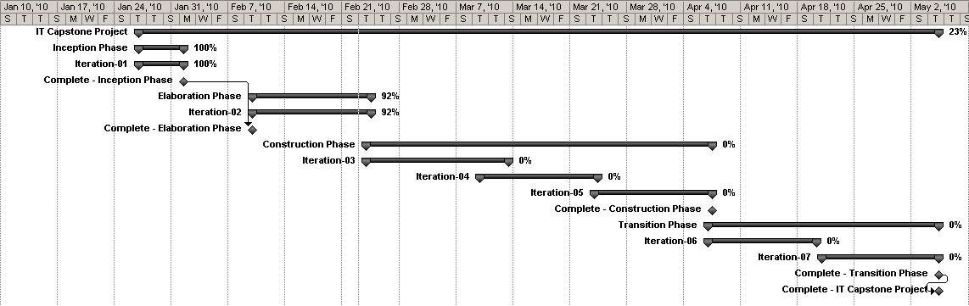
Figure 1: Current Gantt View of Project. Project is currently 22% complete.

