**Title:** Trader Brews

**Repo:** https://github.com/FlyMoe/Trader-Brews

**Project Description:** Not many people know this, but there’s an underground society of beer traders. Beers are local to the region the breweries are located. Most craft breweries aren’t big enough for mass distribution outside of their local region. That’s where beer trading comes in. If you want a beer from a brewery you can’t get locally, you need to trade for it. There are a few sites that offer trades for users: Beeradvocate and RateBeer. But there’s a ton of functionality that these sites are missing that would make for a better user experience.   
  
Some functionality I’m going to add are:  
1. A User creates an account to log in.  
2. Users will then be able to create a profile for others to see.  
3. A “cellar” module will be added where the users can add all the beers they want to trade. The cellar will be able to be seen (or not depending on the settings) by other users.   
4. A search functionality will be added so users can search for beers that they want to trade.

5. The users would be able to contact each other to set up the trade.

6. Blog about beer related stuff

7. If time permits, maybe a forum for beer related talk.

**Technology Used:**HTML, CSS, JavaScript, Bootstrap, JQuery - used for the front end of the application.   
  
Node - used for the routes to the pages  
  
MySQL - database used to hold the data

Passport - Used for signing in or creating an account.

PHP - Not sure yet, I’ll figure it out later.  
  
**Layout:**

1. Login Page
   1. Create New account
   2. Login to the application
2. New Account
   1. Create User Name
   2. Create Password
3. Home Page
   1. Profile Module
   2. Cellar Module
   3. Search Module
   4. Chat Module
   5. Message Board Module

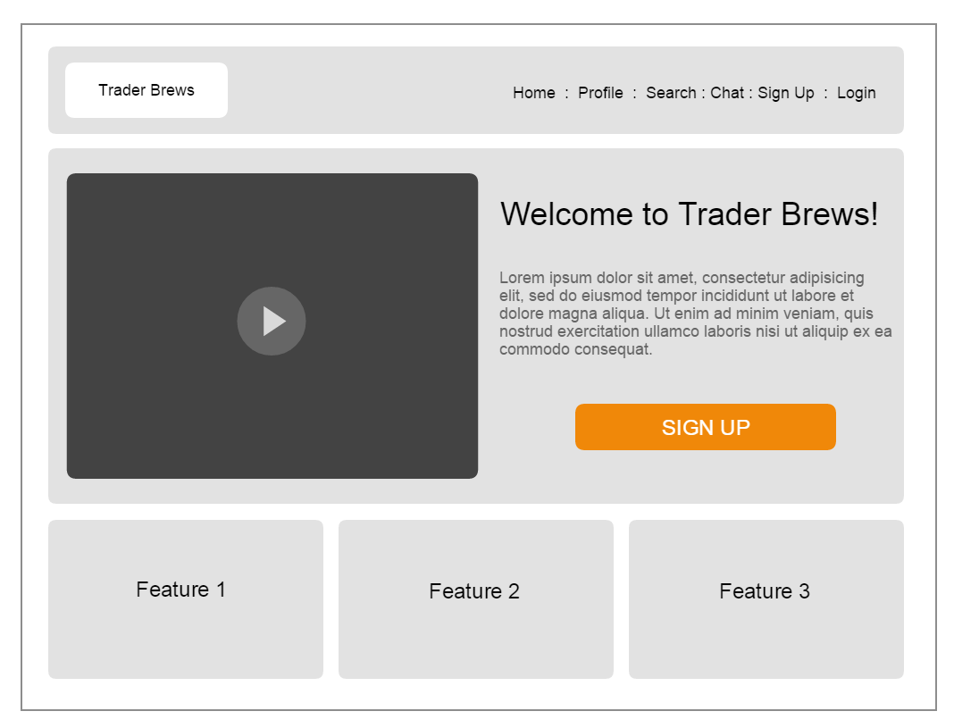

1. Profile Module
   1. First Name (required)
   2. Last Name (required)
   3. Address (required)
   4. Zip Code (required)
   5. Phone Number (required)
   6. Profile Pic
2. Cellar Module
   1. List of beers in the cellar

Name/ Brewery

Size of beer

Bottle Date

Number of beers in cellar

* 1. Add a beer to the Cellar

Name of beer

Brewery

Size of beer

Bottle Date

Number of beers in cellar

Drink By

Notes

1. Search Module
   1. Search by beer name
   2. Search by brewery
   3. Search by user name
2. Chat Module
   1. Open up chat window to chat with users
3. Message Board Module (if there’s time)