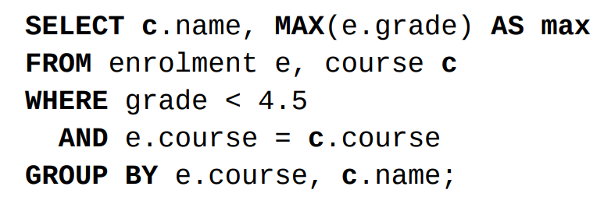
1. 常见约束 (DDL)
• PRIMARY KEY (col) → 唯一 + 非空
• UNIQUE → 允许多个 NULL
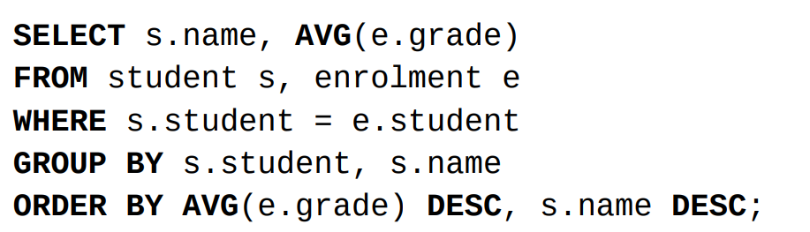
• CHECK (col > 0) → 检查条件
• FOREIGN KEY (a) REFERENCES table(col) → 外键约束

2. JOIN 模板
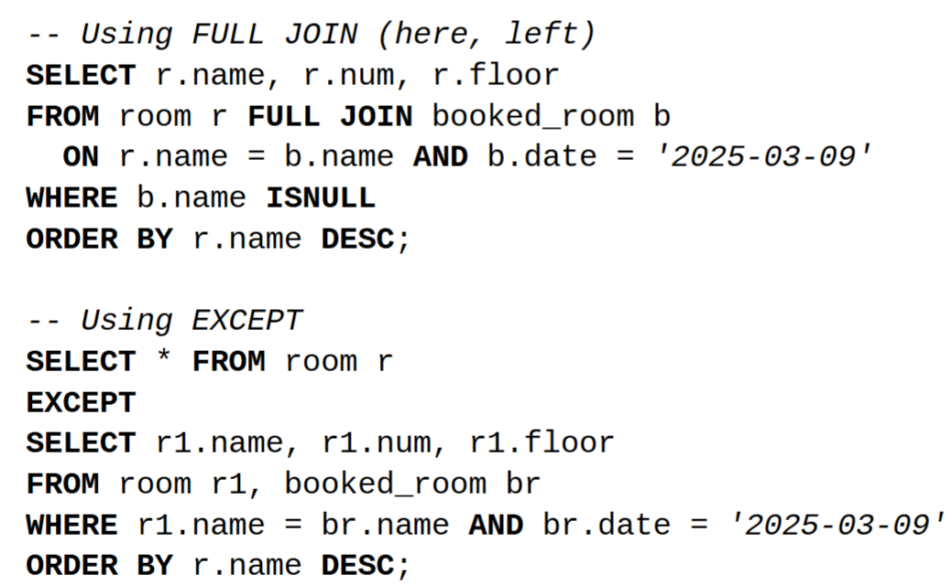
SELECT ...
FROM A, B
WHERE A.id = B.id;

3. 子查询
... WHERE col IN (SELECT ...);
... WHERE col NOT IN (SELECT ...);
... WHERE EXISTS (SELECT ...);

4. 聚合与分组 (Aggregate)
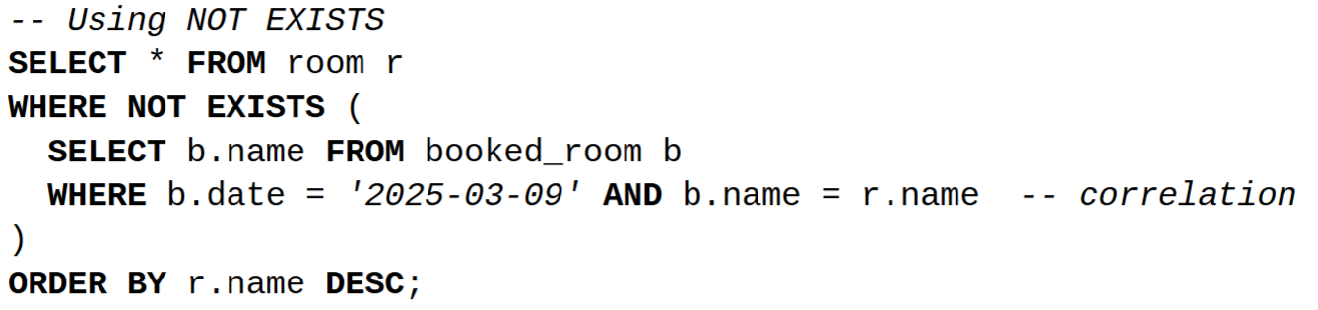
SELECT col, AVG(x) AS avg
FROM T
GROUP BY col
HAVING AVG(x) > 2;

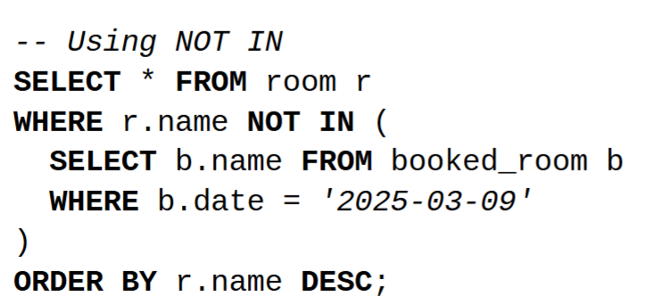
5. 去重与排序
SELECT DISTINCT ...
ORDER BY grade ASC, name DESC;

6. 常见查询模式
• 找未出现过：NOT IN / LEFT JOIN ... IS NULL
• 找最大/平均：MAX(), AVG(), GROUP BY
• 多条件排序：ORDER BY a ASC, b DESC
示例：找未被预订的房间（2025-03-09）
SELECT r.name
FROM room r
WHERE r.name NOT IN (
SELECT b.name FROM booked_room b WHERE b.date='2025-03-09'
)
ORDER BY r.name DESC;

7. ERD 提示
• 实体 → 表
• 关系 → 外键
• 主键翻译：单属性或复合键
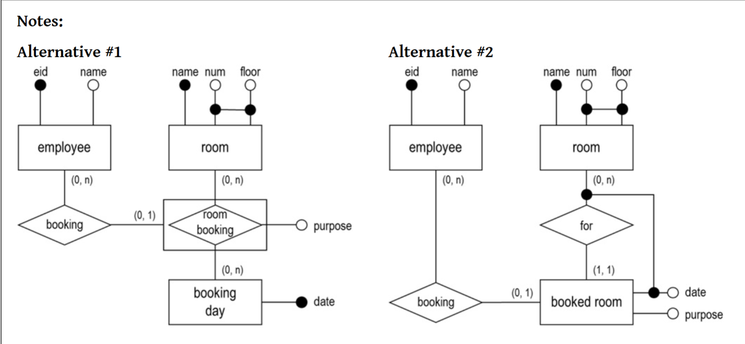
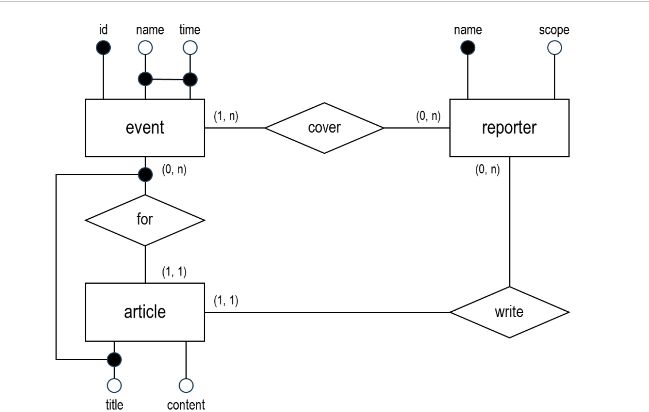
• 例外情况：多值属性 → 单独表；弱实体需依赖主实体

