**School:** Computer Science

**Institution:** University of Windsor

**Term:** Fall 2019

**Course:** Comp-3150 (03-60-315-1) : Database Management Systems

**Instructor:** Dr. C. I. Ezeife

**Assignment #**1 : Total: 50 marks

**Handed Out:Thurs. Sept 12, 2019; Due Thurs Sept 26, 2019**

**Objective of Assignment**: To test on knowledge of database concepts and its 3-level architecture necessary for designing databases and their applications as well as practice on use of entity-relationship (ER) model to design databases.

**Scope**: Assignment covers materials from Chapters 1, 2 and 3 of book discussed in class.

**Electronic Assignment Submission:** Done through <http://blackboard.uwindsor.ca>

**Marking Sheme** : The mark for each of the questions is indicated beside each question.

**Academic Integrity Statement**: Remember to submit only work that is yours and include the following confidentiality agreement and statement at the beginning of your assignment.

**CONFIDENTIALITY AGREEMENT & STATEMENT OF HONESTY**

**I confirm that I will keep the content of this assignment/examination confidential.**

**I confirm that I have not received any unauthorized assistance in preparing for or doing this assignment/examination. I confirm knowing that a mark of 0 may be assigned for copied work.**

________________________________________ ________________________________________

Student Signature Student Name (please print)

________________________________________ ________________________________________

Student I.D. Number Date

**Marking Scheme : The mark for each question and sub question is shown with the question below. Place your solutions in tables provided for answers where possible.**

**For office Use only**

|  |  |
| --- | --- |
| **Question** | **Mark** |
| **1** | **/10** |
| **2** | **/10** |
| **3** | **/10** |
| **4** | **/20** |
| **Total** | **/50** |

**CHAPTER 1: DATABASES AND DATABASE USERS**

1. Given the simple Employee-Workson-Project database schema that contains three files described as follows, answer the following questions with regards to this database. (Total for que 1 is 10 marks)

Emp (eid : integer, ename : string, age : integer, salary: real)

Workson (eid : integer, pid : integer, hours : integer)

Project (pid : integer, pname : string, budget : real, managerid : integer)

Note : eid, ename, age and salary are the employee id, name, age and salary respectively. Also, hours is the number of hours worked by employee on a project. The rest of the attributes pid, pname, budget and managerid are the project id, name, budget and managerid respectively. A manager is an employee.

1. Create a valid instance of this database containing values for its records with at least four records in each file. A valid instance does not violate any database integrity contraints. (3 marks)
2. Provide 2 informal English queries from this database with their answers. Each query should involve at least 2 of the files in the database and your answer should indicate the files (e.g., Emp, Workson) needed to answer each query and specify what fields are being retrieved as the result (e.g., ename, age). Please, provide your solution in the 3 column table below. (4 marks)
3. Specify at least 3 relationships with other database files (one for each of the 3 database files) among the records of the database. For each file (e.g., Emp) list any relationships it has with other files through its fields (e.g., eid). Provide your solution using the table below.   
    (3 marks)  
     
   Solution : (3 marks for 1i)

|  |  |  |
| --- | --- | --- |
| Query | Answer | Files involved |
| 1. Create a valid instance of this database containing values for its records with at least four records in each file.   (3 marks) | An instance of the Employee-Workson-Project database is :  Emp  Workson  Project | ----- |
| 2. Provide 2 informal English queries from this database with their answers. Each query should involve at least 2 of the files in the database and your answer should indicate the files (e.g., Emp, Workson) needed to answer each query and specify what fields are being retrieved as the result (e.g., ename, age). (4 marks)  i.  ii. | Result of query  ii. |  |
| 3. Specify at least 3 relationships with other database files (one for each of the 3 database files) among the records of the database. For each file (e.g., Emp) list any relationships it has with other files through its fields (e.g., eid). Provide your solution using the table below.   (3 marks) |  |  |

1. Recall that a database has many types of users, each of whom may require a different view of the database. For example, one user of the Employee-Workson-project database of question 1 may be accessing and printing the details and salaries of each employee frequently and thus a view for this user is created. Another view for this database is checking that project has available budget before expenditure such as paying salaries. (Total for que 2 is 10 marks)
2. Using this Employee-Workson-Project database,give 2 additional views that may be needed by other user groups for the database. (5 marks)

Solution : (5 marks for 2i)

|  |
| --- |
|  |

ii) Give 5 examples of integrity constraints that you think can apply to the Employee-Workson-Project database of question 1. (5 marks)

Solution : (5 marks for 2ii)

|  |
| --- |
|  |

**CHAPTER 2: DATABASE SYSTEM CONCEPTS AND ARCHITECTURE**

3.a. Design a simple database schema with not more than 4 files for a University database system indicating all applicable integrity constraints and information. Also, show a sample database state for the database. (5 marks for a)

b. Using your database, describe the difference between logical and physical data independence.

(5 marks for b)

(Total for que 3 is 10 marks)

|  |  |
| --- | --- |
| Question | Answers |
| 1. Design a simple database schema with not more than 3 files for a University database system indicating all applicable constraints and information. Also, show a sample database state for the database.  (5 marks) | Simple University database schema is :  Some integrity constraints are :  A state of this database is : |
| 1. Using your database, describe the difference between logical and physical data independence |  |

**CHAPTER 3: DATA MODELING USING THE ENTITY-RELATIONSHIP (ER) MODEL**

4- Consider the ER diagram of Figure 3.21 given below, which shows a simplified schema for an airline reservations system. Using this ER diagram, provide the requirements description of this database by (a) clearly identifying all the entities, b) the relationships connecting the entities, c) the constraints in this schema (cardinality, participation) and d) the sentences specifying the requirements of the database whose design is the ER diagram. Try to be as precise as possible in your requirements and constraints specification. An example interpretation of the constraint label of 1 to N for DEPARTURE_AIRPORT is ‘Each Airport has many flight legs departing from it’. An example part of the requirement specification sentences is : `The database represents each AIRPORT, keeping its unique AirportCode, the AIRPORT Name, and the City and State in which the AIRPORT is located.’

Place your answers in the table provided below. (Total for que 4 is 20 marks)  
  
(Note : 10 marks for correct entity and relationship identifications with their attributes (5 for entities and 5 for relationships), 5 marks for correct constraints interpretations on the edge labellings, 5 marks for correct verbal interpretations of the database being represented by the ER digram.

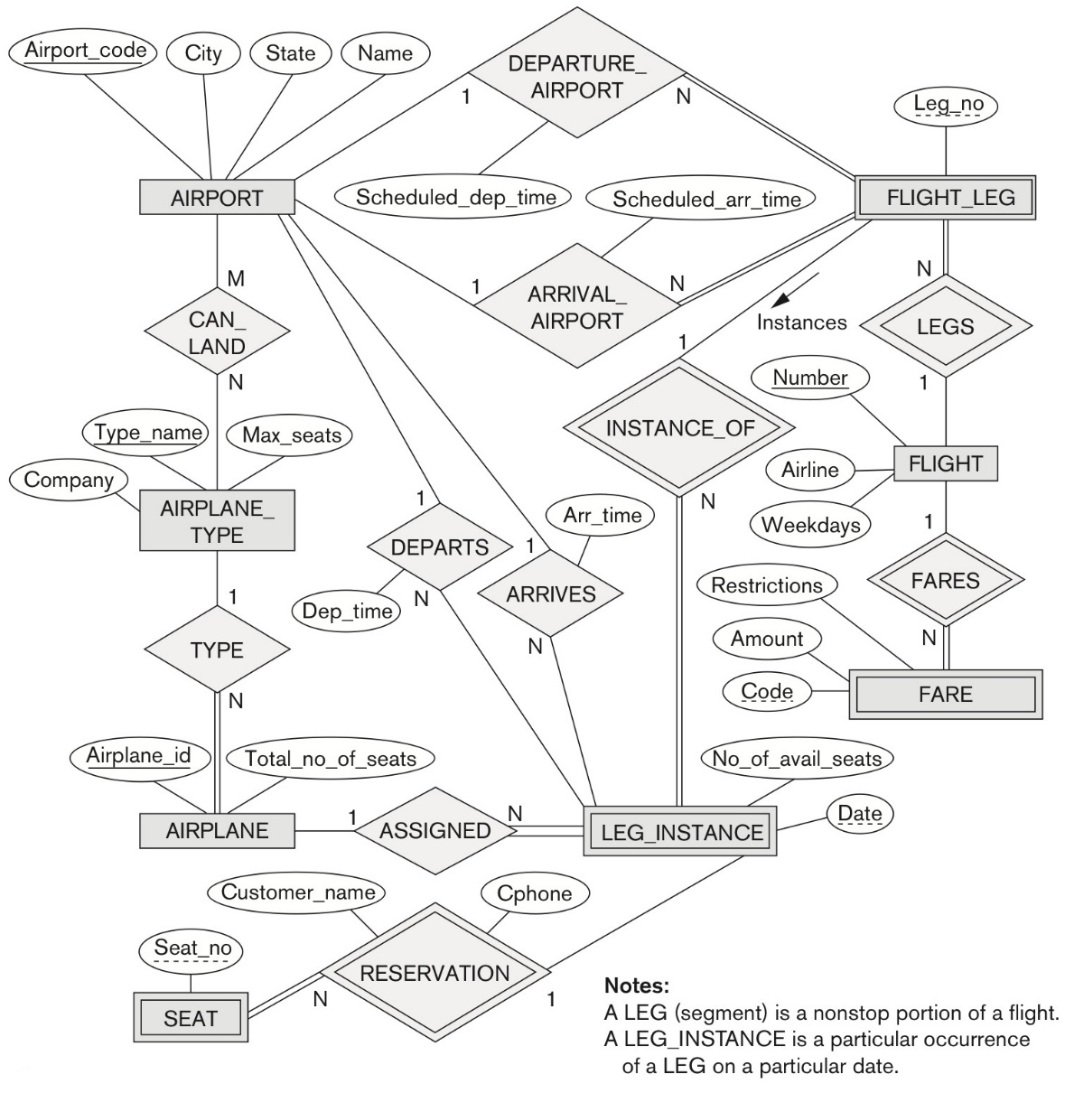

**Figure 3.21** An ER diagram for an AIRLINE database schema.

***Solution :***

(Total for que 4 is 20 marks)

|  |  |
| --- | --- |
| Specific Requrieement/Constraint Type | Requirements and Constraints from the ER diagram |
| Entities and attributes  (5 marks) |  |
| Relationships and attributes  (5 marks) |  |
| Interpretation of each of the constraints represented on the edge labels (5 marks) |  |
| Verbal requirements description in sentences of the database  (5 marks) | ***Answer:***  . |