**Name: Xiangtian ZHENG**

**Student ID: 1852763**

1. **Question 1:**

With no refractory period,the spike train is:

the fano factor over wondows of width 10ms : 1.0088901355759137

the fano factor over wondows of width 50ms : 1.0143289999149105

the fano factor over wondows of width 100ms : 1.0310972317553961

the coefficient of variation of the inter-spike interval : 1.0024320425056725

With 5ms refractory period,the spike train is:

the fano factor over wondows of width 10ms : 0.7512364188706216

the fano factor over wondows of width 50ms : 0.6890770192994996

the fano factor over wondows of width 100ms : 0.6801411722659042

the coefficient of variation of the inter-spike interval : 0.8221230152289828

1. **Question 2:**

the fano factor over wondows of width 10ms : 1.1198442813566911

the fano factor over wondows of width 50ms : 2.9333009948508413

the fano factor over wondows of width 100ms : 4.107101234118765

the coefficient of variation of the inter-spike interval : 2.0085523370640965

1. **Question 3:**

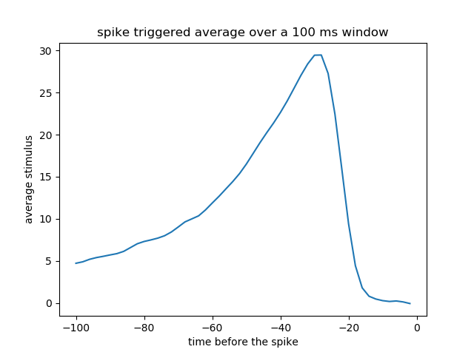

1. **Question COMSM2127:**

Below are plots when the spikes are not neccesarily adjacent:

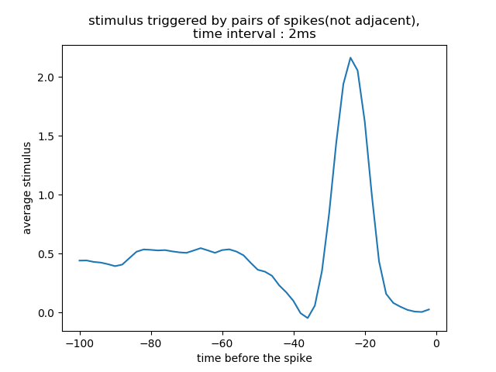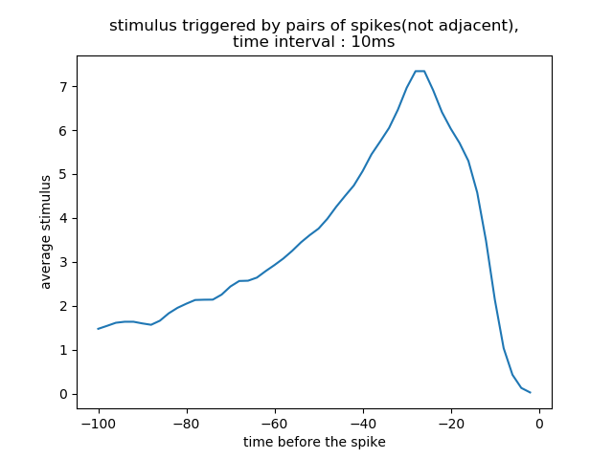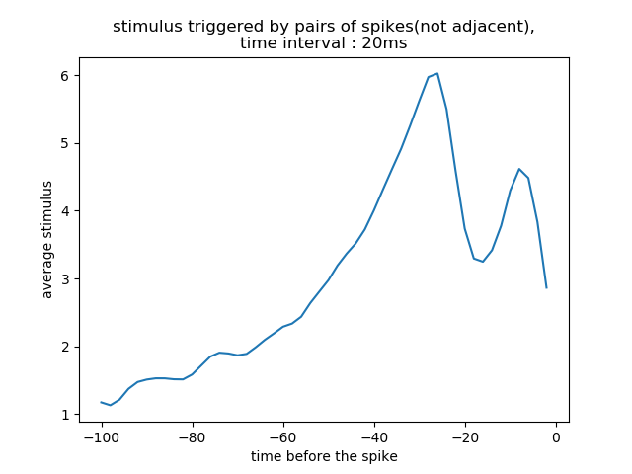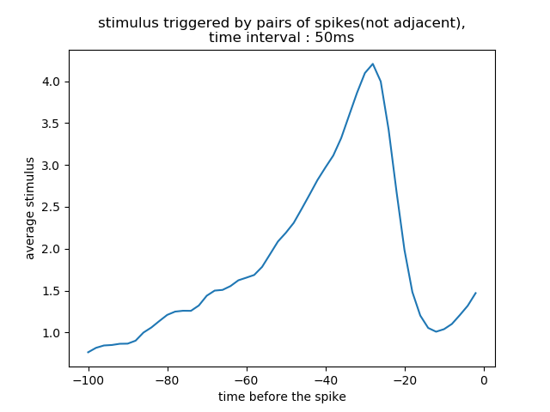

Below are plots when the spikes are adjacent:

