**Name: Xiangtian ZHENG**

**Student ID: 1852763**

**Question 1:**

We use Euler’s Method to calculate approximation.

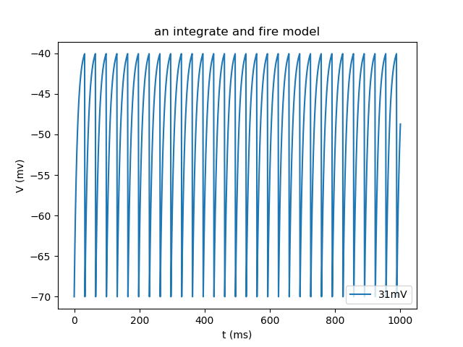

Figure :An integrate and fire model for one neuron simulated for 1s.

**Question 2:**

We use Euler’s Method to calculate the approximation.

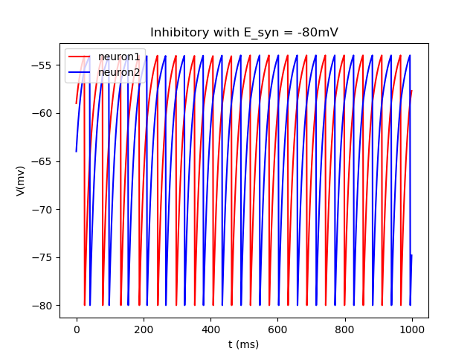

Figure : An integrate and fire model for two neurons with inhibitory synaptic connection simulated for 1s. We set the initial membrane potentials to random values, two curves converged to opposite phase with time passed by.

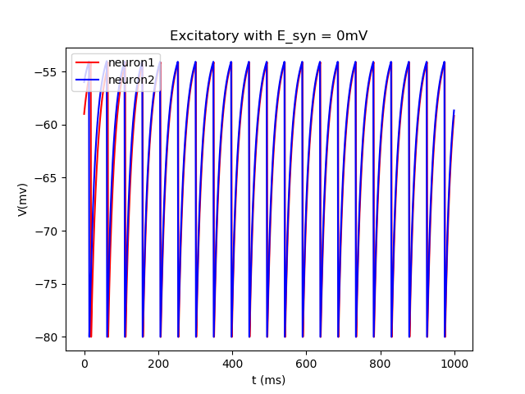

Figure :An integrate and fire model for two neurons with excitatory synaptic connection simulated for 1s. We set the initial membrane potentials to random values, two curves converged to same phase with time passed by.

**Question COMSM2127:**

1. To calculate the minimum current Ie required for the neuron, we should take it as constant, and solve the equation from Question1:

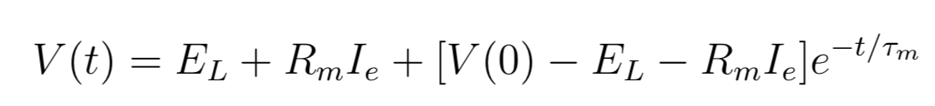

With time increases, the last expoential increases and converge to zero, so to produce a action we must let the *(EL+RmIe)* exceeds Vthreshold , here we got :



Using the parameters given in question1, we got the answer: Ie >3 nA.

1. If we choose to simulate the input current with Ie = 2.9 nA, we can plot the following Figure and the membrane potential will converge to -39 mV, which will never exceed Vt = -40 mV.

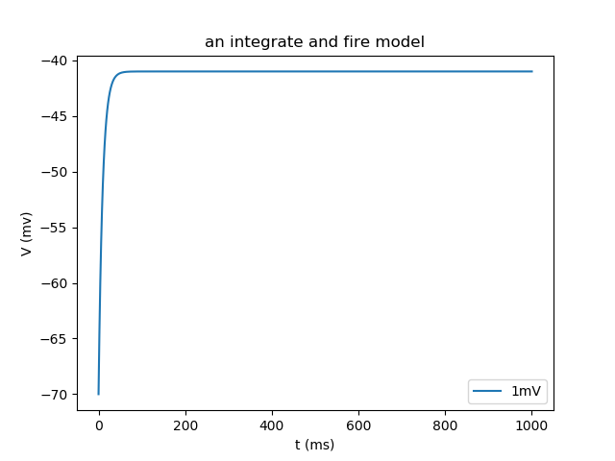

Figure :An integrate and fire model for one neuron with simulated for 1s, with Ie = 2.5nA.

1. We can see from the following Figure, with the current exceeds the threshold of 3nA, spikes start being produced. As the current increases, the firing rate goes up.

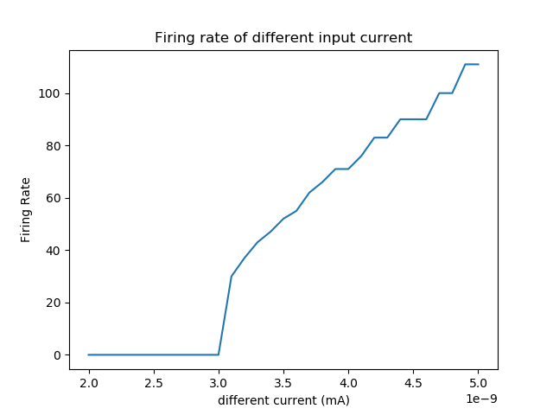

Figure :Graph showing the spike count (firing rate) against different currents ranging from 2nA to 5nA, in steps of 0.1nA.