Concept 1: Fixed-Wing UAV AC designed to fight wildfires

1. Short description & mission
Wildfires can be detected in really early stages by small drones. Big wildfires are fought with heavy Cargo Airplanes. We come in between: Fire gets detected while it is still small, so drone has an impact!

2. Configuration / possible design
- 200 kg Payload. Fire Retardent OR Fire Extinguishing Bombs.
Bombs: Not used for Wildfires, but have advantage to just retardant (Storage, Reload, Wind influence)
Fire retardant: Used
- Need many in small operating radius, large distances we lose first strike potential
- “20-30 could cover size of California (WINDRACER)”
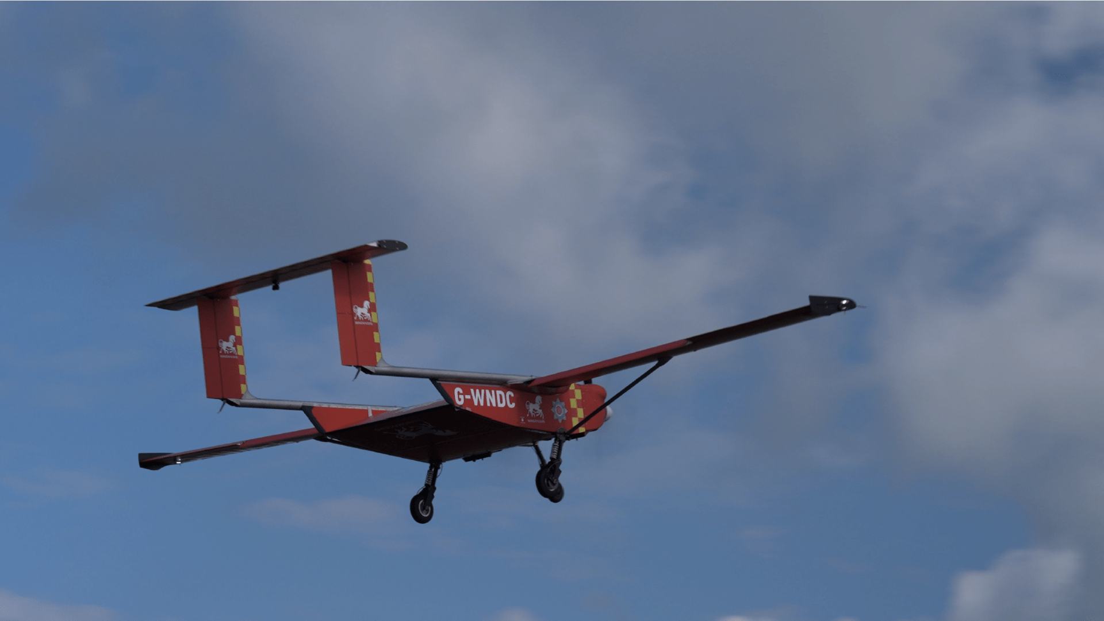
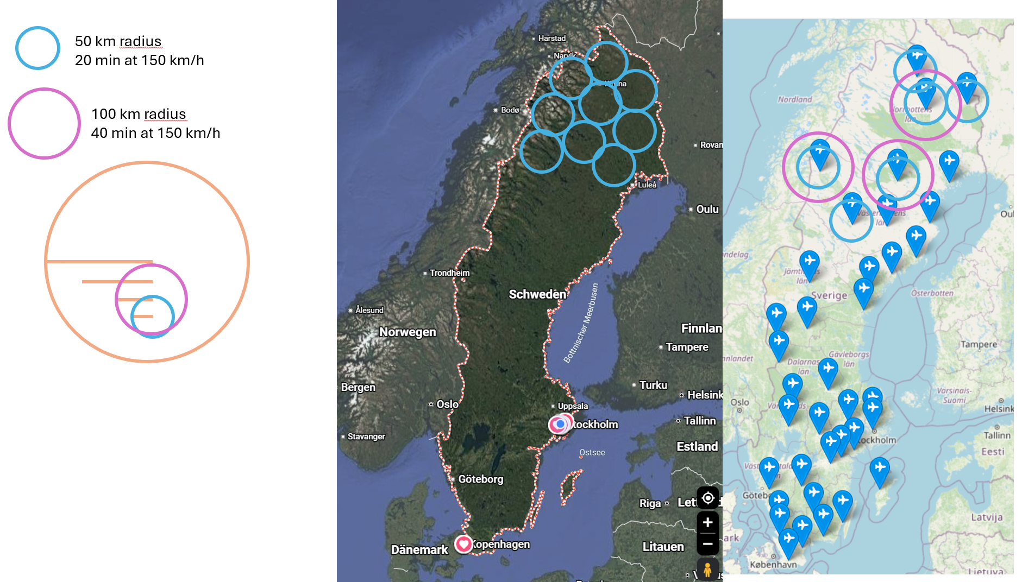

1. How fast the fire grows
Time after detection | Fire area | Head fire length
At detection | ~40 m² | ~25 m
15 min | 350 m² | 24 m
20 min | 630 m² | 32 m
30 min | 1 400 m² | 48 m
60 min | 5 700 m² | 97 m
Assumes very early detection and moderate spread (2 m/min, elliptical growth).
2. How much we cover
Agent | Area covered | Line at 5 m width
3 000 l retardant (AT-802 reference) | 6 000 m² | —
200 l retardant | 400 m² | 80 m
200 kg bombs (8 × 23 kg, ≥50 m² each) | 435 m² | —
30 kg bombs (1–2 units) | 65 m² | —
Retardant at 0.5 l/m² (mean effective value in US operational studies). Bomb values from manufacturer specification.
3. Drops required
Time after detection | Fire area | Drops of 200 l / 200 kg
15 min | 350 m² | 1 drop
20 min | 630 m² | 2 drops
30 min | 1 400 m² | 3–4 drops
60 min | 5 700 m² | 14 drops

3. Consequences
- Bombs and Extinguishing liquid draw a line, don’t really cover a area
- 15-20 min Flight Time (One way!)
- Hard restrictions on Take-Off and Landing, need more then just Airfields and a big fleet
- Should still be able to assist other drones area in firefighting: One drone could be there in 8 min, second one in 20 and other maybe 30 min Gives chances to circle in fire, bring under control (Important when defining flight distance)
- Could be flying back, fast reload, sent out again Electric might be feasible? ( I still don’t thinks so …)
- Focus: Easy maintainable, Robust against temperatures, could get heavy
- Fleet just sits around
- Need space in every airport

6. Open questions / research

Concept 2: Fixed-Wing UAV AC designed for cargo delivery/humanitarian Aid

1. Short description & mission
Cargo UAV, bringing goods, supply, humanitarian aid in rural area/regions
Different scope then firefighting: Long Range (NOT ENDURANCE)

2. Configuration / possible design
Companys already researching: Flypyka https://www.flypyka.com/dropship
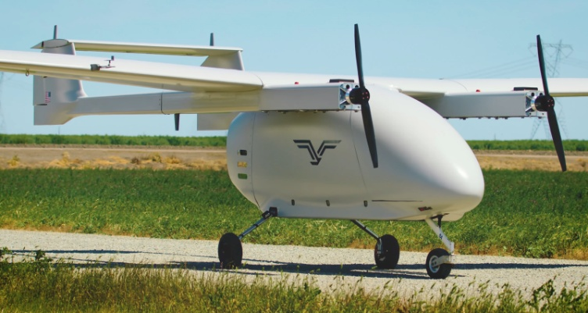
Windracer https://windracers.com/
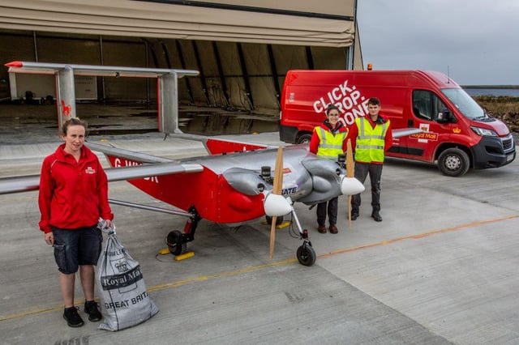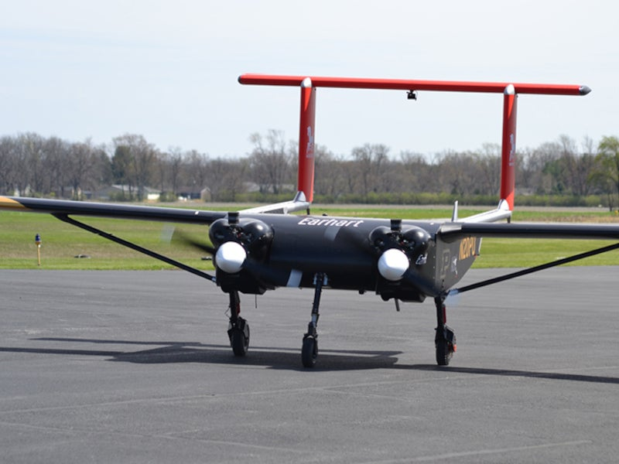
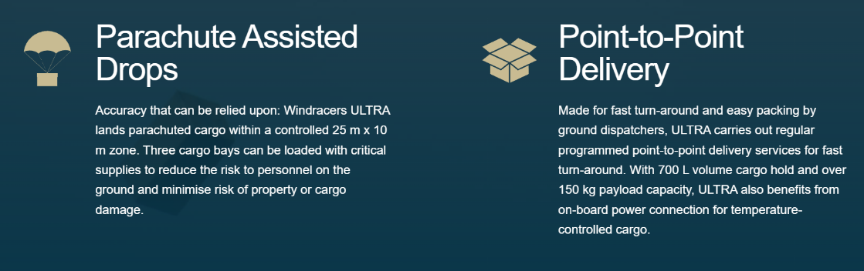
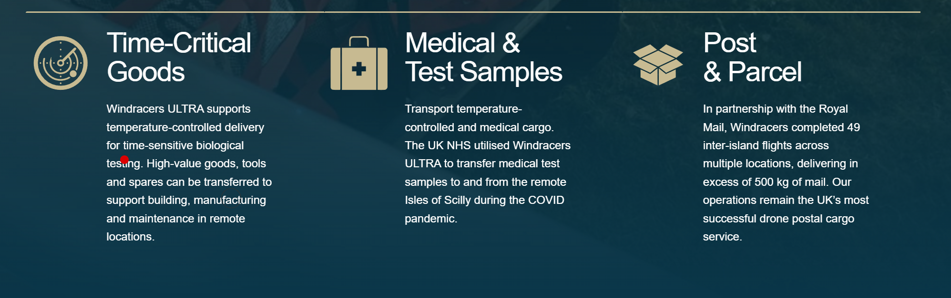

3. Consequences
- Relly focused on delivering cargo with huge range
- Idea: Could take that and make it multipurpose, switchable cargo you just clip to the Body
- Focus here is 700l volume with 150 kg payload: Maybe make it sma

Concept 3: UAV electric fixed win

1. Short description & mission
Idea: an unmanned electric motor-glider that is easy to produce (consumer 3D printing, like the Lofted Aero Mojave, ~3 m wingspan), carries a small payload from a grass field, flies a useful distance. Yellow values are reasonable first guesses.

2. Configuration / possible design

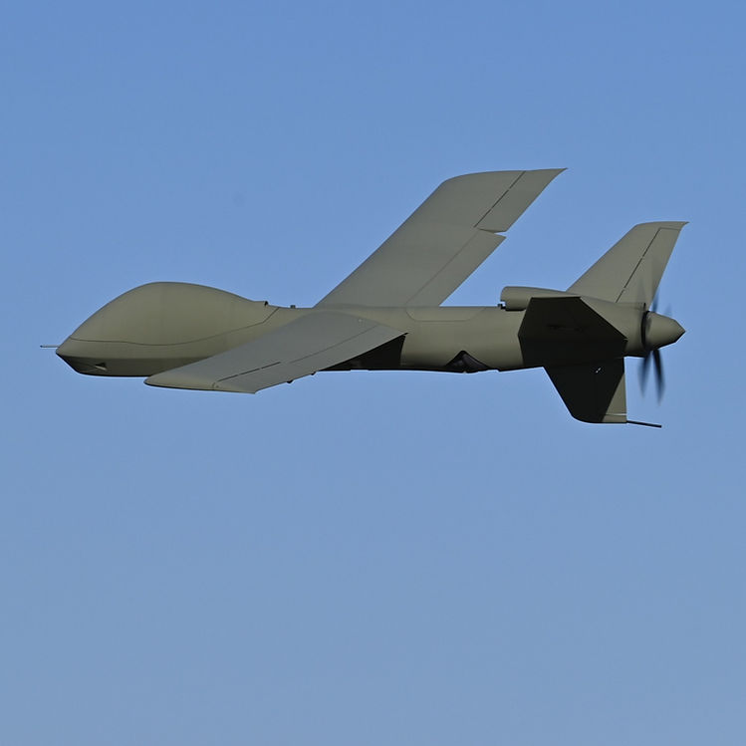
Focus on manufacturing: 3D printable (At home)

. First parameters (non-binding starting values)
Rough numbers are enough – they feed the constraint analysis and initial sizing and may change later.
Parameter | Starting value / assumption | Rationale / source | Gets validated by
Propulsion concept | propeller | e.g. electric (battery), hybrid, piston/propeller, turboprop | Task 5
Focus: endurance or range | range | What is prioritised – and why? | Task 1
Range [km] | 150 | state whether one-way or out-and-back | Task 1
Endurance [h] | 1 h | incl. loiter time over the target area | Task 1
Payload – mass [kg] | 200 |  | Task 1/4
Payload – type | ? | e.g. fire retardant, drop container, sensors | Task 1/4
MTOW / overall weight [kg] | 700 |  | Task 4
Empty weight [kg] | 335 | optional, if already estimable | Task 4
Take-off distance [m] | 250 |  | Task 1
Take-off ground / launch method | Non assisted | e.g. paved runway, grass/gravel, catapult, STOL | Task 1
Service ceiling [m] | 3000
Cruise speed [km/h] | 140 | optional
Wingspan [m] / wing area | 12-15 (max 15) | optional, first estimate
Rate of Climb | 5 m/s

Next steps: What does the Book say?

1. Requirements Phase: Wish List Mission we have above

2. Conceptual Design Phase: Transform initial specifications into external geometry
This is from page 16-17
# | Task | Section | Remarks
1 | Understand requirements, mission definition, and the implications of the regulations the aircraft will be certified to. | — | Doesnt really give us a definition on what requirements really are. Missin Definition is IMPORTANT!
2 | Study aircraft in the same class — for good ideas and for what to avoid. Qualitatively evaluate which configuration suits the mission. Decide on a propulsion methodology. | —
3 | Estimate development and manufacturing cost for a 5-year production run. Break-even volume, retail price, operating cost, labour force. Compare to competition. | 2.2, 2.3 | Need?
4 | Create a constraint diagram from the target performance of STEP 1. | 3.2 | To Do
5 | Select critical performance parameters (T/W or BHP/W and W/S) from the constraint diagram. | 3.2
6 | Estimate initial empty and gross weight using weight ratios and historical relations. Conduct a thorough mission analysis. | 6.2 | To Do
7 | From STEPS 4 and 6, estimate initial wing area and required thrust or power. Requires a guess for Cʟ,max. Check that the selected W/S and T/W meet all performance requirements and stall speed limits simultaneously. | 3.2
8 | Estimate initial tail surface area and position using the Vʜᴛ / Vᴠᴛ methodology. | 11.4
9 | Propose a wing layout suiting the mission: AR, TR, airfoils, planform, dihedral, washout. Use a decision matrix for airfoil selection. Expect changes in the next iteration. | 8, 9 | 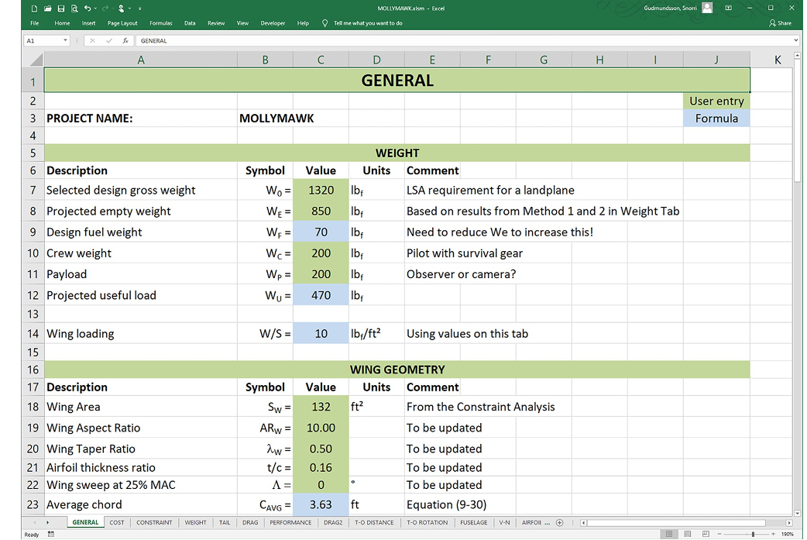
10 | Sketch several initial configurations, evaluate pros and cons methodically, select a candidate. | 4
11 | Select engine type and layout — number, type, properties, location — based on the propulsion methodology from STEP 2. | 7
12 | Estimate empty, gross and fuel weight for the candidate configuration using statistical, direct and/or known weights methods. | 6.3–6.5
13 | Determine empty weight CG, CG loading cloud, gross weight CG, movement due to fuel burn, and inertia properties. | 6.6
14 | Determine a candidate CG envelope from STEP 13. Expect this to change after STEP 16. | 6.7
15 | Lay out the fuselage: space claims, occupant location, baggage, cargo. | 12.3
16 | Perform a detailed static and dynamic stability analysis of the candidate configuration. | various
17 | Modify tail surface geometry per the stability results. Dynamic modes must converge; geometry will likely need morphing to eliminate diverging modes. | 11, 24, 25
18 | Evaluate layout modifications as needed: structural load paths, control system layout, flight control layout, high-lift system, landing gear layout. | various
19 | Modify the design for benign stall characteristics via washout, airfoils, slats, flaps. | 9, 10
20 | Perform a detailed drag analysis. Design for minimum drag by eliminating flow separation and adding fairings. | 16
21 | Detailed performance analysis: take-off, climb, cruise, range, descent, landing. Sensitivity analyses. Create a payload-versus-range plot. | 17–23
22 | Optimise and refine where possible. | various
23 | Regulatory evaluation: (1) Does it meet the applicable regulations? (2) Does it meet all STEP 1 requirements? (3) Does it satisfy the STEP 1 mission? Any NO → return to STEP 10. | 14 CFR 23
24 | Freeze the OML by releasing a document-controlled electronic solid model. | —
25 | Create a V-n diagram. | 17.4
26 | Detailed load analysis. | —
27 | Move into the preliminary design phase. | —

To do’s:
- Mission and Reqirement: (Sego did half the work already if we decide on that concept!)
Mission profile, payload in numbers, operating environment, regulatory framework, sort out questions like Bombs vs Liquid
Takeoff distance, climb rate, cruise speed & altitude, range, μ (surface), density/altitude
- (Constraint Diagram) and parameter research (Andre G. ? Can maybe use yours? Do we need to change sth? Also Luca)
Spreadsheet with the equations implemented, just use random numbers for now
Get the numbers by comparison to other aircrafts
2x people
- Weight Estimate / Cost? (Andre R. seems to be interested in cost? )
Chapter 6, rough estimation, historical values. Think of manufacturing Material? Technology?
- Propulsion (Maybe Hugo? I think you already more or less started it?)
Propulsion comparison, battery calculation on whether electric works for your range
Electric could really be feasible look Pelican 2 !!!!
- Configuration (Ylann wants to)
Chapter 4 read, candidate layouts for your mission collected with pros and cons — no decision yet
- Project Planning:
What are our next steps? Who does what? Get Information about Designing an Aircraft haha
Cook book in mAtlab

