Aircraft Design Project — Team Meeting Agenda
KTH Fall 2026 — Fixed-Wing UAV Design
Date: | ___________________ | Time: | ___________________
Location: | ___________________ | Attendees:

Agenda Overview
Time | Agenda Item | Lead
0:00 – 0:30 | Open floor: feedback, changes, or new ideas on our current mission | All
0:30 – 1:15 | First starting values for the design process — propose & discuss together | All
1:15 – 1:40 | What has to be done? What part of the project do you want to focus on? | All
1:40 – 1:50 | Recap: relevant book chapters (background reading) | All
1:50 – 2:00 | Wrap-up: next steps & date of next meeting | All

1. Mission Check-In (30 min)
Open discussion — everyone gets space to raise changes, concerns, or new ideas about our current mission concept before we move forward.
- Recap of the mission:
Unmanned Aircraft Vehicle, Glider Like, High Efficiency
Make it multifunctional: Surveillance + Transport capacity (Medical Aid, Firefirghting)
- Anyone want to propose a change or addition?
- Anything unclear or unresolved from last time?
Here we write protocol:

2. First Starting Values — Propose & Discuss
1. Fixing the mission and performance requirements
2. Wing loading W/S and power/thrust loading, then weight and wing area. (See Ch. 3, Constraint Analysis)
3. Constraint analysis
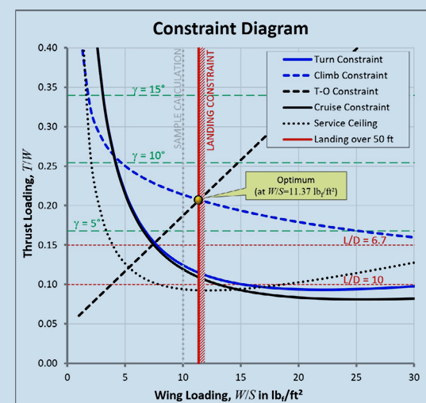
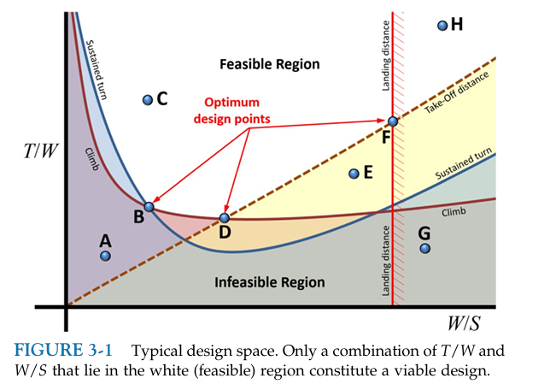
LOOK AT THE EXCEL

Parameter |  |  | Starting value (to discuss) | Why? (reasoning)
 |  | A — Mission requirements (we decide these; they set the whole design)
Payload weight | What the plane has to carry extra |  | e.g. 10–25 kg (aid kit / powder)
Range / endurance | How far and how long? Where should it be? |  | e.g. 150–300 km / 2–4 h
Cruise speed | How fast does it has to be? |  | e.g. 100–140 km/h
Cruise altitude |  |  | e.g. 500–2000 m
Stall / approach speed |  |  | low (safe drops) — sets max W/S
Take-off & landing distance |  |  | short / unprepared strip?
Rate of climb / climb angle | 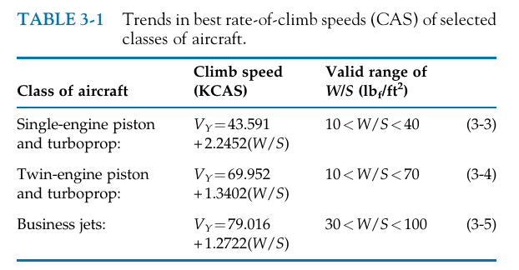 |  | e.g. reach altitude in X min
 |  | B — Initial sizing assumptions (guessed from similar aircraft, Ch. 3 Table 3-2)
Propulsion type |  |  | electric vs. combustion
Max lift coefficient CLmax |  |  | ≈ 1.4–1.6 (clean)
Aspect ratio (AR) |  |  | high, glider-like ≈ 12–18
Max lift-to-drag L/Dmax |  |  | target high ("good efficiency")
Min drag coefficient CDmin |  |  | ≈ 0.02–0.03 (clean design)
Empty-weight fraction |  |  | from statistics (Ch. 6 method)
Note: W/S, T/W (or P/W), MTOW and wing area are results we compute from these — not values we pick directly.

3. What Has to Be Done — What Interests You?
Just in what would you be interested in?

- Mission definition & literature review (existing UAVs, the need for ours) -
- Initial sizing & constraint analysis (W/S, T/W, the constraint diagram)
- Weight analysis & CG (MTOW, empty & payload weight)
- Aerodynamics — wing & airfoil design
- Powerplant / propulsion selection
- Tail & fuselage design, final configuration
- Report & LaTeX template / editing

4. Background Reading (recap — not mandatory)
