Propulsion

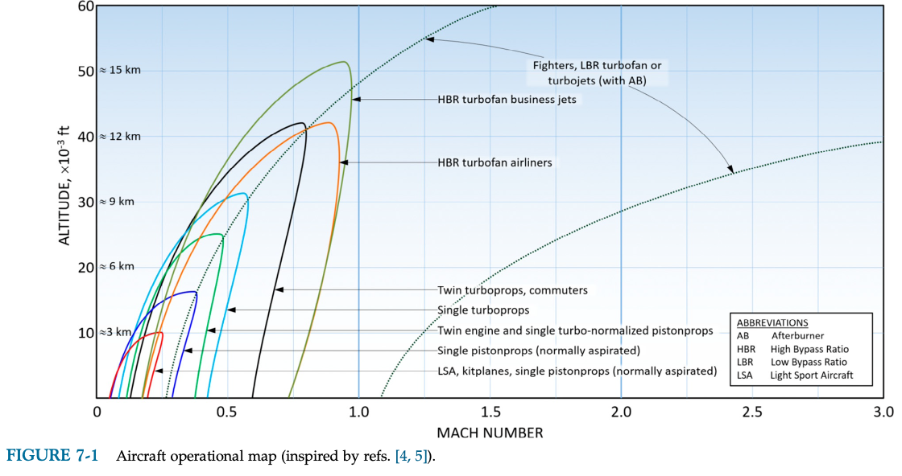
LSA, single pistonprop / electroprop (allows medium speed and high altitudes)

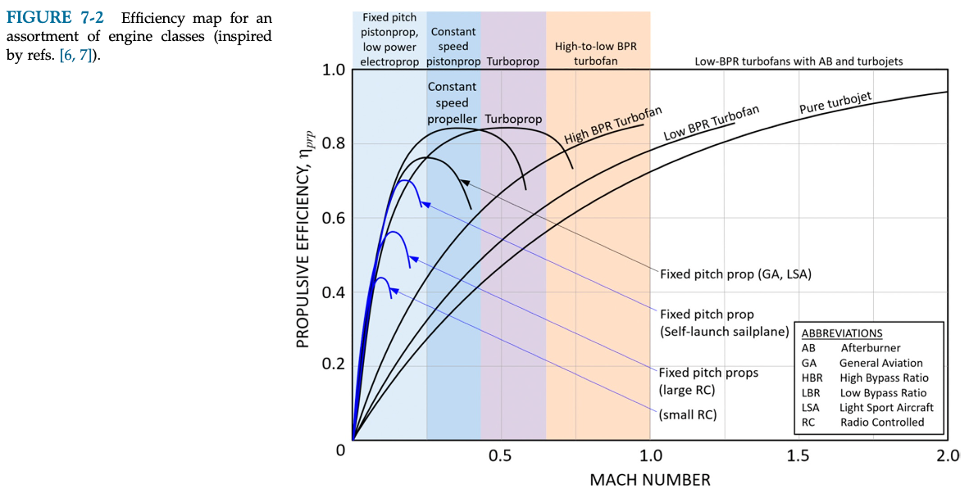
Fixed pitch prop (constant speed propeller gives no clear higher efficiency and fixed pitch is simple to produce)

Criteria | Single Pistonprop | Electroprop
Consumption | SFC approx. 0.47 lb/(BHP·h) ≈ 286 g/kWh (Table 7-4, 7-6). Around 2-5 kg fuel per sortie. Engine efficiency only ~25-30 % | Drivetrain efficiency ca. 0.82 (battery, ESC, motor, Fig. 7-56). Needs ca. 11 kWh battery per sortie incl. reserve
Power | Needs ca. 127 BHP rated since power drops on hot days near the fire (Eq. 7-12). Rotax 914 (115 BHP) a bit too weak, O-235 (125 BHP) ok | Power does not depend on altitude/temperature (p. 248). 4 x 25 kW motors like Pelican 2 ≈ 100 kW. Battery must handle ca. 10C (Eq. 7-51)
Weight | Engine 70-116 kg (Table 7-4) + ca. 5 kg fuel + installation ≈ 90-135 kg | Battery ca. 95 kg (Eq. 7-50, 150 Wh/kg) + motors/ESC ca. 25 kg ≈ 120 kg
Price | Cheaper, well-proven engines | More expensive, mainly because of high-C batteries
Cost and availability of fuel/electricity | Avgas/mogas easy to transport to the fire area in cans/trucks. Fuel cost higher per flight | Needs charging at the base (grid or generator) and several battery sets for swapping. Electricity cheap but infrastructure needed in the field
Environmental impact | CO2 and other emissions, must be calculated + SAF discussed (course requirement). Ca. 6-15 kg CO2 per sortie | Assumed zero emissions during flight (course brief). Battery production has an impact but not part of the scope
Mechanical complexity | Many moving parts (pistons, valves, ignition, fuel system), carburettor/injection | Few moving parts, motor + ESC + battery. Easy to use several motors for redundancy (p. 248)
Maintainability | TBO 1200-1500 h (Table 7-4), oil changes, spark plugs etc. | Low maintenance, mainly bearings and battery health check. Batteries degrade over cycles (Table 7-12)
Cooling | Needs cooling air through the engine, cowling and baffles (p. 212-224). Harder in hot air near fire | ESC loses 5-20 % as heat (p. 250), battery needs some cooling. High temperature reduces battery life (p. 246)
Inlet and exhaust requirements | Needs cooling inlet and exhaust outlet, adds drag and must be sized (Section 7.2.7, p. 216) | No exhaust, only small cooling openings for ESC/battery

Criteria (importance 1-7) | Single Pistonprop | Electroprop
Consumption (4) | 1 | 3
Power (6) | 2 | 3
Weight (7) | 3 | 2
Price (2) | 3 | 2
Cost and availability of fuel/electricity (3) | 3 | 2
Environmental impact (5) | 1 | 3
Mechanical complexity (3) | 1 | 3
Maintainability (3) | 2 | 3
Cooling (2) | 1 | 2
Inlet and exhaust requirements (2) | 1 | 3
TOTAL: | 70 | 97

