Alan Jiang, Janet Liang

CS3451, Computer Graphics

Professor Rossignac

Project 3B: 3D Tango Dancer

**Problem Statement**

Having created a 2D Tango Dancer, we can tackle creating a 3D Tango Dancer. We needed to implement caplets, kinematics, animation, and free foot path computation again using three dimensions. In addition, the Tango Dancer needed to have a three dimensional body and a dance partner. The program itself must also support saving and loading of footprint path files.

**Accomplishments**

* We successfully implemented the creation of accurate 3D caplets.
* We are able to calculate the position of the knee and the ankle based on the locations of the hip and ball of the foot.
* We can show the Tango Dancer’s lower body model performing the four phases of forward moving, tango step (transfer, collect, rotate, and aim).
* We created a partner that would mirror the movements of the Tango Dancer, while always facing him and interlocking hands with him.
* We animated the Tango Dancer and his partner dancing around a footprint path
* We replaced the yellow dance floor with a cuter red and black patterned floor.
* We designed our Tango Dancer and his partner after Jack Skellington and Sally from Tim Burton’s *A Nightmare Before Christmas*.

**Images**

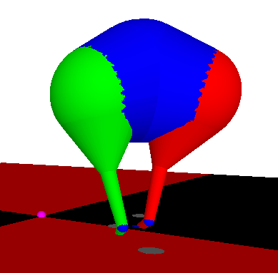

Over-exaggerated example of the lower body model to show that the 3D caplets are working correctly.

The lower body of our Dancer at the end of the Aim phase in the forward Tango step.

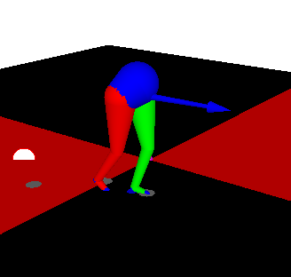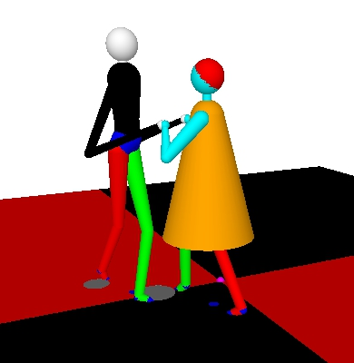

Our Dancer with his partner preparing for their dance.

**Behind The Scenes Math**

Challenge 1: Drawing Jack Skellington and Sally to suitable proportions, while maintaining constant distance between them with their hands interlocked.

Pseudocode:

//Jack’s Upper Body

Find two points above his pelvis; one for the thinner part of his torso, the other for his chest.

Draw spheres at the three points, the pelvis, lower torso, and upper torso.

Draw caplets between the pelvis and lower torso and the lower torso and the upper torso.

Create a lower neck point at the upper torso point.

Create an upper neck point X distance, the a little more than the length of the neck, above the lower neck point.

Draw a sphere for the head above the upper neck point.

Calculate a right shoulder and left shoulder point near the top sides of the upper torso.

Using a vector that points backwards, downwards, and outwards from the shoulder point, calculate the elbow points on both the left and right side.

Draw spheres at the shoulder and elbow points.

Draw a caplet connecting the right shoulder with the right elbow.

Draw a caplet connecting the left shoulder with the left elbow.

Using a vector that points upward and inward from the elbow, calculate the wrist points for the left and right side.

Draw a sphere at the wrist point.

Draw a caplet connecting the right wrist with the right elbow.

Draw a caplet connecting the left wrist with the left elbow.

Draw two larger spheres are the wrist points for hands.

//And then use trial and error to manipulate the dimensions and proportions to look more like the character.

//Sally’s body

Draw a sphere where the torso should end.

Determine how long the dress should be and draw a caplet from there using the radius of the bottom dress to the lower neck sphere.

Using the torso end point, create a lower neck point.

Find a pointer above the lower neck where the upper neck should be.

Draw a sphere at the upper neck and connect it to the lower neck with a caplet.

Calculate the center point of the head, so that it’s above the upper neck.

Draw a sphere for the head.

Offset the head point by one forward and upwards.

Draw the offset sphere in a different color for a short haircut.

Offset the main dancer’s hands in the forward direction to get the locations for Sally’s hands.

Draw spheres for the hands.

Using a vector that points downwards, forwards, and outwards from the wrist point, find the elbow points.

Draw a sphere at each elbow point.

Connect the respective elbow points and wrist points using caplets.

Draw caplets between respective elbow points and shoulder points.

//Using trial and error again, adjust the values until the character looks right.

Challenge 2: