Gompertz growth model:
$N_{t+1}=N_{t}e^{\left(r-d*log\left(N_{t}\right)\right)}$ Eqn 1

Describes logistic growth, with r the rate of increase and d a parameter that describes the strength of density-dependence.
Figure shows population growth with staring number N = 1, r = 0.5, d = 0.15
The carrying capacity = $e^{r/d}$ = 28.03
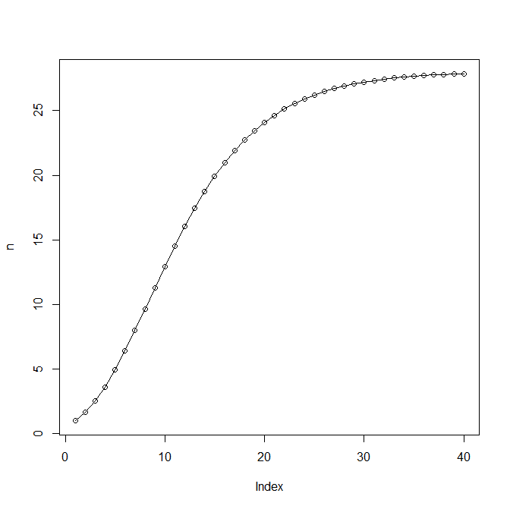

We can extend this to allow the rate of increase to be dependent on the value of a resource via parameter β. If the resource changes over time (e.g. seed availability, rainfall….) then both the rate of increase and the carrying capacity will change over time.
$N_{t+1}=N_{t}e^{\left(r + β*\text{resource }- d*log\left(N_{t}\right)\right)}$ Eqn 2
An example with β = 0.2 and starting value N = 1, with a fluctuating resource.
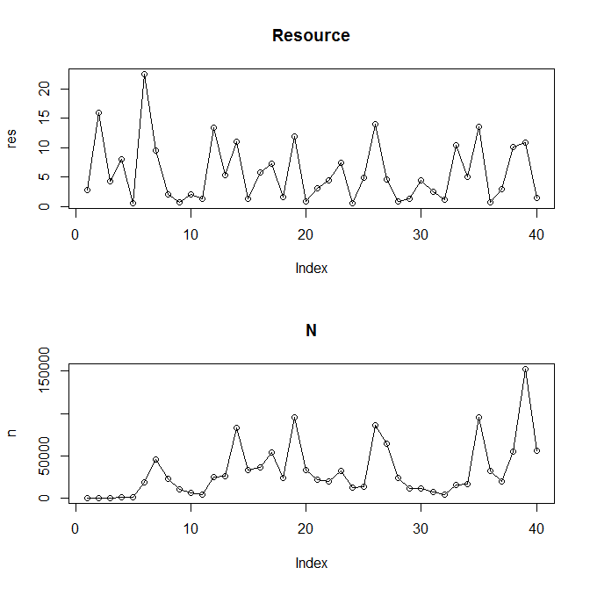

If we set $X_{t}=\text{log}\left(N_{t}\right)$ and log-transform equation 2 we get:
$$X_{t+1}=X_{t}+r+β*\text{resource}-d*X_{t}$$

The is the process model we can fit.

