GroupBalanced11_v1 全历史严格验证

结论
不优于基准
评价期 20160201 至 20260720；完整年度需至少 6 年胜出。
本结论属于历史回测证据，不等同于方案冻结后的前瞻样本外验证。

全期三方案比较
方案 | D10-D1年化 | Top20超额 | D10回撤 | Top20回撤 | D10换手 | Top20换手
Fixed4_Equal | 11.89% | 7.53% | -28.32% | -39.25% | 79.58% | 30.90%
Full11_Equal | 5.89% | 4.44% | -35.91% | -43.02% | 70.11% | 30.10%
GroupBalanced11_v1 | -0.42% | 2.01% | -45.33% | -46.47% | 86.06% | 36.89%

完整年度稳定性
year | metric | challenger | baseline | delta | challenger_wins
2017 | d10_d1 | 8.81% | 28.29% | -19.48% | False
2017 | top20_excess | -12.73% | -9.10% | -3.63% | False
2018 | d10_d1 | -3.49% | 4.85% | -8.33% | False
2018 | top20_excess | -0.18% | 2.44% | -2.62% | False
2019 | d10_d1 | -0.90% | 4.45% | -5.35% | False
2019 | top20_excess | -7.33% | -6.47% | -0.85% | False
2020 | d10_d1 | 18.79% | 24.06% | -5.27% | False
2020 | top20_excess | -2.97% | -4.08% | 1.11% | True
2021 | d10_d1 | -19.30% | -13.13% | -6.17% | False
2021 | top20_excess | 10.04% | 10.77% | -0.73% | False
2022 | d10_d1 | -16.08% | -14.42% | -1.66% | False
2022 | top20_excess | 1.45% | 1.20% | 0.25% | True
2023 | d10_d1 | 10.89% | 12.15% | -1.26% | False
2023 | top20_excess | 22.49% | 26.48% | -3.99% | False
2024 | d10_d1 | -21.96% | -15.77% | -6.20% | False
2024 | top20_excess | -8.77% | -5.21% | -3.56% | False
2025 | d10_d1 | 2.49% | 0.96% | 1.53% | True
2025 | top20_excess | 15.56% | 16.43% | -0.87% | False

月度配对统计
metric | months | mean_delta | median_delta | win_rate | simple_t | newey_west_lag | newey_west_stat | newey_west_two_sided_p | bootstrap_repetitions | bootstrap_block_months | bootstrap_ci_95_low | bootstrap_ci_95_high | bootstrap_significant_positive
d10_d1 | 126 | -0.51% | -0.45% | 30.95% | -4.814391555038678 | 4 | -4.5210397191040395 | 6.153663954416497e-06 | 10000 | 6 | -0.73% | -0.27% | False
top20_excess | 126 | -0.18% | -0.14% | 34.92% | -3.3951894254486246 | 4 | -3.110958043705087 | 0.001864814331573468 | 10000 | 6 | -0.28% | -0.05% | False

严格判定门禁
门禁 | 结果
全期收益 | {"d10_d1": false, "top20_excess": false}
年度稳定 | {"d10_d1": false, "top20_excess": false}
Bootstrap显著性 | {"d10_d1": false, "top20_excess": false}
最大回撤 | {"d10_d1": false, "top20": false}
平均换手 | {"d10_d1": false, "top20": false}

图表
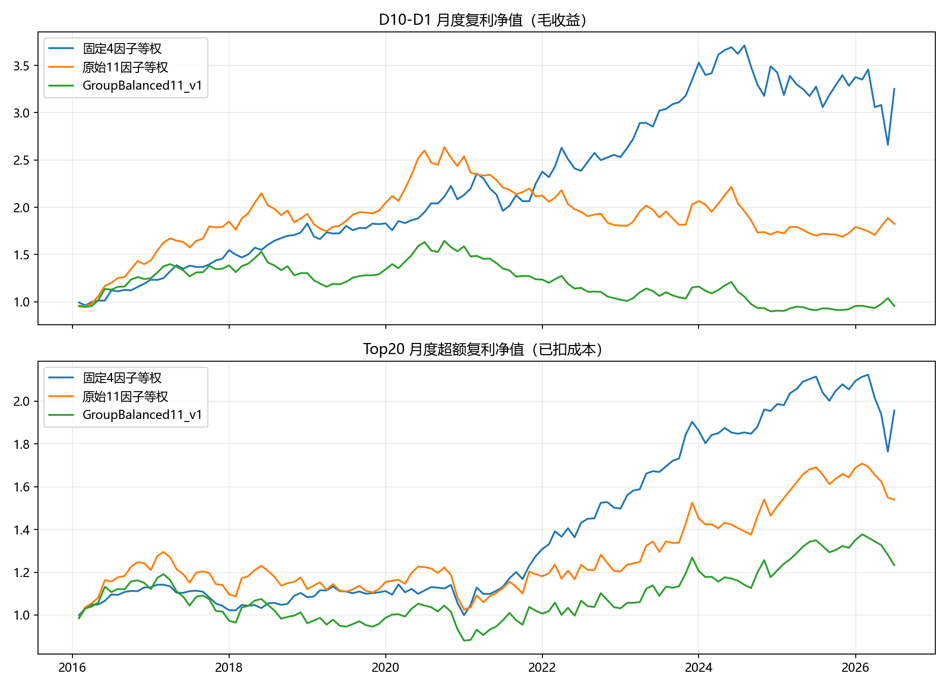
cumulative_performance
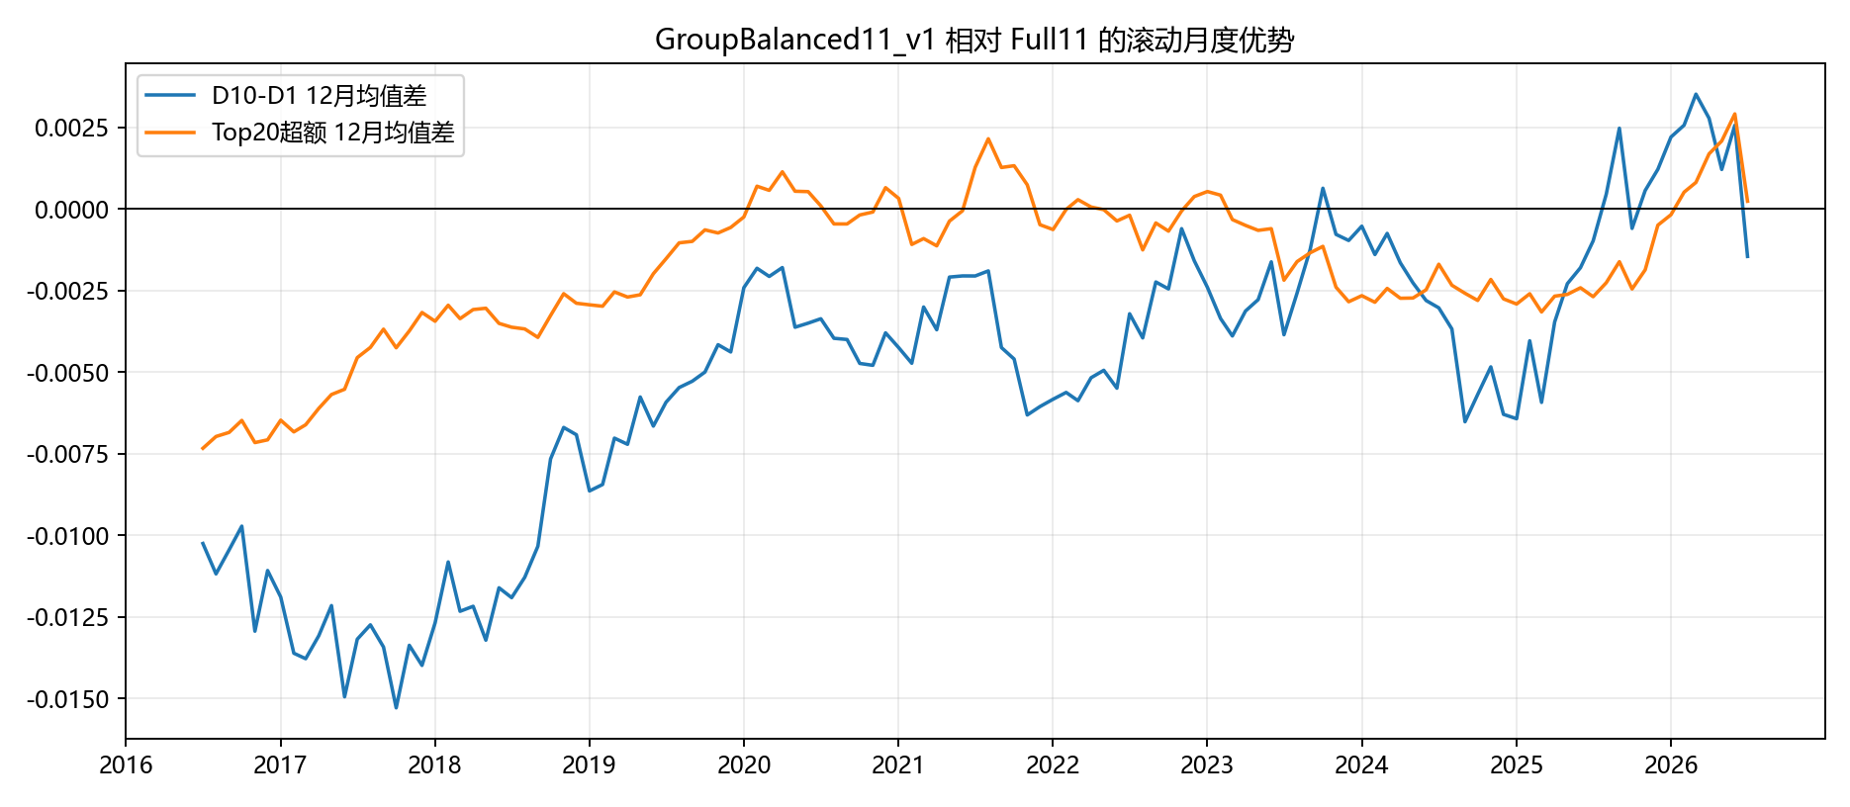
monthly_paired_advantage
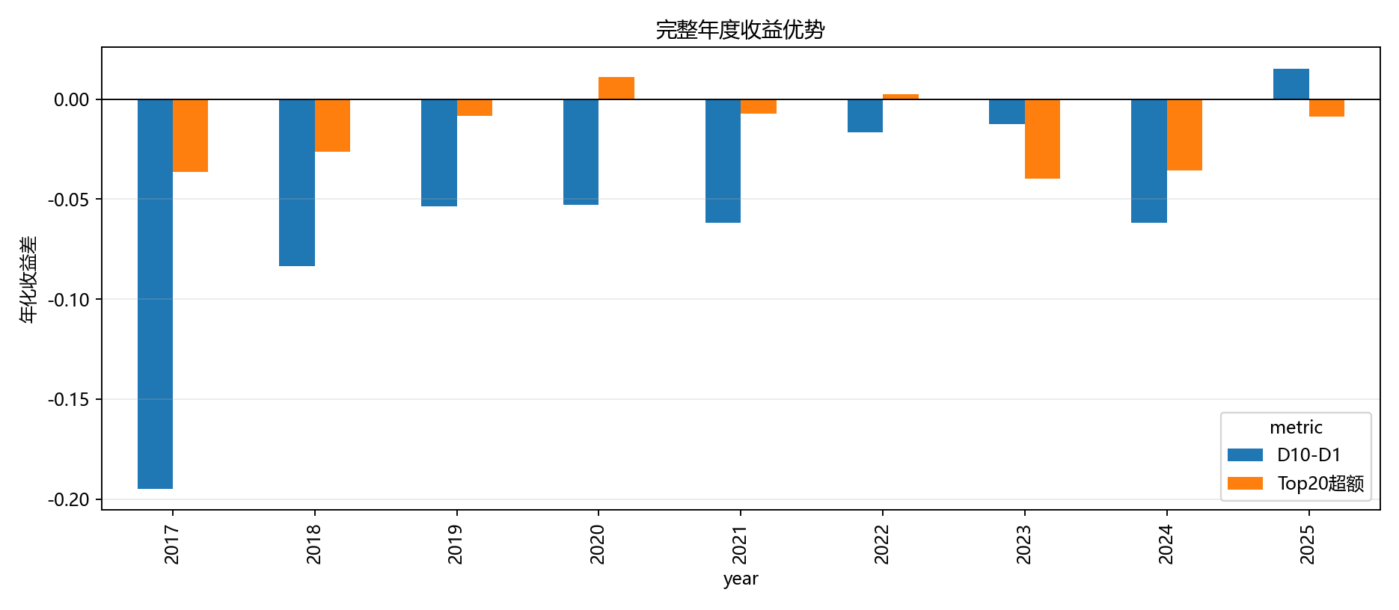
annual_advantage
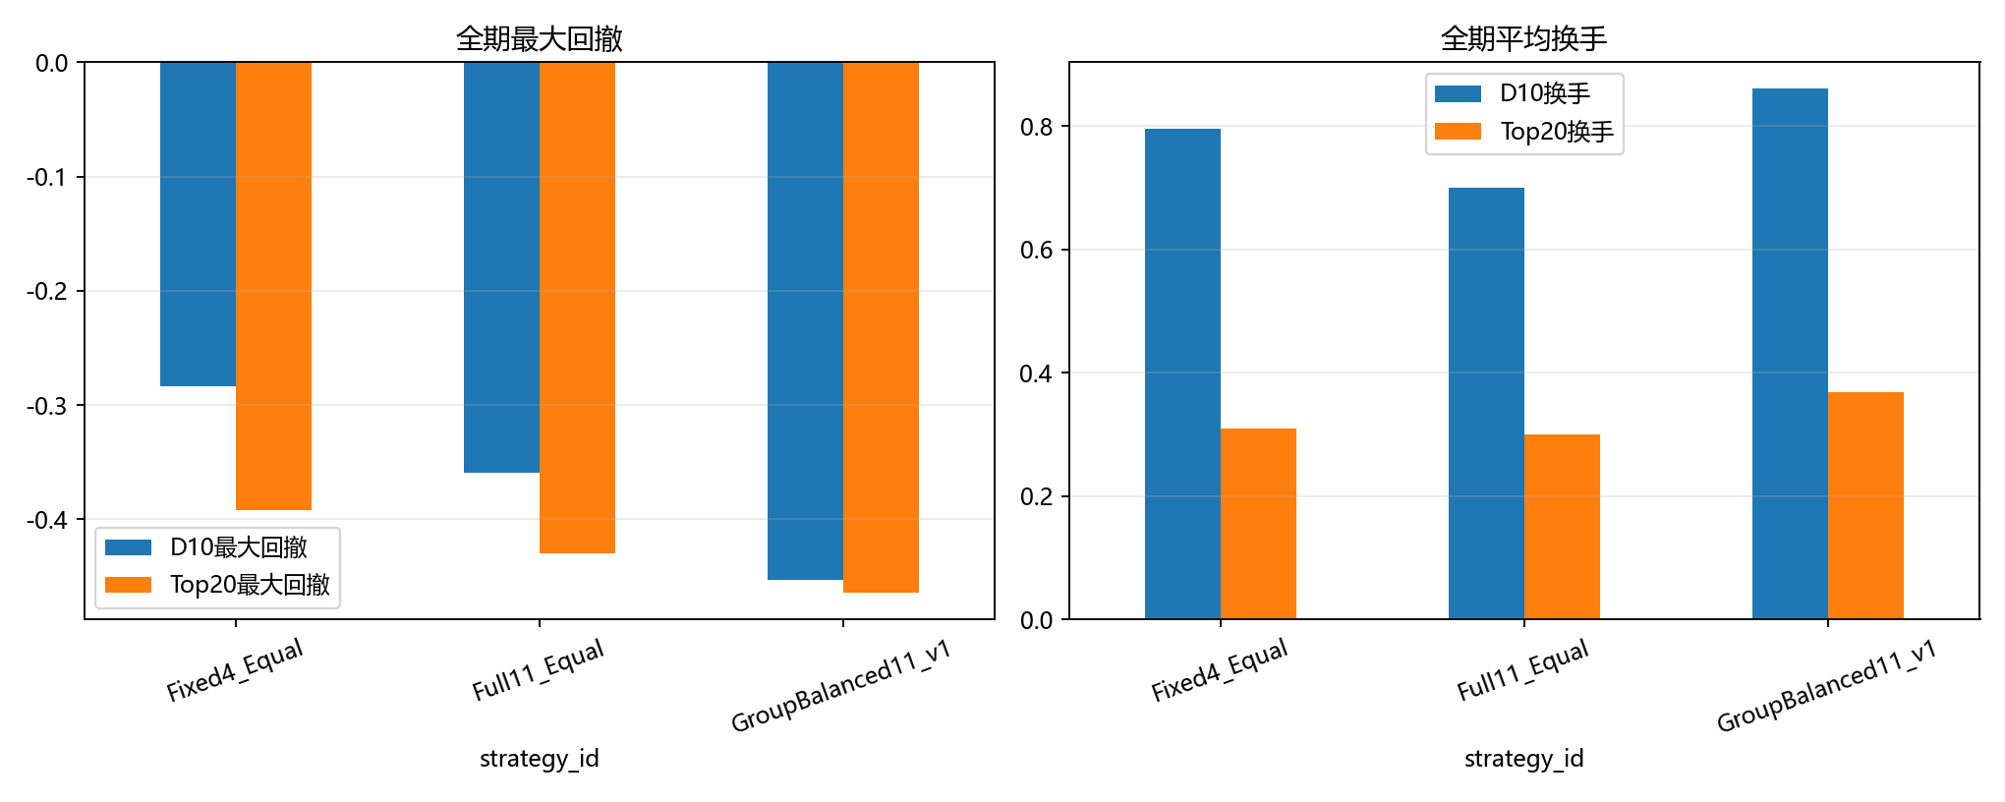
risk_and_turnover
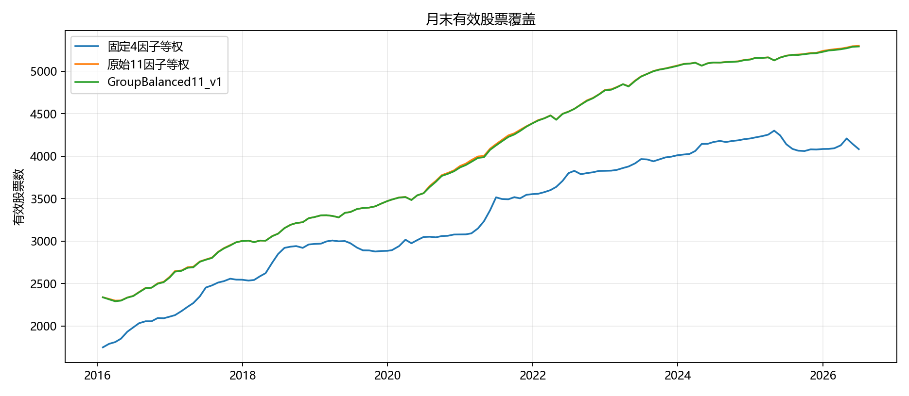
coverage

数据质量
check | status | critical | detail
adjusted_return_coverage | passed | True | min=20150105, max=20260720, rows=11505611
benchmark_coverage | passed | True | benchmark=000985.CSI, min=20150105, max=20260720, rows=2804
catalog:__database__:cross:daily_adj_factor | passed | True | all daily rows have adj_factor (checked_at=2026-07-20T17:37:43Z)
catalog:__database__:cross:daily_trade_calendar | passed | True | daily covers open trade days in its date range (checked_at=2026-07-20T17:37:43Z)
catalog:__database__:view:v_adjusted_returns | passed | True | queryable rows=11505611 (checked_at=2026-07-20T17:37:43Z)
catalog:__database__:view:v_fina_indicator_asof_intervals | passed | True | queryable rows=410325 (checked_at=2026-07-20T17:37:43Z)
catalog:__database__:view:v_index_data | passed | True | queryable rows=820823 (checked_at=2026-07-20T17:37:42Z)
catalog:__database__:view:v_stock_universe_daily | passed | True | queryable rows=11505611 (checked_at=2026-07-20T17:37:43Z)
catalog:fina_indicator_vip:dataset_integrity | warning | False | rows with null or empty primary key values in required columns: 10 (checked_at=2026-07-20T17:37:34Z); rows without announcement visibility are excluded by the existing factor loader
frozen_factor_availability | passed | True | factor_count=11, first_volatility=20160129
evaluation_boundary | passed | True | first_signal=20160129, first_execution=20160201
shared_strategy_calendar | passed | True | expected_signals=126, strategy_signals={'Full11_Equal': 126, 'Grouped8_Equal': 126, 'Fixed4_Equal': 126}, duplicates=0
benchmark_alignment_through_20260720 | passed | True | missing_strategy_day_benchmark_rows=0
benchmark_alignment_through_20260707 | passed | True | missing_strategy_day_benchmark_rows=0
reference_2025_to_20260707_reproduction | warning | False | within_tolerance=3/42; the archived CSV was produced from an earlier database snapshot and is retained as a drift diagnostic
数据库以 read_only=True 打开；旧代码、旧配置、数据库与旧输出受运行前后审计保护。

