- Effect of baseline
实验设置：Loss type: [“reinforce_with_baseline”, “no_baseline”]

实验结果：
- Train accuracy
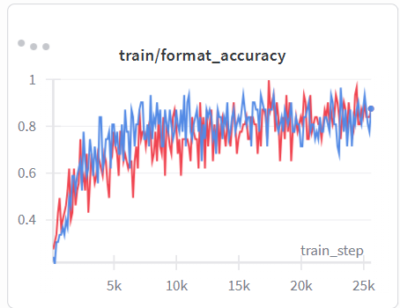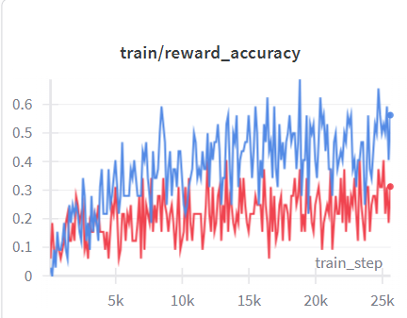
 | “no_baseline”(red) | “reinforce_with_baseline”(blue)
Format accuracy | 0.87 | 0.87
Answer accuracy | 0.31 | 0.56

Validation accuracy:
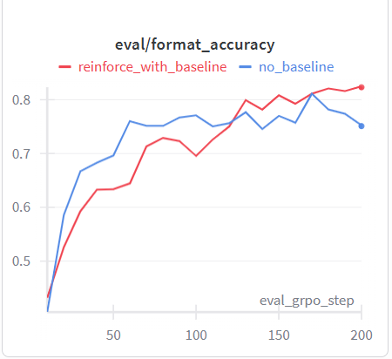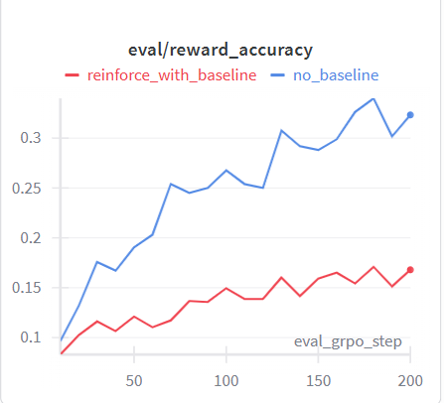
 | “no_baseline” | “reinforce_with_baseline”
Format accuracy | 0.82 | 0.75
Answer accuracy | 0.16 | 0.32

- Token entropy
“no_baseline” > “reinforce_with_baseline”

Conclusion: As for answer accuracy: “no_baseline” is worse than “reinforce_with_baseline”, and for format accuracy, based on both train and validation reward curves, both perform almost the same.
For token entropy, “no_baseline” is larger than “reinforce_with_baseline”, which means “no_baseline” has lower generation confidence
For training stability, i.e. the grad norm, however, “no_baseline”(no more than 1) is much lower than “reinforce_with_baseline” (25 the largest).

- maksed_mean/ masked_norm
实验设置：修改计算loss：[maksed_mean/ masked_norm]
metrices to compare：生成的response length，validation accuracy，训练稳定性（gradient norm等）

response len:
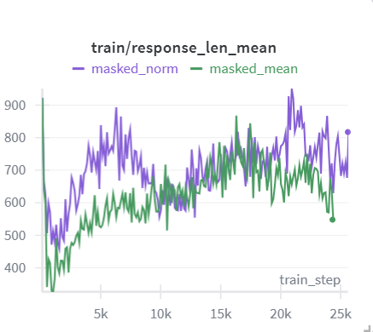
mask_norm更长

Validation accuracy:
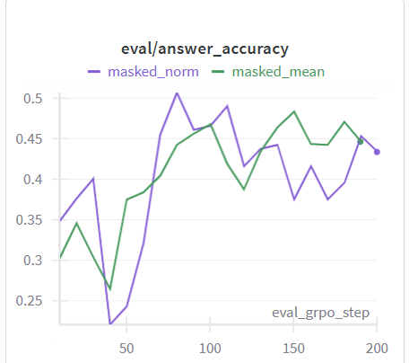
Mask_norm和mask_mean差不多

Grad_norm:
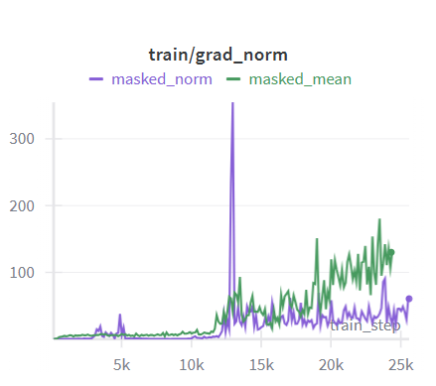
Mask_mean更高，训练更不稳定，因为其total grad更大。

- Effect of std normalization
实验设置：修改计算compute_group_normalized_reward: with/without std norm
metrices to compare： validation accuracy，训练稳定性（gradient norm等）

- Off-policy GRPO hyperparameters sweep
- Experiment variables
epochs_per_rollout_batch
train_batch_size

- Experiment metrices
- Validation reward
Validation reward curve / validation steps: sample efficiency
Validation reward curve / wall-clock time: compute efficiency

- Per-token entropy
Per-token entropy

- Response length
Mean/ std response length

- Stability
Grad norm

- 实验设置：
- Broad sweep: 在小grpo_steps上探索off-policy hyperparameter对metrices影响
Grpo_steps = 50
rollout_batch_size = 256
epochs_per_rollout_batch: {1, 3, 5}
train_batch_size: {32, 64, 128}
- 探索epochs_per_rollout_batch影响：在[1, 2, 3]上测试
- 观察validation reward升高速度随epoch的变化，以及对应compute cost（time）增加
- 观察per-token entropy下降速度变化

- 探索train_batch_size影响，fix epochs_per_rollout_batch, 在[32, 64, 128, 256]上测试
- 挑选出最优train_batch_size * epochs_per_rollout_batch组合

- Focused sweep:
Based on the result of “Broad sweep”, select 2-3 best configs to run longer grpo_steps: 200

