2020 Fall Verilog Project
HW2 – Placement and Routing using Innovus
Student ID | B07901021 |  | Name | 潘世軒
Testbench_APR |  | PASS
Clock Cycle |  | 6(ns)
Cell Area |  | Total area of Core: 6008.796 um²
Total Time |  | 59904(ns)
Area*Time |  | 359950915.584
How to report area in Innovus?
- File > Report > Summary > choose Text only, file name: summaryReport.rpt>OK, find Total area of Core.

APR NanoRoute Result (截圖)
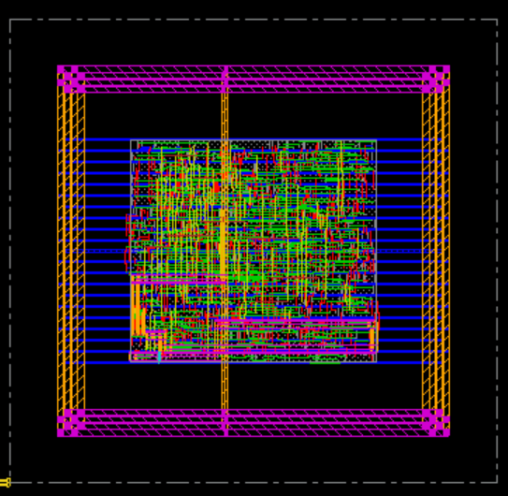

APR Simulation Result (截圖)
