2020 Fall Verilog Project
HW1 Counting the Number of Vertex Covers by Circle Graph
Verilog - RTL and Synthesis Report
Student ID | B07901021 | Name | 潘世軒
Testbench(RTL) | Pass
Testbench(Syn) | Pass
Clock Cycle(Syn) | 6(ns)
Cell Area(Syn) | 4778.180988
Total Time(Syn) | 59904(ns)
Area*Time(Syn) | 286232152.905152

Synthesis Result (截圖)
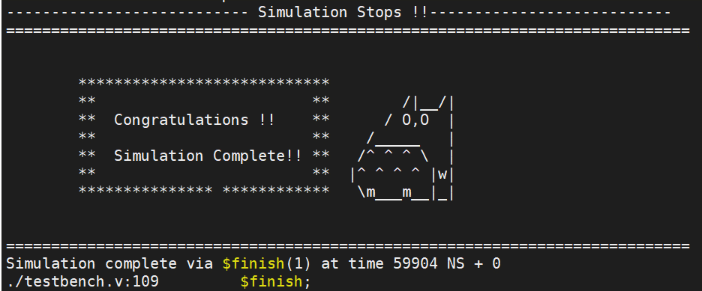
Timing Report

****************************************
Report : timing
-path full
-delay max
-max_paths 1
-sort_by group
Design : SET
Version: N-2017.09-SP2
Date : Tue Nov 24 23:13:24 2020
****************************************

Operating Conditions: slow Library: slow
Wire Load Model Mode: top

Startpoint: i_reg[1] (rising edge-triggered flip-flop clocked by clk)
Endpoint: candidate_reg[0]
(rising edge-triggered flip-flop clocked by clk)
Path Group: clk
Path Type: max

Des/Clust/Port Wire Load Model Library
------------------------------------------------
SET tsmc13_wl10 slow

Point Incr Path
-----------------------------------------------------------
clock clk (rise edge) 0.00 0.00
clock network delay (ideal) 1.00 1.00
i_reg[1]/CK (DFFRX1) 0.00 1.00 r
i_reg[1]/QN (DFFRX1) 0.64 1.64 r
U205/CO (ADDFX2) 0.37 2.01 r
U148/CO (ADDFXL) 0.28 2.29 r
U150/S (ADDFXL) 0.62 2.91 r
U180/Y (CLKINVX1) 0.22 3.13 f
U320/Y (NOR2X1) 0.18 3.31 r
mult_pow_129/U5/CO (ADDFXL) 0.52 3.83 r
mult_pow_129/U4/S (ADDFXL) 0.37 4.20 r
U155/S (ADDFXL) 0.59 4.80 f
U348/Y (OAI222XL) 0.59 5.39 r
U349/Y (OAI222XL) 0.25 5.63 f
U350/Y (OA21XL) 0.22 5.85 f
U351/Y (AOI211X1) 0.21 6.06 r
U195/Y (CLKINVX1) 0.11 6.18 f
U144/Y (OAI31X1) 0.20 6.38 r
U167/Y (AND2X2) 0.32 6.70 r
U203/Y (AO22X1) 0.19 6.89 r
candidate_reg[0]/D (DFFRX1) 0.00 6.89 r
data arrival time 6.89

clock clk (rise edge) 10.00 10.00
clock network delay (ideal) 1.00 11.00
clock uncertainty -0.10 10.90
candidate_reg[0]/CK (DFFRX1) 0.00 10.90 r
library setup time -0.12 10.78
data required time 10.78
-----------------------------------------------------------
data required time 10.78
data arrival time -6.89
-----------------------------------------------------------
slack (MET) 3.89

Area Report

****************************************
Report : area
Design : SET
Version: N-2017.09-SP2
Date : Tue Nov 24 23:12:56 2020
****************************************

Information: Updating design information... (UID-85)
Library(s) Used:

typical (File: /home/raid7_2/course/cvsd/CBDK_IC_Contest/CIC/SynopsysDC/db/typical.db)

Number of ports: 121
Number of nets: 493
Number of cells: 342
Number of combinational cells: 284
Number of sequential cells: 53
Number of macros/black boxes: 0
Number of buf/inv: 50
Number of references: 53

Combinational area: 3262.402839
Buf/Inv area: 191.806197
Noncombinational area: 1515.778149
Macro/Black Box area: 0.000000
Net Interconnect area: 40833.536591

Total cell area: 4778.180988
Total area: 45611.717579

Power Report
Loading db file '/home/raid7_2/course/cvsd/CBDK_IC_Contest/CIC/SynopsysDC/db/typical.db'
Information: Propagating switching activity (low effort zero delay simulation). (PWR-6)
Warning: Design has unannotated primary inputs. (PWR-414)
Warning: Design has unannotated sequential cell outputs. (PWR-415)

****************************************
Report : power
-analysis_effort low
Design : SET
Version: N-2017.09-SP2
Date : Tue Nov 24 23:13:11 2020
****************************************

Library(s) Used:

typical (File: /home/raid7_2/course/cvsd/CBDK_IC_Contest/CIC/SynopsysDC/db/typical.db)

Operating Conditions: slow Library: slow
Wire Load Model Mode: top

Design Wire Load Model Library
------------------------------------------------
SET tsmc13_wl10 slow

Global Operating Voltage = 1.08
Power-specific unit information :
Voltage Units = 1V
Capacitance Units = 1.000000pf
Time Units = 1ns
Dynamic Power Units = 1mW (derived from V,C,T units)
Leakage Power Units = 1pW

Cell Internal Power = 160.2389 uW (74%)
Net Switching Power = 57.6749 uW (26%)
---------
Total Dynamic Power = 217.9139 uW (100%)

Cell Leakage Power = 1.2658 uW

Internal Switching Leakage Total
Power Group Power Power Power Power ( % ) Attrs
--------------------------------------------------------------------------------------------------
io_pad 0.0000 0.0000 0.0000 0.0000 ( 0.00%)
memory 0.0000 0.0000 0.0000 0.0000 ( 0.00%)
black_box 0.0000 0.0000 0.0000 0.0000 ( 0.00%)
clock_network 0.0000 0.0000 0.0000 0.0000 ( 0.00%)
register 0.1336 7.5533e-03 4.1246e+05 0.1415 ( 64.57%)
sequential 0.0000 0.0000 0.0000 0.0000 ( 0.00%)
combinational 2.6670e-02 5.0122e-02 8.5334e+05 7.7645e-02 ( 35.43%)
--------------------------------------------------------------------------------------------------
Total 0.1602 mW 5.7675e-02 mW 1.2658e+06 pW 0.2192 mW

