Source: https://reactjs.org/tutorial/tutorial.html

General Notes

class vs. className
- class is a HTML attribute
- .className allows to get/set that attribute in React code

To trigger a function when something happens to an element (e.g. user clicks on it), don’t forget to pass a function!
- RIGHT: onClick={() => doSomething()}
- WRONG: onClick={doSomething()}
→In the wrong case, the function is called everytime the component with that element re-renders (note: the element might be the component itself)

Naming convention:
- If it’s a prop that’s supposed to something when an event happens, name it on[Event] (e.g. onClick)
- If it’s a method that handles an event, name it handle[Event] (e.g. handleClick)

React.Component
Passed attributes are stored in this.props.xxx
The component’s own attributes are stored in this.state.xxx

To reference a class that extends React.Component use <XXX />, e.g. <Square />

Whenever this.setState(...) is used, the component and all its children are re-rendered

When to lift state up
- We want to collect data from multiple children
- We want children to communicate with each other
→The parent passes the uplifted state variable as a prop to its children

How to lift state up
- Put the state variable in the parent’s constructor
- In the parent, pass an additional prop for the relevant event listener, that returns a function of the parent
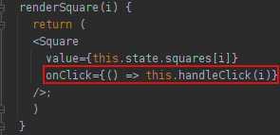
- In the child, let the event listener return a function, that calls the passed prop
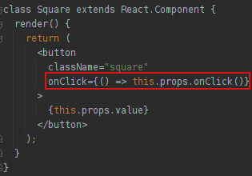

A component that is fully controlled by its parent is called a controlled component

If a React component only contains a render() method, then convert it to a function component!
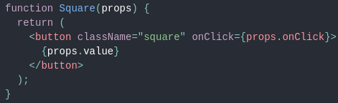
→It’s no longer a class
→The render function is gone
→We don’t have to return a function in event handlers
→If we pass a function as a prop we call it as an attribute (idk why???)
→Instead of this.props we write props

Immutability

2 possible ways to change data
- Mutate the data
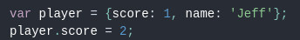
- Replace the data with a new copy
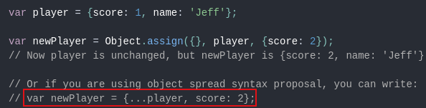
Why you should always replace instead of mutating
- It simplifies historization (e.g. to detect changes, or undo)
- Change detection simplifies controlled re-rendering

