Source: https://www.robinwieruch.de/javascript-fundamentals-react-requirements
Most recent archive: https://web.archive.org/web/20210217094557if_/https://www.robinwieruch.de/javascript-fundamentals-react-requirements

How to run a basic react file without making a backend
Source: https://stackoverflow.com/questions/46506332/run-simple-react-js-in-browser-locally
→Create Hello World node react app, then change the react file App.js
→Change into the newly created directory, then run npm start

How to debug a react file
- Install the React Developmer Tools Browser Addon https://addons.mozilla.org/en-US/firefox/addon/react-devtools/
- Run your hello world app
- In your browser open the debugging stuff using F12
- There should be two new tabs: Components and Profiler

How React files can look
Minimal setup:
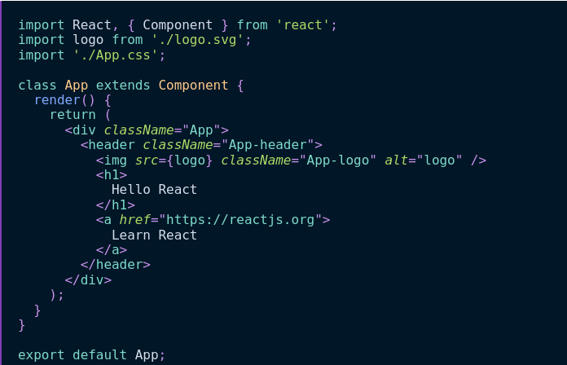
Using state and functions:
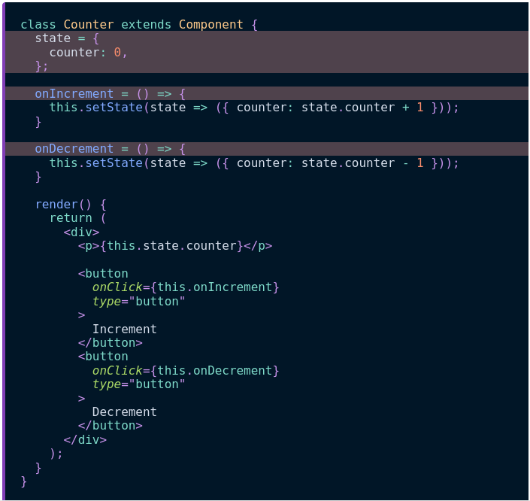

Classes
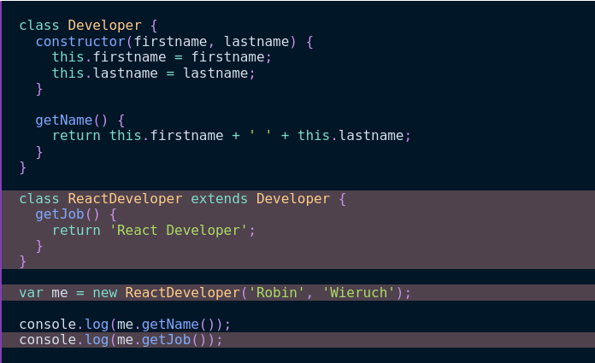
→The constructor method needs to be called constructor
→To inherit from a class use extends

Arrow functions
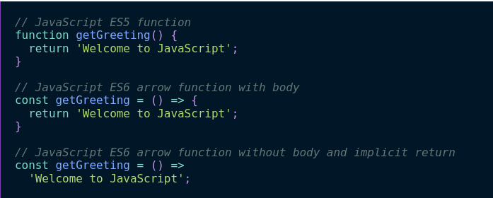

Functions as Components in React
Instead of defining React components using classes, use functions!
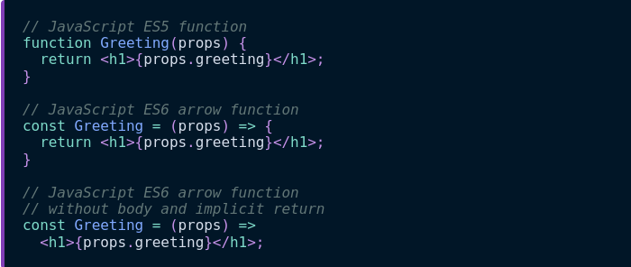

Template literals
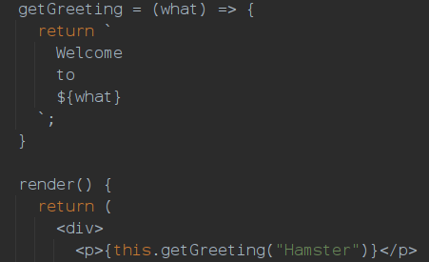

Map, Reduce, Filter
- Map: Iterate over an array. Per item do …
- Filter: Returns a subset of an array matching given conditions
- Reduce: Aggregates over an array. https://developer.mozilla.org/en-US/docs/Web/JavaScript/Reference/Global_Objects/Array/Reduce
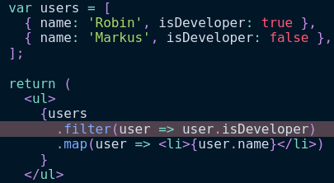

Variable types
- var: don’t use this anymore
- let: use when a variable needs to be reassigned (e.g. in a for loop)
- const: use when variable value is permanent

Ternary operators
Used for conditional rendering
2 ways of using them:
- condition ? do if true : do if false
- condition && do if true
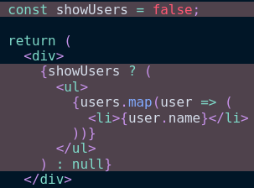

Import & Export
→When creating the hello world react app, src/App.js contains React code that is then imported in src/index.js

Export: Can be used to export variables, methods and classes
→export default is used to highlight the main functionality of the module we export from
Import: Can be used to import npm packages as well as variables, methods and classes from other files
→Can use relative paths when importing from other files
→Can use an alias when importing, i.e. import x as y

React packages and IDE addons
https://www.robinwieruch.de/react-libraries

Asynchronous JavaScript
https://developer.mozilla.org/en-US/docs/Learn/JavaScript/Asynchronous
→Use promises for asynchronous tasks

Higher-order functions
Idea: Functions can return other functions
Possible to use a shorthand for this, e.g.
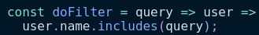

Useful shorthands
- Object property is called the same as another variable
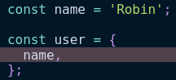
- Dynamic naming
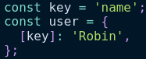

Destructuring
Idea: You can select a subset from an array of key value pairs, by specifying relevant keys
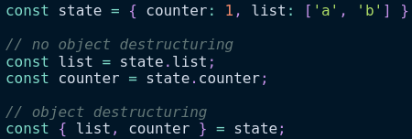
This can be used to not carry props around all the time
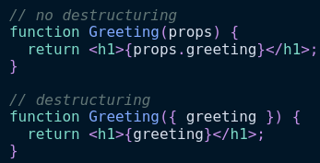
Alternatively, if the array doesn’t have keys, you can imply the index
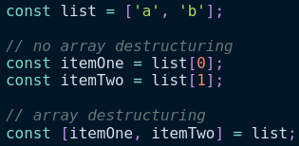
This is used by React hooks, e.g. for the state
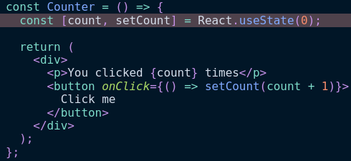

Spread Operator
The spread operator is 3 dots …
Its meaning is context dependent
When destructuring it can be used to bundle unspecified components of an array into the ...rest variable
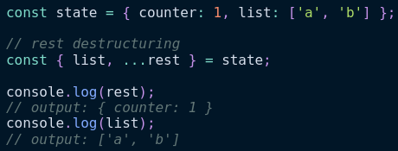
When passing an object around this can save you from always explicitely writing each property that is being passed
