IAM Users and Groups
Caleb Quisenberry
University of Advancing Technology
June 22, 2024

Author Note
This paper was prepared for NTS336, Cloud Security, taught by Professor Aaron Jones.

Identity Access Management (IAM) Users and Groups.
Learning about IAM in AWS is a crucial step in understanding how to keep our cloud environments secure. Creating IAM users, groups, roles, and managing policies are fundamental skills that every AWS user should master. In this paper, I will walk you through the process of setting up IAM users and groups and attaching policies to control permissions.
Users and Groups
Users
The process of creating users and groups is very streamlined within AWS. Users are important for a wide variety of reasons. These include security concepts such as least privilege, and enhanced logs for SIEM or forensics.
To create your first user, you navigate to IAM. From there you choose Users from the left menu. There you find a “Create user” button. Clicking that brings you to User details where you enter the User name. The next screen allows you to assign the user to a group, and even allows for creation of the first group. I created the admin group from this screen, which will be explored in the following section. You then review the configurations associated with your new user and save. The following two screenshots show the create group option, and then the Users tab showing the two users created for this assignment along with their assigned group.
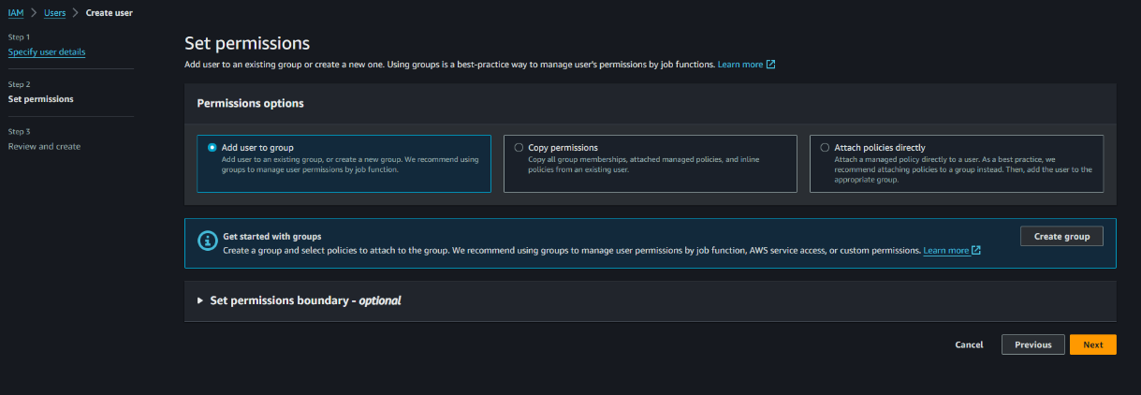
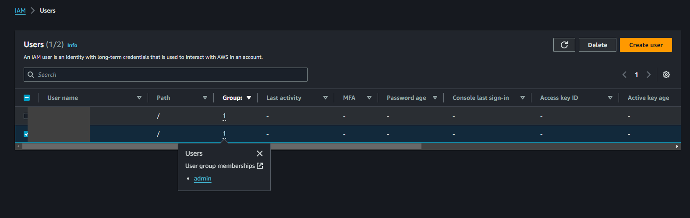
Groups
Groups are straightforward to set up. When creating your first user you are prompted to create a group to add them to. Choosing that option brings you to a screen that asks you to set the group name and permissions. At time of writing, there are 930 preconfigured permissions policies. You also have the option of creating policies. When the group is created you can assign users to it. The following screenshot shows the User groups with the “admin” group name, and the “AdministratorAccess” attached policy.
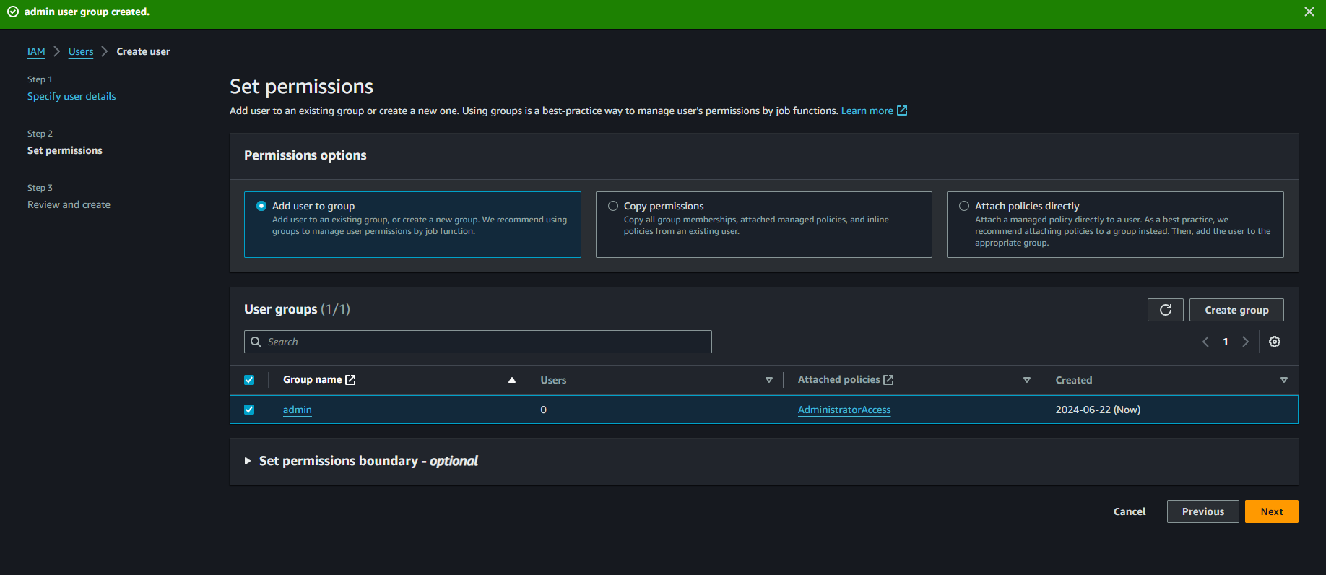
Policies
IAM policies are essential for defining permissions and controlling access to resources in an organization’s IT infrastructure. They specify who (users or roles) can perform what actions (read, write, execute) on which resources (servers, databases, applications). The primary purpose is to enhance security by ensuring only authorized users have access. By implementing IAM policies, organizations can enforce the principle of least privilege, minimizing security risks and maintaining a secure environment.
Conclusion
Mastering IAM users and groups in AWS is essential for maintaining a secure and efficient cloud environment. The processes of creating and managing users, groups, and policies are straightforward yet powerful tools that enable precise control over access and permissions. By implementing IAM policies, organizations can enforce security best practices, thereby minimizing risks. As demonstrated, AWS provides a user-friendly interface and powerful functionalities that are crucial for any AWS user to understand and utilize effectively.

References
Self-paced digital training on AWS - AWS Skill Builder. (n.d.). Explore.skillbuilder.aws. Retrieved June 22, 2024, from https://explore.skillbuilder.aws/learn/course/85/play/8064/authentication-and-authorization-with-aws-identity-and-access-management
What is AWS Single Sign-On? - AWS Single Sign-On. (n.d.). Docs.aws.amazon.com. https://docs.aws.amazon.com/singlesignon/latest/userguide/what-is.html

