Configuring Firewall Rules in AWS
Caleb Quisenberry
University of Advancing Technology
June 30, 2024

Author Note
This paper was prepared for NTS336, Cloud Security, taught by Professor Aaron Jones.

Configuring Firewall Rules in AWS
Network security is a crucial aspect of managing cloud resources. AWS EC2 instances must be secured by configuring appropriate firewall rules to control access to the instances. This assignment focuses on creating a firewall rule that allows connections on ports 80 and 443 from any IP address and restricts SSH access on port 22 to a specific IP address.
Steps to Create and Configure Firewall Rules
Step 1: Accessing the EC2 Management Console
To begin, log into the AWS Management Console and navigate to the EC2 dashboard. From there, select "Security Groups" under the "Network & Security" section.
Step 2: Creating a New Security Group
Create a new security group by clicking the "Create security group" button. Provide a name and description for the security group.
Step 3: Adding Inbound Rules
Add the necessary inbound rules to allow connections on specific ports:
- HTTP (Port 80):
  - Type: HTTP
  - Protocol: TCP
  - Port Range: 80
  - Source: 0.0.0.0/0 (Allows connections from any IP address)
- HTTPS (Port 443):
  - Type: HTTPS
  - Protocol: TCP
  - Port Range: 443
  - Source: 0.0.0.0/0 (Allows connections from any IP address)
- SSH (Port 22):
  - Type: SSH
  - Protocol: TCP
  - Port Range: 22
  - Source: [Your Specific IP Address]/32 (Allows connections only from your specific IPv4 address)
Save the security group after adding these rules.
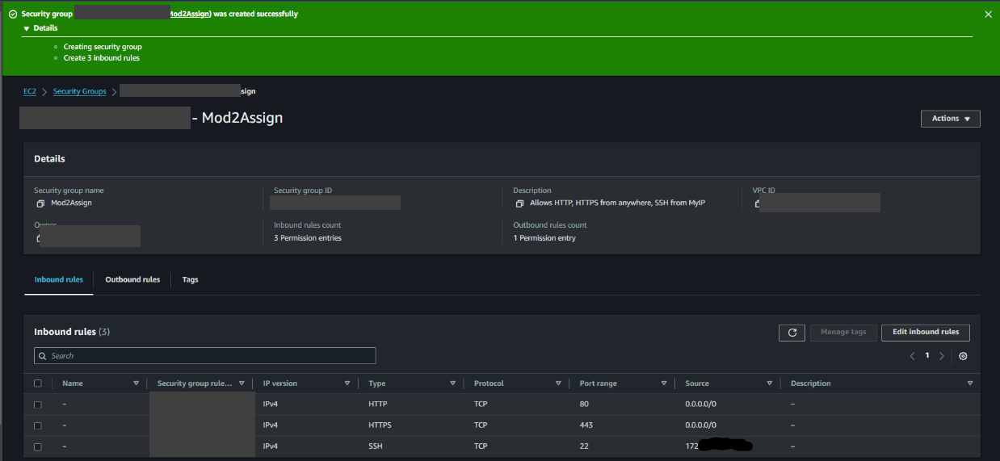
Step 4: Applying the Security Group to an EC2 Instance
Navigate to the "Instances" section and select the EC2 instance you want to apply the security group to. In the "Actions" menu, choose "Networking" and then "Change Security Groups." Attach the newly created security group to the instance.
Significance of Each Port
Port 80 (HTTP)
Port 80 is used for HTTP traffic, allowing web browsers to connect to web servers. Enabling this port allows users to access web applications hosted on the EC2 instance.
Port 443 (HTTPS)
Port 443 is used for HTTPS traffic, providing a secure version of HTTP. It ensures that data transmitted between the user's browser and the web server is encrypted, which is essential for protecting sensitive information.
Port 22 (SSH)
Port 22 is used for SSH connections, enabling secure remote login to the EC2 instance. Restricting SSH access to a specific IP address enhances security by limiting potential attack vectors to only known and trusted IP addresses.
Importance of Restricting SSH Access
Restricting SSH access to a specific IP address is crucial for enhancing the security of the EC2 instance. By allowing only trusted IP addresses to connect via SSH, the risk of unauthorized access and potential attacks is significantly reduced. This ensures that only authorized personnel can manage and configure the instance remotely.
Challenges and Resolutions
During the process, one challenge was ensuring that the specific IP address for SSH access was correctly identified and configured. This was resolved by verifying the IP address using a trusted IP-checking service and double-checking the security group settings in the EC2 Management Console.

Conclusion
Creating and configuring firewall rules in the AWS EC2 Management Console is a vital practice for securing cloud resources. By allowing necessary traffic on ports 80 and 443 while restricting SSH access to a specific IP address, we can enhance the security and accessibility of EC2 instances. This assignment provided firsthand experience in managing network security through practical application.

References
AWS. (2019). Amazon EC2 Security Groups for Linux Instances - Amazon Elastic Compute Cloud. Amazon.com. https://docs.aws.amazon.com/AWSEC2/latest/UserGuide/ec2-security-groups.html

