DevOps Basics with Ansible and AWS
Caleb Quisenberry
University of Advancing Technology

Author Note
This paper was prepared for NTW216, Foundations of Systems Administration taught by Robert Benton.

DevOps Basics with Ansible and AWS
This paper will explore the fundamental principles of DevOps by illustrating my journey while deploying a new instance on AWS and using Ansible to automate its management. Ansible is open source and provides automation that reduces the complexity of managing systems.

Instance Launch and Configuration
We begin by launching a new instance. Because of my experience with earlier assignments, I am comfortable with the process. No screenshots were taken of this process. A standard Ubuntu instance was launched and an inbound rule to allow ping was set. This is to help with troubleshooting issues and was not required for the assignment. The instance was then configured to allow SSH.
Ansible
Upon reviewing the documentation provided in the assignment, I discovered that Ansible does not support a Windows installation. I went through a couple of options that each presented their own challenges. Due to the frustration level involved, most of those struggles were not captured in screenshot. First, I attempted to run an Ubuntu VM and struggled with the .pem file I saved, as it was on the host machine. Oracle’s VirtualBox fought me on both copy from host and drag and drop options. I then used Windows Subsystem for Linux (WSL) to run an Ubuntu instance. This was a valuable experience as I had not tried this option before, and I plan to become more proficient with this utility soon. I ran into an issue that I believe has to do with firewall permissions but did not continue to troubleshoot due to time constraints. I was able to ping my AWS instance but could not connect with SSH. I then simply fired up a laptop I have that has Ubuntu as its primary OS. I still ran into a few obstacles but was able to complete the assignment. The following screenshot shows the SSH connection between my laptop and the AWS instance.
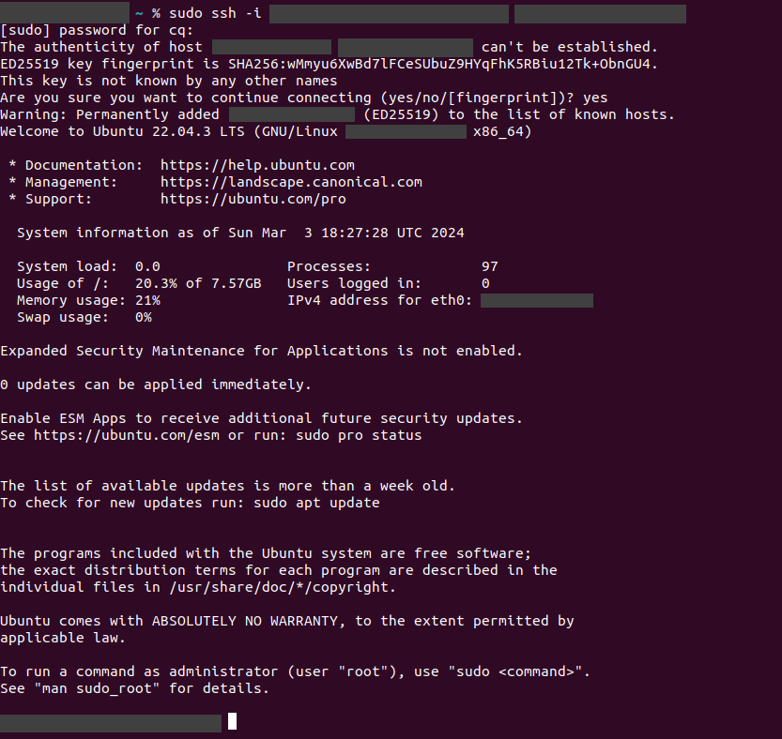
Once connectivity was achieved, I installed Ansible. The documentation calls for using pipx, so that was installed first. The following screenshot shows the successful Ansible installation.
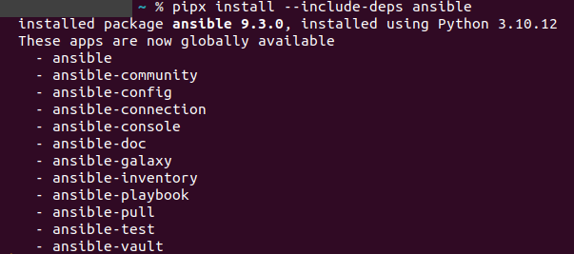
Configuration and Communication
In order to configure Ansible to communicate with my AWS instance, a configuration file called inventory.ini was created and edited in nano. This file contains the public address of my AWS instance and the location of the necessary .pem file. The following screenshot is of the file in nano.
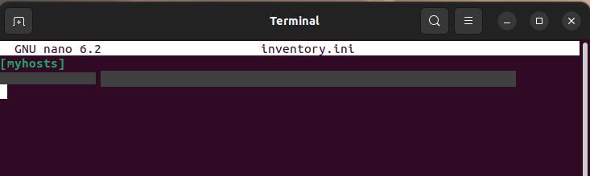
I then used nano again to create a playbook that updates and upgrades packages in apt. I struggled a couple of times even though I followed the script provided in the assignment. The fix was found in some of the example playbooks from the Ansible documentation. I added a line that said “remote_user: ubuntu” and was then able to connect and run the playbook. The following screenshot shows the file before I added that line.
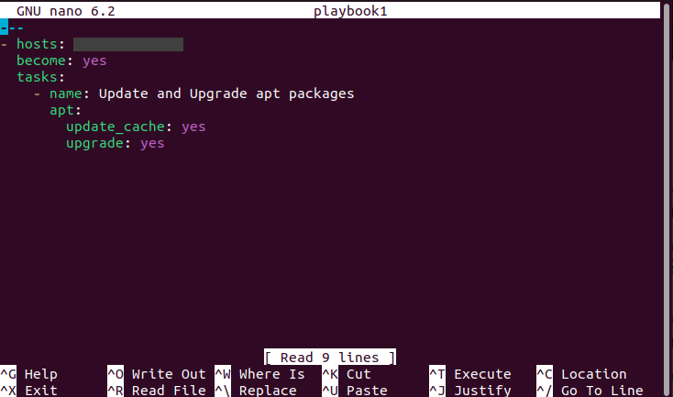
This next screenshot shows the file with the line added.
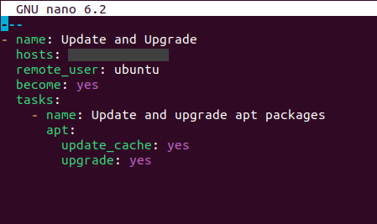
This next screenshot shows the terminal response for both the original file, and the successful run of the playbook.
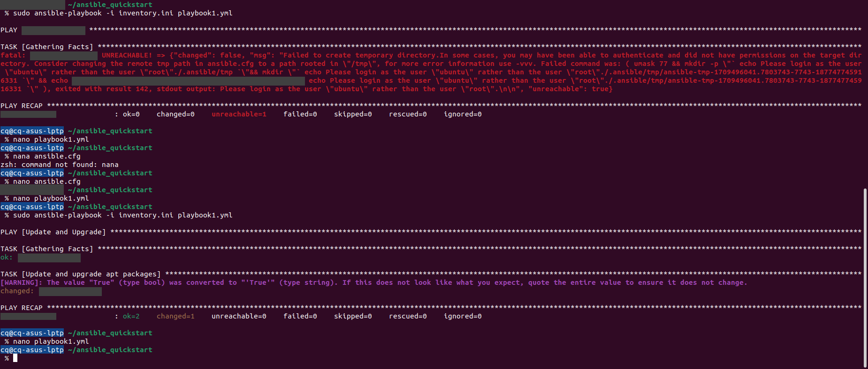
Verification
The last step of the assignment is to check to ensure that updates and upgrades have been accomplished. I went to the instance connect provided by AWS and checked for upgradeable packages. I found none. That is shown in the following screenshot.
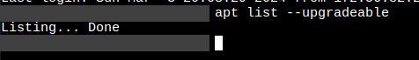
Conclusion
I find value in the assignments that I struggle with. The self-guided learning required to overcome the challenges I faced is invaluable. The act of researching and deploying fixes to complete the assignment reinforces and deepens the knowledge of the subject matter.

References
craigloewen-msft. (n.d.). What is Windows Subsystem for Linux? Learn.microsoft.com. https://learn.microsoft.com/en-us/windows/wsl/about
Introduction to Ansible — Ansible Documentation. (n.d.). Docs.ansible.com. https://docs.ansible.com/ansible/latest/getting_started/introduction.html

