UFW and SSH
Caleb Quisenberry
University of Advancing Technology

Author Note
This paper was prepared for NTW216, Foundations of Systems Administration taught by Robert Benton.

UFW and SSH
This paper details the launch of an AWS instance using an Ubuntu operating system. The purpose of the instance is to allow us to gain familiarity with Uncomplicated Firewall (UFW) on Ubuntu servers.
Instance Launch and SSH Connection
In the first couple of steps of the assignment we are to launch a new Ubuntu instance, enable SSH access, and choose the appropriate key pair settings. A best practice would be to limit SSH traffic to certain IP addresses and to review other security protocols during creation. This is followed by connection through SSH to our instance. The following shows the connection using PuTTY in the foreground and the instance detail pane in the background. This demonstrates completion of these steps.
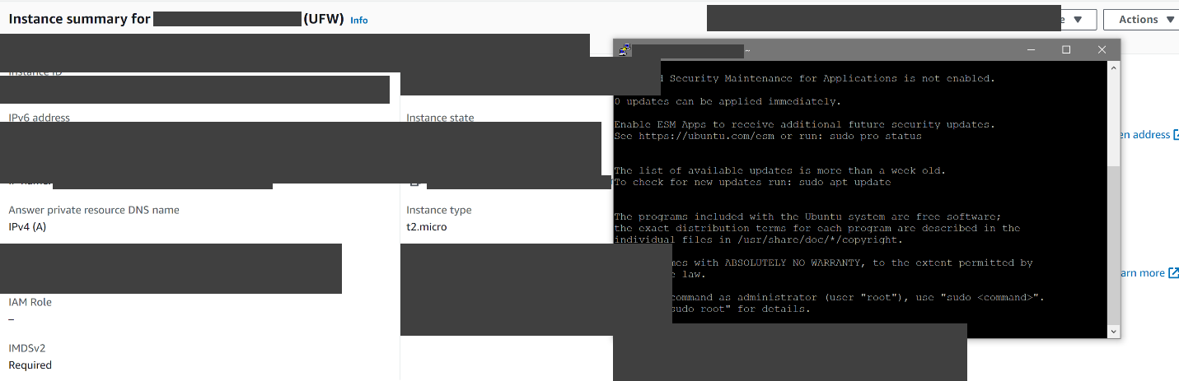
Uncomplicated Firewall
One of the first things I have been doing in the assignments so far is to update and upgrade through the package manager. The tail end of the output from this will be visible at the top of the first screenshot, below.
UFW Install
We use the common package manager to install UFW. In this case it was already installed and had been updated and/or upgraded with the previous commands. This is shown in the following screenshot.
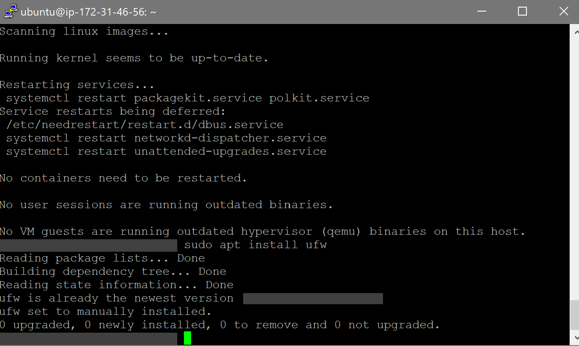
SSH Access
Before enabling UFW we need to enable SSH traffic. If this is not done, our current connection can be severed, and we can be locked out. This is shown below.
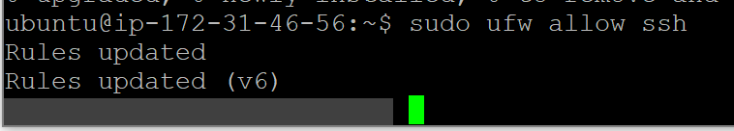
Enabling the Firewall
Next, we simply enable the firewall. If we had not allowed SSH traffic in the previous step, this is when connection would be lost.
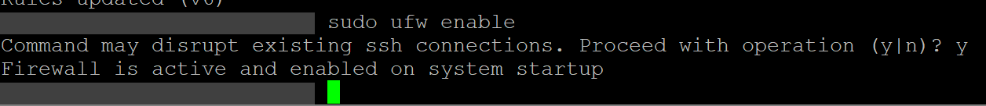
Status Verification
To ensure that the firewall is active and that SSH traffic is allowed, we check the status. If the firewall were active and SSH was not allowed it would be apparent without this step.
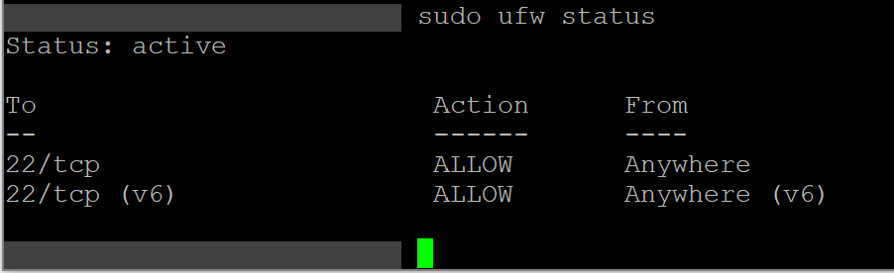
Conclusion
This assignment is a refresher for the process of managing firewall rules and access controls. This same process was covered in the steps of the guide to setting up a VPN server in week two. It was well timed with a return from spring break and refreshed my interest in the topic of the course.

References

