Rapid Testing and Automation
Caleb Quisenberry
University of Advancing Technology
March 24, 2024

Author Note
This paper was prepared for NTW216, Foundations of Systems Administration taught by Robert Benton.

Rapid Testing and Automation
The rapid evolution of cloud computing has transformed the landscape of network architecture, data management, and service delivery. In such environments, testing and automation are not merely beneficial; they are essential components to ensure reliability, efficiency, and the successful deployment of services. This paper explores the significance of testing and automation in cloud environments, with a focus on AWS, detailing an approach to automating Elastic Compute Cloud (EC2) operations through scripting.
Significance of Testing and Automation in AWS
Testing and automation in AWS or any cloud environment play pivotal roles in maintaining system integrity, performance, and security. Automated scripts and tools enable developers and system administrators to rapidly deploy and manage cloud resources, streamline workflows, and minimize human errors. For AWS, particularly, where the ecosystem comprises numerous services interconnected across global infrastructure, automation ensures that resources are optimally utilized, costs are controlled, and configurations are consistent across deployments.
Setting Up AWS CLI and Script Development
The AWS Command Line Interface (CLI) was downloaded and installed as part of this assignment but was not used beyond that point. AWS has a built-in command line tool that is easier to use. This tool is called AWS CloudShell. Citing the AWS Documentation (2024) the documentation states “AWS CloudShell is a browser-based, pre-authenticated shell that you can launch directly from the AWS Management Console.” This provides many ease of use and security benefits. Citing further from the AWS documentation;
The AWS credentials that you used to sign in to the console are automatically available in a new shell session. Because AWS CloudShell users are pre-authenticated, you don’t need to configure credentials when interacting with AWS services using AWS CLI version 2. The AWS CLI is pre-installed on the shell's compute environment. (Documentation, AWS CloudShell, User Guide)
The screenshot below shows the result of the version query of AWS CLI. This is to illustrate the installation of the CLI to ensure satisfaction of the rubric.
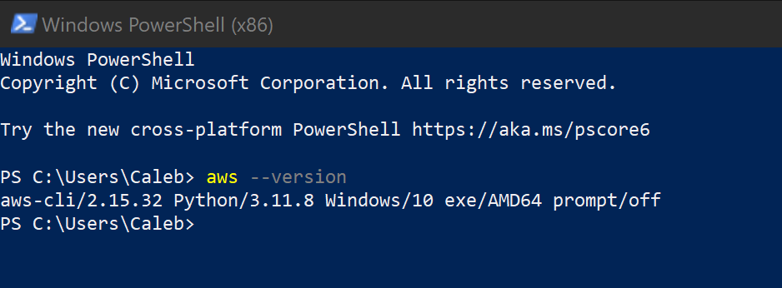
Script Overview and EC2 Operation Explanation
The Python script developed for automating tasks in AWS involves several key steps to manage EC2 instances effectively. Initially, it imports necessary modules, including boto3 for interacting with AWS services, and time to manage delays. The script then initializes an EC2 resource object, allowing for direct interaction with EC2 instances.
The first major function, ‘launch_instance()’, oversees the creation of an EC2 instance using specified parameters such as the image ID, instance type, and key pair name. This function waits until the instance is running, then refreshes its state to ensure accurate information is available for retrieval.
Following the instance launch, the ‘query_instance_details()’ function is invoked to print the newly created instance's ID, public IP address, and current state, providing immediate feedback on the operation's success.
To allow for verification and observation in the AWS Management Console, the script pauses execution for five minutes using a sleep function. This intentional delay offers a practical window to inspect the instance outside of the automation script.
Finally, the ‘terminate_instance()’ function is called to safely terminate the EC2 instance. It waits until the termination process is complete, ensuring that resources are cleaned up and not left running unintentionally. This sequence of steps demonstrates a thoughtful approach to automating cloud operations, emphasizing both efficiency and safety.
The following screenshot shows the script in the text editor nano. Note the comments that describe operations at various steps. This script was written with the assistance of OpenAI’s ChatGPT. Comments and specifics such as ‘ImageID’ and ‘KeyName’ are added by me.
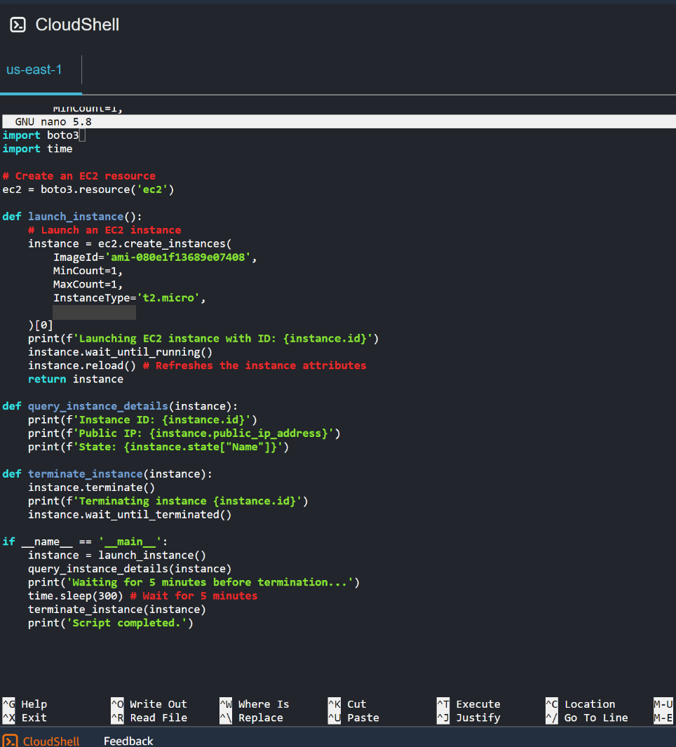
Script Functionality
The script is run by running the command ‘python ec2_automation.py’. The use of AWS CloudShell for this assignment simplified the creation of screenshots. Both the EC2 dashboard and the command line can be seen in one image. The following screenshot shows the instance running in the EC2 dashboard. It also shows the return from the ‘query_instance_details’ function in the script. This screenshot was taken within the five-minute pause written into the script.
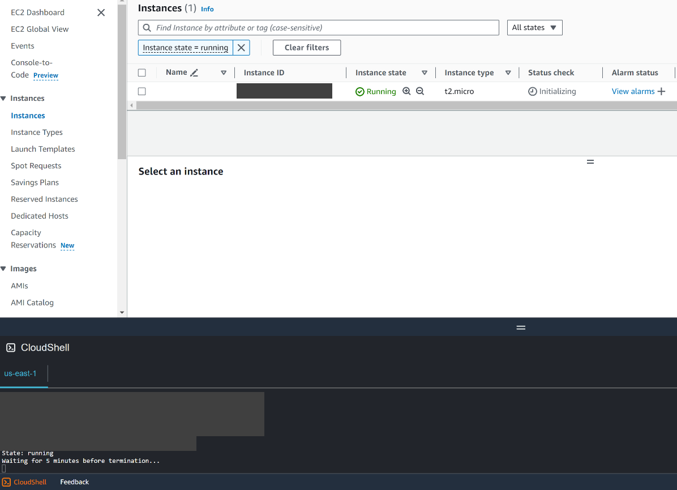
Successful operation of the script also requires termination of the instance. The following screenshot shows the terminated instance in the EC2 dashboard. It also shows completion of the script itself in the final line.
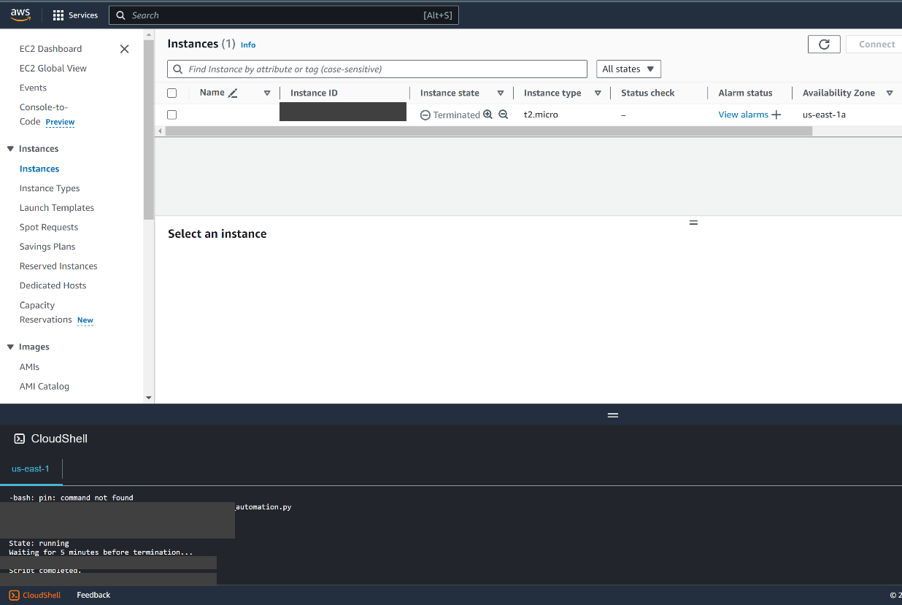
Challenges Encountered and Overcome
The use of AWS CloudShell avoided some of the obstacles that may have been encountered when completing this assignment. Primarily, the need to ensure proper credential configuration. The use of AWS Identity and Access Management (AWS IAM) was not required to enable access to the command line tools. The exploration of AWS IAM could easily have presented challenges that were easily overcome with the use of the cloud native command line.
Security Considerations and Best Practices
Security best practices for AWS CloudShell are built upon the AWS Shared Security Responsibility Model. Some of the user’s responsibilities include using IAM permissions and policies and using features like Safe Paste. IAM permissions and policies enable administrators to control access and ensure that users can only perform actions related to their role. Safe Paste can catch malicious code or security risks from text copied from external sources.

References
OpenAI. (2023). ChatGPT [Software]. https://chat.openai.com
Security best practices for AWS CloudShell - AWS CloudShell. (n.d.). Docs.aws.amazon.com. Retrieved March 24, 2024, from https://docs.aws.amazon.com/cloudshell/latest/userguide/security-best-practices.html
Set up the AWS CLI - AWS Command Line Interface. (n.d.). Docs.aws.amazon.com. Retrieved March 24, 2024, from https://docs.aws.amazon.com/cli/latest/userguide/getting-started-quickstart.html
What is AWS CloudShell? - AWS CloudShell. (n.d.). Docs.aws.amazon.com. https://docs.aws.amazon.com/cloudshell/latest/userguide/welcome.html
What is AWS Single Sign-On? - AWS Single Sign-On. (n.d.). Docs.aws.amazon.com. https://docs.aws.amazon.com/singlesignon/latest/userguide/what-is.html

