Network Design Proposal
Caleb Quisenberry
University of Advancing Technology
November 31, 2024

Author Note
This paper was prepared for NTW275, Network Infrastructure Design I, taught by Professor Aaron Jones.

Network Design Proposal
This paper is a network design proposal for a multinational corporation with offices in three cities. It aims to design a secure, scalable, and reliable network that integrates the disparate offices, supports collaboration, and accommodates future growth.

Network Architecture
The two choices considered for this design were Multiprotocol Label Switching (MPLS) and Software Defined Wide Area Network (SD-WAN). Due primarily to the cost and scalability concerns, the chosen network architecture for GlobalTech Enterprises is a hybrid design incorporating SD-WAN technology. This architecture includes a core layer that provides centralized routing and high-speed connectivity between New York, London, and Tokyo. The distribution layer manages inter-office traffic and dynamic routing, ensuring efficient communication across all sites. The access layer supports local area networks (LANs) within each office, connecting devices such as workstations and printers. By leveraging SD-WAN, this architecture dynamically routes traffic through optimal paths, balancing performance and cost while maintaining security. This hybrid approach integrates on-premises resources with cloud services. Each office features redundant edge routers, and redundant uplinks to ensure connectivity.
Addressing Operational Requirements
The network design for GlobalTech Enterprises addresses key operational requirements by ensuring multi-site integration, security, scalability, redundancy, and high-performance connectivity. Multi-site integration is achieved through dynamic routing and efficient traffic management, enabling effective collaboration across global offices. Security is prioritized with measures such as encryption, access controls, and real-time threat detection to protect sensitive data. Scalability is built into the design through modular components and cloud integration, allowing the network to grow with the organization. Redundancy is implemented with failover systems and backup links to ensure uninterrupted operations, while high-speed connectivity supports data-intensive applications and real-time communication. This comprehensive approach ensures a secure, dependable, and future-proof network infrastructure for the organization.
Implementation and Maintenance
The implementation plan for GlobalTech Enterprises’ network design follows a structured approach to ensure successful deployment and ongoing reliability. The process begins with a planning phase that includes site assessments, hardware procurement, and configuration design. Deployment involves setting up core infrastructure components such as routers, switches, and secure connections for SD-WAN and cloud integration. Once deployed, rigorous testing is conducted to validate connectivity, security, and redundancy measures, including failover scenarios. Post-deployment, a maintenance strategy is established with continuous monitoring, regular updates, and robust support plans to ensure the network remains secure, reliable, and scalable over time. This systematic plan ensures a smooth transition to the new network infrastructure while minimizing risks.
Challenges and Mitigation Strategies
The network design addresses potential challenges through proactive mitigation strategies. Integration of multiple global sites increases complexity, which is managed using centralized tools for streamlined network control. Cybersecurity threats are mitigated with a layered security approach, including encryption, access controls, and real-time threat detection. Scalability costs are addressed through modular network components and cloud-based resources, ensuring efficient expansion. Redundancy measures, such as failover systems and backup connections, safeguard against outages, ensuring continuous operations. These strategies collectively minimize risks and enhance the reliability and resilience of the network.
Screenshots
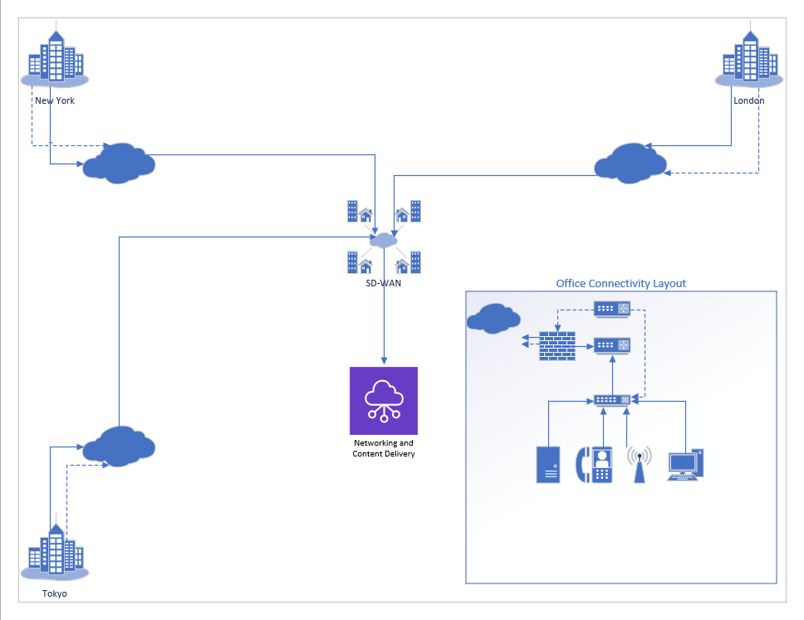
Conclusion
This network design ensures GlobalTech Enterprises achieves a robust, secure, and scalable infrastructure capable of supporting its operations globally. With advanced technologies like SD-WAN and AWS cloud integration, the network is future-proof and ready for expansion.

References
Capcon networks | Network consulting company in Austin, TX. (n.d.). Capcon Networks. https://www.capconnetworks.com/benefits-and-considerations-of-hybrid-networks
Cisco SD-WAN solution overview. (n.d.). Cisco. https://www.cisco.com/c/en/us/solutions/collateral/enterprise-networks/sd-wan/nb-06-sd-wan-sol-overview-cte-en.html
MacLean, K. (2024, March 13). Next-Gen interconnection: SD-WAN and its role in hybrid IT optimization. DataBank | Data Center Evolved. https://www.databank.com/resources/blogs/next-gen-interconnection-sd-wan-and-its-role-in-hybrid-it-optimization/
SD-WAN vs. MPLS: How do they stack up for your needs? (2024, May 20). Turnium. https://turnium.com/sd-wan-vs-mpls/

