Server Infrastructure Plan
Caleb Quisenberry
University of Advancing Technology
November 30, 2024

Author Note
This paper was prepared for NTW275, Network Infrastructure Design I, taught by Professor Aaron Jones.

Server Infrastructure Plan
This paper will explore assignment 2.1, exploring the creation of a server infrastructure plan for a mid-sized healthcare company. It will explore several operational and cloud integration requirements.

Cloud Services and Configurations
HealthCo will use AWS services to meet its operational needs while ensuring HIPAA compliance. Amazon S3 will provide secure, scalable file storage, Amazon SES will manage reliable and authenticated email communication, Amazon EC2 with Elastic Load Balancing will host the company’s website, and Amazon RDS will manage the available and redundant database for patient records and scheduling. Additionally, an on-premises Dell PowerEdge R750 server will support Windows Active Directory for centralized user management and authentication.
File Storage
HealthCo's file storage needs will be met using Amazon S3, a secure, scalable solution designed for compliance with HIPAA regulations. S3 buckets will employ server-side encryption to protect sensitive patient data and enable versioning to track changes to medical records. AWS Identity and Access Management (IAM) policies will ensure that access to storage is strictly controlled and auditable. Older data will be archived using S3 Glacier to reduce costs, while lifecycle management policies will automate data transitions between storage classes. This setup provides HealthCo with a dependable, cost-effective, and compliant file storage system.
Email Management
HealthCo will use Amazon Simple Email Service (SES) for its email communication needs, ensuring a secure and reliable platform capable of handling high volumes. SES will implement DomainKeys Identified Mail (DKIM) and Sender Policy Framework (SPF) to authenticate emails and enhance security. Monitoring will be managed via Amazon CloudWatch, with alerts configured for delivery issues.
Web Hosting
HealthCo's web hosting requirements will be fulfilled using Amazon EC2 instances combined with an Elastic Load Balancer (ELB) for scalability and high availability. The web servers will be deployed on EC2, with the ELB distributing traffic evenly across instances to manage increased web traffic. Static assets will be stored on Amazon S3 and served via Amazon CloudFront to improve performance and reduce latency. Auto Scaling Groups will dynamically adjust the number of EC2 instances based on demand, ensuring a reliable and responsive experience for users to access HealthCo's website and online appointment booking system.
Database Management
HealthCo's database management needs will be addressed with Amazon RDS (Relational Database Service), configured for high availability and redundancy. A multi-AZ deployment will ensure continuous operation during hardware failures, while automated backups and point-in-time recovery will safeguard against data loss. Read replicas will be used to enhance scalability by offloading read-heavy workloads, and encryption at rest and in transit will secure sensitive patient and billing data.
On-premises Server
HealthCo will deploy an on-premises server to manage Windows Active Directory (AD) for centralized user authentication and management. This server will support essential functions such as user account management, group policies, and local authentication, ensuring secure and efficient identity management.
Server Infrastructure Plan
The server infrastructure plan for HealthCo uses a hybrid approach. AWS services such as S3, SES, EC2, and RDS will provide secure file storage, reliable email communication, scalable web hosting, and highly available database management. An on-premises server will support Windows Active Directory for centralized user management and authentication. This hybrid approach ensures compliance with HIPAA regulations, supports future growth, and delivers high availability and redundancy across all systems.
Scalability
The infrastructure plan ensures scalability by leveraging AWS services like Auto Scaling Groups for EC2 instances to dynamically adjust computing resources based on demand. Amazon S3’s tiered storage options enable cost-effective scaling as file storage needs grow, while Amazon RDS read replicas allow the database to handle increased workloads. This design ensures HealthCo’s infrastructure can expand to support more users, higher web traffic, and greater data storage requirements.
Redundancy
Redundancy is achieved through features like Amazon RDS Multi-AZ deployments, which provide failover capability for the database, and cross-region replication in S3 for critical file storage. The use of Elastic Load Balancers ensures continuous web hosting availability, even during instance failures. These redundancy measures minimize downtime and ensure reliable operations for HealthCo’s systems.
Security
Security is integrated into the infrastructure, with services like AWS Identity and Access Management (IAM) for strict access control, encryption for all stored and transmitted data, and AWS Shield and Web Application Firewall (WAF) to protect against DDoS and other attacks. Also, the on-premises Active Directory server enhances identity management while ensuring sensitive data remains secure and compliant with HIPAA requirements.
Screenshots
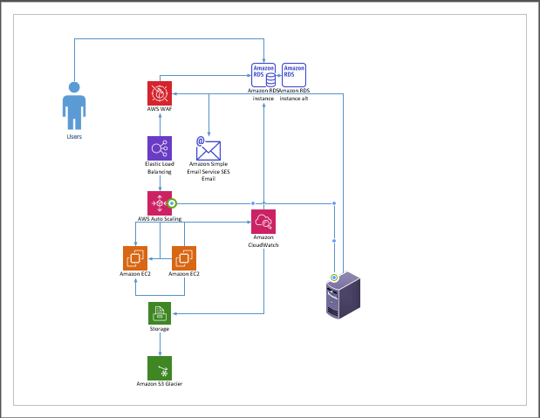

References
Dell. (n.d.). Poweredge R750 Spec Sheet. https://i.dell.com/sites/csdocuments/Product_Docs/en/poweredge-R750-spec-sheet.pdf
Iainfoulds. (n.d.). Active directory domain services overview. Microsoft Learn: Build skills that open doors in your career. https://learn.microsoft.com/en-us/windows-server/identity/ad-ds/get-started/virtual-dc/active-directory-domain-services-overview
What are AWS waf, AWS shield advanced, and AWS firewall manager? (n.d.). https://docs.aws.amazon.com/waf/latest/developerguide/what-is-aws-waf.html
What is Amazon CloudFront? (n.d.). https://docs.aws.amazon.com/AmazonCloudFront/latest/DeveloperGuide/Introduction.html
What is Amazon CloudWatch? (n.d.). https://docs.aws.amazon.com/AmazonCloudWatch/latest/monitoring/WhatIsCloudWatch.html
What is Amazon EC2? (n.d.). https://docs.aws.amazon.com/AWSEC2/latest/UserGuide/concepts.html
What is Amazon relational database service (Amazon RDS)? (n.d.). https://docs.aws.amazon.com/AmazonRDS/latest/UserGuide/Welcome.html
What is Amazon S3? (n.d.). https://docs.aws.amazon.com/AmazonS3/latest/userguide/Welcome.html
What is Amazon SES? (n.d.). https://docs.aws.amazon.com/ses/latest/dg/Welcome.html
What is elastic load balancing? (n.d.). https://docs.aws.amazon.com/elasticloadbalancing/latest/userguide/what-is-load-balancing.html
What is IAM? (n.d.). https://docs.aws.amazon.com/IAM/latest/UserGuide/introduction.html

