Logical and Physical Topologies
Caleb Quisenberry
University of Advancing Technology
November 31, 2024

Author Note
This paper was prepared for NTW275, Network Infrastructure Design I, taught by Professor Aaron Jones.

Logical and Physical Topologies
To introduce this paper, I want to take a more conversational tone to share some background about why I chose this network for the assignment. I work for an ISP that specializes in building fiber-to-the-home (FTTH) networks in rural areas. Right now, we are in the middle of completely redesigning the exchange I support. This includes moving the location of the Central Office (CO), also known as Node 1 (N1). While our setup does not perfectly match the examples used in class, the principles behind the design align closely with the goals of this assignment. This redesign considers critical physical factors like optical budgets and the area’s challenging geography. The network design I am presenting started as a proposal I created a few months back, and I have expanded it for this project. For privacy, I have fictionalized the company name.

Company Overview
Castle Networks is a traditional phone company with a history stretching back over a century. The company’s mission has always been to bring connectivity to underserved rural areas across two vastly different states. Over time, the focus has shifted from providing landline phone service to delivering fast, reliable internet. The push to modernize and upgrade outdated infrastructure has created opportunities to completely redesign legacy networks. This proposal outlines a new FTTH project serving a rural exchange. The project includes over sixty miles of backbone fiber, a full network redesign, and improvements that will impact more than six hundred customers.
Physical Considerations
The area covered by this project is distinctive. The exchange stretches nearly 70 miles along a river valley, making it long but relatively narrow. It is a remote desert region prone to severe summer storms, which can cause washouts and disrupt fiber service. Currently, the network uses a combination of fiber backhaul and copper delivery (Fiber to the Node, or FTTN). However, the existing fiber is insufficient for expansion and lacks the capacity needed for future growth.
Several physical factors must be addressed in this design, including distances, geography, and subscriber density. These factors influence decisions about node and splitter cabinet placement. Equipment from ADTRAN’s Total Access 5000 (TA5K) series will be used for both nodes and the Central Office. The backbone will feature a 10G ring for scalability, with all components calibrated for the required distances. The ring uses fibers three and four in a single cable run due to the geographical constraints of the area.
Logical Topology
At its core, this project upgrades an existing ADTRAN network that currently relies on outdated hardware with limited capacity. The current 1G ring cannot meet the growing demand for higher speeds, so the redesign focuses on upgrading to a 10G-capable ring. This involves relocating the uplink node (N1) and reducing the total number of nodes in the ring. The network will include loop protection, with a Ring Protection Link (RPL) managed through software to prevent traffic loops and ensure continuity during disruptions.
Key upgrades include replacing the enterprise switch with a Cisco Catalyst 9600 Series, which provides enhanced scalability and security. At the exchange level, the edge router will be upgraded to a Cisco ASR-9903, offering advanced capabilities and flexibility for future deployments. This redesign ensures the network can handle today’s demands while being prepared for tomorrow’s challenges.
Screenshots
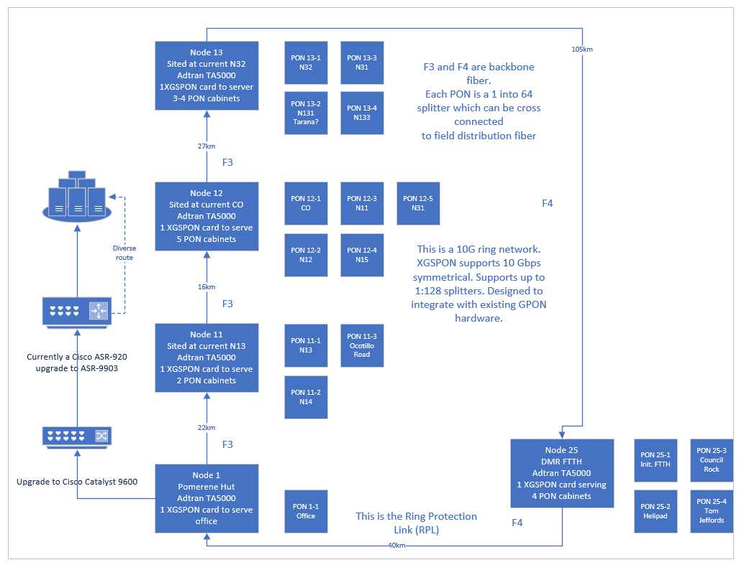
Conclusion
This network redesign for Castle Networks represents a significant step toward modernizing the infrastructure and meeting the evolving needs of rural customers. By transitioning from a limited, outdated 1G ring to a robust 10G-capable network, the project ensures both improved performance and scalability for future growth. The physical and logical considerations, such as geography, optical budgets, and advanced equipment upgrades, create a solid foundation for reliable and high-speed connectivity.
This project not only addresses current challenges but also positions Castle Networks to continue its legacy of bridging the digital divide in underserved areas. By leveraging modern technologies like the Cisco Catalyst 9600 and ASR-9903, along with ADTRAN’s proven TA5K platform, the redesigned network achieves a balance of flexibility, resilience, and cost-effectiveness. This proposal demonstrates how thoughtful planning, and strategic upgrades can transform legacy systems into forward-looking networks designed to scale to meet future demands.
References
Cisco ASR 9903 compact high-performance router data sheet. (n.d.). Cisco. https://www.cisco.com/c/en/us/products/collateral/routers/asr-9000-series-aggregation-services-routers/datasheet-c78-744035.html
Cisco catalyst 9600 series switches data sheet. (n.d.). Cisco. https://www.cisco.com/c/en/us/products/collateral/switches/catalyst-9600-series-switches/nb-06-cat9600-series-data-sheet-cte-en.html
Total access 5000 series. (n.d.). Adtran. https://www.adtran.com/en/products-and-services/fiber-access-and-aggregation/optical-line-terminals/total-access-5000-series

