Network Design Evaluation
Caleb Quisenberry
University of Advancing Technology
December 22, 2024

Author Note
This paper was prepared for NTW275, Network Infrastructure Design I, taught by Professor Aaron Jones.

Network Design Evaluation
This report evaluates a segment of a real-world network, focusing on the integration and optimization of two networks following the acquisition of one company by another. The merging of these networks presents unique challenges and opportunities for improvement in performance, cost efficiency, and scalability.
For this proposal, a small portion of the extensive network has been selected to illustrate the key integration considerations and opportunities for optimization. This subset includes five wireless sites serving Point-to-Multipoint (PMP) client locations from the acquired company’s network and two wireless sites, a Central Office (CO), and a meet point with 10G uplinks from the acquiring company’s network.
The goal of this evaluation is to propose a design that integrates these two networks seamlessly while addressing inefficiencies, reducing costs, and preparing the combined infrastructure for future growth.

Opportunities for Optimization
The acquired network consists of five wireless sites providing Point-to-Multipoint (PMP) connectivity to client locations. Of these five sites, only one features a fiber uplink, while the remaining four rely on wireless backhaul links to connect to the uplink site. This uplink site is located on leased property, which incurs significant operational costs.
The acquiring company operates a network in the same geographical area, consisting of two wireless sites, a Central Office (CO), and a meet point. The meet point is a critical asset, equipped with two 10Gbps uplinks from separate internet providers, offering high capacity and redundancy.
The integration of these networks presents several opportunities for optimization. Key considerations include reducing dependency on the high cost leased site, leveraging the meet point’s robust uplinks, and enhancing overall network performance and reliability. The following diagram illustrates the initial layout of the two networks, with text colors used to differentiate each original network.
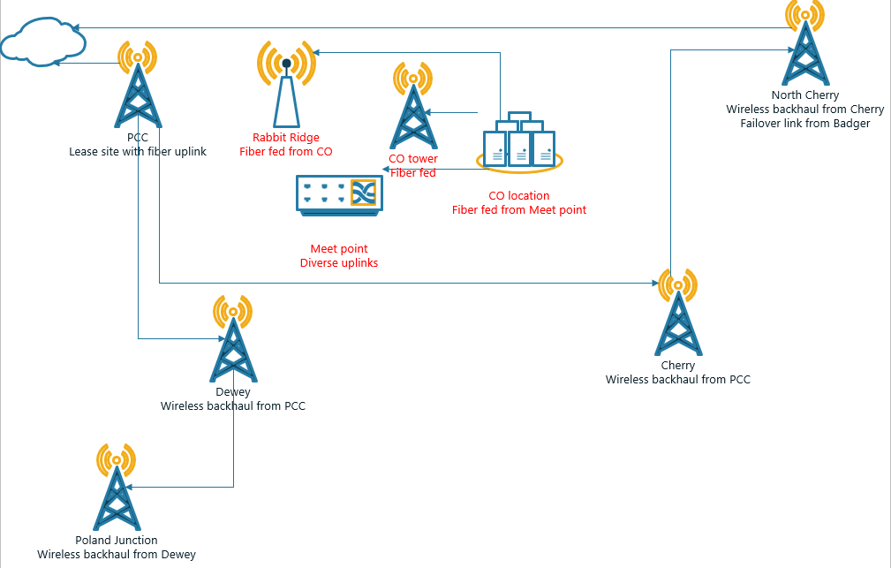
Optimization Strategies
The integration of the acquired network into the existing infrastructure presents significant opportunities for optimization, focusing on cost reduction, improved performance, and long-term scalability. A key aspect of this plan involves removing the PCC site, which currently serves as the high-cost fiber uplink location. Point-to-Multipoint (PMP) customers served by this site will be transitioned to Rabbit Ridge, which is better suited to manage the load and eliminates the recurring expenses associated with the leased PCC site. This adjustment not only reduces costs but also simplifies the network by eliminating two tower locations.
Similarly, the CO tower will be decommissioned, as its coverage is more effectively overseen by the North Cherry site. By redistributing coverage to this site, the network eliminates redundant infrastructure, streamlining operations and reducing maintenance costs. The removal of both the PCC and CO towers represents a strategic reduction in overall network complexity while maintaining or even improving client service levels.
To further optimize performance, fiber links will be constructed to key locations. A new fiber link will be built from the Meet Point to the Dewey site, creating a high-capacity, low-latency connection to replace wireless backhaul at that site. Another fiber link will connect the CO to the North Cherry site, enabling the replacement of the current wireless backhaul with a direct fiber connection. These upgrades reduce reliance on wireless backhaul, cutting the number of wireless-dependent sites from four to two while significantly improving throughput and reducing latency. This strategic move enhances the scalability of the network and positions it to manage future growth effectively.
By redistributing PMP clients to Rabbit Ridge and North Cherry, the network not only optimizes coverage but also ensures that resources are better utilized. The new fiber uplinks to Dewey and North Cherry provide increased reliability and capacity, supporting the network's ability to adapt to client demands. The reduction in infrastructure, including the removal of two towers, allows for better alignment of resources with network requirements while reducing operating costs and maintenance overhead.
The following screenshot illustrates the combined and optimized network.
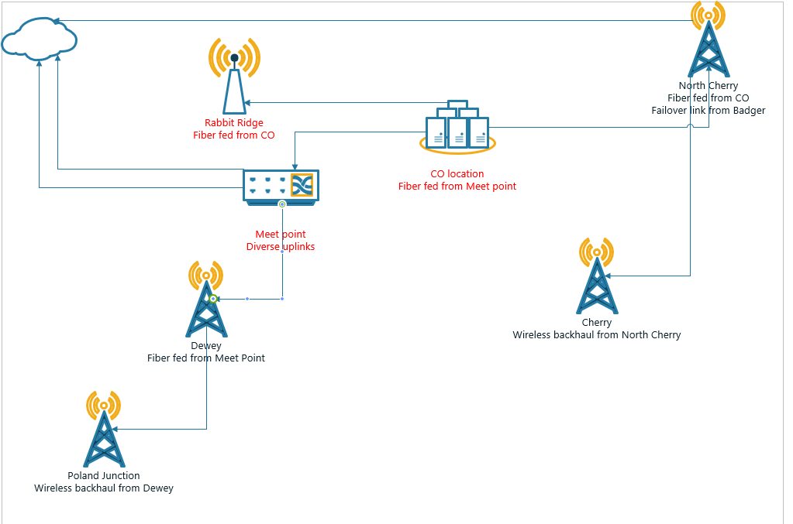
Benefits and Challenges
The integration and optimization of the acquired network provides a range of benefits but also presents certain challenges that must be addressed for successful implementation.
Benefits
The most immediate benefit of this plan is the reduction in operational costs. By eliminating the PCC uplink site and the CO tower, significant expenses associated with leased property and maintenance are removed. Additionally, transitioning PMP customers to Rabbit Ridge and North Cherry streamlines the network by consolidating coverage and improving resource allocation.
Another key benefit is the improvement in network performance and reliability. The construction of fiber links to Dewey and North Cherry reduces the reliance on wireless backhaul, which inherently has higher latency and lower throughput compared to fiber. This upgrade enhances the overall capacity of the network and ensures low-latency, high-bandwidth connections for critical sites, paving the way for future scalability.
The consolidation of infrastructure simplifies network management, reducing the number of towers and wireless backhaul links. This simplification minimizes points of failure, enhances redundancy, and reduces the workload for maintenance teams. Furthermore, better utilization of robust sites like Rabbit Ridge and North Cherry enhances coverage while maintaining service quality for PMP clients.
Challenges
One of the primary challenges of this integration is the upfront investment required for the construction of the new fiber links. Although these links provide long-term cost savings and performance improvements, the initial costs can be significant and may require careful budget planning and resource allocation.
Another challenge lies in the transition of PMP customers from PCC and CO towers to Rabbit Ridge and North Cherry. This migration must be carefully managed to avoid service disruptions and ensure that the new sites can handle the increased client load without degradation in performance. This includes evaluating capacity, adjusting configurations, and communicating effectively with affected clients.
The decommissioning of the PCC and CO towers also requires thorough planning to avoid potential gaps in coverage. Temporary solutions may be needed during the transition to ensure uninterrupted service. Additionally, environmental, and regulatory considerations associated with constructing new fiber links must be navigated, potentially adding complexity and delays to the project timeline.
Finally, the integration of two networks with different existing infrastructures and operational practices may create challenges in unifying management, monitoring, and maintenance processes. The successful merger of these systems will require coordination between teams, potentially retraining personnel, and establishing new protocols to ensure seamless operation.
Conclusion
The integration and optimization of the acquired and existing networks provide a unique opportunity to streamline operations, reduce costs, and enhance overall performance. By carefully addressing inefficiencies, such as the reliance on high-cost uplink sites and wireless backhaul and implementing strategic upgrades like fiber connections to key locations, the proposed design achieves significant improvements in scalability, reliability, and long-term sustainability.
In summary, the proposed design achieves a balance between cost efficiency and enhanced performance, establishing a robust and scalable foundation for the integrated network. This approach not only meets the current operational needs but also prepares the infrastructure for future expansion and evolving client demands. With careful execution, the combined network will deliver improved service quality, greater reliability, and sustainable growth opportunities.

References

